Fatal Shootings Dashboard

Design Summary

In your one-page summary, you can also provide extra information about your design to highlight any background work or to assist the user in understanding and/or using your interface.

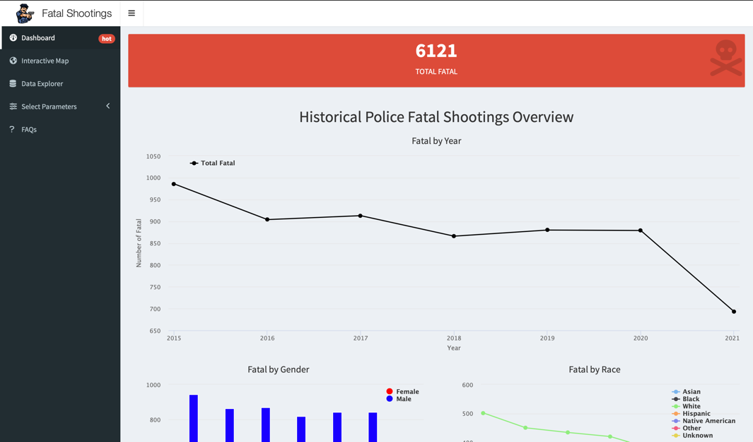

Dashboard

Interactive Map

Data Explorer

Select Parameters

FAQs

Appendix