Question 1a.

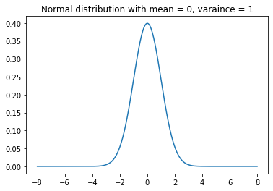

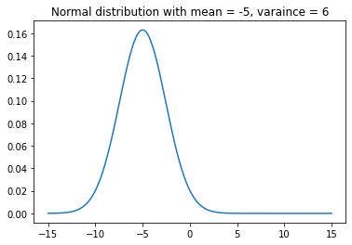

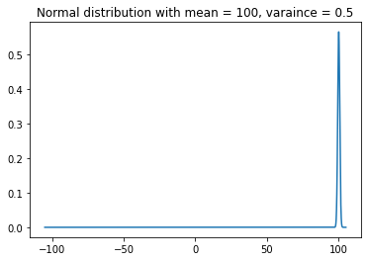

Question 1b.

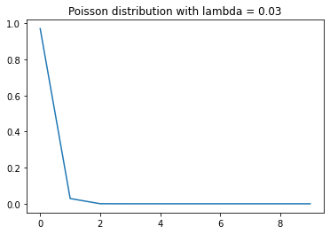

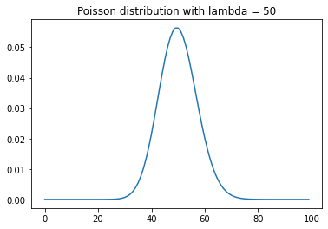

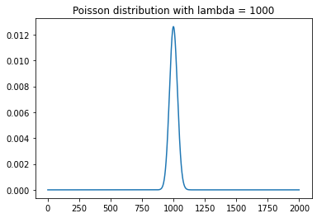

Question 2a.

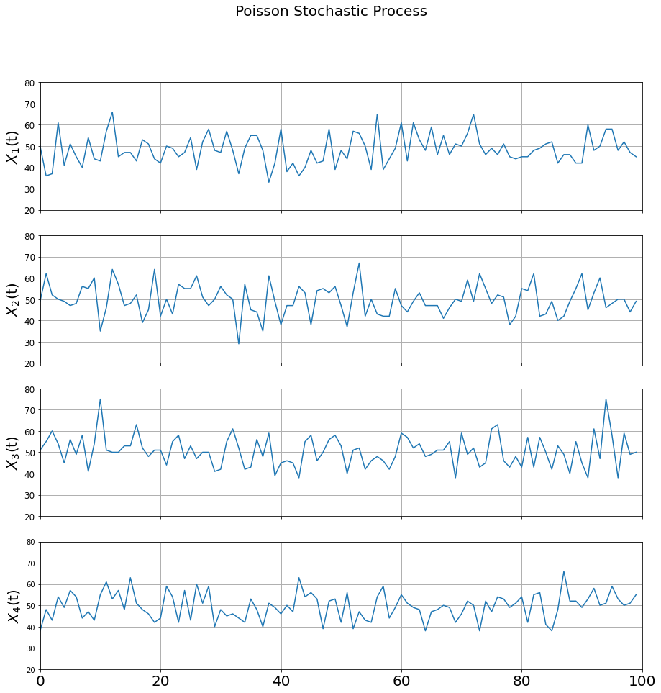

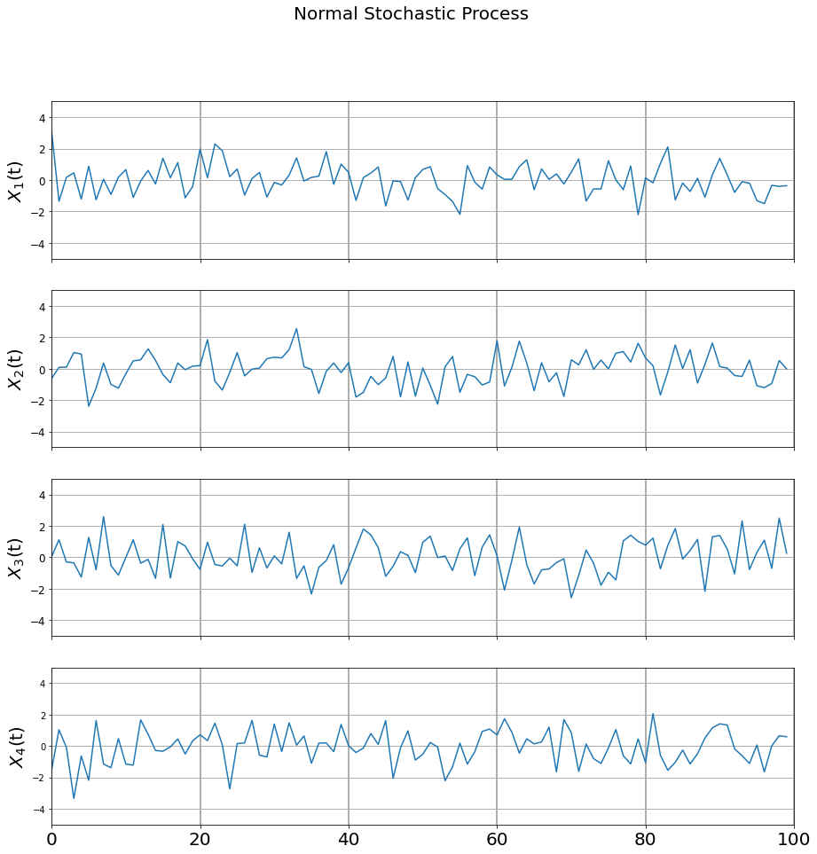

Question 3a

Ice Cream

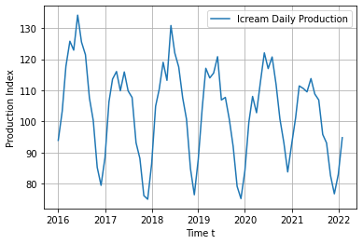

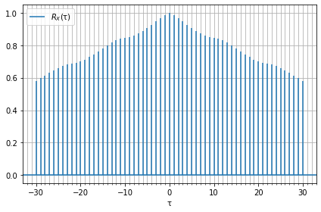

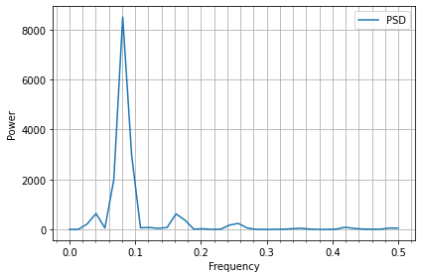

Whole Food

We can see from the original graph that it is a non-stationary time series, the general trend is going down before time 60 and going up after that time point. The seasonality is not quite obvious on this graph. I can tell a slight seasonality of 66 as a period from the autocorrelation graph and it can be verified in the PSD graph as 1/0.015 = 66.

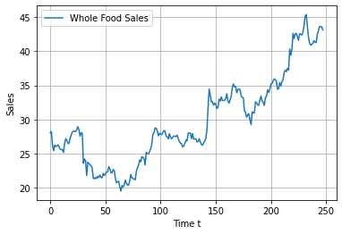

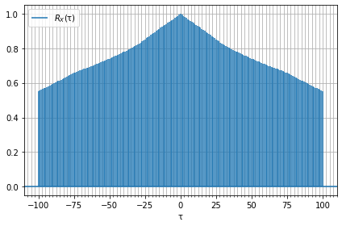

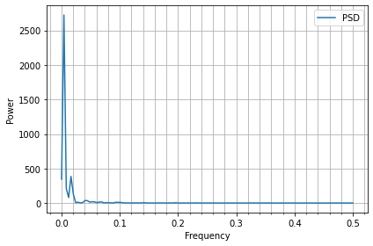

Pharmaceutical

I can tell from the original graph that it is quite like a stationary time-series. From the autocorrelation graph below, the autocorrelation drops really fast in a short period of time and no periodic pattern can be found which means no seasonality in the original graph. In the PSD graph, we can see more than 10 peaks with high power so still no seasonality can be concluded.

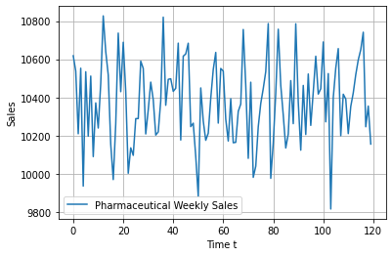

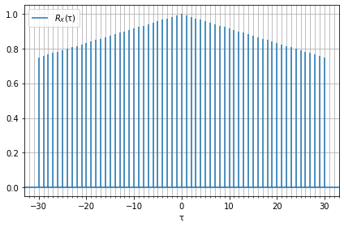

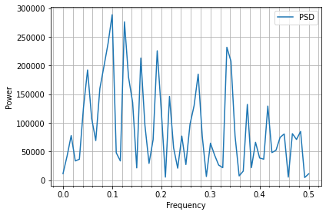

Viscosity

The original graph does not tell much about the trend and seasonality. Although there is no obvious seasonality can be seen from the autocorrelation graph, four peaks appear on the PSD graph. Because there are only 100 time points on the original graph, the first peak can be ignored. The second peak is shown at 0.03 which means the first seasonal pattern repeats after 33, the third peak shown at 0.07 which means the second seasonal pattern repeats after 1/0.07 = 14 and the last peak shown at 0.12 which means the last seasonal pattern repeats after 1/0.12 = 8.

