**Question1:**

MA(5) for Viscosity

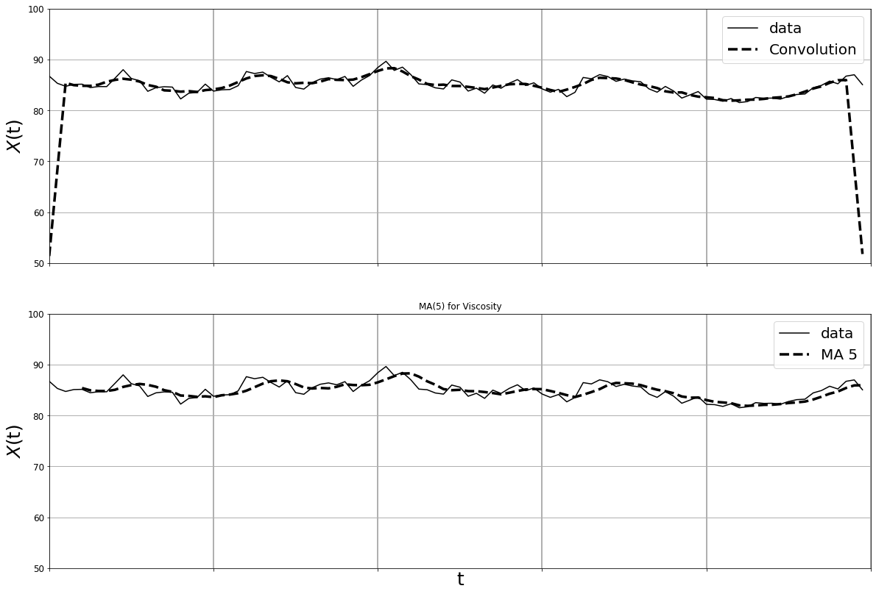

MA(10) for Viscosity

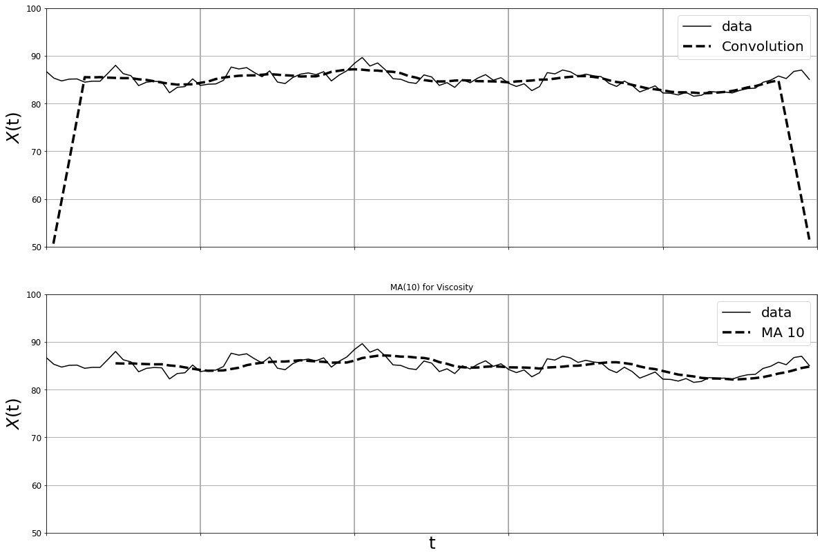

MA(20) for Viscosity

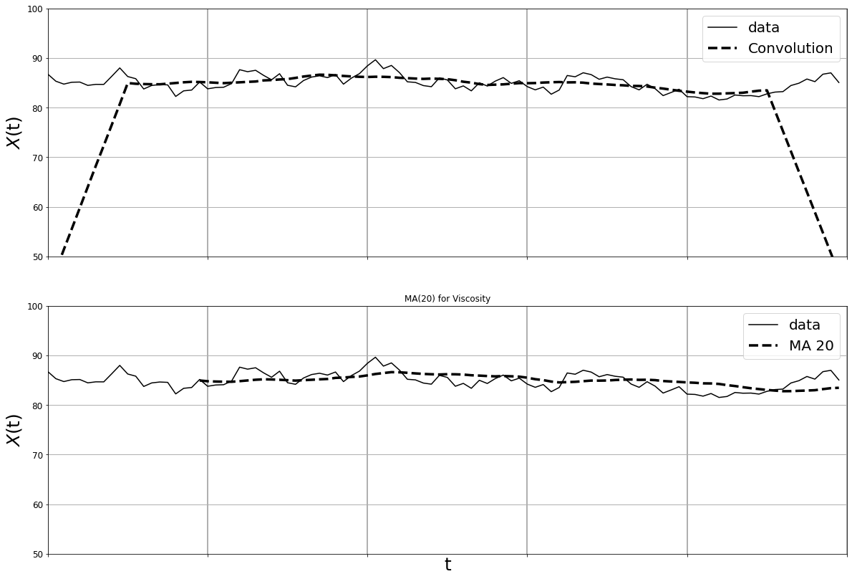

MA(5) for WholeFood

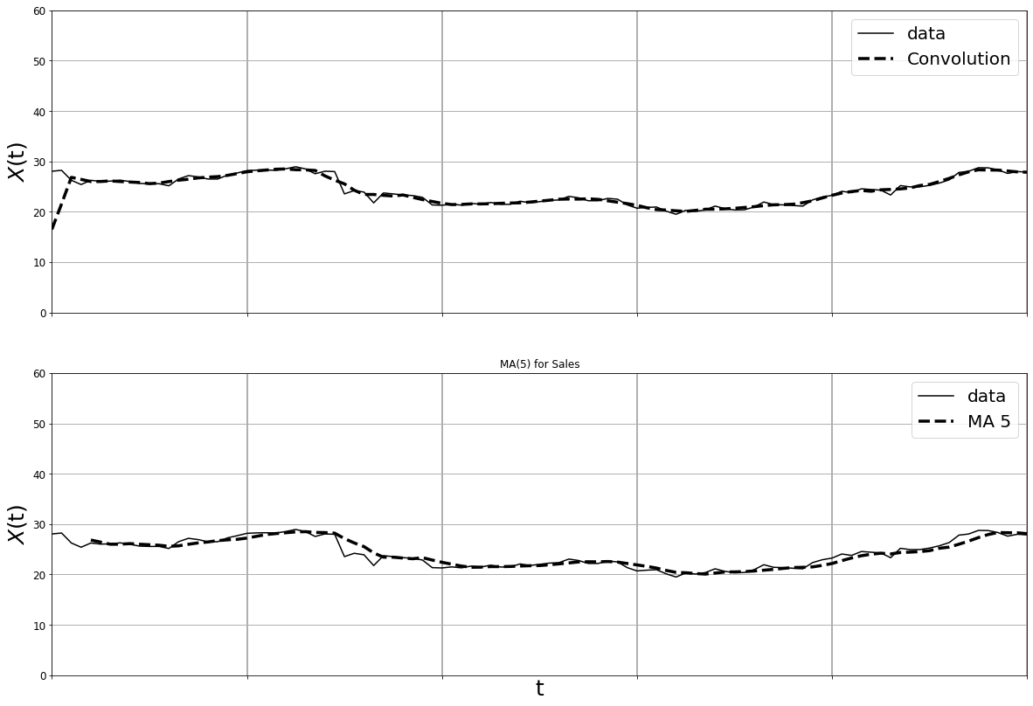

MA(10) for WholeFood

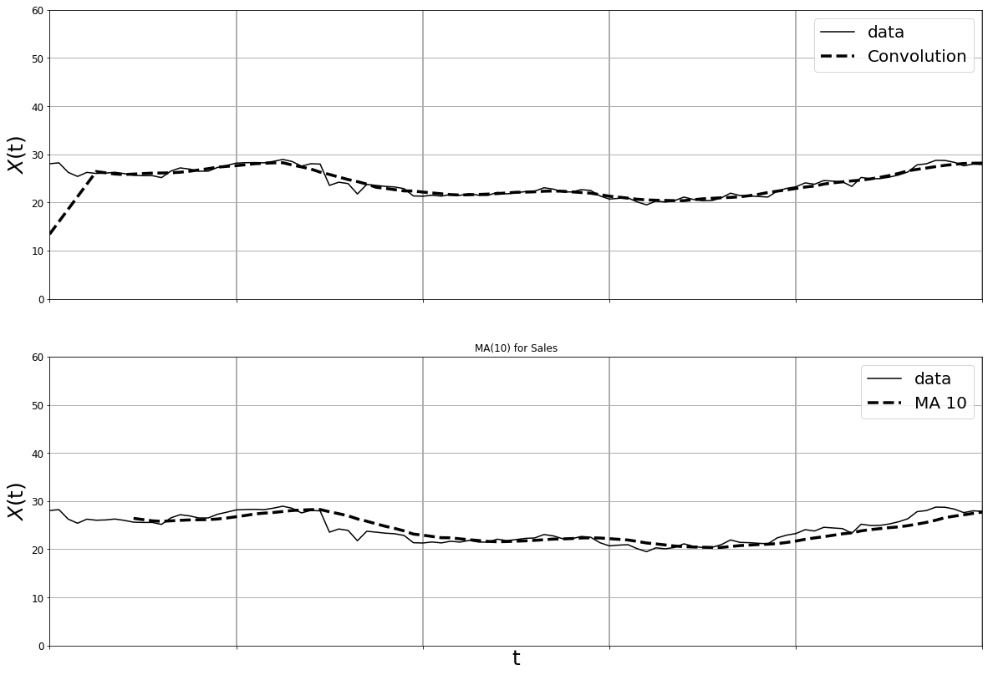

MA(20) for WholeFood

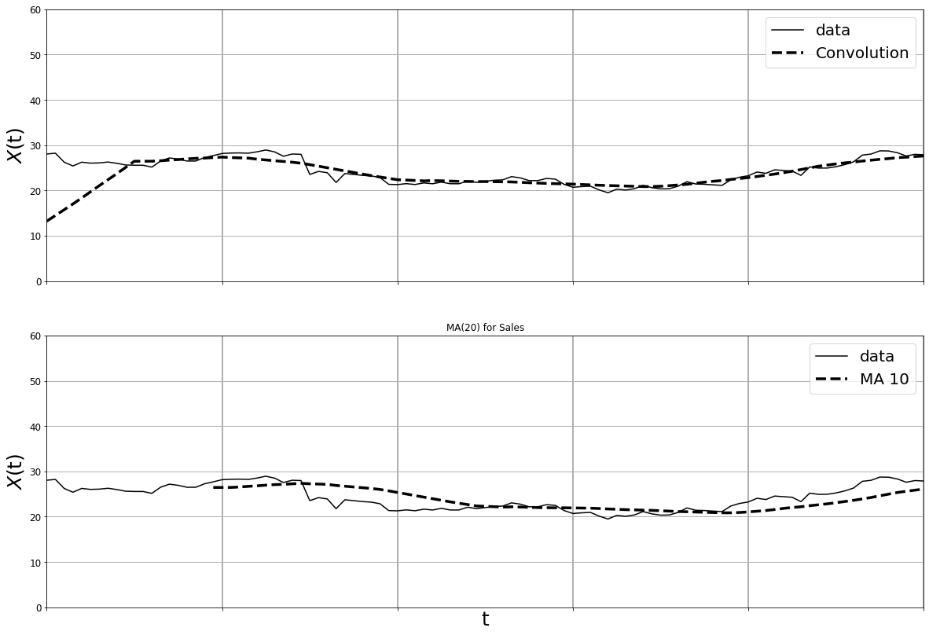

MA(5) for Pharmaceutical

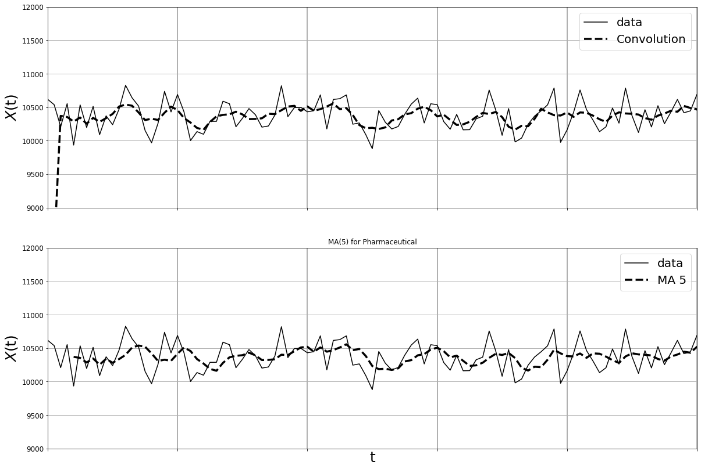

MA(10) for Pharmaceutical

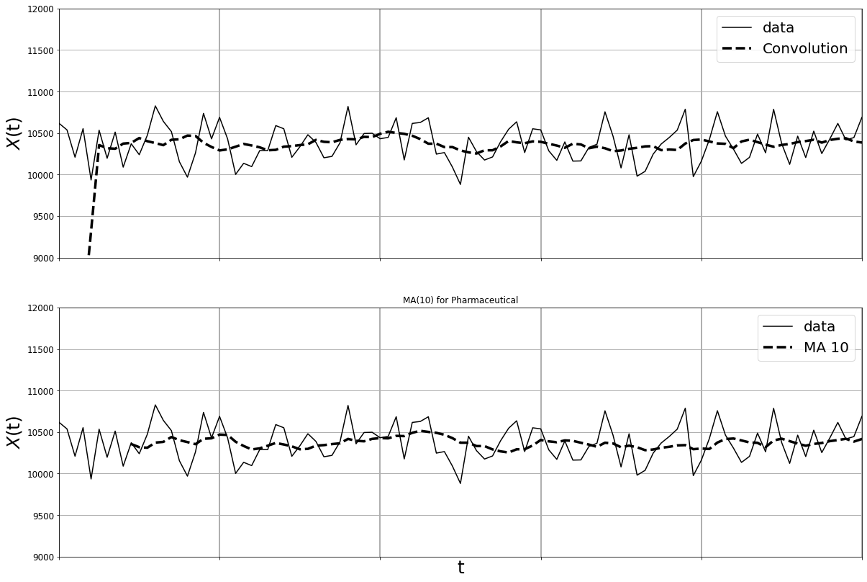

MA(20) for Pharmaceutical

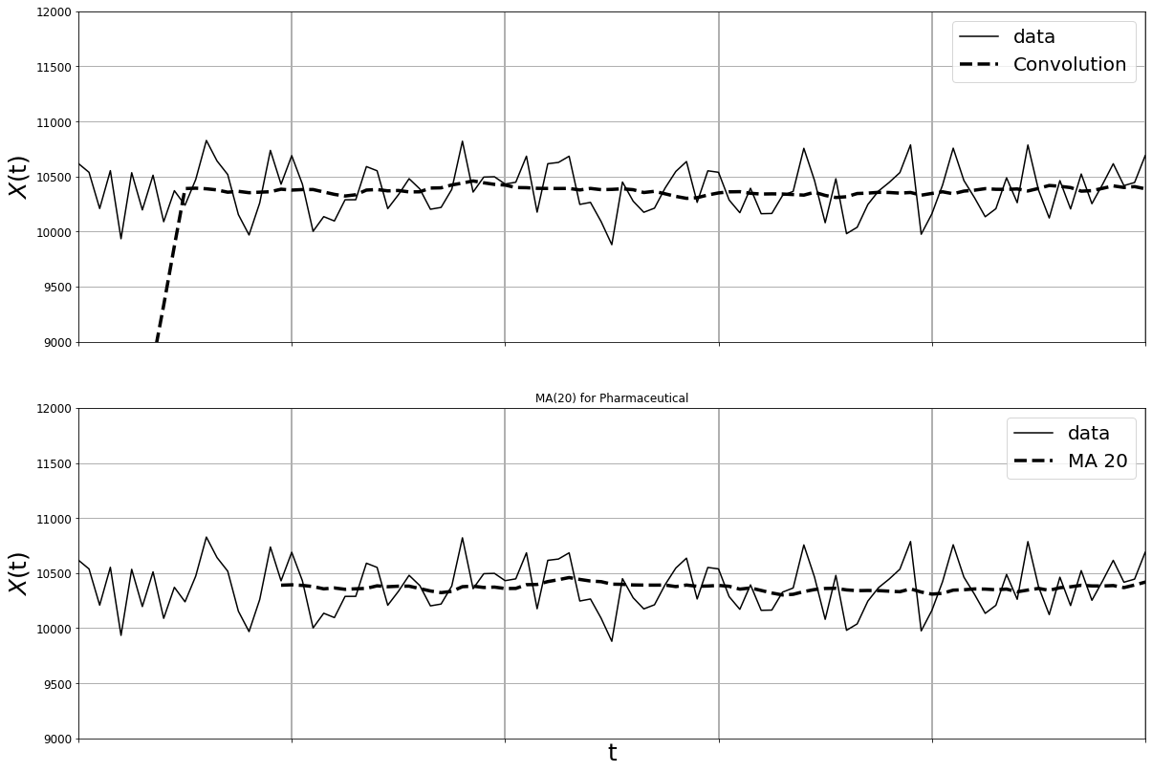

**Question2:**

AR(1), c=0, phi = 0.01, 0.5, 0.9

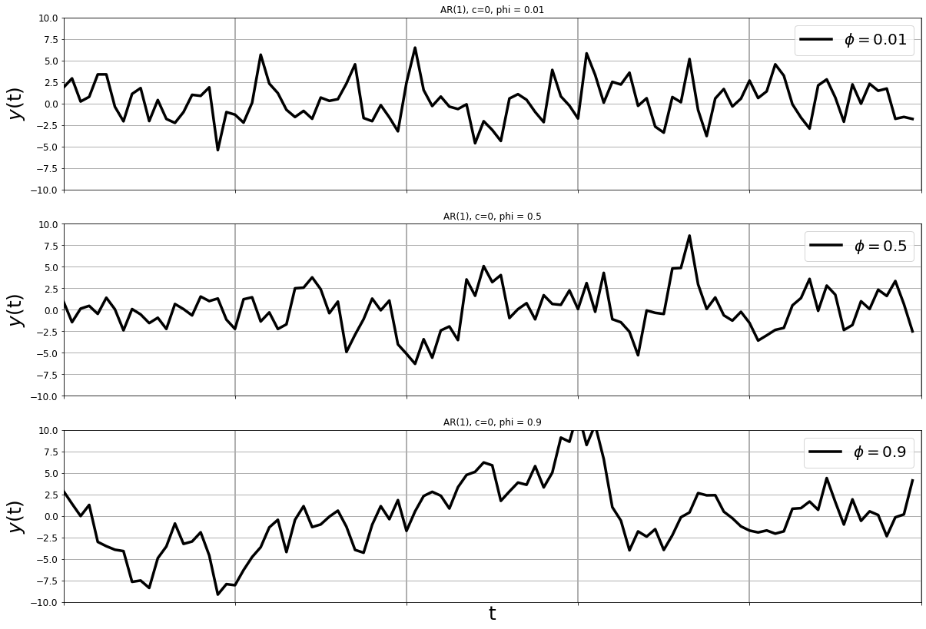

AR(2), c=0, phi_1=0.01, phi_2=0.01

AR(2), c=0, phi_1=0.5, phi_2=0.5

AR(2), c=0, phi_1=0.9, phi_2=0.9

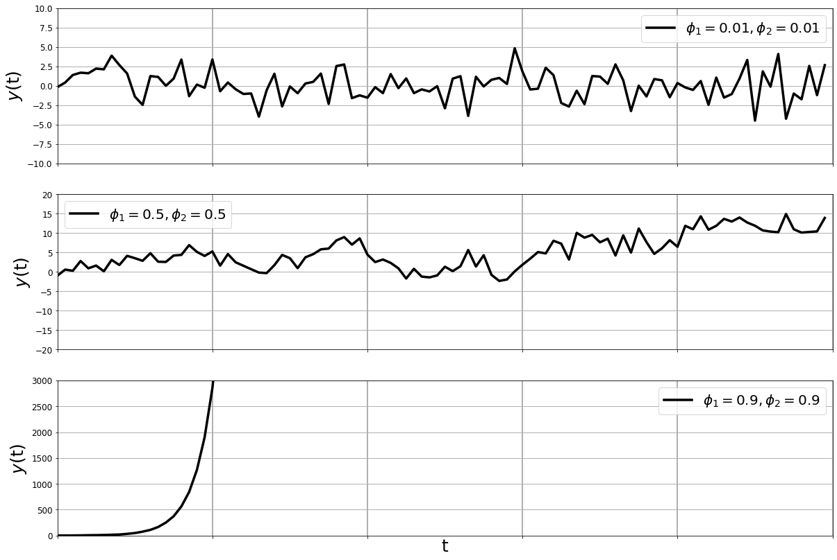

**Question3**

Butterworth Filter for LP on Icecream

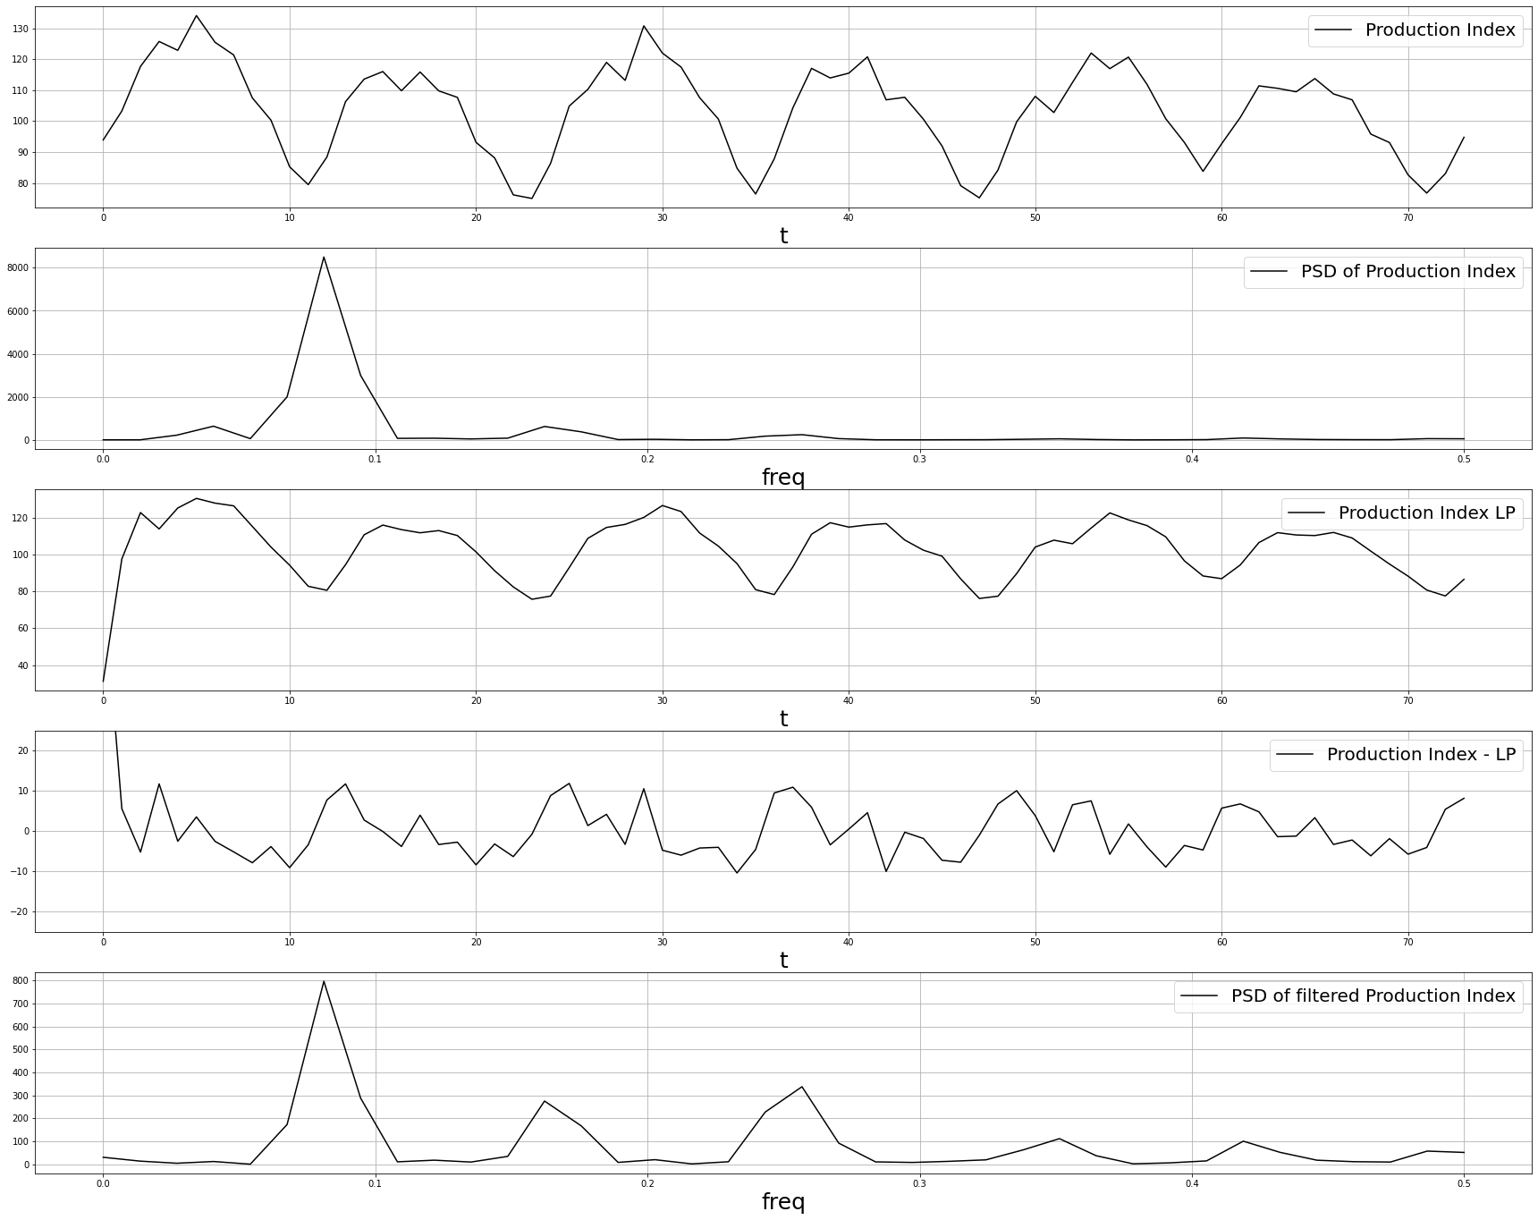

Butterworth Filter for LP on Viscosity

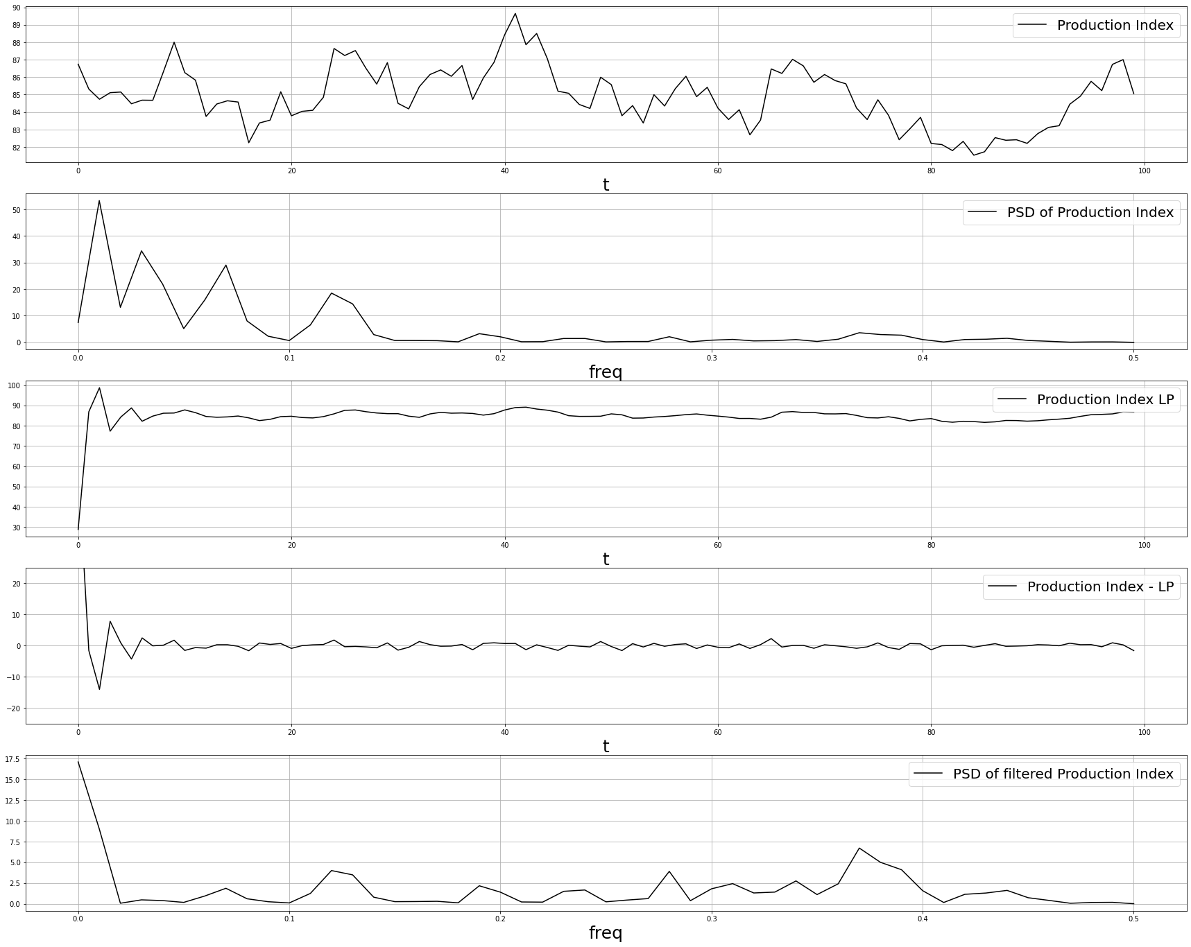

Butterworth Filter for LP on WholeFood

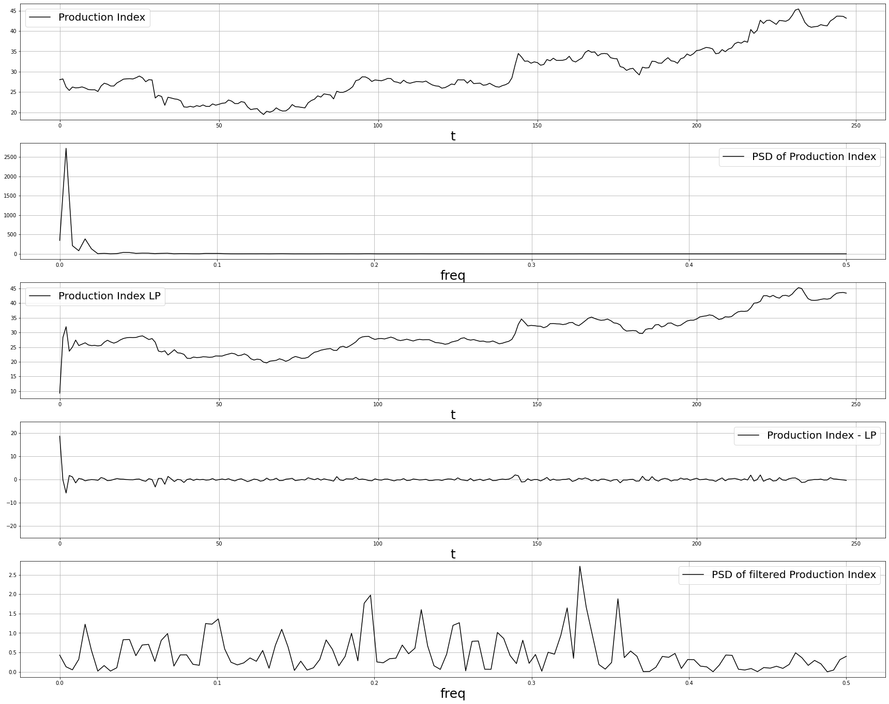

Butterworth Filter for LP on Pharmaceutical

