Problem1

(a).

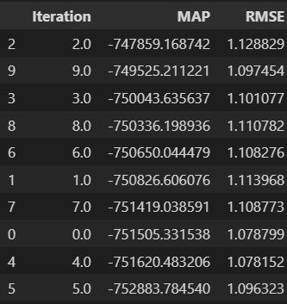

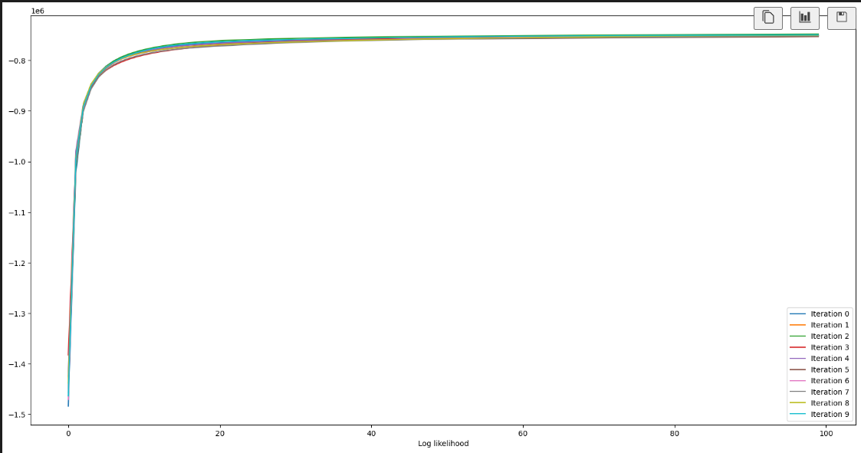

(b).

Star Wars:

My Fair Lady:

GoodFellas:

Probelm2:

