SPARQL verification of the BBMRI-ERIC evaluation query set
Run on obib_v2.5.owl with example data (two donors per query). Text after # in a query is a comment giving the label of the IRI on that line.

S01
Diabetes patients who have never been treated with insulin
PREFIX obo: <http://purl.obolibrary.org/obo/>
SELECT DISTINCT ?donor WHERE {
?donor a obo:OBIB_0000728 . # specimen donor
?donor obo:RO_0000091 ?d1 . # has disposition
?d1 obo:OBI_0002135 ?c1 . # has specified value
FILTER(regex(str(?c1), "^E1[0-4]"))
OPTIONAL {
?donor obo:RO_0000056 ?e . # participates in
?e obo:OBI_0002135 ?atc . # has specified value
FILTER(regex(str(?atc), "^A10A"))
}
FILTER(!bound(?e))
}

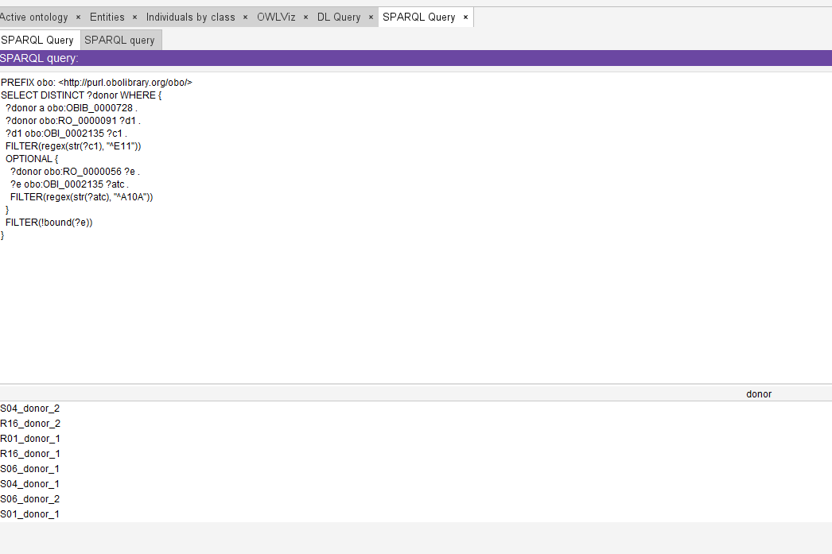
Verification: A SPARQL query was run on example data with two donors with diabetes (E11), only one of whom participates in a drug exposure coded A10A (insulins). The query returns donors with a disease coded in the ICD-10 range E10 to E14 and no recorded insulin exposure. It correctly excluded the donor treated with insulin. It also returned the diabetic donors created for other queries (S04, S06, R01, R16), none of whom has an insulin exposure, which is also correct.

S02
Colorectal cancer, excluding paediatric donors
PREFIX obo: <http://purl.obolibrary.org/obo/>
SELECT DISTINCT ?donor WHERE {
?donor a obo:OBIB_0000728 . # specimen donor
?donor obo:RO_0000091 ?d1 . # has disposition
?d1 obo:OBI_0002135 ?c1 . # has specified value
FILTER(regex(str(?c1), "^C(18|19|20)"))
OPTIONAL {
?age a obo:OBIB_0002206 . # age at event
?age obo:IAO_0000136 ?donor . # is about
?age obo:IAO_0000004 ?years . # has measurement value
FILTER(?years < 18)
}
FILTER(!bound(?age))
}
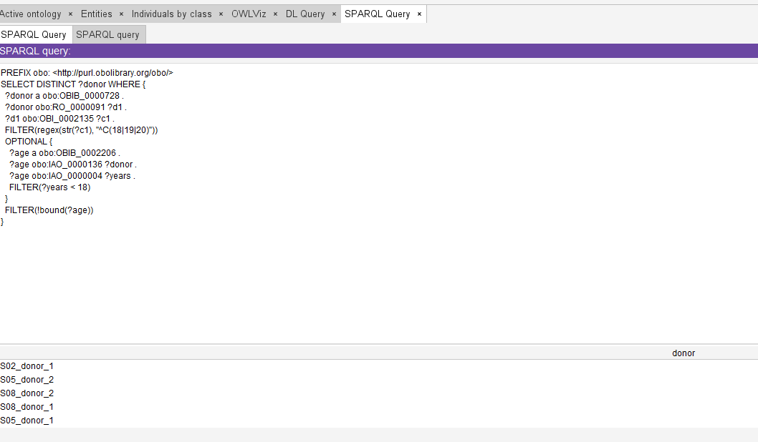
Verification: A SPARQL query was run on example data with two donors with colorectal cancer (C18.7 and C18.0), aged 55 and 12. The query returns donors with a disease coded C18, C19 or C20 and excludes those with an age at event below 18. It correctly excluded the 12 year old donor. It also returned the colorectal cancer donors created for S05 and S08, who have no recorded age and are therefore not excluded.

S03
MS patients with brain imaging
PREFIX obo: <http://purl.obolibrary.org/obo/>
SELECT DISTINCT ?donor WHERE {
?donor a obo:OBIB_0000728 . # specimen donor
?donor obo:RO_0000091 ?d1 . # has disposition
?d1 obo:OBI_0002135 ?c1 . # has specified value
FILTER(regex(str(?c1), "^G35"))
?donor obo:OBIB_0002194 ?image . # sample donor dataset type
?image a obo:OBIB_0002210 . # body (radiological) image
}
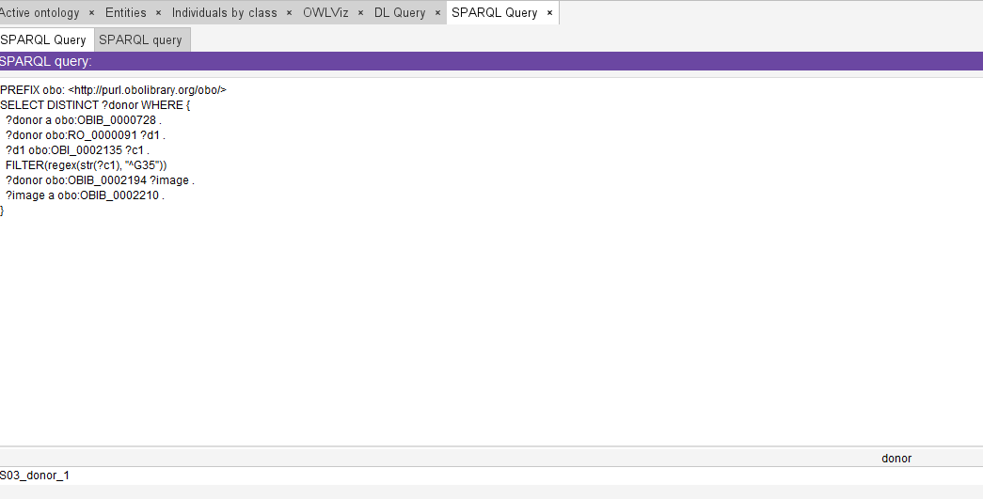
Verification: A SPARQL query was run on example data with two donors with multiple sclerosis (G35), only one of whom has a body (radiological) image. The query returns donors with a disease coded G35 and a dataset of type body (radiological) image, and correctly returned only the donor with the image, although this donor has no physical specimen.

S04
Proben von Patienten mit Typ-2-Diabetes (E11) und Nierenerkrankung
‘Samples from patients with type 2 diabetes (E11) and kidney disease’
PREFIX obo: <http://purl.obolibrary.org/obo/>
SELECT DISTINCT ?donor WHERE {
?donor a obo:OBIB_0000728 . # specimen donor
?donor obo:RO_0000091 ?d1 . # has disposition
?d1 obo:OBI_0002135 ?c1 . # has specified value
FILTER(regex(str(?c1), "^E11"))
?donor obo:RO_0000091 ?d2 . # has disposition
?d2 obo:OBI_0002135 ?c2 . # has specified value
FILTER(regex(str(?c2), "^N[0-2]"))
}
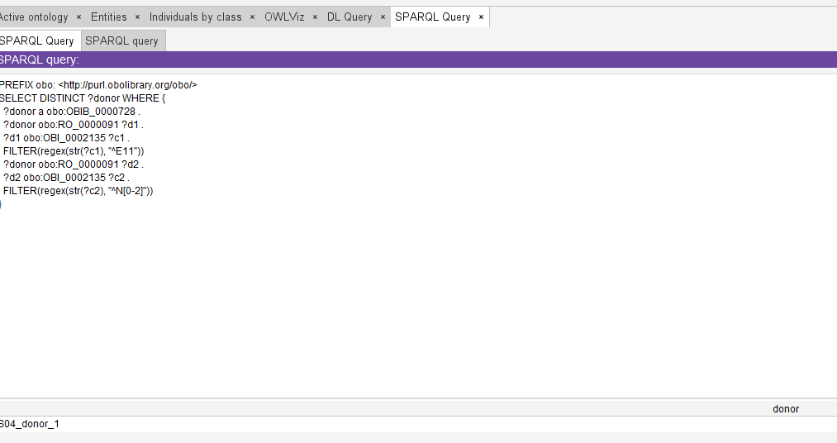
Verification: A SPARQL query was run on example data with two donors with type 2 diabetes (E11), only one of whom also has a kidney disease (N18.3). The query returns donors with a disease coded E11 and a second disease coded in the ICD-10 range N00 to N29, and correctly returned only the donor with both conditions.

S05
Collections with diagnosis C18.7 and available frozen tissue
PREFIX obo: <http://purl.obolibrary.org/obo/>
SELECT DISTINCT ?collection WHERE {
?collection a obo:OBIB_0002075 . # collection
?collection obo:RO_0002351 ?specimen . # has member
?specimen a obo:OBIB_0002173 . # Tissue (fresh frozen)
?process obo:OBI_0000299 ?specimen . # has_specified_output
?process obo:OBI_0000293 ?donor . # has_specified_input
?donor obo:RO_0000091 ?d1 . # has disposition
?d1 obo:OBI_0002135 ?c1 . # has specified value
FILTER(regex(str(?c1), "^C18\\.7"))
}
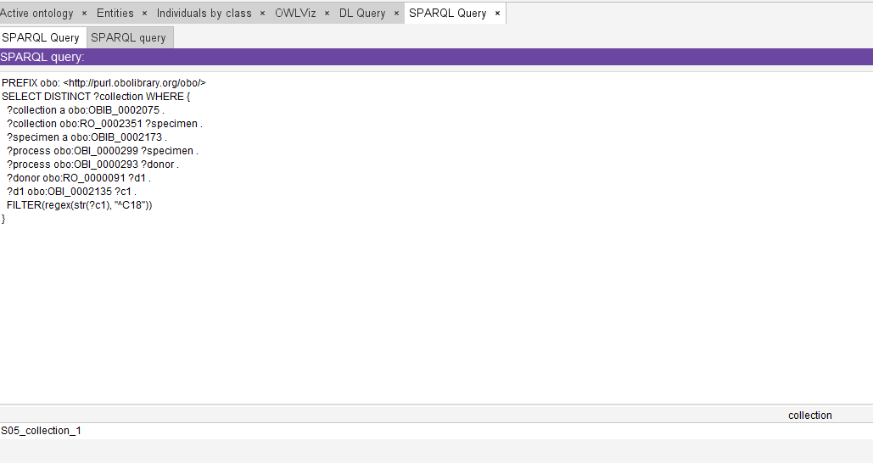
Verification: A SPARQL query was run on example data with two collections, each holding one specimen from a donor with colorectal cancer (C18.7). One specimen is frozen tissue (Tissue (fresh frozen)) and the other is FFPE. The query returns collections that have a frozen tissue specimen as a member whose donor has a disease coded C18.7, and correctly returned only the collection with frozen tissue.

S06
Chemotherapy patients who happened to also be diabetic
PREFIX obo: <http://purl.obolibrary.org/obo/>
SELECT DISTINCT ?donor WHERE {
?donor a obo:OBIB_0000728 . # specimen donor
?donor obo:RO_0000056 ?e . # participates in
?e obo:OBI_0002135 ?atc . # has specified value
FILTER(regex(str(?atc), "^L01"))
?donor obo:RO_0000091 ?d1 . # has disposition
?d1 obo:OBI_0002135 ?c1 . # has specified value
FILTER(regex(str(?c1), "^E1[0-4]"))
}
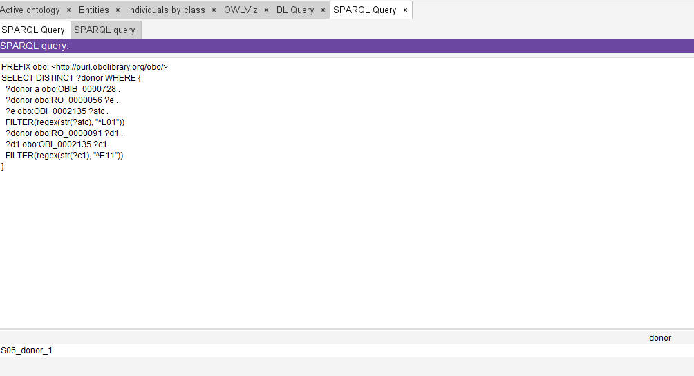
Verification: A SPARQL query was run on example data with two donors with diabetes (E11), only one of whom participates in a drug exposure coded L01 (antineoplastic agents). The query returns donors with a chemotherapy exposure and a disease coded in the range E10 to E14, and correctly returned only the donor who received chemotherapy.

S07
Diabetic patients who happened to have had chemotherapy
PREFIX obo: <http://purl.obolibrary.org/obo/>
SELECT DISTINCT ?donor WHERE {
?donor a obo:OBIB_0000728 . # specimen donor
?donor obo:RO_0000091 ?d1 . # has disposition
?d1 obo:OBI_0002135 ?c1 . # has specified value
FILTER(regex(str(?c1), "^E1[0-4]"))
?donor obo:RO_0000056 ?e . # participates in
?e obo:OBI_0002135 ?atc . # has specified value
FILTER(regex(str(?atc), "^L01"))
}
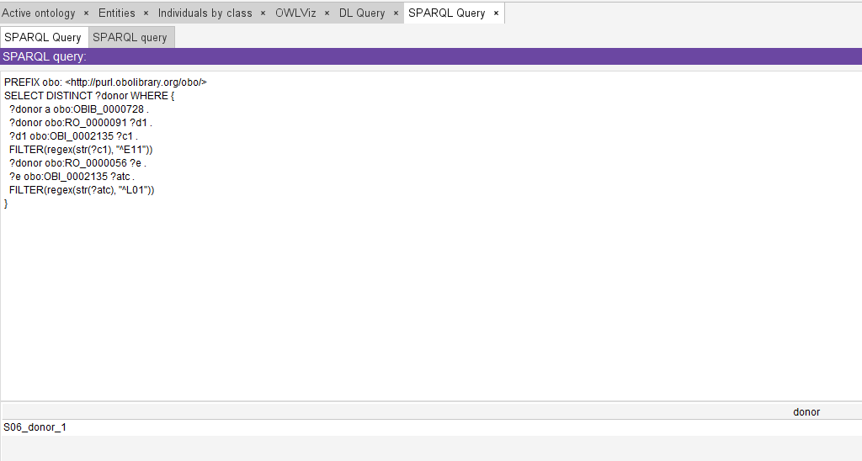
Verification: The same example data as S06 were used, with the two criteria in the opposite order in the query. The query correctly returned the same donor, which shows that the order of the criteria does not affect the result.

S08
Stage III colorectal cancer with matched normal tissue
PREFIX obo: <http://purl.obolibrary.org/obo/>
SELECT DISTINCT ?donor WHERE {
?donor a obo:OBIB_0000728 . # specimen donor
?donor obo:RO_0000091 ?d1 . # has disposition
?d1 obo:OBI_0002135 ?c1 . # has specified value
FILTER(regex(str(?c1), "^C(18|19|20)"))
?stage obo:IAO_0000136 ?d1 . # is about
?stage obo:OBI_0001938 ?group . # has value specification
FILTER(?group = obo:OBI_0002321 || ?group = obo:OBI_0002322 || ?group = obo:OBI_0002323) # Stage IIIA (AJCC 7th), Stage IIIB (AJCC 7th), Stage IIIC (AJCC 7th)
?p1 obo:OBI_0000293 ?donor . # has_specified_input
?p1 obo:OBI_0000299 ?tumour . # has_specified_output
?tumour obo:OBIB_0002033 ?scd . # has diagnosis
?scd obo:OBI_0002135 ?sc . # has specified value
FILTER(regex(str(?sc), "^C(18|19|20)"))
?p2 obo:OBI_0000293 ?donor . # has_specified_input
?p2 obo:OBI_0000299 ?normal . # has_specified_output
?normal a obo:OBIB_0002173 . # Tissue (fresh frozen)
OPTIONAL { ?normal obo:OBIB_0002033 ?x . } # has diagnosis
FILTER(!bound(?x))
}
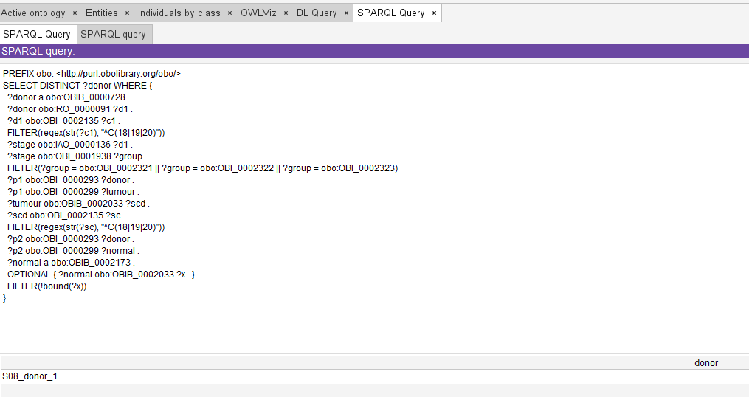
Verification: A SPARQL query was run on example data with two donors with colorectal cancer (C18.7), each with stage IIIB (AJCC 7th) attached to the disease and a tumour tissue specimen whose sample content diagnosis is C18.7. Only one donor also has a second tissue specimen without any diagnosis, representing matched normal tissue. The query returns donors with colorectal cancer, a stage IIIA, IIIB or IIIC, a tumour specimen with a cancer diagnosis and a further tissue specimen without any diagnosis, and correctly returned only the donor with matched normal tissue.

S09
I need samples for my study

PREFIX obo: <http://purl.obolibrary.org/obo/>
PREFIX rdfs: <http://www.w3.org/2000/01/rdf-schema#>
SELECT DISTINCT ?sample WHERE {
?sample a ?type .
{ ?type rdfs:subClassOf* obo:OBI_0100051 . } # specimen
UNION
{ ?type rdfs:subClassOf* obo:OBIB_0002150 . } # Tissue (fresh frozen or fixed)
}
limit 10

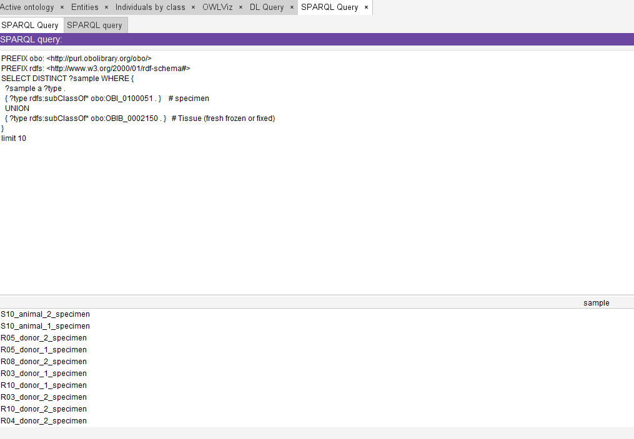
Verification: A SPARQL query was run that selects all samples in the ontology, that is every individual whose type is specimen or one of its subclasses. Tissue (fresh frozen or fixed) and its subclasses are not placed under specimen, so they had to be added to the query as a second class. The query correctly returned all 20 specimens of the example data, including the specimens taken from animals.

S10
Samples from neutered male animals in veterinary collections
PREFIX obo: <http://purl.obolibrary.org/obo/>
SELECT DISTINCT ?specimen WHERE {
?specimen obo:RO_0001000 ?animal . # derives from
?animal a obo:OBI_0100026 . # organism
?animal obo:OBIB_0002025 ?sex . # has biological sex
?sex a obo:PATO_0000384 . # male
?collection obo:RO_0002351 ?specimen . # has member
?source a obo:OBIB_0002074 . # animal
?source obo:IAO_0000136 ?collection . # is about
}
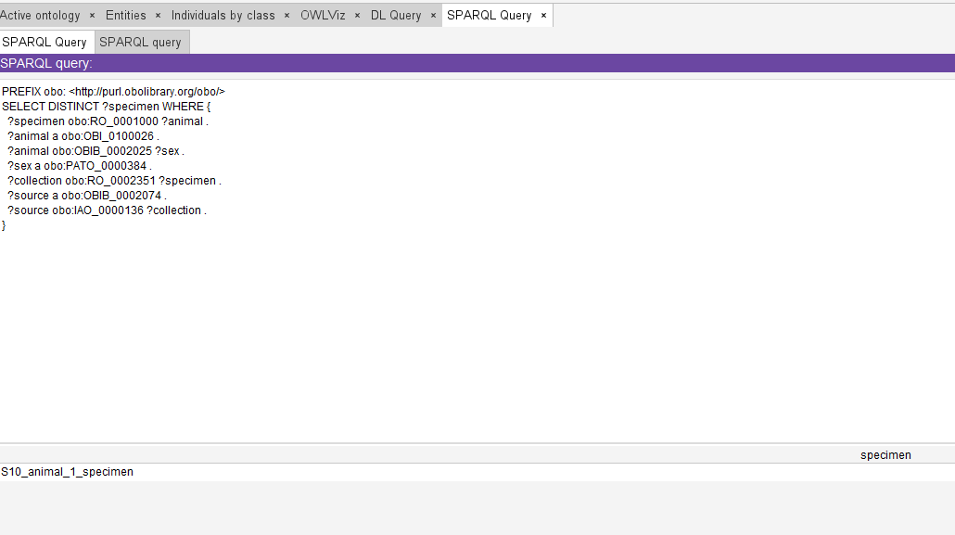
Verification: A SPARQL query was run on example data with two animal organisms (Mammalia), one male and one female, each with a specimen in a collection whose sample source is animal. The query returns specimens derived from a male organism in a collection with sample source animal, and correctly returned only the specimen of the male animal. "Neutered" was not tested, since it cannot be represented.

R01
Psoriazis vulgaris diagnosed on patient with diabetes mellitus (E11)
PREFIX obo: <http://purl.obolibrary.org/obo/>
SELECT DISTINCT ?donor WHERE {
?donor a obo:OBIB_0000728 . # specimen donor
?donor obo:RO_0000091 ?d1 . # has disposition
?d1 obo:OBI_0002135 ?c1 . # has specified value
FILTER(regex(str(?c1), "^L40\\.0"))
?donor obo:RO_0000091 ?d2 . # has disposition
?d2 obo:OBI_0002135 ?c2 . # has specified value
FILTER(regex(str(?c2), "^E11"))
}
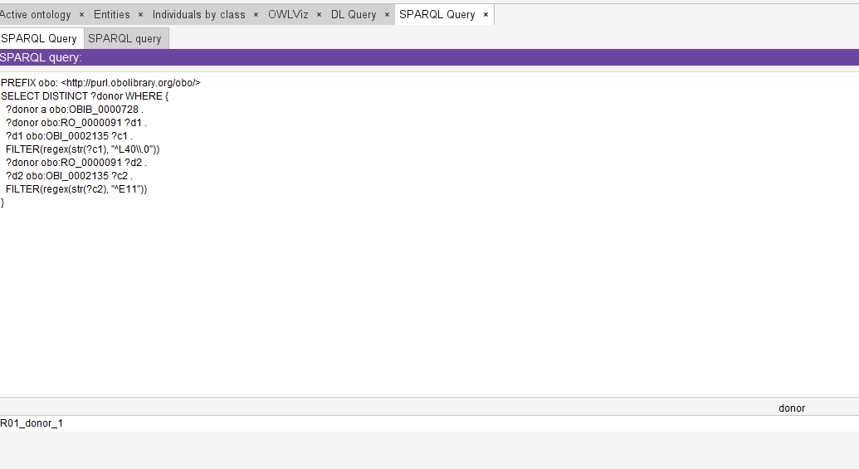
Verification: A SPARQL query was run on example data with two donors with psoriasis vulgaris (L40.0), only one of whom also has diabetes mellitus (E11). The query returns donors with a disease coded L40.0 and a disease coded E11, and correctly returned only the donor with both conditions.

R02
Stroke patients with available MRI scan
PREFIX obo: <http://purl.obolibrary.org/obo/>
SELECT DISTINCT ?donor WHERE {
?donor a obo:OBIB_0000728 . # specimen donor
?donor obo:RO_0000091 ?d1 . # has disposition
?d1 obo:OBI_0002135 ?c1 . # has specified value
FILTER(regex(str(?c1), "^I6[0-4]"))
?donor obo:OBIB_0002194 ?image . # sample donor dataset type
?image a obo:OBIB_0002210 . # body (radiological) image
}
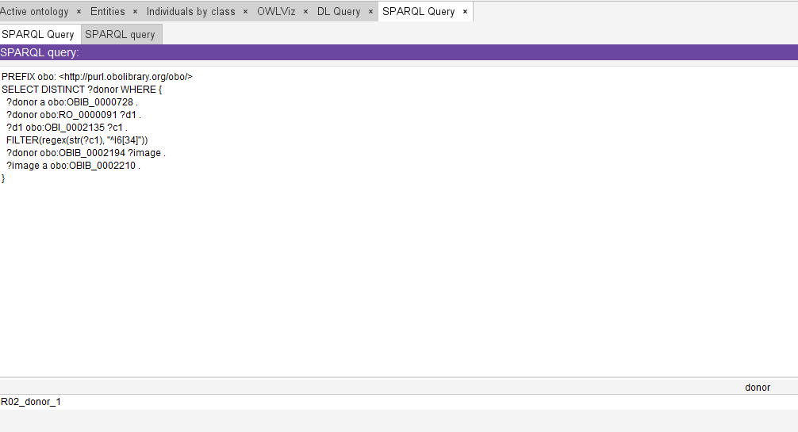
Verification: A SPARQL query was run on example data with two donors with stroke (I63.9), only one of whom has a body (radiological) image. The query returns donors with a disease coded in the range I60 to I64 and a dataset of type body (radiological) image, and correctly returned only the donor with the image.

R03
Serum from elderly woman patients with Carcinoma uteri and anaemia
PREFIX obo: <http://purl.obolibrary.org/obo/>
SELECT DISTINCT ?specimen WHERE {
?donor a obo:OBIB_0000728 . # specimen donor
?donor obo:RO_0000091 ?d1 . # has disposition
?d1 obo:OBI_0002135 ?c1 . # has specified value
FILTER(regex(str(?c1), "^C5[45]"))
?donor obo:RO_0000091 ?d2 . # has disposition
?d2 obo:OBI_0002135 ?c2 . # has specified value
FILTER(regex(str(?c2), "^D(5[0-9]|6[0-4])"))
?process obo:OBI_0000293 ?donor . # has_specified_input
?process obo:OBI_0000299 ?specimen . # has_specified_output
?specimen a obo:OBI_0100017 . # blood serum specimen
?donor obo:OBIB_0002025 ?sex . # has biological sex
?sex a obo:PATO_0000383 . # female
?age a obo:OBIB_0002206 . # age at event
?age obo:IAO_0000136 ?donor . # is about
?age obo:IAO_0000004 ?years . # has measurement value
FILTER(?years >= 65)
}
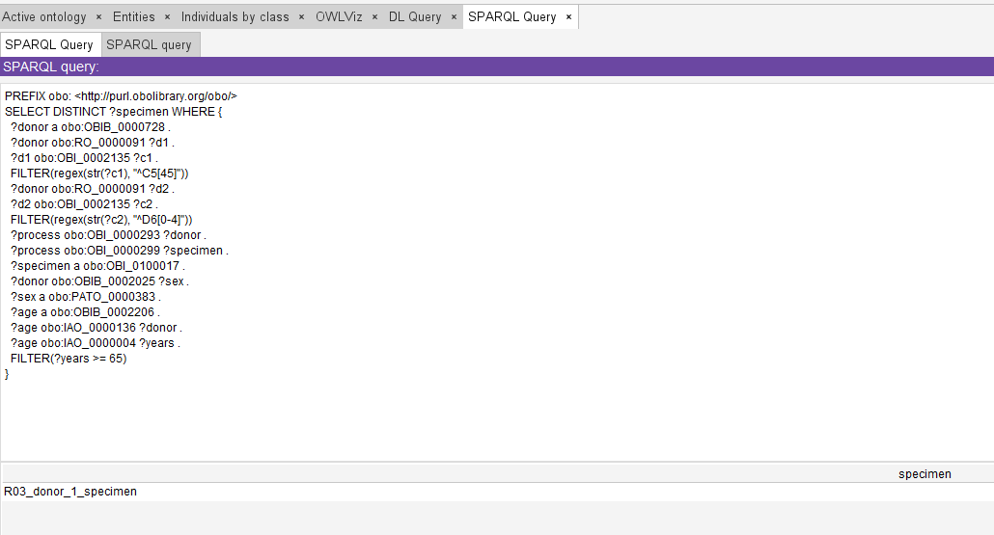
Verification: A SPARQL query was run on example data with two female donors with carcinoma uteri (C55) and anaemia (D64.9), each with a blood serum specimen, aged 72 and 45. The query returns blood serum specimens of female donors aged 65 or more with a disease coded C54 or C55 and a disease coded in the range D50 to D64, and correctly returned only the specimen of the 72 year old donor.

R04
Serum/Plasma from patients between 40 and 60 years old treated for myocardial infarction
PREFIX obo: <http://purl.obolibrary.org/obo/>
SELECT DISTINCT ?specimen WHERE {
?donor a obo:OBIB_0000728 . # specimen donor
?donor obo:RO_0000091 ?d1 . # has disposition
?d1 obo:OBI_0002135 ?c1 . # has specified value
FILTER(regex(str(?c1), "^I2[12]"))
?process obo:OBI_0000293 ?donor . # has_specified_input
?process obo:OBI_0000299 ?specimen . # has_specified_output
?specimen a ?type .
FILTER(?type = obo:OBI_0100017 || ?type = obo:OBI_0100016) # blood serum specimen, blood plasma specimen
?age a obo:OBIB_0002206 . # age at event
?age obo:IAO_0000136 ?donor . # is about
?age obo:IAO_0000004 ?years . # has measurement value
FILTER(?years >= 40 && ?years <= 60)
}
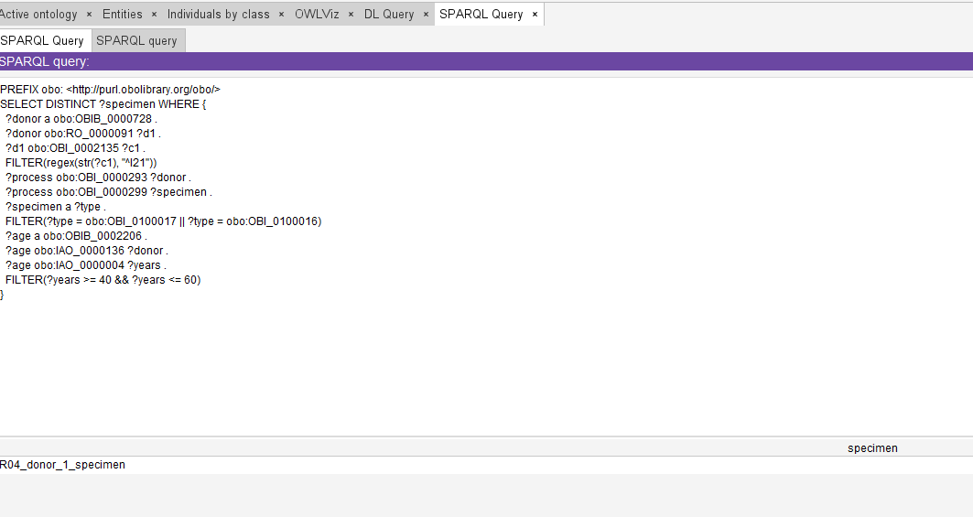
Verification: A SPARQL query was run on example data with two donors with myocardial infarction (I21.9), each with a blood plasma specimen, aged 50 and 70. The query returns blood serum or blood plasma specimens of donors aged 40 to 60 with a disease coded I21 or I22, and correctly returned only the specimen of the 50 year old donor.

R05
Urine samples from male Prostate CA and urinary tract infection patients
PREFIX obo: <http://purl.obolibrary.org/obo/>
SELECT DISTINCT ?specimen WHERE {
?donor a obo:OBIB_0000728 . # specimen donor
?process obo:OBI_0000293 ?donor . # has_specified_input
?process obo:OBI_0000299 ?specimen . # has_specified_output
?specimen a obo:OBI_0000651 . # urine specimen
?donor obo:RO_0000091 ?d1 . # has disposition
?d1 obo:OBI_0002135 ?c1 . # has specified value
FILTER(regex(str(?c1), "^C61"))
?donor obo:RO_0000091 ?d2 . # has disposition
?d2 obo:OBI_0002135 ?c2 . # has specified value
FILTER(regex(str(?c2), "^N39\\.0"))
?donor obo:OBIB_0002025 ?sex . # has biological sex
?sex a obo:PATO_0000384 . # male
}
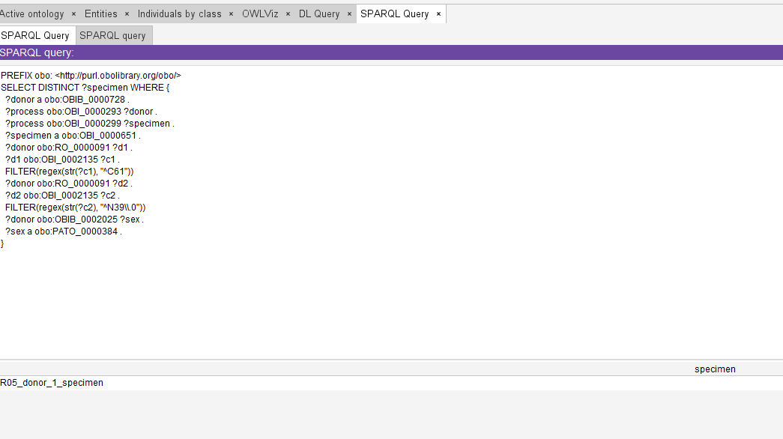
Verification: A SPARQL query was run on example data with two male donors with prostate cancer (C61), each with a urine specimen, only one of whom also has a urinary tract infection (N39.0). The query returns urine specimens of male donors with a disease coded C61 and a disease coded N39.0, and correctly returned only the specimen of the donor with both conditions.

R06
Muži s vysokým krvným tlakom a infarktom myokardu
‘Men with high blood pressure and myocardial infarction’

PREFIX obo: <http://purl.obolibrary.org/obo/>
SELECT DISTINCT ?donor WHERE {
?donor a obo:OBIB_0000728 . # specimen donor
?donor obo:RO_0000091 ?d1 . # has disposition
?d1 obo:OBI_0002135 ?c1 . # has specified value
FILTER(regex(str(?c1), "^I1[0-5]"))
?donor obo:RO_0000091 ?d2 . # has disposition
?d2 obo:OBI_0002135 ?c2 . # has specified value
FILTER(regex(str(?c2), "^I2[12]"))
?donor obo:OBIB_0002025 ?sex . # has biological sex
?sex a obo:PATO_0000384 . # male
}
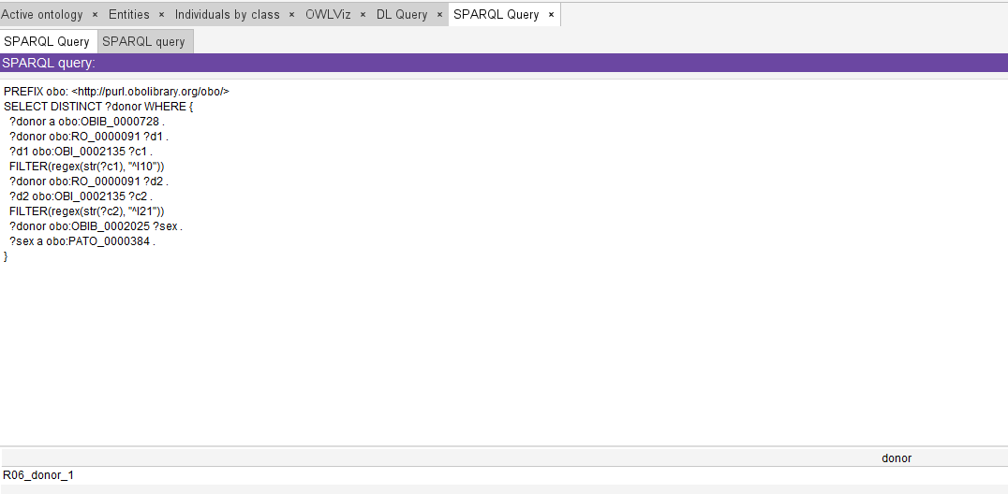
Verification: A SPARQL query was run on example data with two donors with hypertension (I10) and myocardial infarction (I21.9), one male and one female. The query returns male donors with a disease coded in the range I10 to I15 and a disease coded I21 or I22, and correctly returned only the male donor.

R07
Cardiac arrhythmia and pulmonary embolism donors
PREFIX obo: <http://purl.obolibrary.org/obo/>
SELECT DISTINCT ?donor WHERE {
?donor a obo:OBIB_0000728 . # specimen donor
?donor obo:RO_0000091 ?d1 . # has disposition
?d1 obo:OBI_0002135 ?c1 . # has specified value
FILTER(regex(str(?c1), "^I4[7-9]"))
?donor obo:RO_0000091 ?d2 . # has disposition
?d2 obo:OBI_0002135 ?c2 . # has specified value
FILTER(regex(str(?c2), "^I26"))
}
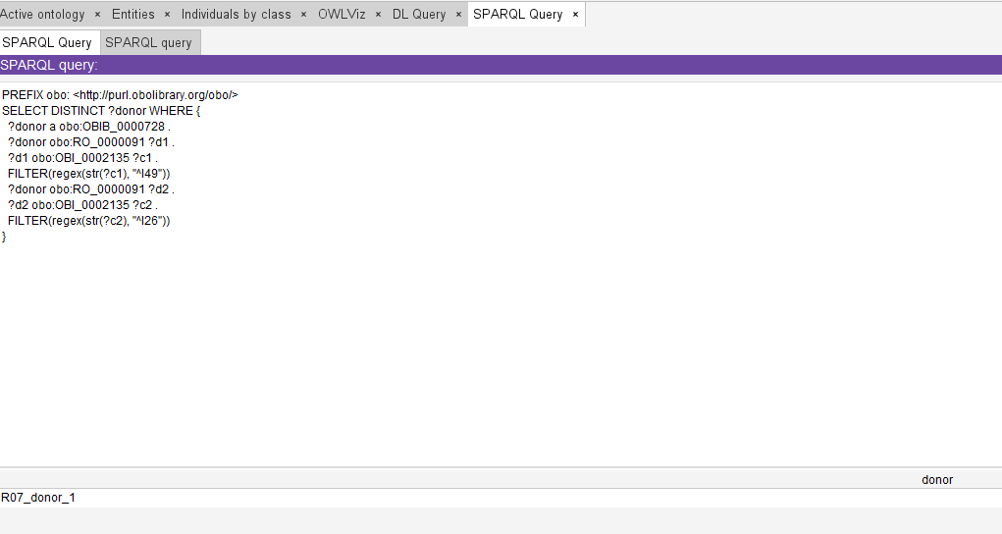
Verification: A SPARQL query was run on example data with two donors with cardiac arrhythmia (I49.9), only one of whom also has pulmonary embolism (I26.9). The query returns donors with a disease coded in the range I47 to I49 and a disease coded I26, and correctly returned only the donor with both conditions.

R08
FFPE tissue samples from patiens with cirrhosis
PREFIX obo: <http://purl.obolibrary.org/obo/>
SELECT DISTINCT ?specimen WHERE {
?donor a obo:OBIB_0000728 . # specimen donor
?process obo:OBI_0000293 ?donor . # has_specified_input
?process obo:OBI_0000299 ?specimen . # has_specified_output
?specimen a obo:OBI_1200000 . # FFPE specimen
?donor obo:RO_0000091 ?d1 . # has disposition
?d1 obo:OBI_0002135 ?c1 . # has specified value
FILTER(regex(str(?c1), "^(K74|K70\\.3)"))
}
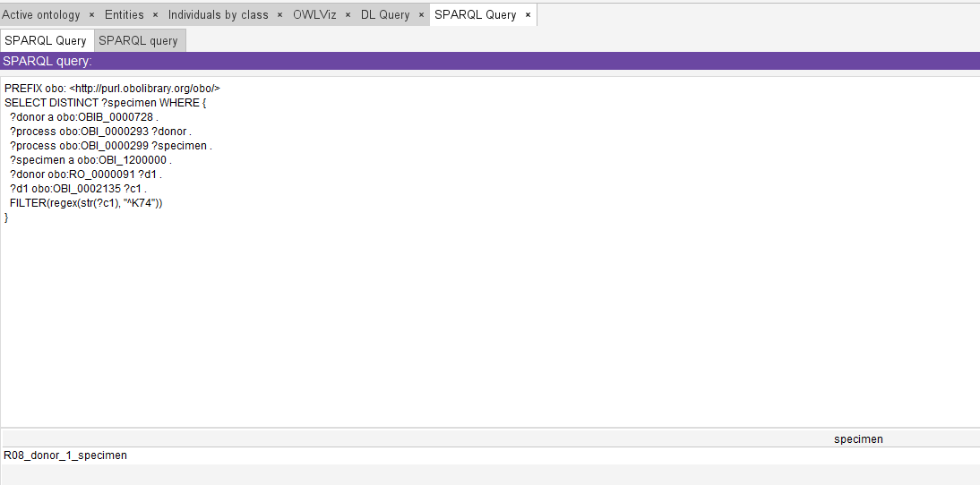
Verification: A SPARQL query was run on example data with two donors with cirrhosis (K74.6), one with an FFPE specimen and one with a blood serum specimen. The query returns FFPE specimens of donors with a disease coded K74 or K70.3, and correctly returned only the FFPE specimen.

R09

Stage 3 lung carcinoma (C34.9) from Poland with value of CYFRA 21-1 between 30 and 60 uq/l
PREFIX obo: <http://purl.obolibrary.org/obo/>
SELECT DISTINCT ?donor WHERE {
?donor a obo:OBIB_0000728 . # specimen donor
?donor obo:RO_0000091 ?d1 . # has disposition
?d1 obo:OBI_0002135 ?c1 . # has specified value
FILTER(regex(str(?c1), "^C34"))
?stage obo:IAO_0000136 ?d1 . # is about
?stage obo:OBI_0001938 ?group . # has value specification
FILTER(?group = obo:OBI_0002321 || ?group = obo:OBI_0002322 || ?group = obo:OBI_0002323) # Stage IIIA (AJCC 7th), Stage IIIB (AJCC 7th), Stage IIIC (AJCC 7th)
}
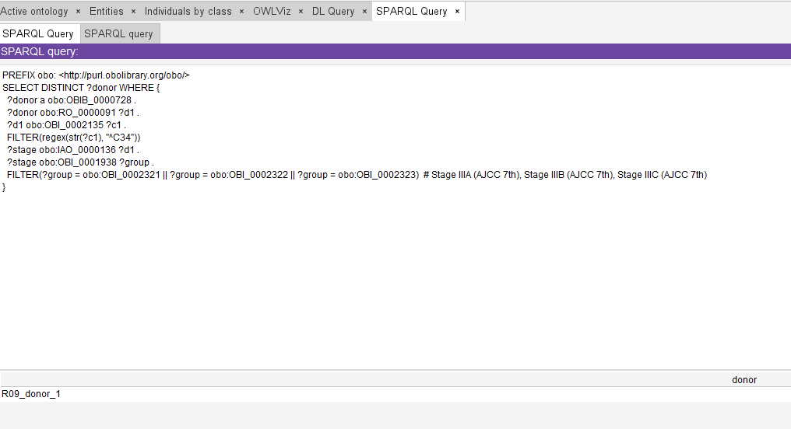

Verification: A SPARQL query was run on example data with two donors with lung carcinoma (C34.9), one with stage IIIA (AJCC 7th) and one with stage I (AJCC 7th) attached to the disease. The query returns donors with a disease coded C34 and a stage of IIIA, IIIB or IIIC, and correctly returned only the donor with stage IIIA. The query covers only the diagnosis and the stage. The CYFRA 21-1 value could not be included, since the analyte is not represented, and "from Poland" maps to no field.

R10
Serum from patients with hyperuricemia
PREFIX obo: <http://purl.obolibrary.org/obo/>
SELECT DISTINCT ?specimen WHERE {
?donor a obo:OBIB_0000728 . # specimen donor
?process obo:OBI_0000293 ?donor . # has_specified_input
?process obo:OBI_0000299 ?specimen . # has_specified_output
?specimen a obo:OBI_0100017 . # blood serum specimen
?donor obo:RO_0000091 ?d1 . # has disposition
?d1 obo:OBI_0002135 ?c1 . # has specified value
FILTER(regex(str(?c1), "^E79\\.0"))
}
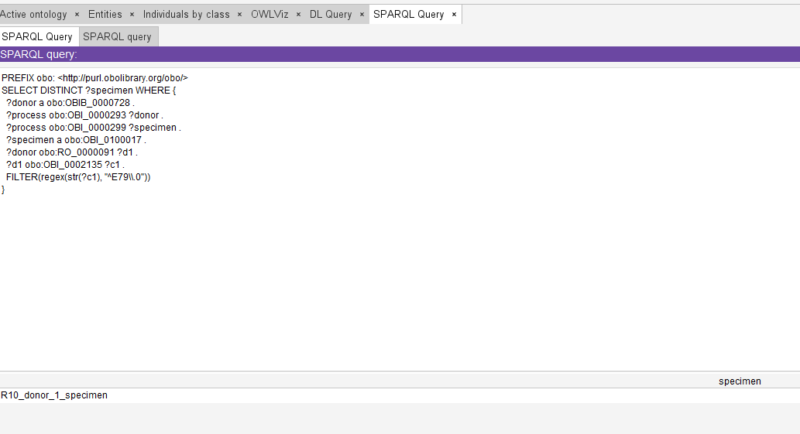
Verification: A SPARQL query was run on example data with two donors with hyperuricemia (E79.0), one with a blood serum specimen and one with a blood plasma specimen. The query returns blood serum specimens of donors with a disease coded E79.0, and correctly returned only the serum specimen.

R11
Cerebrospinal fluid from patient diagnosed with meningitis and epilepsy
PREFIX obo: <http://purl.obolibrary.org/obo/>
SELECT DISTINCT ?specimen WHERE {
?donor a obo:OBIB_0000728 . # specimen donor
?process obo:OBI_0000293 ?donor . # has_specified_input
?process obo:OBI_0000299 ?specimen . # has_specified_output
?specimen a obo:OBI_0002502 . # cerebrospinal fluid specimen
?donor obo:RO_0000091 ?d1 . # has disposition
?d1 obo:OBI_0002135 ?c1 . # has specified value
FILTER(regex(str(?c1), "^G0[0-3]"))
?donor obo:RO_0000091 ?d2 . # has disposition
?d2 obo:OBI_0002135 ?c2 . # has specified value
FILTER(regex(str(?c2), "^G40"))
}
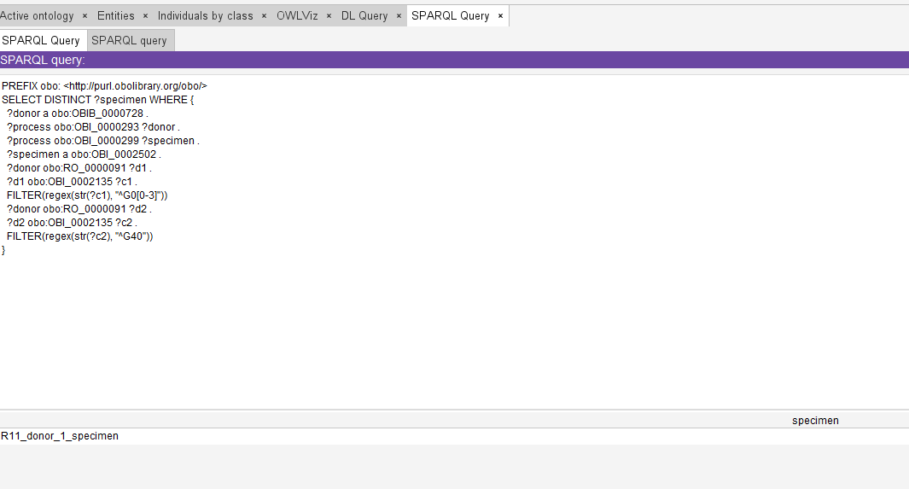
Verification: A SPARQL query was run on example data with two donors with meningitis (G03.9), each with a cerebrospinal fluid specimen, only one of whom also has epilepsy (G40.9). The query returns cerebrospinal fluid specimens of donors with a disease coded in the range G00 to G03 and a disease coded G40, and correctly returned only the specimen of the donor with both conditions.

R12
Donors under 30 with femur fracture and embolism using contraception
PREFIX obo: <http://purl.obolibrary.org/obo/>
SELECT DISTINCT ?donor WHERE {
?donor a obo:OBIB_0000728 . # specimen donor
?donor obo:BFO_0000051 ?f . # has part
?f a obo:OGMS_0000045 . # disorder
?f obo:OBI_0002135 ?fc . # has specified value
FILTER(regex(str(?fc), "^S72"))
?donor obo:RO_0000091 ?d1 . # has disposition
?d1 obo:OBI_0002135 ?c1 . # has specified value
FILTER(regex(str(?c1), "^I(26|74)"))
?donor obo:RO_0000056 ?e . # participates in
?e obo:OBI_0002135 ?atc . # has specified value
FILTER(regex(str(?atc), "^G03A"))
?age a obo:OBIB_0002206 . # age at event
?age obo:IAO_0000136 ?donor . # is about
?age obo:IAO_0000004 ?years . # has measurement value
FILTER(?years < 30)
}
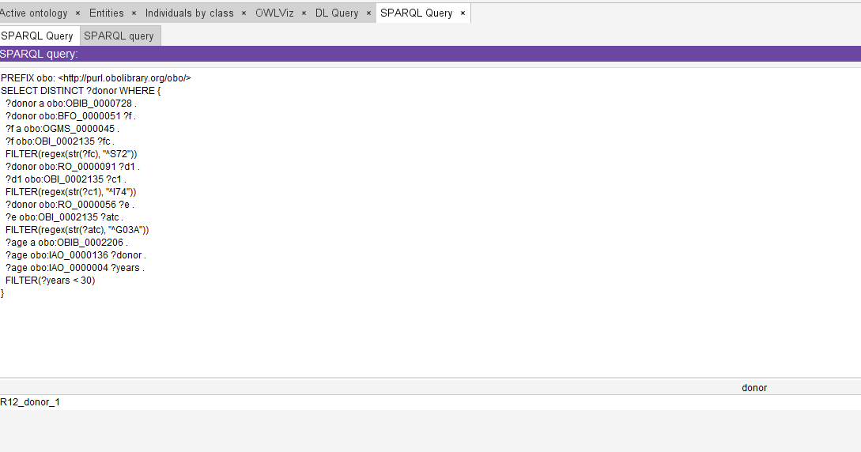
Verification: A SPARQL query was run on example data with two female donors with a femur fracture (S72.0, represented as a disorder) and embolism (I74.9), both participating in a drug exposure coded G03A (hormonal contraceptives), aged 25 and 40. The query returns donors under 30 with a disorder coded S72, a disease coded I26 or I74 and a contraceptive exposure, and correctly returned only the 25 year old donor.

R13
Elderly samples diagnosed with Colitis ulcerosa and Anaemia
PREFIX obo: <http://purl.obolibrary.org/obo/>
SELECT DISTINCT ?donor WHERE {
?donor a obo:OBIB_0000728 . # specimen donor
?age a obo:OBIB_0002206 . # age at event
?age obo:IAO_0000136 ?donor . # is about
?age obo:IAO_0000004 ?years . # has measurement value
FILTER(?years >= 65)
?donor obo:RO_0000091 ?d1 . # has disposition
?d1 obo:OBI_0002135 ?c1 . # has specified value
FILTER(regex(str(?c1), "^K51"))
?donor obo:RO_0000091 ?d2 . # has disposition
?d2 obo:OBI_0002135 ?c2 . # has specified value
FILTER(regex(str(?c2), "^D(5[0-9]|6[0-4])"))
}
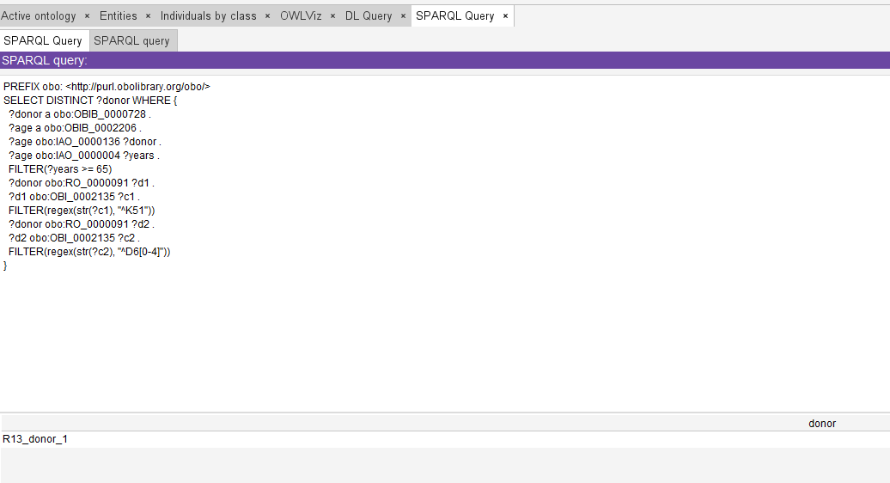
Verification: A SPARQL query was run on example data with two donors with ulcerative colitis (K51.9) and anaemia (D64.9), aged 70 and 40. The query returns donors aged 65 or more with a disease coded K51 and a disease coded in the range D50 to D64, and correctly returned only the 70 year old donor.

R14
Austrian patients diagnosed with sclerodermia
PREFIX obo: <http://purl.obolibrary.org/obo/>
SELECT DISTINCT ?donor WHERE {
?donor a obo:OBIB_0000728 . # specimen donor
?donor obo:RO_0000091 ?d1 . # has disposition
?d1 obo:OBI_0002135 ?c1 . # has specified value
FILTER(regex(str(?c1), "^M34"))
}
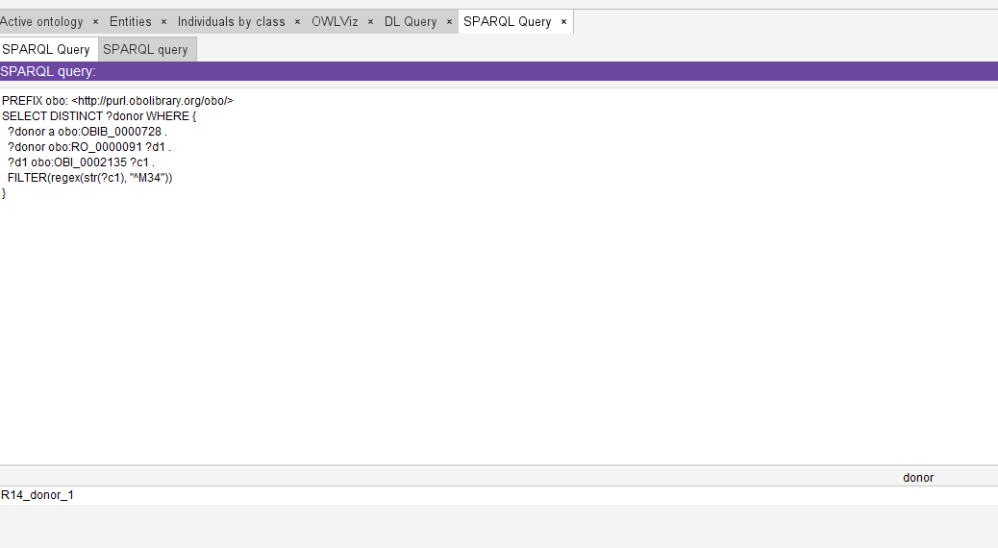
Verification: A SPARQL query was run on example data with two donors, one with systemic sclerosis (M34.9) and one with systemic lupus erythematosus (M32.9). The query returns donors with a disease coded M34, and correctly returned only the donor with systemic sclerosis.

R15
Prostate cancer patients treated by chemotherapy with level of PSA over 4 ng/ml
PREFIX obo: <http://purl.obolibrary.org/obo/>
SELECT DISTINCT ?donor WHERE {
?donor a obo:OBIB_0000728 . # specimen donor
?donor obo:RO_0000091 ?d1 . # has disposition
?d1 obo:OBI_0002135 ?c1 . # has specified value
FILTER(regex(str(?c1), "^C61"))
?donor obo:RO_0000056 ?e . # participates in
?e obo:OBI_0002135 ?atc . # has specified value
FILTER(regex(str(?atc), "^L01"))
}
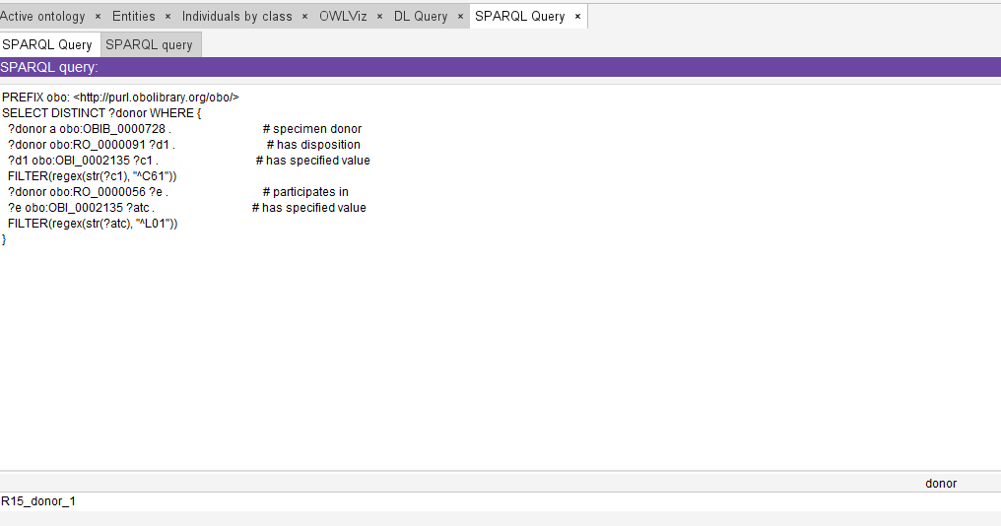

Verification: A SPARQL query was run on example data with two donors with prostate cancer (C61), only one of whom participates in a drug exposure coded L01 (antineoplastic agents). The query returns donors with a disease coded C61 and a chemotherapy exposure, and correctly returned only the donor treated with chemotherapy. The query covers only the diagnosis and the chemotherapy. The PSA level could not be included, since the analyte is not represented.

R16
Patients with diabetes mellitus type 2 and Rheumatoid arthritis treated by Corticosteroids
PREFIX obo: <http://purl.obolibrary.org/obo/>
SELECT DISTINCT ?donor WHERE {
?donor a obo:OBIB_0000728 . # specimen donor
?donor obo:RO_0000091 ?d1 . # has disposition
?d1 obo:OBI_0002135 ?c1 . # has specified value
FILTER(regex(str(?c1), "^E11"))
?donor obo:RO_0000091 ?d2 . # has disposition
?d2 obo:OBI_0002135 ?c2 . # has specified value
FILTER(regex(str(?c2), "^M0[56]"))
?donor obo:RO_0000056 ?e . # participates in
?e obo:OBI_0002135 ?atc . # has specified value
FILTER(regex(str(?atc), "^H02"))
}
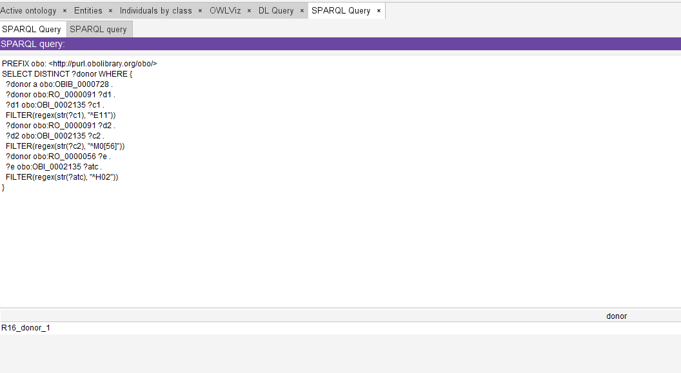
Verification: A SPARQL query was run on example data with two donors with type 2 diabetes (E11) and rheumatoid arthritis (M06.9), only one of whom participates in a drug exposure coded H02 (corticosteroids for systemic use). The query returns donors with a disease coded E11, a disease coded M05 or M06 and a corticosteroid exposure, and correctly returned only the donor treated with corticosteroids.

R17
Pregnant female patients diagnosed with SLE
PREFIX obo: <http://purl.obolibrary.org/obo/>
SELECT DISTINCT ?donor WHERE {
?donor a obo:OBIB_0000728 . # specimen donor
?donor obo:RO_0000091 ?d1 . # has disposition
?d1 obo:OBI_0002135 ?c1 . # has specified value
FILTER(regex(str(?c1), "^M32"))
?donor obo:OBIB_0002025 ?sex . # has biological sex
?sex a obo:PATO_0000383 . # female
?diag a obo:OGMS_0000073 . # diagnosis
?diag obo:IAO_0000136 ?donor . # is about
?diag obo:OBI_0002135 ?z . # has specified value
FILTER(regex(str(?z), "^Z33"))
}
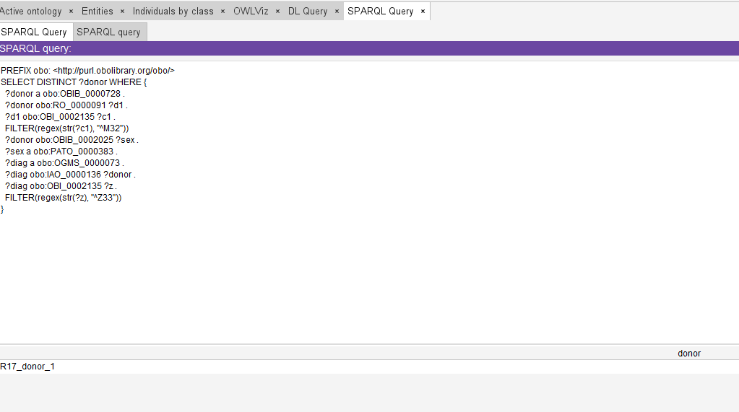
Verification: A SPARQL query was run on example data with two female donors with systemic lupus erythematosus (M32.9), only one of whom has a diagnosis of pregnant state (Z33) about her. The query returns female donors with a disease coded M32 and a diagnosis coded Z33, and correctly returned only the pregnant donor.

R18
Samples of malignant melanoma patients
PREFIX obo: <http://purl.obolibrary.org/obo/>
SELECT DISTINCT ?specimen WHERE {
?donor a obo:OBIB_0000728 . # specimen donor
?donor obo:RO_0000091 ?d1 . # has disposition
?d1 obo:OBI_0002135 ?c1 . # has specified value
FILTER(regex(str(?c1), "^C43"))
?process obo:OBI_0000293 ?donor . # has_specified_input
?process obo:OBI_0000299 ?specimen . # has_specified_output
}
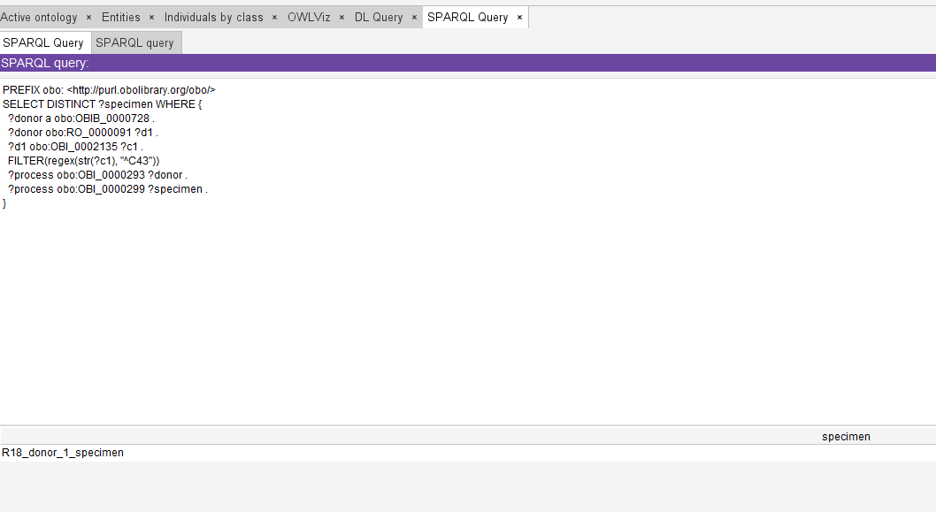
Verification: A SPARQL query was run on example data with two donors with malignant melanoma (C43.9), only one of whom has provided a specimen (FFPE). The query returns specimens of donors with a disease coded C43, and correctly returned only the specimen of that donor.

R19
Patients diagnosed with cataracta H25
PREFIX obo: <http://purl.obolibrary.org/obo/>
SELECT DISTINCT ?donor WHERE {
?donor a obo:OBIB_0000728 . # specimen donor
?donor obo:RO_0000091 ?d1 . # has disposition
?d1 obo:OBI_0002135 ?c1 . # has specified value
FILTER(regex(str(?c1), "^H25"))
}
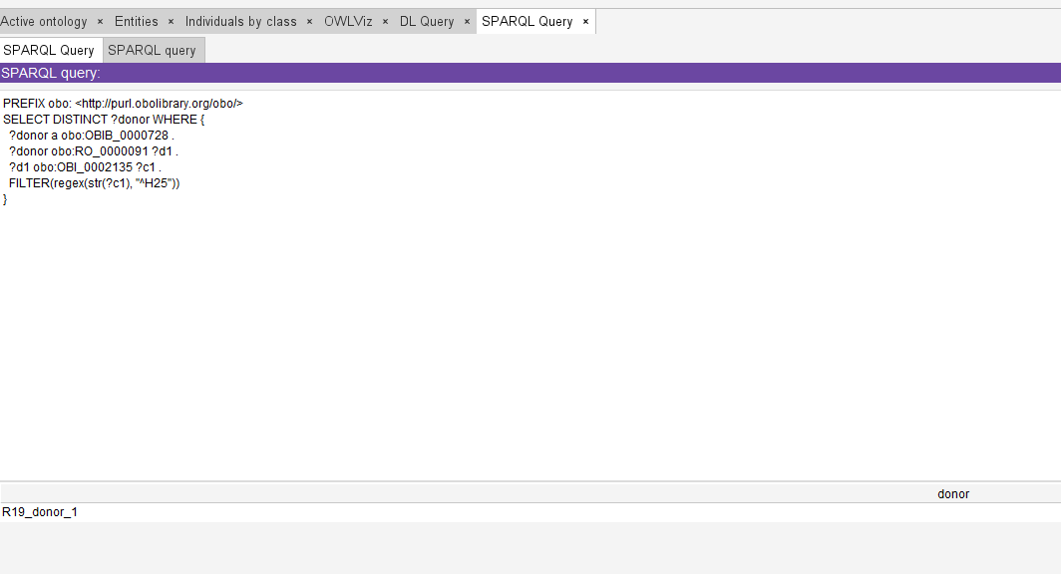
Verification: A SPARQL query was run on example data with two donors with cataract, one coded H25.9 (senile cataract) and one coded H26.9 (other cataract). The query returns donors with a disease coded H25, and correctly returned only the donor with senile cataract.

R20
Donors under 18 years old with bronchial asthma and pneumonia, who are not receiving corticosteroid therapy
PREFIX obo: <http://purl.obolibrary.org/obo/>
SELECT DISTINCT ?donor WHERE {
?donor a obo:OBIB_0000728 . # specimen donor
?age a obo:OBIB_0002206 . # age at event
?age obo:IAO_0000136 ?donor . # is about
?age obo:IAO_0000004 ?years . # has measurement value
FILTER(?years < 18)
?donor obo:RO_0000091 ?d1 . # has disposition
?d1 obo:OBI_0002135 ?c1 . # has specified value
FILTER(regex(str(?c1), "^J45"))
?donor obo:RO_0000091 ?d2 . # has disposition
?d2 obo:OBI_0002135 ?c2 . # has specified value
FILTER(regex(str(?c2), "^J1[2-8]"))
OPTIONAL {
?donor obo:RO_0000056 ?e . # participates in
?e obo:OBI_0002135 ?atc . # has specified value
FILTER(regex(str(?atc), "^H02"))
}
FILTER(!bound(?e))
}
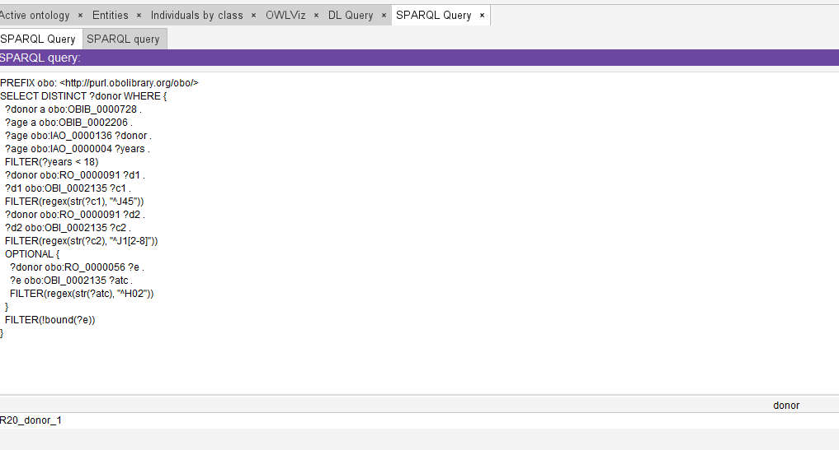
Verification: A SPARQL query was run on example data with two donors with bronchial asthma (J45.9) and pneumonia (J18.9), aged 10 and 9, only one of whom participates in a drug exposure coded H02 (corticosteroids for systemic use). The query returns donors under 18 with a disease coded J45, a disease coded in the range J12 to J18 and no recorded corticosteroid exposure, and correctly returned only the donor without corticosteroid treatment.

