A Technology Ecosystem Tailored for Students and General Users

International Group
Ming Chuan University Department of Computer Science and Information Engineering
Faculty Advisor：Hsin Hung Kuo⁽¹⁾
Team Members：Tran Ba Duy⁽²⁾ ,Le Thi Thu Ngan⁽³⁾,Nguyen Hoang Yen^{（4）}Duong Than Thai⁽⁵⁾
E-mail Address: kuo@mail.mcu.edu.tw⁽¹⁾,duyt97975@gmail.com⁽²⁾, lthungan585@gmail.com ⁽³⁾，huangyan1612@gmail.com⁽⁴⁾, duongthaidmnhbsls12@gmail.com^{（5）}

Abstract

This study proposes an integrated A.I. ecosystem designed to reduce dependence on centralized platforms and address limitations in data security, cost, and deployment flexibility. The framework combines Large Language Models (LLMs) with Digital Signal Processing (DSP) to enable concurrent processing of text and audio within an LLM-centered architecture, aiming to improve technological autonomy, data control, and multimodal scalability.
The ecosystem includes three core modules: ViChat for enterprise text processing and controlled data management, ViRecord for real-time audio processing with an average latency of 1.5–2 seconds, and ViAssistant, which integrates A.I. with IoT through an STT → intent → action → TTS pipeline using ESP32 devices. The architecture is designed for future expansion to process multiple digital signals such as text, audio, images, and sensor data. Experimental results show stable operation, efficient resource usage, and practical applicability across enterprise, educational, and smart-home environments, forming a foundation for scalable multimodal A.I. systems.

- Introduction

During the rapid growth of artificial intelligence, over 65% of users rely on applications such as chatbots, translation, data analysis, and workflow automation, most of which depend on centralized platforms, creating challenges in data security, cost efficiency, and customization. Advances in Large Language Models (LLMs) and Digital Signal Processing (DSP) enable AI systems to process both text and audio within controlled environments.
This project proposes a self-managed AI ecosystem focused on performance, security, and scalability, consisting of ViChat for enterprise text processing, ViRecord for real-time multilingual speech processing, and ViAssistant for speech-based IoT control. The goal is to reduce dependence on external AI services while optimizing hardware resources and maintaining effective data control.
- Technologies Used

The system is developed in Python, with Django serving as the backend framework and Django Channels enabling real-time communication via WebSocket. MySQL is utilized for data management, including conversation logs, metadata storage, and contextual retrieval.
For A.I. and language processing, the system deploys Large Language Models (LLMs) with flexible configurations (2B-671B) and optimized context window management to enhance response quality. The speech processing pipeline consists of:
- Speech-to-Text (STT) using Whisper for audio transcription;
- An AI-based decision engine for context analysis and dialogue management;
- Text-to-Speech (TTS) for converting textual responses into audio output.
The overall architecture follows a layered design (Application Layer – AI Engine Layer – Data Storage Layer), ensuring scalability, maintainability, and secure on-premise deployment for enterprise data protection.

- ViChat – LLM-Based Text Signal Processing System

  - Design Objectives
ViChat is an LLM-based Text Signal Processing system designed for enterprise environments rather than a conventional chatbot. It reduces data leakage risks from public A.I. platforms by providing a controlled, internal A.I. infrastructure.

The system supports internal text analysis, structured conversation management, and flexible LLM configuration based on enterprise hardware and operational requirements. It is positioned as an Enterprise A.I. Platform that integrates an application framework with a specialized language processing engine.

  - System Architecture

The system architecture is divided into three layers:
- Application Layer
- AI Engine Layer
- Data Storage Layer
This layered design enhances system scalability and facilitates future maintenance and expansion.

  - Text Signal Processing Methodology

ViChat operates through a structured text processing pipeline:
- Receiving user input;
- Data normalization and preprocessing (e.g., tokenization and cleaning);
- Retrieving relevant contextual information from the database;
- Performing intent and contextual analysis;
- Optimizing the prompt before submission to the LLM;
- Generating responses, optionally in real-time streaming mode;
- Storing responses to support subsequent interactions.
This mechanism enables the system to maintain conversational continuity and enhance response quality through context-aware processing.

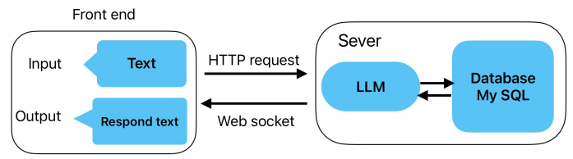
Figue 1: Real-time LLM System Architecture

  - Technical Strengths

ViChat is optimized for performance, security, and scalability. It supports flexible LLM configurations ranging from 2B to 671B parameters, incorporates context management strategies, and applies prompt optimization techniques to reduce computational cost. Real-time streaming via WebSocket further enhances response latency and user interaction efficiency.
All data are stored internally, minimizing the risk of data leakage. The layered architecture enables seamless integration of advanced components such as Retrieval-Augmented Generation (RAG) and vector databases, as well as future expansion to audio processing modules, without modifying the core system architecture.

- ViRecord – Real-Time Audio Signal Processing System

  - Design Objectives

ViRecord is a real-time audio processing system integrated with an LLM for multilingual communication scenarios. It overcomes the high latency and limited contextual capability of traditional translation systems.
The platform provides real-time audio processing, Speech-to-Text conversion, context-aware translation, multilingual support, and hardware-optimized performance. Its goal is to deliver efficient, low-latency communication within a scalable and controllable A.I. framework.

  - System Architecture

The ViRecord architecture is structured into three primary layers:
- Audio Processing Layer
- Language Processing Layer
- Application and Storage Layer
This layered design ensures modularity, scalability, and efficient integration between real-time audio signal processing and language model–based analysis within the overall system framework.

  - Signal Processing Methodology

ViRecord operates based on a real-time audio processing pipeline structured as follows: audio acquisition from a microphone → segmentation into audio chunks → DSP-based preprocessing (noise filtering and signal normalization) → streaming Speech-to-Text (STT) conversion → contextual analysis using a Large Language Model (LLM) → translation into the target language → data visualization and storage.
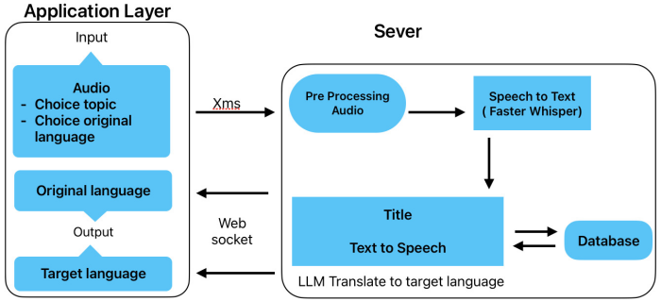
Figue 2: Real-Time Audio Processing and Multilingual Translation Architecture
This pipeline is designed to ensure continuous conversational flow, minimize processing latency, and preserve contextual coherence in translation, rather than treating each sentence as an isolated unit.

  - Latency Optimization Mechanism

A key feature of ViRecord is its Dual-Line Processing mechanism for latency reduction. Instead of waiting for the entire utterance to be completed before translation, the system operates two parallel processing lines:
- Line 1 – Audio Processing: continuously captures audio input and converts short audio segments into text.
- Line 2 – Language Processing: initiates translation as soon as the first text segment becomes available, without waiting for sentence completion.
This parallel architecture reduces the average end-to-end latency to approximately 2–3 seconds under stable hardware and network conditions, significantly enhancing real-time communication performance and user experience.

  - Technical Strengths

ViRecord integrates DSP and LLM to improve speech recognition accuracy and context-aware translation. The system supports real-time audio streaming and flexible deployment on on-premises or cloud servers. It is scalable and can be extended with TTS, multilingual support, and integration with conferencing or IoT systems.

- ViAssistant – IoT-Integrated Voice Assistant Platform

  - Design Objectives

ViAssistant is designed to enable intelligent voice-based interaction within smart environments. Rather than functioning solely as a conventional voice command tool, the system serves as an integrated audio signal processing and decision-making platform powered by artificial intelligence. It aims to enhance user interaction with smart devices while ensuring real-time responsiveness and system autonomy.
Within the proposed A.I. ecosystem, ViAssistant operates as the smart device control module, complementing ViChat (text signal processing) and ViRecord (audio signal processing).

  - Hardware Architecture and Implementation Technologies

- Speech-to-Text (STT – faster-whisper): Converts audio signals into text.
- Decision/AI Engine: Performs intent classification and executes control logic or conversational responses.
- Text-to-Speech (TTS – Microsoft Edge Voices): Converts textual responses into audio signals.
This architecture enables flexible selection and configuration of AI models according to deployment requirements and hardware resources.

  - Hardware and Operational Mechanism

The system is designed to be low-cost and easily deployable in smart home environments, using an ESP32 as the central Wi-Fi-enabled controller. Hardware components include an INMP441 (I2S) microphone for audio capture, an OLED display for system status visualization, relay modules for device control (e.g., lighting), and a DHT22 sensor for environmental data acquisition.
The primary processing workflow consists of:
- The client streams real-time audio input.
- The server performs Speech-to-Text conversion.
- The system classifies user intent and executes the corresponding action.
- A response is generated and converted to speech via TTS.
- The result is returned to the client as audio output along with device status information.
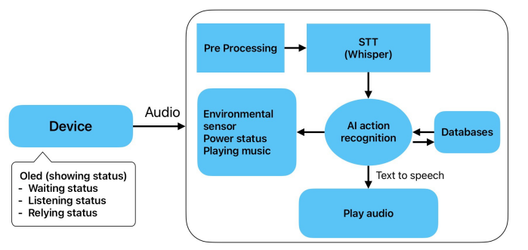
Figure 3:Real-Time Voice Processing and IoT Control Architecture
In addition to real-time operation, the system also provides auxiliary APIs for testing and extended integration.

  - Technical Strengths and Application Value

ViAssistant follows a “realtime-first” design principle, ensuring continuous interaction and minimal latency. The clearly defined processing pipeline (STT → intent classification → execution → TTS) enhances maintainability and scalability. Its flexible architecture allows the addition of IoT devices, sensors, or upgraded AI models without modifying the core system structure.

- Implementation

  - Experimental Objectives

The experiments were conducted to comprehensively evaluate the system’s performance and feasibility based on four criteria: (1) real-time operational capability, (2) end-to-end latency of text and audio processing across the entire pipeline, (3) system stability during long-term continuous operation, and (4) scalability with respect to hardware configurations.
The three core modules—ViChat, ViRecord, and ViAssistant—were first evaluated independently and subsequently integrated to assess overall system performance.

  - Deployment Environment

The system was deployed on a Windows-based internal server (laptop) equipped with an Intel Core i7-14650HX CPU, NVIDIA RTX 5060 GPU, and 32GB DDR5 RAM. The backend utilized Django with Django Channels for real-time streaming, MySQL for data storage, and Whisper for Speech-to-Text processing. An ESP32 IoT device communicated with the server via WebSocket, and all experiments were performed within a LAN environment with latency below 10 ms to ensure stable evaluation.

  - Test Scenarios

    - ViChat (Text Processing Module)

- Continuous submission of 50–100 conversational queries..
- Maintenance of long-context conversations exceeding 10 dialogue turns.
- Monitoring of CPU and GPU utilization over time.

    - ViRecord (Audio Processing Module)

- Continuous audio recording for 3–5 minutes.
- Chunk-based audio processing using streaming STT.
- Stability evaluation under background noise conditions.

    - ViAssistant (Voice + IoT Module)

- Execution of 30–50 device control commands.
- Continuous sensor data querying.
- Evaluation of intent classification accuracy.
- Stability testing of WebSocket connectivity between the server and ESP32.

  - Measurement Methodology

The following performance metrics were recorded:
- End-to-end system latency.
- Processing time at each stage of the pipeline.
- Command execution success rate.
- CPU, GPU, and RAM utilization.
- System stability during continuous operation exceeding one hour.
All experimental data were automatically logged and stored for subsequent quantitative analysis.

- Experimental Results

  - Performance Evaluation of ViChat Module

Table 1: Performance Comparison of ViChat in Streaming and Non-Streaming Modes
Metric | Streaming
First Response Latency | 0,9s
Total Completion Time | 2,1s
GPU Utilization | 68%
CPU Utilization | 42%

The streaming mode significantly reduces the initial response latency (First Token Latency), thereby improving user experience without causing a substantial increase in computational resource consumption.
Additionally, the system maintained stable contextual coherence over more than 15 consecutive dialogue turns without observable performance degradation.

  - Performance Evaluation of the ViRecord Module

Table 2. Performance Comparison of ViRecord under Sequential and Dual-Line Processing
Metric | Dual-Line
Average STT Latency | 1,1s
Recognition Error Rate | 3,2%
CPU Usage | 49%

The Dual-Line Processing mechanism reduces audio processing latency by approximately 38% and improves speech recognition accuracy in noisy environments.
These results indicate that parallel processing effectively optimizes the DSP pipeline and enhances multi-core resource utilization efficiency.

  - Performance Evaluation of the ViAssistant Module

The measured voice-to-IoT latency includes the time required for Speech-to-Text processing, LLM-based decision processing, and command transmission to the ESP32 device. The observed latency level meets practical real-time interaction requirements for smart home systems.

Table 3. Performance Metrics of the ViAssistant Voice–IoT Module
Metric | Value
Average Voice-to-IoT Latency | 1000–2000 ms
Command Success Rate | 96.8%
Sensor Response Time | 180 ms
WebSocket Disconnection Rate | < 1%

- Discussion

The experimental results demonstrate that the system effectively satisfies real-time operational requirements. Latency is significantly reduced through streaming mechanisms and Dual-Line Processing, achieving a command success rate above 96% while maintaining scalability across different hardware configurations.
However, the current system does not yet integrate Computer Vision capabilities. Further optimization of the Speech-to-Text (STT) model is required, along with the enhancement of ViAssistant’s user interface and advanced functionalities, in order to improve multimodal capacity and practical deployment readiness.

- Future Development

The next phase focuses on expanding the ViChat, ViRecord, and ViAssistant ecosystem through four directions: developing multi-modal AI integrating text, audio, and vision; optimizing ViRecord with improved GPU usage and adaptive STT models; enhancing ViAssistant with web/mobile interfaces and real-time IoT management; and expanding the LLM ecosystem by building scalable applications and APIs around a unified AI core.

- Conclusion

The three modules—ViChat, ViRecord, and ViAssistant—were developed as proof-of-concept components of an integrated AI ecosystem capable of simultaneously processing text and audio signals within a unified architectural framework. The system supports flexible deployment and customization, reducing dependence on centralized AI platforms and making it suitable for enterprise environments, multilingual communication, and smart home applications.
Overall, these projects establish the foundation for a multi-modal AI model that emphasizes performance, security, scalability, and technological autonomy, while opening opportunities for the development of flexible and practical AI applications in real-world scenarios.

- References

[1] “Attention Is All You Need”, Vaswani et al NeurIPS 2017.
[2]”Language Models are Few-Shot Learners”, Brown et al., NeurIPS 2020.
[3]”LLaMA: Open and Efficient Foundation Language Models”, Touvron et al., Meta AI 2023.
[4]”Robust Speech Recognition via Large-Scale Weak Supervision”, Radford et al., OpenAI 2022.
[5]”Discrete-Time Signal Processing”, Oppenheim & Schafer.
[6]”Flamingo: a Visual Language Model for Few-Shot Learning”, DeepMind 2022
[7]”SpeechT5: Unified-Modal Encoder-Decoder Pre-Training for Spoken Language Processing”, Microsoft Research 2022
[8]”TinyML: Machine Learning with TensorFlow Lite on Arduino and Ultra-Low-Power Microcontrollers”
[9] “Internet of Things: Architecture and Design Principles”
[10] “Machine Learning and Security”

