# CS 255 System Design Document Template

This template lays out all the different sections that you need to complete for Project Two. Each section has guidance to prompt your thinking. You will need to continually reference the interview transcript as you work to make sure that you are addressing your client’s needs. There is no required length for the final document. Instead the goal is to complete each section based on what your client’s needs are. Remove this note when you are finished, and replace all bracketed text with the relevant information.

## UML Diagrams

### UML Use Case Diagram

### UML Activity Diagrams

### UML Sequence Diagram

### UML Class Diagram

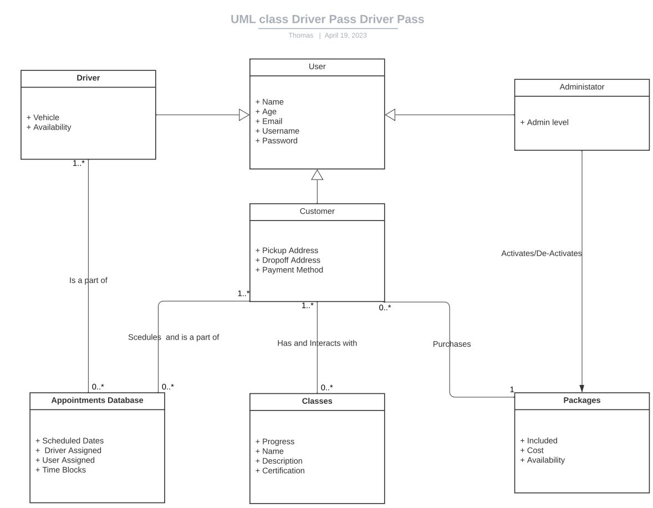

## Technical Requirements

* Minimum of 1TB database space for cloud storage.
* Minimum of 1TB database space for a local backup of the main database.
* Always on connectivity via cloud computing.
* Adjustable cloud size based on usage to go no lower than the minimum.
* The actual site can be created and maintained via a JavaScript MERN or MEAN stack.
* At least one internal person for basic maintenance and troubleshooting.
* A browser will be required for anyone trying to access the site.