Orpina
Brand Identity & Photoshoot Guidelines
3D Printed Earrings — Athens, Greece

Founded in | Athens, Greece
Product | 3D printed earrings — minimal, colourful, playful
Material | Eco-friendly 3D printed polymer
Values | Sustainability · Creativity · Joyfulness · Craftsmanship
Aesthetic | Bold colour · Sculptural form · Mediterranean light
Document | Brand Identity v1.0 — March 2026

1. Brand Identity

1.1 Who We Are
Orpina is an Athens-based earring brand that designs and produces 3D printed statement jewelry. We take raw digital imagination and turn it into wearable, tactile art — producing something from nothing, layer by layer. Every pair of earrings is a small act of creative courage.

We are not a traditional jewelry brand. We do not work with metal casting or gemstones. Our process is fundamentally different: we design in 3D space, we print with intention, and we create pieces that are as light as they are bold. The result is jewelry that feels modern, feels considered, and feels alive with colour.

1.2 Mission
To design earrings that give women permission to be bold, playful, and unapologetically themselves — every single day.

1.3 Brand Values
Value | What it means for Orpina
Sustainability | We use eco-friendly 3D printing materials. We produce on demand — no overstock, no waste. We care about the planet as much as we care about aesthetics.
Playfulness | We play with shapes, colours, and forms that fine jewelry would never dare try. We believe fashion should make you smile.
Creativity | Every design starts as a digital sketch and becomes a physical object. We produce something from nothing. This excites us and it shows.
Accessibility | Beautiful, statement earrings should not cost a fortune. 3D printing lets us create at a price point that invites women in rather than shutting them out.
Authenticity | We are a small brand from Greece. We do not pretend to be a global luxury house. Our voice is warm, direct, and human.

1.4 Target Audience
Age range | 25–45
Location | Greece primarily, broader European market
Lifestyle | Fashion-conscious, values individuality over conformity, appreciates design and craft
Shopping behaviour | Buys earrings as self-treats and gifts, prefers unique pieces over mass-market jewelry
Relationship to fashion | Follows trends but makes them her own — she wears bold earrings with a simple white shirt and owns the look
Values | Eco-awareness, supporting small businesses, creativity, self-expression
Instagram behaviour | Saves posts that inspire her, shares pieces she owns, tags brands she genuinely loves

1.5 Brand Personality
If Orpina were a person, she would be a 32-year-old woman living in Athens — a designer or architect or art director. She spends her weekends at the laiki agora and her evenings at gallery openings. She wears cobalt blue earrings with a plain white linen dress and everyone in the room notices them. She is confident but not arrogant. Warm but not soft. Creative but not chaotic.

Orpina IS | Orpina is NOT
Bold and colourful | Loud or aggressive
Playful and joyful | Childish or frivolous
Minimal in form, maximal in colour | Maximalist or cluttered
Eco-conscious and intentional | Preachy or self-righteous
Warm and approachable | Corporate or cold
Artisan and crafted | Mass-market or disposable
Mediterranean and sun-drenched | Generic or locationless

2. Visual Identity

2.1 Colour Palette
The Orpina colour palette is drawn directly from the brand's product range and from the light of Athens. It is warm, bright, and confident. These colours appear in both the products themselves and in the photoshoot styling, backgrounds, and brand communications.

 | Colour | HEX | Role
 | Orpina Blue | #2B4EFF | Hero colour. The signature cobalt blue that appears across the core product range. Bold, electric, unmistakable.
 | Mediterranean Coral | #E8634A | Secondary hero. Warm, sun-soaked coral — Greek summer on your ears. Used in the floral and seasonal ranges.
 | Blossom Pink | #D4748A | Soft accent. The romantic pink of the blossom collection. Feminine without being passive.
 | Warm Sand | #F0E6D3 | Primary background. The colour of warm Athenian plaster and sun-bleached linen. Used in flat lays and studio backdrops.
 | Ivory White | #F7F4EF | Clean background. Slightly warm white for clean product shots and digital backgrounds.
 | Deep Night | #2C2C2C | Contrast. Used sparingly in moody editorial shots (see image 5 reference). Never dominant.

2.2 Typography Direction
Orpina's typography is clean, geometric, and confident — a reflection of the brand's 3D design roots. Headlines are set in weight. Body copy gives the products space to breathe.

Headlines: Geometric sans-serif (e.g. Futura, DM Sans Bold). All caps or title case. Never italic.
Subheadings: Medium weight geometric sans-serif. Title case only.
Body copy: Regular weight, generous line spacing (1.6x). Short paragraphs. Direct language.
Captions & labels: Small, light weight. Never competes with the product image.

2.3 Brand Voice
Voice quality | What it sounds like | What it never sounds like
Warm & direct | Short sentences. Talks like a friend, not a brand. | Corporate announcements. Press release language.
Playful & confident | Uses colour and shape as metaphors. Finds joy in the everyday. | Cringe humour. Forced hashtags. Slang that doesn't fit.
Intentional | Every word earns its place. Nothing filler. | Keyword stuffing. Vague aspirational language.
Eco-aware | Mentions sustainability naturally, not as a badge. | Greenwashing. Lecturing the audience.

Banned words & phrases
Never use these in any Orpina communication:

- stunning, gorgeous, must-have, obsessed, slaying, iconic, fire (as adjective)
- luxury (we are accessible, not luxury)
- eco-friendly product (let the material and process speak — show don't tell)
- perfect gift (too generic — be specific about who and why)
- shop now (too aggressive — use: find yours, make it yours, link in bio)

Approved CTAs
- Find yours — link in bio
- Save this for your next self-treat
- Tag someone who needs these in their life
- Which colourway is you? Tell us below
- DM us for custom colour options
- Made in Athens, worn everywhere

3. Photoshoot Guidelines
These guidelines are derived directly from Orpina's existing campaign photography and define the visual language all future shoots — real or AI-generated — must follow. The images in this document represent the brand at its best: bold, sun-drenched, expressive, and always product-first.

3.1 The Orpina Shoot Philosophy
Every Orpina image must do three things simultaneously: make the earring the undeniable hero, make the woman wearing it feel powerful and joyful, and make the viewer stop scrolling. These are not competing goals. They work together.

The earring is never decoration in an Orpina image. It is the subject. Everything else — the model's expression, the background, the light, the outfit — exists to make the earring sing louder.

3.2 Lighting
Preferred style | Natural sunlight. Hard directional light that creates real shadows is actively encouraged — it gives the images energy and a sense of place.
Direction | Side-lit (45–90 degrees) or from above. Never flat frontal lighting — it kills the 3D form of the earrings.
Temperature | Warm. 3000K–4000K equivalent. The light should feel like Athens in late morning or mid-afternoon.
Shadows | Shadows are welcome and beautiful in Orpina images. The shadow of a daisy-chain earring on a bare shoulder (image 4) is part of the story.
What to avoid | Harsh flash. Cold blue-white studio lighting. Overexposed highlights that lose earring detail. Flat lighting.

3.3 Model Direction
The models in Orpina images are not passive mannequins. They are expressive, present, and confident. The brand celebrates diversity — in skin tone, in hair, in facial features. Every woman in an Orpina image looks like she chose to be exactly where she is.

Poses | Profile shots showing the earring in full (images 1, 2, 3, 4). Three-quarter face. Looking away from camera with intention. Eyes closed in joy or reverie (images 3, 4). Hands near face framing the earring area.
Expressions | Contemplative (image 1). Calm confidence (image 2). Pure joy and abandon (image 3). Sensory pleasure (image 4). Intimate and direct (image 5). Never forced smiles. Never blank fashion-face.
Hair | Up, braided, or slicked back — the earring must never be hidden by hair. This is non-negotiable.
Skin | Natural, glowing. Minimal makeup or bold lip (red, coral) — never full heavy makeup that competes with the earring.
Framing | Tight crop. Face and neck. Rarely full body. The earring should occupy significant real estate in the frame.

3.4 Backgrounds & Settings
Setting | How to use it | Reference image
Warm plaster / stone wall | Textured, warm-toned backgrounds that feel Mediterranean. Sandy beige. Never painted white or clinical. | Images 1 and 4 — the wall behind the model is doing as much work as the outfit.
Neutral studio grey | Clean grey backdrop for close-up character shots. Warm grey, not cool. | Images 2 and 3 (studio portion) — lets the cobalt blue earrings pop completely.
Outdoor / poolside | Real-world environments with strong natural context. Sun, water, warmth. Feels editorial and alive. | Image 3 — poolside setting makes the wavy earring feel like summer itself.
Dark / moody studio | Used sparingly for contrast and drama. Deep teal or charcoal. Only for the pink/blossom range where the contrast works. | Image 5 — the dark background makes the pink flower earring glow.
What to avoid | White seamless studio backgrounds. Busy or cluttered environments. Cold or clinical settings. Anything that says 'generic product photography'. | —

3.5 Styling & Wardrobe
The outfit is a supporting actor, not a co-star. It must complement the earring's colour and energy without competing with it.

Colour principle | Use complementary or analogous colours to the earring. Mustard yellow with cobalt blue (image 1). Coral with warm skin and sandy background (image 4). Black with cobalt for maximum pop (image 2).
Necklines | Off-shoulder, bare shoulder, wide V-neck, or high turtleneck. The neck and ear must be visible and framed well.
Textures | Chunky knit, smooth cotton, bare skin. Textures add life. Avoid shiny or patterned fabrics that distract.
Jewellery | No other jewellery visible except Orpina earrings. Rings are acceptable if hands are in frame (image 4) but should be simple.
What to avoid | Busy prints, logos, or patterns that compete visually. High necklines that cover the neck. Shiny fabrics that reflect light unpredictably.

3.6 Shot Types for Instagram
Shot type | Format | Description & when to use
Hero editorial | Feed 1:1 | Close profile or three-quarter shot. Model wearing earring in strong natural light. The definitive Orpina image. Used for new product launches and hero posts.
Expression close-up | Feed 1:1 | Tight crop on face and earring. Model's expression is the story. Joy, confidence, reverie. Used for emotional / entertaining content.
Earring detail | Feed 1:1 | Extreme close-up of the earring worn or held. Shows the 3D form, texture, and colour in full detail. Used for educational posts about materials and process.
Lifestyle context | Feed 1:1 | Model in a real environment — poolside, courtyard, street. Earring is still hero but the world around her tells a story. Used for seasonal and entertaining content.
Story portrait | Story 9:16 | Vertical crop of editorial shot. Model fills the frame. Strong and immediate. Used for Stories and Reels thumbnails.
Product flat lay | Feed 1:1 | Earring on a warm sandy or linen surface. No model. Clean and minimal. Used for e-commerce, promotional posts, and carousel details.

3.7 The Five Reference Images — What They Teach Us
These five images from Orpina's existing portfolio define the brand at its visual best. Every future shoot should aim to capture at least one of these energies.

Image 1 — The Contemplative

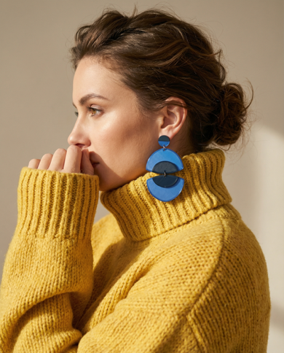
Warm indoor light through a window. Mustard yellow turtleneck knit. Cobalt blue geometric crescent earring. Model in profile, hands raised to lips, gaze distant and thoughtful. Lesson: Hard light and real shadow make 3D printed earrings look architectural and intentional. The colour contrast (cobalt on mustard) is bold and fashion-forward.

Image 2 — The Confident

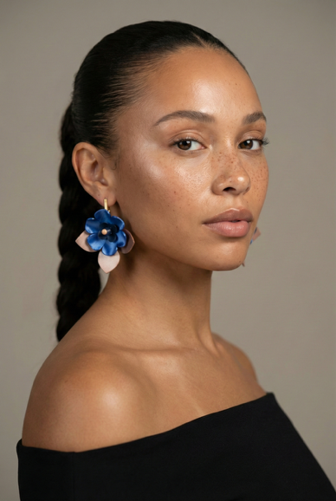
Clean warm grey studio background. Black off-shoulder top. Cobalt blue flower earring. Model in three-quarter profile, direct and calm. Gold bar stud visible on opposite ear. Lesson: A neutral studio background lets the earring be the only story. The model's direct energy communicates that Orpina is for women who know exactly who they are.

Image 3 — The Joyful

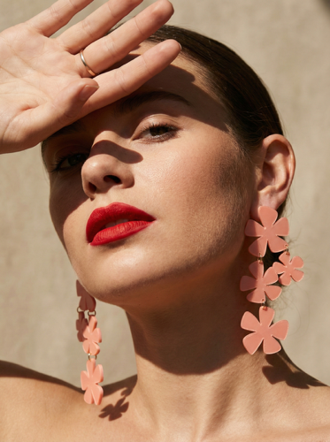
Outdoor poolside setting. Brilliant summer light. Yellow cactus-print swimsuit. Cobalt blue wavy abstract earring. Model with eyes closed, face tilted up, lips pursed. Lesson: The most expressive image in the portfolio. The poolside context, the abstract earring shape, and the model's pure joy make this the most shareable image. This is the Orpina spirit at full volume.

Image 4 — The Sensory

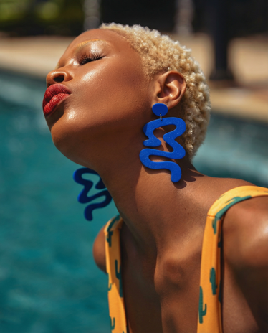
Warm stone exterior wall. Bare shoulders. Coral pink daisy-chain earrings. Model shielding her eyes with her hand, face angled up, red lips. Lesson: Hard directional sunlight creates beautiful shadows from the earring chain. The monochrome near-match of earring colour to skin creates a warm, intimate image. Hands in frame work when they frame the ear.

Image 5 — The Intimate

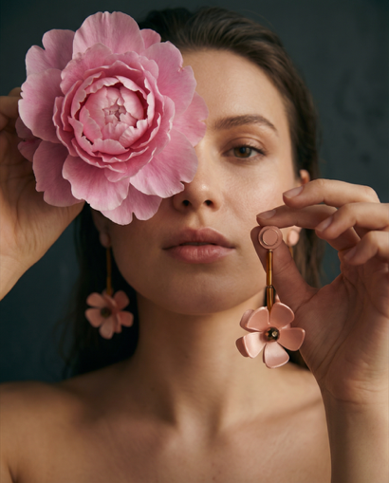
Dark deep teal studio background. Bare shoulders. Blush pink flower drop earring — one worn, one held up to camera. Large pink peony flower obscuring one eye. Lesson: The dark background makes the pink earring luminous. The held-up earring shows the product in detail. The peony prop works because it echoes the earring's shape. Props are allowed when they rhyme with the product.

4. AI Image Generation Rules
When generating product images using Gemini Imagen or any AI image tool, every prompt must be anchored to the visual rules in this document. The following rules are mandatory for all AI-generated Orpina content.

4.1 Prompt Must-Haves
- Always specify the earring type and colour explicitly (e.g. 'cobalt blue 3D printed floral drop earring').
- Always specify the lighting: warm, directional, natural sunlight or warm studio — never cold or flat.
- Always specify background from the approved palette: warm sand plaster, warm grey studio, outdoor Mediterranean.
- Always specify model positioning: profile, three-quarter, or close-up crop showing earring clearly.
- Always end with: 'Editorial portrait photography. Earring is the hero. Photorealistic. No text overlays.'
- Specify hair is up, braided, or back — never loose over the earring.

4.2 Prompt Must-Avoids
- Never use 'white studio background' or 'seamless backdrop'.
- Never use 'soft diffused lighting' as the primary light — Orpina uses directional warm light.
- Never use 'smiling at camera' — expressions are always more complex and intentional.
- Never use 'full body shot' — Orpina crops tight on face, ear, and earring.
- Never allow hair to fall over the earring in the generated image.
- Never generate images where the earring is small or peripheral in the frame.

4.3 Example Prompt Structure
Use this structure as the template for every Orpina AI image prompt:

[EARRING DESCRIPTION] — cobalt blue 3D printed geometric crescent drop earring,
[PRESENTATION] — worn on a woman's ear, profile view, hair in updo,
[LIGHTING] — warm directional natural sunlight from the left, 3200K,
real shadows cast by the earring,
[BACKGROUND] — warm sandy plaster wall, textured, Mediterranean,
[CROP] — tight editorial portrait crop, face and neck visible,
[EXPRESSION] — calm, contemplative, gaze distant,
[STYLE ANCHOR] — editorial portrait photography, earring is the hero,
photorealistic, no text overlays.

5. Quick Reference Card
A one-page summary of the most important brand rules for anyone creating Orpina content.

Category | The rule
Hero colours | Orpina Blue #2B4EFF · Mediterranean Coral #E8634A · Blossom Pink #D4748A
Background colours | Warm Sand #F0E6D3 · Ivory White #F7F4EF · Warm Grey (studio)
Light | Warm, directional, natural. Real shadows welcome. Never cold or flat.
Model hair | Always up, back, or braided. Earring must always be fully visible.
Expressions | Contemplative, joyful, confident, sensory. Never blank or forced smiles.
Framing | Tight crop. Face, neck, ear. Earring occupies significant frame real estate.
Outfits | Complement earring colour. Bare or simple neckline. No busy prints.
Props | Only if they rhyme with the earring's shape or colour (e.g. peony with flower earring).
What we never do | White seamless backdrops, cold lighting, hair over earrings, full body shots, forced smiles.
Voice | Warm, direct, playful. Short sentences. No: stunning, gorgeous, must-have, obsessed.

End of Document — Orpina Brand Identity & Photoshoot Guidelines v1.0 — March 2026

