*Homework assignment 3*

Evaluation – Kupujem prodajem

1. Design

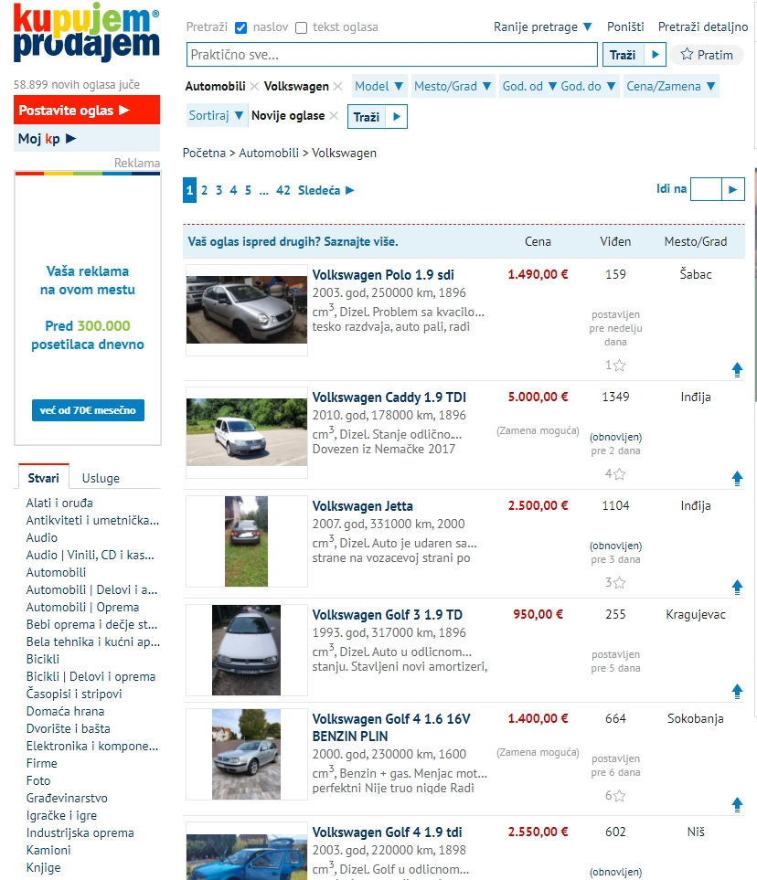

I can say that design of this website is not very modern, but it’s simple and user friendly.

1. Navigation

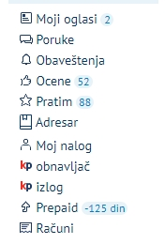  
Navigation has everything you need. All important web pages are in one place and easy to access.

1. Ease of use

Thanks to the simple design and all possible options from menu, this website is very easy to use and everything is adjusted for users.

1. Accuracy  
     
   My opinion is that this website is very specific, obviously because on this site everyone could post their products to sell, and it is debatable if this website is accurate.
2. Up to date  
     
   Owner of this website doesn’t need to worry about updates. This type of website doesn’t have to be that much often updated.
3. Helpful graphics  
     
   Maybe helpful graphic from this website is a part of main page that shows current exchange rate.
4. Compatibility  
     
   “Kupujem prodajem” works on every web browser, even on smartphone web browsers, and very important, this website has android application which is very useful and good.

*Tomislav Živadinović, 3948*