Table of Contents
Chapter 1 1
Section 1 1

Chapter 1

Section 1
Tunnels demonstrate significant advantages in transportation infrastructure, especially in mountainous regions, where they effectively overcome natural obstacles such as alignment constraints and elevation limitations, greatly shortening travel distances. According to statistical data as of the end of 2024 (Source: “2024 Statistical Bulletin on the Development of the Transportation Industry”[1]), the total number of highway tunnels nationwide has increased to 28,724, including 2,261 extra-long tunnels with a combined length of 10.3287 million extended meters, and 8,047 long tunnels with a combined length of 14.1018 million extended meters. As of the end of 2023, a total of 25 extra-long highway tunnels exceeding 10 km in length have been completed and put into operation in China.
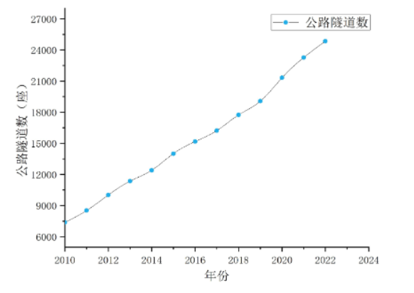 | 
Figure 1 Highway Tunnels in China from 2010 to 2024 | Figure 2 Accident Scene
For example, the “8·27” major truck fire accident in the Maoliling Tunnel on the G15 Shenhai Expressway in 2019 resulted in 5 fatalities and 31 injuries (including 15 severe injuries); tunnel facilities, vehicles passing through, and the involved truck and cargo sustained severe damage; and the “3·19” traffic accident on the Jihé Section of the Hunan–Beijing Expressway in 2024. The relationship among R, Y⁵, X_{min}, and$\sqrt{Time}$ is given by the following formula:
$R=X_{min}+Y^{5}×\sqrt{Z}$
Table 1 Representative Cases of Highway Tunnels in China (Partial)
Tunnel Name | Time | Accident Type | Accident Cause | Casualties
Yanhou Tunnel | 2014 | Collision | Rear-end collision between two vehicles | 40 deaths
Maoliling Tunnel | 2014 | Fire | Vehicle spontaneous combustion | Resulted in 5 fatalities

[1] I. Lejri, I. Vukalović, A. Grimm, A. Eckert, Proanthocyanidins from Ginkgo extract EGb 761® improve bioenergetics and stimulate neurite outgrowth in vitro, Frontiers in Pharmacology 16 - 2025 (2025). https://doi.org/10.3389/fphar.2025.1495997.

