Heaps’ law plot for task #1:  
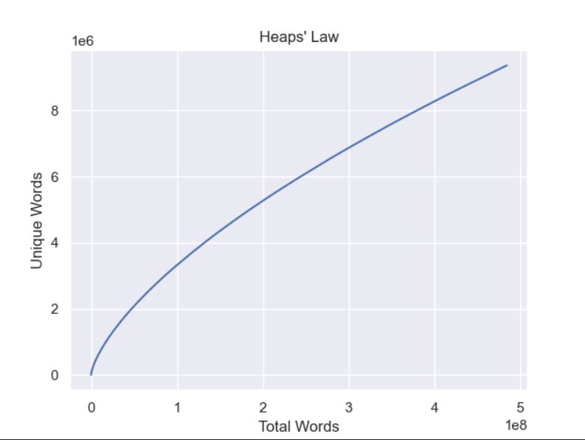

The chance accuracy for random solutions for task #2

  
  
The accuracy I got for my solution (using trigram model):  
