**Integrations’ Fullstack Questionnaire/Tzofia levy**

**Section_1**

A response to x1 takes 3 seconds while a response to x2 takes 5 seconds. In this solution the execution is not fast because it wastes 3 seconds (x2 is waiting for x1). Therefore, the correct solution is that the calls to the API will be made at the same time and thus we will save 3 seconds

**Section_2**

Implement it using recursion

*Advantage* : easy, working with complex data structures

*Disadvantage*: Sometimes very useful Memory, Bugs and stack overflow caused by recursion fallacies that are easy to fall into.

Implement without recursion

*Solution*: We will use queue data structures. We will insert the root first and in each iteration:* We will print the head of the queue *We will put its children in the queue and so on. (The code is attached).

*Advantage*: efficiency, Less memory usage

*Disadvantage*: its hard with a complex and deep data structure

**Section_4**

**1.** Waiting for the number from the remote server is outside the function, which may cause a knocking down when entering the data into 'promises'. We have to wait for information every time we want to enter a number.

**2.**

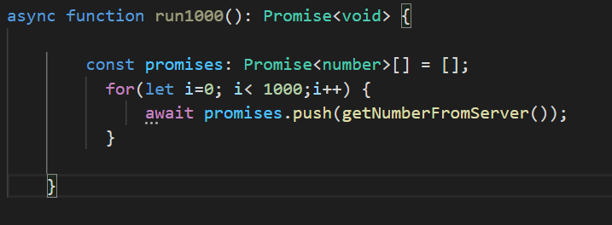

**Section_7**

An endpoint to list users by multiple ids

We will receive a list of user IDs in the function. We will go through the list and for each ID we will run GetUserbyId.

An endpoint to replace a user by id

We will receive in the function a new id and an the object we want to replace, the function will update it to the new id we received.

An endpoint to create multiple users

We will receive an array of objects in the function and run CreateUser on each object **Section_8**

Acsses Token

A secure string that a client uses to access protected resources. Clients who have a valid authorization grant, instance issues access tokens. Each access token has a specific scope, lifetime, and other attributes.

Refresh Token

A certificate that a client uses to obtain new access tokens without the need for additional user authorization. When it is first authorized to receive an access token then an instance issues a refresh token to the client. The lifetime of a refresh token is much longer compared to the lifetime of an access token Refresh tokens can also expire, but are silent over time.

**Section_9**

