NATIONAL INSTITUTE OF TRANSPORT

DEPARTMENT OF COMPUTING AND COMMUNICATION TECHNOLOGY PROGRAM : BACHELOR’S DEGREE IN INFORMATION TECHNOLOGY MODULE NAME : DISTRIBUTED SYSTEMS
MODULE CODE : ITU 08106
LECTURE’S NAME : Ms. SARAH FLORENCE ACADEMIC YEAR : 2025/2026
GROUP NUMBER 12
TASK : GROUP ASSGINMENT 03

S/N | NAME | REG NUMBER | SIGNATURE
1 | ALLY KHAMIS | NIT/BIT/2023/2179
2 | ISAYA MBIFILE | NIT/BIT/2023/2320
3 | LUGALILA LUGALILA | NIT/BIT/2023/2286
4 | EMANUEL NGUMBO | NIT/BIT/2023/2285
5 | MUHIDIN HASSANI | NIT/BIT/2023/2118
6 | STEPHEN SAMWEL | NIT/BIT/2023/2125
7 | PETER LAMECK | NIT/BIT/2023/2080
8 | ASHERI MANEMBE | NIT/BIT/2023/2312
9 | JAMES MARWA | NIT/BIT/2023/2263
10 | BENNY SANGA | NIT/BIT/2023/2322
11 | DOTTO MCHENYA | NIT/BIT/2023/2205
12 | TAZE JUMANNE | NIT/BIT/2023/2216
13 | STEVEN TARIMO | NIT/BIT/2023/2124
14 | GABRIEL MBEKE | NIT/BIT/2023/2053
15 | CASTOR S LUVANDA | NIT/BIT/2023/2107

STEVEN TARIMO
Introduction
Based on our question the topic below explains how cloud computing systems are designed, using Google as a real-world case study, and how the Big Data paradigm helps improve computing power and resource sharing. These technologies allow organizations to process large amounts of data efficiently, reliably, and at a lower cost.
ALLY KHAMIS
Cloud computing
Cloud computing is a modern technology that provides on-demand access to virtualized computing resources over the internet. Instead of owning physical infrastructure, organizations of all sizes use cloud services to store data, run applications, and scale resources anytime, anywhere, using a pay-as-you-go model offered by providers like AWS and GCP.

LUGALILA LUGALILA
Cloud Computing Architecture
Architecture of cloud computing is the combination of both SOA (Service Oriented Architecture) and EDA (Event Driven Architecture). Client infrastructure, application, service, runtime cloud, storage, infrastructure, management and security all these are the components of cloud computing architecture.

The cloud architecture is divided into 2 parts:
- Frontend
- Backend
ISAYA MBIFILE
1. Frontend
Frontend of the cloud architecture refers to the client side of cloud computing system. Means it contains all the user interfaces and applications which are used by the client to access the cloud computing services/resources. For example, use of a web browser to access the cloud platform.
TAZE JUMANNE
2. Backend
Backend refers to the cloud itself which is used by the service provider. It contains the resources as well as manages the resources and provides security mechanisms. Along with this, it includes huge storage, virtual applications, virtual machines, traffic control mechanisms, deployment models, etc.

The below figure represents an internal architectural view of cloud computing.
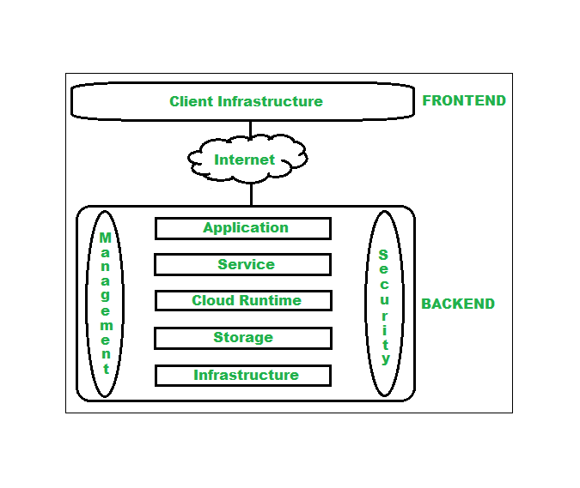
EMANUEL NGUMBO
Google cloud computing design.
Google’s cloud architecture is built on distributed systems, meaning many computers work together as one powerful system. The design focuses on scalability, reliability, and efficiency.
Google is a pioneer in large-scale cloud computing, powering services such as Search, Gmail, YouTube, Drive, and GCP.
- Infrastructure Design
Google runs a global network of data centers that use millions of low-cost servers connected by high-speed fiber. Rather than one supercomputer, many ordinary machines work together to provide large capacity and redundancy.
MUHIDIN HASSANI
- Distributed Computing Model
Google splits tasks across many machines so work runs in parallel. Core technologies include the Google File System for distributed storage, Big table for large structured data, and MapReduce for parallel data processing. This approach makes systems faster, more reliable, and easy to scale.

- Automatic Resource Management
Google’s platform automatically assigns CPU, memory, and storage, balances workloads across servers, and reroutes work when failures occur. These features keep services available and reduce downtime.
STEPHEN SAMWEL
Understanding big data.
Big Data is a general term for high-volume, complex and rapidly growing data sets that are hard for traditional database systems to manage. It includes large numbers, short-time variations, and diverse information materials that require sophisticated methods of information management and analysis to provide better quality information for decision-making and automation of business processes.
GABRIEL MBEKE
Key characteristics that make Big Data different from regular data. Each "V" highlights a challenge or feature that Big Data systems need to handle:
The 5 Vs of Big Data
- Volume: It aims at the very volume of data that may exceed terabytes, Exabyte’s, and even more in some cases.
- Velocity: This refers to the rate at which information is created and analyzed or a decision is made or the speed at which a solution is being proffered.
ASHERI MANEMBE
- Variety: Big Data is large volumes of structured, semi-structured, and unstructured information. Data sources include textual information, images, video, and sensor data.
- Veracity: The accuracy and trustworthiness of data are crucial. Big Data often comes from multiple sources, making it challenging to ensure its quality.
- Value: The ultimate goal of Big Data is to extract valuable insights that can drive business decisions and strategies.
CASTOR S LUVANDA
How big data improves computing capacity and enables resource sharing.
How big data improves computing capacity.
1. Parallel Processing
Big Data divides a large task into many small tasks that run at the same time on different machines, increasing speed.
Example: Google splits search indexing into many parts and processes them simultaneously on multiple servers, producing results faster.
DOTTO MCHENYA
2. Horizontal Scaling
Big Data increases computing power by adding many low-cost servers instead of upgrading one expensive machine.
Example: When search traffic grows, Google adds more servers to its cluster, and overall processing capacity increases.
3. Data locality (processing near storage)
Big Data processes data on the same machine where the data is stored, reducing network delays.
Example: Google’s storage system lets a server analyze its locally stored data without sending it across the network.
JAMES MARWA
How Big Data Enables Resource Sharing
1. Resource Pooling
Big Data systems share CPU, memory, and storage among many users to avoid wasting resources.
Example: Google uses the same data center hardware to run Gmail, YouTube, and Google Drive efficiently.
PETER LAMECK
2. Multi-Tenancy and Isolation (secure shared infrastructure)
Multiple users share the same hardware, but their data and applications remain separate and secure.
Example: Different companies use Google Cloud on the same servers, but each company’s data is isolated.

3. Load Balancing and Auto scaling
Big Data distributes workloads evenly and automatically adjusts resources based on demand.
Example: When a YouTube video becomes popular, traffic is spread across servers and more servers are added automatically.
BENNY SANGA
Conclusion.
Google’s cloud computing design demonstrates how distributed systems, virtualization, and automatic resource management enable highly scalable, reliable, and efficient services. By combining cloud computing with Big Data techniques, Google can process massive amounts of information in parallel, scale computing resources dynamically, and share infrastructure securely among multiple users. This integration of cloud and Big Data not only enhances computing capacity but also ensures optimal resource utilization, high availability, and fast, reliable service delivery, making it a model for modern large-scale cloud systems.

