# Git

* Git常用命令及方法大全

https://www.cnblogs.com/miracle77hp/articles/11163532.html

* Windows版国内下载路径

https://npm.taobao.org/mirrors/git-for-windows/

# JDK8

<https://www.oracle.com/java/technologies/javase/javase-jdk8-downloads.html>

不要装9或以上版本！

# Maven

<https://maven.apache.org/download.cgi>

这个文件：apache-maven-3.*.*\conf\settings.xml

拷贝到C:\Users\你的用户\.m2，并增加以下镜像：

<mirror>

<id>alimaven</id>

<name>aliyun maven</name>

<url>http://maven.aliyun.com/nexus/content/groups/public/</url>

<mirrorOf>central</mirrorOf>

</mirror>

# IntellJ IDEA

https://www.jetbrains.com/idea/download

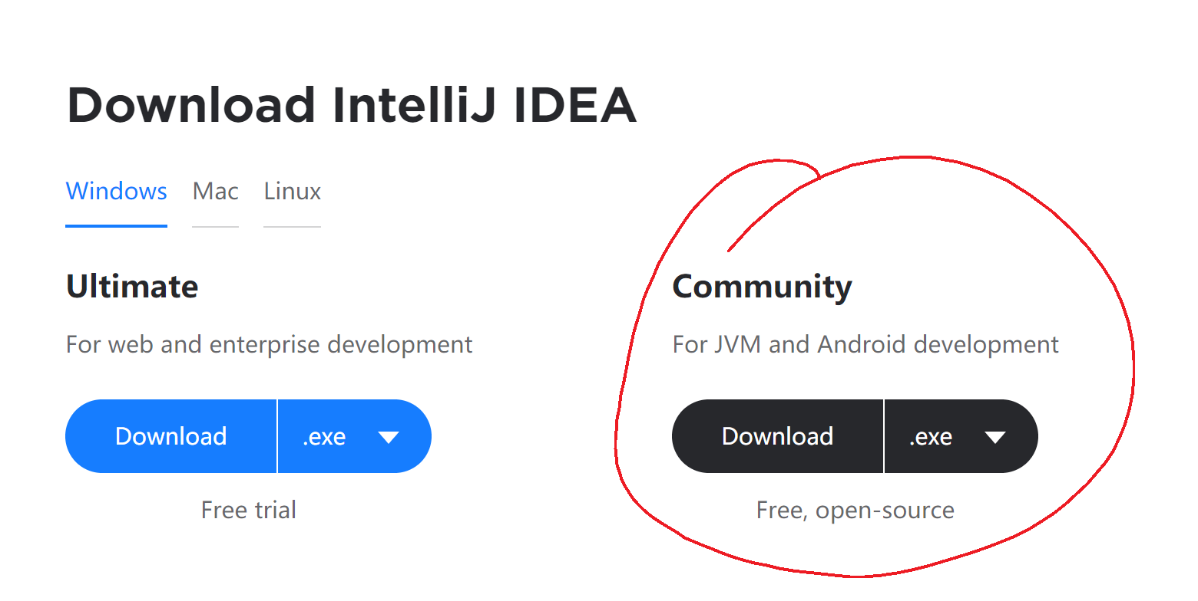

# MySQL 5.7.33

<https://dev.mysql.com/downloads/mysql/>

版本：MySQL Community Server 5.7.29（或5.7.33）

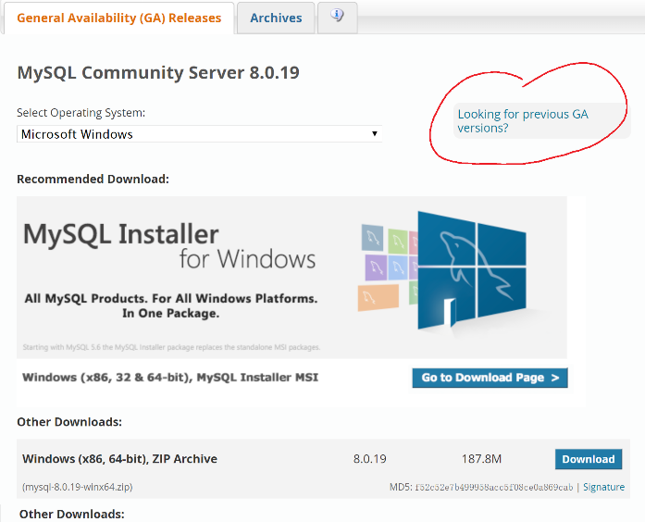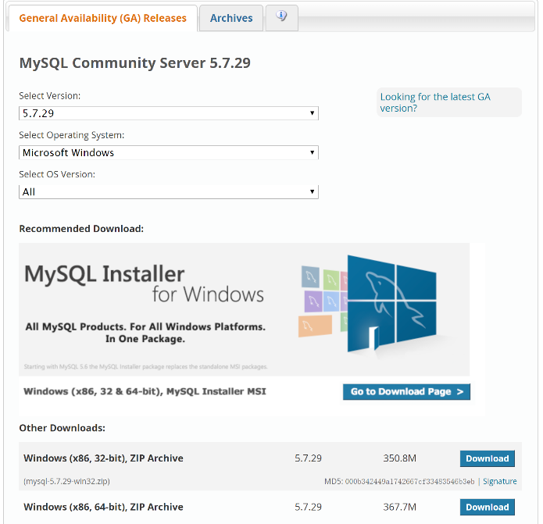

# intelij 插件：Database Navigator

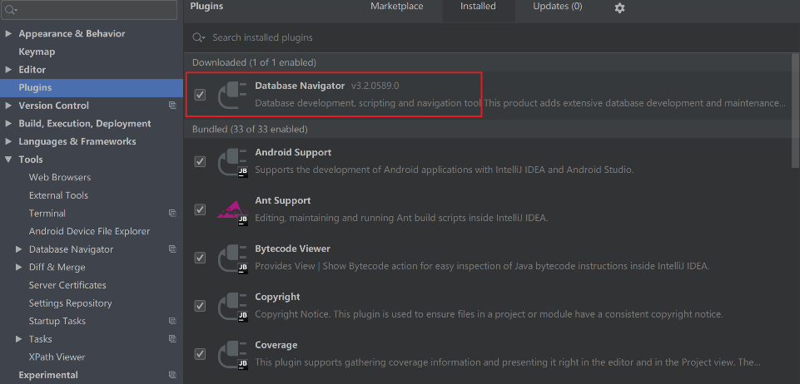

如果报错：The server time zone value 'ÖÐ¹ú±ê×¼Ê±¼ä' is unrecognized or represents more than one time zone....

解决方案:

show variables like '%time_zone%';

set global time_zone='+8:00';

# tomcat-8

<https://tomcat.apache.org/download-80.cgi>

apache-tomcat-8.5.51（或8.5.63）

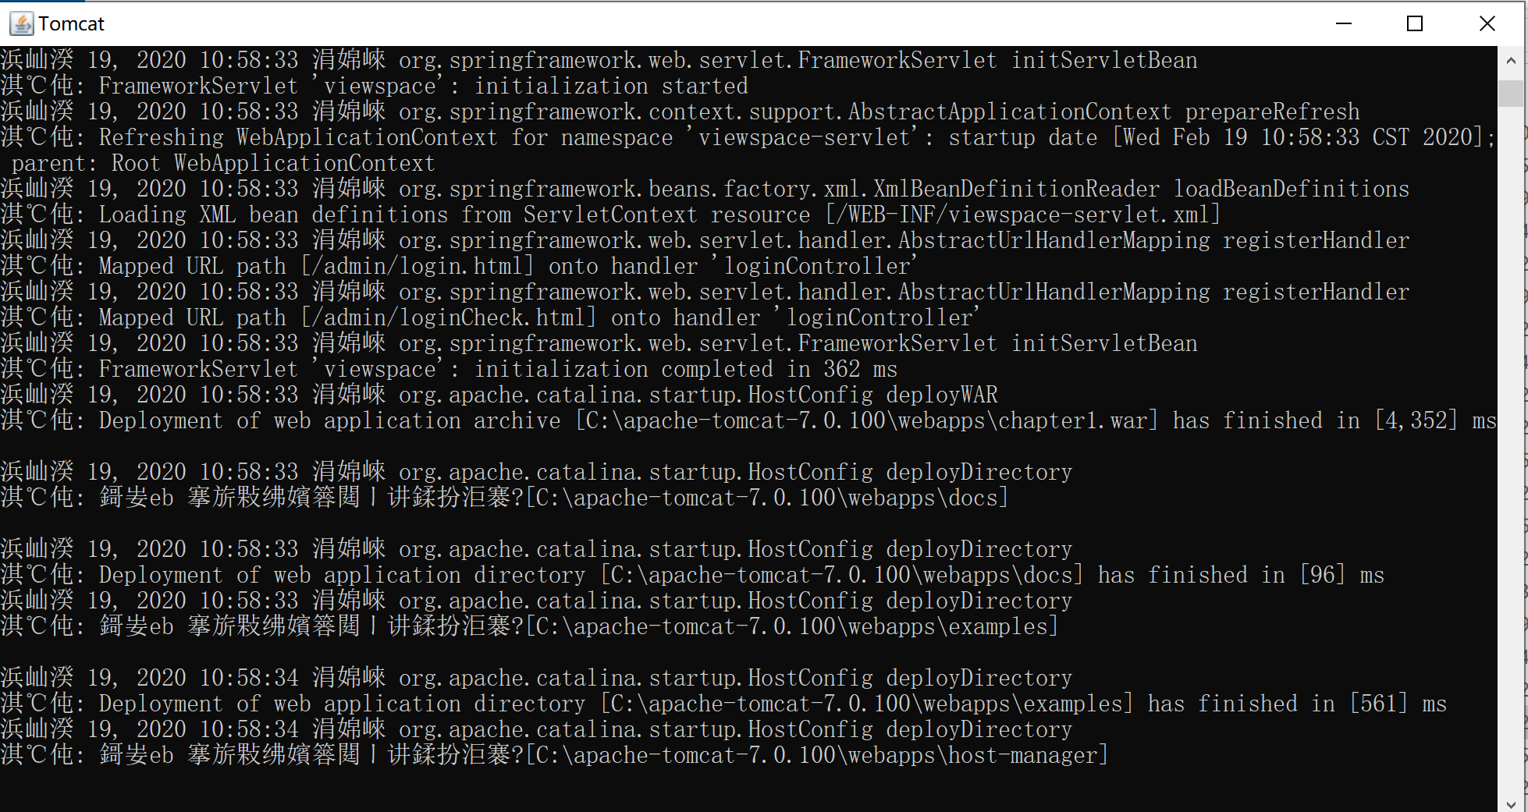

如果出现乱码，请修改文件C:\apache-tomcat-8.5.51\conf\logging.properties

java.util.logging.ConsoleHandler.level = FINE

java.util.logging.ConsoleHandler.formatter = org.apache.juli.OneLineFormatter

java.util.logging.ConsoleHandler.encoding = UTF-8

改成GBK

# 其它工具

Jetty、spring、junit、mockito