Tao Tang

Comp 3710

Assignment 3

Use case

As our project is an online notetaking app, our app is opening to all people who need to take note, for example, college student.

Case #1

Student open the app while the class is beginning

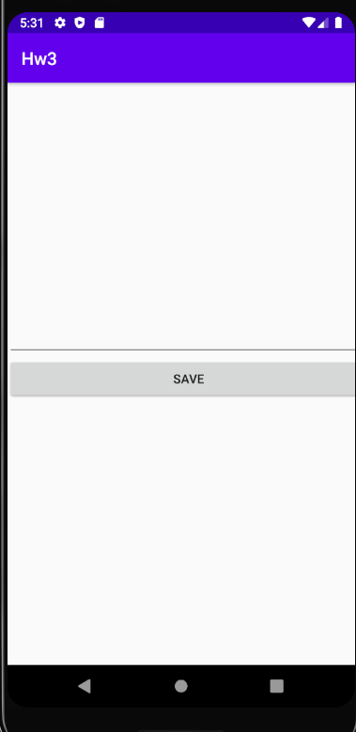

Case #2

Student finish taking the note and then save the note into the file, and there is a file list on the lower-part of the screen.

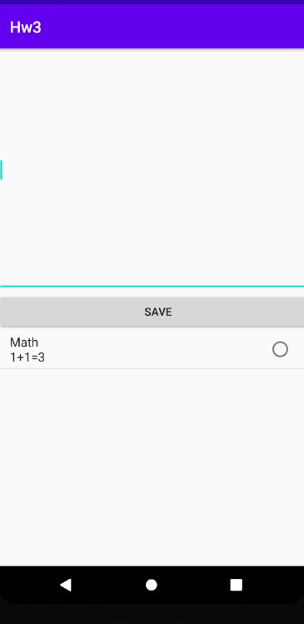

Case #3

Student opened the note that they toke and then re-edit the note and then save

