MINISTRY OF SCIENCE AND HIGHER EDUCATION OF KAZAKHSTAN
Department of Information Technologies and Computer Science

FINAL PROJECT REPORT

EURIKA

Development of an Online Olympiad Platform for School Students

Authors: Myktybaev Nurmukhammet Khanafiaevich
Year: 2026

TABLE OF CONTENTS
Introduction 3
Chapter 1. Theoretical Background and Problem Statement 5
1.1 Context: Olympiad Education in Kazakhstan 5
1.2 Existing Solutions and Their Limitations 7
1.3 Project Goals, Objectives and Scope 8
Chapter 2. System Design and Implementation 10
2.1 Frontend Development 10
2.2 Backend Architecture and Security 15
Conclusion 22
References 24

INTRODUCTION
In the modern era of digital transformation, educational technology has become one of the most rapidly evolving sectors. The ability to conduct assessments, competitions, and intellectual challenges through digital platforms not only reduces administrative overhead but also democratizes access to high-quality educational content regardless of a student's geographical location. This is especially relevant in Kazakhstan, where vast distances between cities and rural areas have historically created significant barriers to equal participation in academic events.
The Eurika platform was conceived and developed as a comprehensive, production-ready web application designed to host online intellectual olympiads for school students across Kazakhstan. The name 'Eurika' (from Greek εὕρηκα — 'I have found it') symbolizes the spirit of discovery, intellectual curiosity, and the joy of problem-solving that lies at the heart of every academic competition. The platform enables parents to register their children, select subjects, complete secure payment, and allow their children to participate in timed olympiad quizzes — all from the comfort of their homes.
The project was developed by the AZgroup team using a modern full-stack technology approach. The backend is built on Laravel 12 (PHP 8.2+), a mature and widely adopted enterprise-grade framework, while the frontend leverages Vue 3 with Vite and Tailwind CSS — technologies that allow rapid development of responsive, accessible, and aesthetically pleasing user interfaces. The system integrates three payment gateways (Kaspi, YooKassa, and Stripe) to accommodate the payment preferences of Kazakhstani users, stores results with cryptographically verifiable certificates, and provides a powerful administrative panel for competition management.
The relevance of this project cannot be overstated. Kazakhstan's national educational reform agenda, reflected in the 'Digital Kazakhstan' state program, places significant emphasis on the development of digital skills from an early age and the adoption of IT in education. Online olympiads represent a concrete and impactful mechanism for achieving these goals: they motivate students to study beyond the standard curriculum, help identify talented individuals across the country, and create a culture of healthy intellectual competition.
This report presents the complete technical and conceptual documentation of the Eurika project. It is structured as follows: the Introduction provides context and motivation; Chapter 1 covers the theoretical background, existing landscape analysis, and formal problem statement; Chapter 2 describes the architecture and implementation details of both the frontend (Section 2.1) and backend (Section 2.2) subsystems; and the Conclusion summarises the results achieved and outlines directions for future development.
The practical significance of this work is confirmed by the fact that all components described herein have been fully implemented, tested, and documented to production-grade standards. The platform is ready for deployment on a standard Linux VPS and includes comprehensive deployment documentation, a 165-item pre-launch checklist, security audit results, and a dedicated administration interface for day-to-day operation.
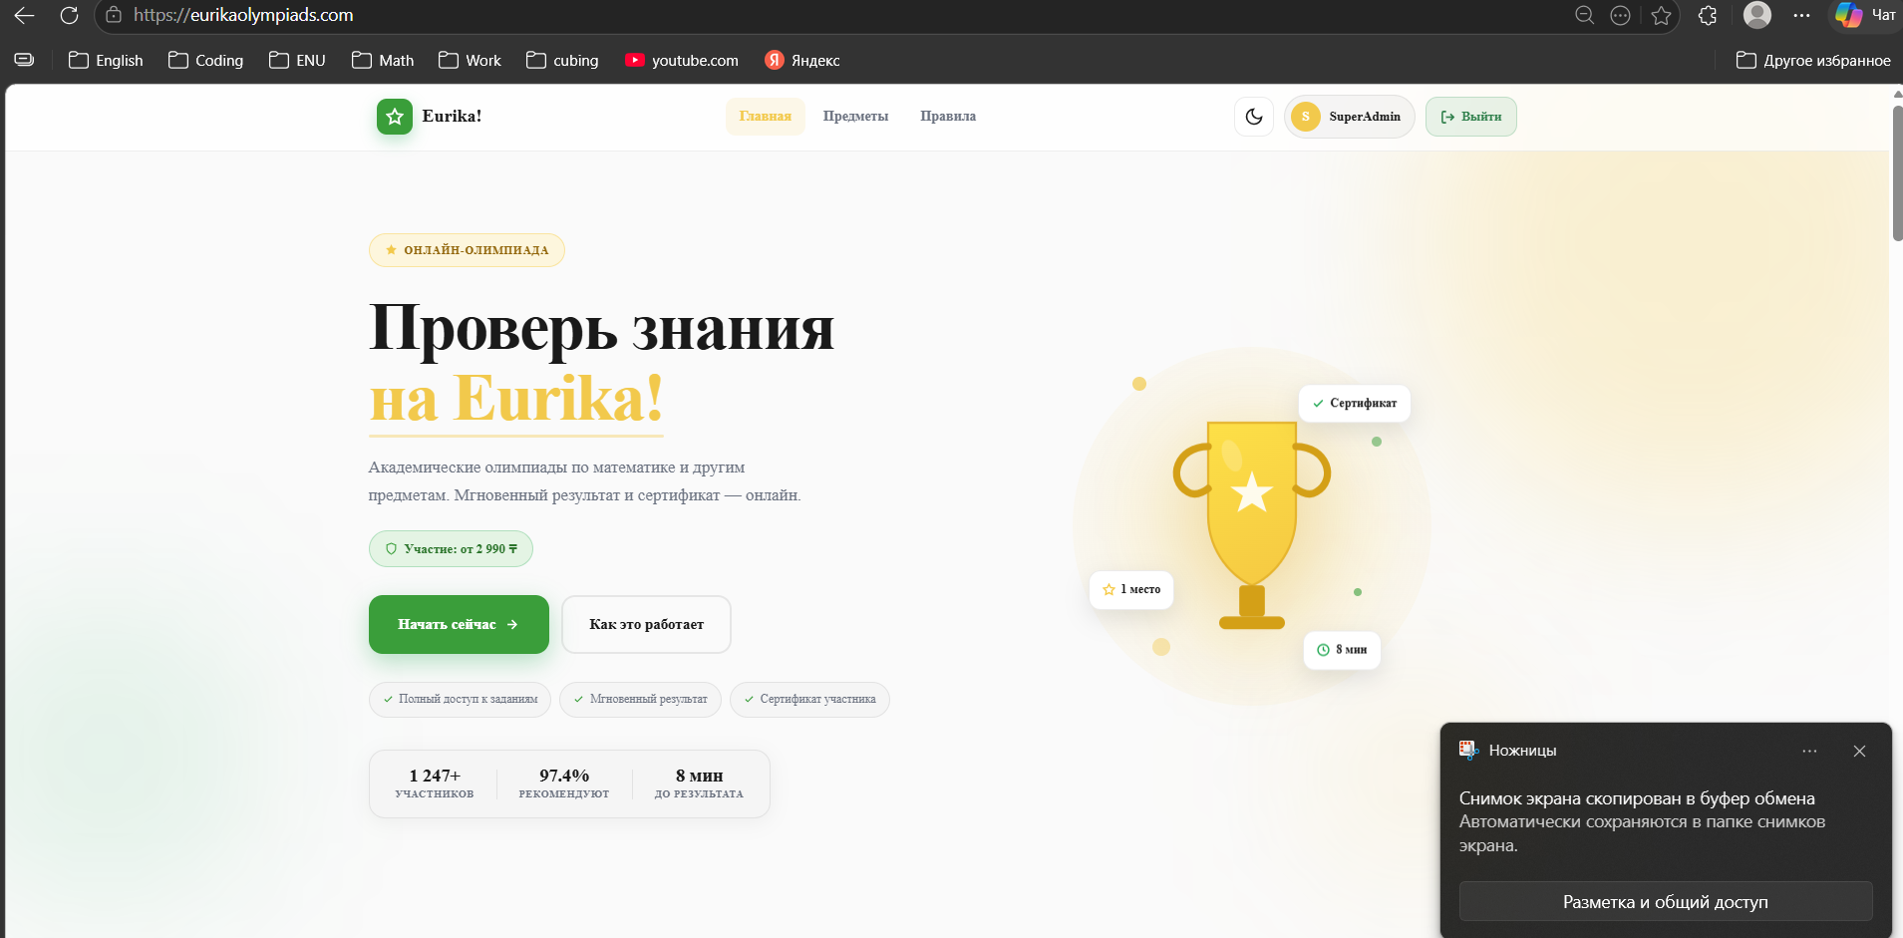

CHAPTER 1. THEORETICAL BACKGROUND AND PROBLEM STATEMENT

1.1 Context: Olympiad Education in Kazakhstan
Academic olympiads occupy a special place in the Kazakhstani educational tradition. They serve multiple interrelated functions: first, they act as talent identification mechanisms that surface gifted students who may not fully express their abilities through standard classroom assessment; second, they provide motivational scaffolding — a structured goal that encourages deeper self-study; and third, they function as a form of curriculum enrichment that broadens students' exposure to advanced problem types and interdisciplinary thinking.
Historically, Kazakhstani olympiads were conducted entirely in person. Students gathered at designated schools or regional centres, where printed question booklets were distributed under invigilator supervision. While this format ensured exam integrity, it introduced significant logistical challenges: rural students often had to travel hundreds of kilometres to participate; organisers faced the burden of printing, distributing, and manually grading thousands of answer sheets; and results could take weeks to be announced.
The COVID-19 pandemic accelerated a global shift toward digital learning and assessment. International platforms such as Kahoot!, Quizlet, Khan Academy, and dedicated olympiad systems emerged to fill the gap. However, the global solutions were not tailored to the Kazakhstani context: they lacked integration with local payment systems (Kaspi Bank dominates retail payments in Kazakhstan with over 14 million active users), were not available in Russian — the primary language of instruction — and did not align with the local curriculum standards set by the Ministry of Education.
The market for private online olympiad services in Kazakhstan has been growing steadily since 2020. Parents are increasingly willing to invest in additional intellectual development for their children, and competition organisers recognise the cost and reach advantages of digital formats. However, the available solutions remain fragmented: many rely on simple Google Forms or manual WhatsApp coordination, which lack reliability, fairness guarantees, and professional certificate issuance.
In this context, the Eurika project addresses a clear and well-defined market need: a purpose-built, professionally developed online olympiad platform that integrates seamlessly into the daily digital life of Kazakhstani families, supports local payment infrastructure, provides a trustworthy and fraud-resistant examination environment, and delivers immediate, meaningful results including verifiable certificates.

1.2 Existing Solutions and Their Limitations
To justify the development of a new platform rather than adapting an existing one, a comparative analysis of available solutions was conducted. The following categories of tools were reviewed:
Generic Quiz/LMS Platforms
Tools such as Google Forms, Typeform, and Microsoft Forms are widely used for informal testing but lack critical features required for formal olympiad management: they do not support payment collection, do not provide violation detection, do not issue certificates, and offer no administrative dashboards for tracking participants across multiple subjects and age categories.
Learning Management Systems (LMS)
Platforms such as Moodle, Schoology, and Canvas are designed for ongoing course delivery rather than event-based competitions. Their configuration overhead is substantial, their UX is not optimised for one-time participation flows (registration → payment → exam → certificate), and they require dedicated server administration expertise. None of them offer native Kaspi payment integration.
Existing Kazakhstani Olympiad Services
Several local providers offer online olympiad certificates through social media and messaging apps. These services typically lack automated exam delivery, rely on manual certificate creation in graphic editors, cannot scale beyond a few hundred participants, and provide no audit trail for organisers. Security is minimal — answer sharing and impersonation are common issues.
The gap analysis reveals that no existing solution satisfactorily addresses all of the following requirements simultaneously: (1) seamless Kaspi payment integration; (2) automated timed quiz delivery with violation tracking; (3) instant result and certificate generation; (4) multi-subject, multi-grade management; (5) a professional administrative dashboard; and (6) a Russian-language UX tailored to Kazakhstani families. The Eurika platform was designed to fulfil all six requirements. 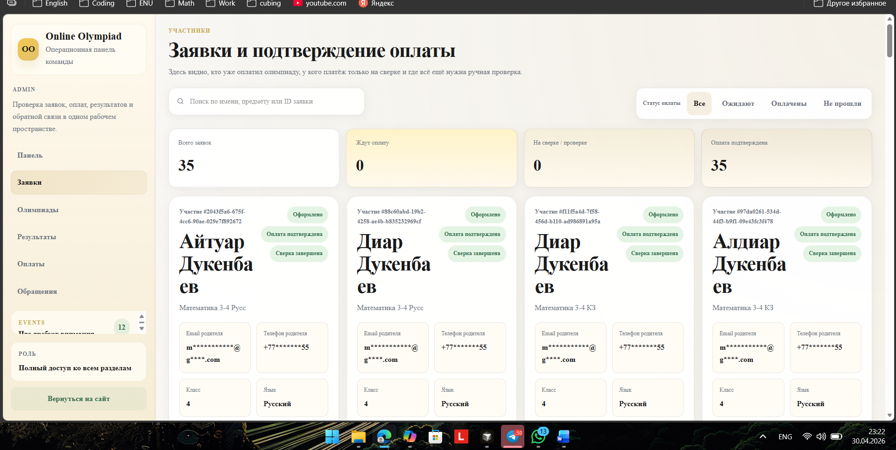

1.3 Project Goals, Objectives and Scope
The overarching goal of the Eurika project is to develop and deploy a reliable, secure, and user-friendly web platform that enables online olympiad organisations to conduct high-quality intellectual competitions for school students in Kazakhstan.
The specific technical objectives are:
- Design and implement a full-stack web application using Laravel 12 (backend) and Vue 3 (frontend) following modern software engineering practices.
- Develop a secure authentication and authorisation system supporting parent accounts, child profiles, and a multi-role administrative panel.
- Integrate three payment gateways — Kaspi, YooKassa, and Stripe — with automated reconciliation and webhook processing.
- Implement a timed quiz engine with real-time violation detection (tab switching, window blur, fullscreen exits, developer tools activation).
- Build a certificate generation subsystem that produces verifiable PDF certificates accessible through a public lookup interface.
- Create a comprehensive administrative dashboard enabling content managers to create and manage quizzes, review participation requests, track payments, and export analytics data.
- Apply industry-standard security measures including Proof-of-Work anti-spam, HMAC webhook verification, rate limiting, Content Security Policy headers, and HTTPS enforcement.
- Produce complete deployment documentation including a production checklist, environment configuration guide, and security audit report.

The scope of the project encompasses all layers of a modern web application: database schema design and migration management, RESTful API development, single-page application frontend, administrative tooling, payment integrations, document processing (PDF/Word question import), and production deployment infrastructure. The project explicitly excludes native mobile application development and machine-learning-based adaptive testing — these are identified as future development directions in the Conclusion.
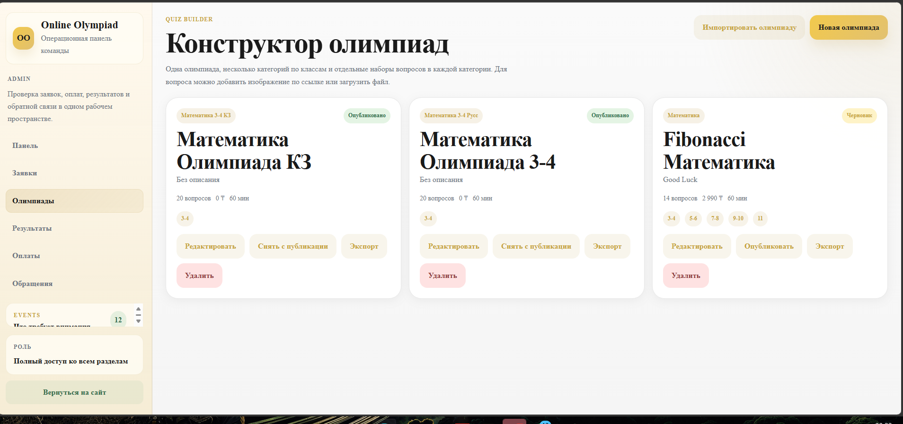

CHAPTER 2. SYSTEM DESIGN AND IMPLEMENTATION
This chapter describes the concrete technical implementation of the Eurika platform. The system follows a client–server architecture with a clear separation between the Vue 3 single-page application (SPA) frontend and the Laravel 12 RESTful API backend. Both subsystems are described in detail below.

2.1 Frontend Development

Technology Selection
The frontend of Eurika is built with Vue 3, the latest major version of the Vue.js progressive JavaScript framework. Vue 3 was selected over its competitors (React, Angular) for several reasons: its Composition API offers clean, reusable logic encapsulation without the complexity of React hooks or Angular's dependency injection system; its file-based Single-File Component (SFC) format keeps template, logic, and styles co-located; and its performance characteristics (virtual DOM diffing, tree-shaking) are well-suited to a data-rich application with many dynamic states.
Vite 7.3 serves as the build tool and development server. It offers sub-second hot module replacement (HMR) during development and produces highly optimised production bundles through Rollup-based code splitting. The Laravel Vite plugin handles asset manifest generation and integrates seamlessly with Laravel's asset pipeline, allowing the SPA to be served from the same domain as the API without cross-origin complications.
Tailwind CSS v4 is used for styling. Tailwind's utility-first approach enables rapid UI development without the specificity conflicts and bloat that accumulate in traditional BEM or component-scoped CSS systems. The project's custom design system — warm beige backgrounds (#f5f0e8), dark text (#2c2c2a), and gold accents (#c9a84c) — is implemented as Tailwind configuration tokens, ensuring visual consistency across all pages.
State management is handled by Pinia 3.0.4, Vue's officially recommended store library. Pinia provides a modular, type-safe store architecture. Key stores in the application include AuthStore (token management, user profile caching), NotificationStore (real-time notification fetching), and QuizStore (active quiz state, timer, and answer tracking). Routing is managed by Vue Router v4 with lazy-loaded route components to minimise initial bundle size.

Application Architecture and Page Structure
The SPA is organised into three distinct logical zones, each with its own router layout and access control logic:
Public Zone
Accessible to all visitors without authentication. Contains the landing page (hero, 'How It Works', testimonials, news), subject catalogue, leaderboard, public certificate verification, login and registration flows, and static informational pages (About, Rules, Public Offer). The landing page is SEO-optimised with dynamic Open Graph meta tags, a sitemap.xml, and a robots.txt generated by the backend, enabling search engine indexing of the platform's public content.
Authenticated User Zone
Available to logged-in parents. The profile section provides a personalised dashboard with child profile management (add/edit multiple children), olympiad request history with real-time payment status updates, quiz results with mistake review, training mode history, payment receipts, and an in-app notification centre. The quiz interface itself — the core user experience of the platform — is implemented as a multi-phase component (pre-quiz instructions → timed exam → results/certificate) with fullscreen enforcement and comprehensive violation detection logic.
Administrative Zone
Accessible only to users with administrative roles. Implements a fully featured dashboard with separate views for olympiad request management, payment reconciliation (CSV import), quiz and question CRUD with image upload and document parsing, participant and results analytics with CSV export, and support callback tracking. Administrative access is controlled by a capability matrix — different roles (Admin, Operator, Content Creator, Analyst) have access to different sections based on assigned capabilities stored in the database.

Key User Interface Components
The quiz interface (Quiz.vue) represents the most technically demanding frontend component. It manages several concurrent concerns:
- Timer management: a reactive countdown driven by JavaScript's Date API (rather than setInterval drift) that automatically submits the exam upon expiry.
- Fullscreen control: the Web Fullscreen API is used to enforce fullscreen mode; exiting fullscreen is treated as a violation.
- Violation tracking: event listeners on document visibilitychange, window blur, and keyboard shortcut detection (F12, Ctrl+Shift+I) send asynchronous violation reports to the backend without interrupting the exam flow.
- Answer persistence: selected answers are stored in the Pinia QuizStore and synced to sessionStorage as a crash recovery mechanism.
- Result rendering: upon submission, the component transitions to an animated result screen displaying the score, rank, and a certificate preview with a QR code for public verification.

The Header component implements a scroll-aware design that transitions from transparent to a frosted-glass background as the user scrolls, providing visual depth without obscuring content. Navigation is fully responsive, collapsing to a burger menu on mobile devices. The notification centre (NotificationCenter.vue) polls the backend on a configurable interval and displays badge counts with smooth CSS transitions.

Internationalisation and Accessibility
The platform uses vue-i18n 9.14.5 for internationalisation. All user-facing strings are stored in locale JSON files, enabling future addition of Kazakh (kk-KZ) and English language support without code changes. The current primary locale is Russian (ru-KZ). Input masking (imask library) is applied to phone number and payment-reference fields to guide users toward valid input formats. QR codes for certificate verification are generated client-side using qrcode.vue, avoiding server round-trips for certificate preview rendering.

2.2 Backend Architecture and Security

Framework and Project Structure
The backend is implemented in Laravel 12, running on PHP 8.2+. Laravel was selected as the framework of choice due to its comprehensive feature set, strong community, well-documented conventions, and the availability of first-party packages that cover the majority of the platform's requirements: Sanctum for API authentication, Horizon for queue monitoring, and built-in support for queued jobs, scheduled tasks, and event broadcasting.
The project follows a standard Laravel directory structure with additional organisation imposed for scalability. Controllers are grouped by domain (Auth, Admin, Olympiad, Quiz, Training, Webhook, Support, AI). Form Requests provide validation and authorisation for all incoming data. Eloquent Models represent the database entities with defined relationships, scopes, and accessors. A dedicated app/Support/ directory houses service classes for cross-cutting concerns such as payment reconciliation, proof-of-work validation, and SEO meta generation.

Database Design
The database layer uses MySQL 8 in production with proper character set (utf8mb4) and collation (utf8mb4_unicode_ci) to support all Russian, Kazakh, and Unicode characters. The schema comprises 15 core tables managed through Laravel migrations, enabling reproducible database setup and safe incremental changes.
The principal entities and their relationships are as follows:
- users — Parent/guardian accounts with hashed passwords, roles, and a JSON settings column for preferences and onboarding state. Public IDs (UUID-based) are used in URLs to prevent enumeration attacks.
- child_profiles — Children linked to a parent user, storing name, birth date, school, and grade level.
- subjects — Olympiad subjects (Mathematics, Science, Literature, etc.) with descriptions and icons.
- quizzes — Quiz definitions linked to subjects, including time limit, price, grade category, and published state.
- questions — Individual questions within a quiz, supporting text and optional image attachments stored on the server filesystem.
- answers — Multiple-choice answer options for each question, with a correct flag and optional explanation text shown after submission.
- olympiad_requests — The central workflow entity linking a parent, child, and subject. Progresses through statuses: pending → approved/rejected, and payment_status: unpaid → paid.
- quiz_results — Immutable records of completed exam attempts, storing the full answer payload as JSON, score percentage, timestamp, violation flags, and the review reason if flagged.
- payment_records — Payment transactions with gateway, amount, status, and reference numbers for reconciliation.
- platform_notifications — In-app notifications with type, payload, and read status per user.
- processed_webhooks — An idempotency log preventing duplicate processing of payment webhook callbacks.

RESTful API Design
The platform exposes a RESTful API organised under the /api prefix. Routes are divided into three groups based on authentication requirements: public routes (accessible without tokens), authenticated user routes (protected by Laravel Sanctum token middleware), and admin routes (additionally protected by capability checks).
The API design adheres to standard REST conventions: resources are represented as nouns, HTTP verbs express intent (GET for retrieval, POST for creation, PATCH for partial update, DELETE for removal), and consistent JSON response envelopes are returned. Paginated collections use Laravel's built-in pagination with configurable page sizes. All responses use appropriate HTTP status codes — 200 OK, 201 Created, 204 No Content, 400 Bad Request, 401 Unauthorised, 403 Forbidden, 404 Not Found, 422 Unprocessable Entity, 429 Too Many Requests.
Key API subsystems include: the Authentication API (registration with POW, login, password reset); the Olympiad API (request submission, status tracking, payment reporting); the Quiz API (quiz retrieval, attempt start, answer submission, violation reporting); the Training API (informal practice mode with immediate feedback); the Admin API (full CRUD operations on all entities with role checks); and the Webhook API (payment gateway callbacks for Kaspi, YooKassa, and Stripe).

Payment Integration
The payment subsystem supports three gateways, each integrated differently to match their technical specifications:
Kaspi Bank
Kazakhstan's dominant payment platform. Kaspi uses a pull-based model: users pay at Kaspi kiosks, ATMs, or the Kaspi app by entering a reference number; the platform exposes a Kaspi-accessible /api/kaspi/check endpoint (IP-whitelisted to Kaspi's servers) that Kaspi calls to verify invoice status. Upon successful payment, Kaspi calls /api/kaspi/pay to confirm the transaction. The KaspiPaymentReconciler service also supports CSV import from Kaspi Bank's merchant portal, enabling batch reconciliation of payments against olympiad requests by matching reference numbers.
YooKassa
A Russian payment aggregator supporting cards, e-wallets, and bank transfers. Integration is webhook-based: upon payment, YooKassa sends a signed POST request to /api/webhooks/yookassa. The webhook handler verifies the HMAC-SHA256 signature against the shared secret, checks the ProcessedWebhooks table for idempotency, and updates the corresponding OlympiadRequest payment status.
Stripe
The international card payment processor. Stripe webhooks arrive at /api/webhooks/stripe and are verified using Stripe's official PHP SDK signature verification. The Stripe integration is positioned as the fallback gateway for international users or in scenarios where Kaspi and YooKassa are unavailable.

Security Architecture
Security was treated as a first-class concern throughout development. The following measures are implemented:
- Proof-of-Work (POW) Anti-Spam: Registration, feedback, and callback request endpoints require the client to solve a computational challenge (hashcash-style SHA-256 puzzle) before the server processes the request. This effectively eliminates automated bot submissions without the UX friction of CAPTCHA.
- Laravel Sanctum Token Authentication: API tokens are issued upon login, stored hashed in the database, and transmitted as Bearer tokens. Token expiration is configurable. Admin tokens are stored separately from user tokens with different lifetime policies.
- Rate Limiting: Separate rate limiters are applied to registration (5/min), login (10/min), password reset (3/min), and API endpoints (60/min for authenticated, 30/min for public). The admin API uses its own rate limit bucket to prevent brute-force attacks on admin credentials.
- HTTP Security Headers: The SecurityHeaders middleware injects Content-Security-Policy, X-Frame-Options (SAMEORIGIN), X-Content-Type-Options (nosniff), Strict-Transport-Security (HSTS with 1-year max-age), Referrer-Policy, and Permissions-Policy on every response.
- HTTPS Enforcement: A dedicated HTTPS enforcement middleware redirects all HTTP traffic to HTTPS when SECURITY_ENFORCE_HTTPS=true. HSTS headers are set with includeSubDomains and preload directives.
- Webhook Signature Verification: All incoming webhooks (Kaspi, YooKassa, Stripe, Telegram) are verified against HMAC signatures before any database operations are performed. Unverified requests are rejected with 401.
- Violation Detection: The quiz engine tracks behavioural signals that indicate potential cheating — tab visibility changes, window blur events, fullscreen exits, copy/paste attempts, and developer tools keyboard shortcuts. Violations are recorded asynchronously and can trigger manual review flags on results.
- Role-Based Access Control (RBAC): Administrative capabilities (dashboard, requests, payments, quizzes, results, callbacks) are stored as a JSON capabilities field on admin user records. The CanPerformAdminAction middleware checks the required capability before processing each admin API request.
- Input Validation: All incoming data is validated through Laravel Form Requests with strict type, length, and format rules. SQL injection is prevented by Eloquent's parameterised query builder. XSS prevention is enforced by Vue's template rendering, which escapes all interpolated values by default. 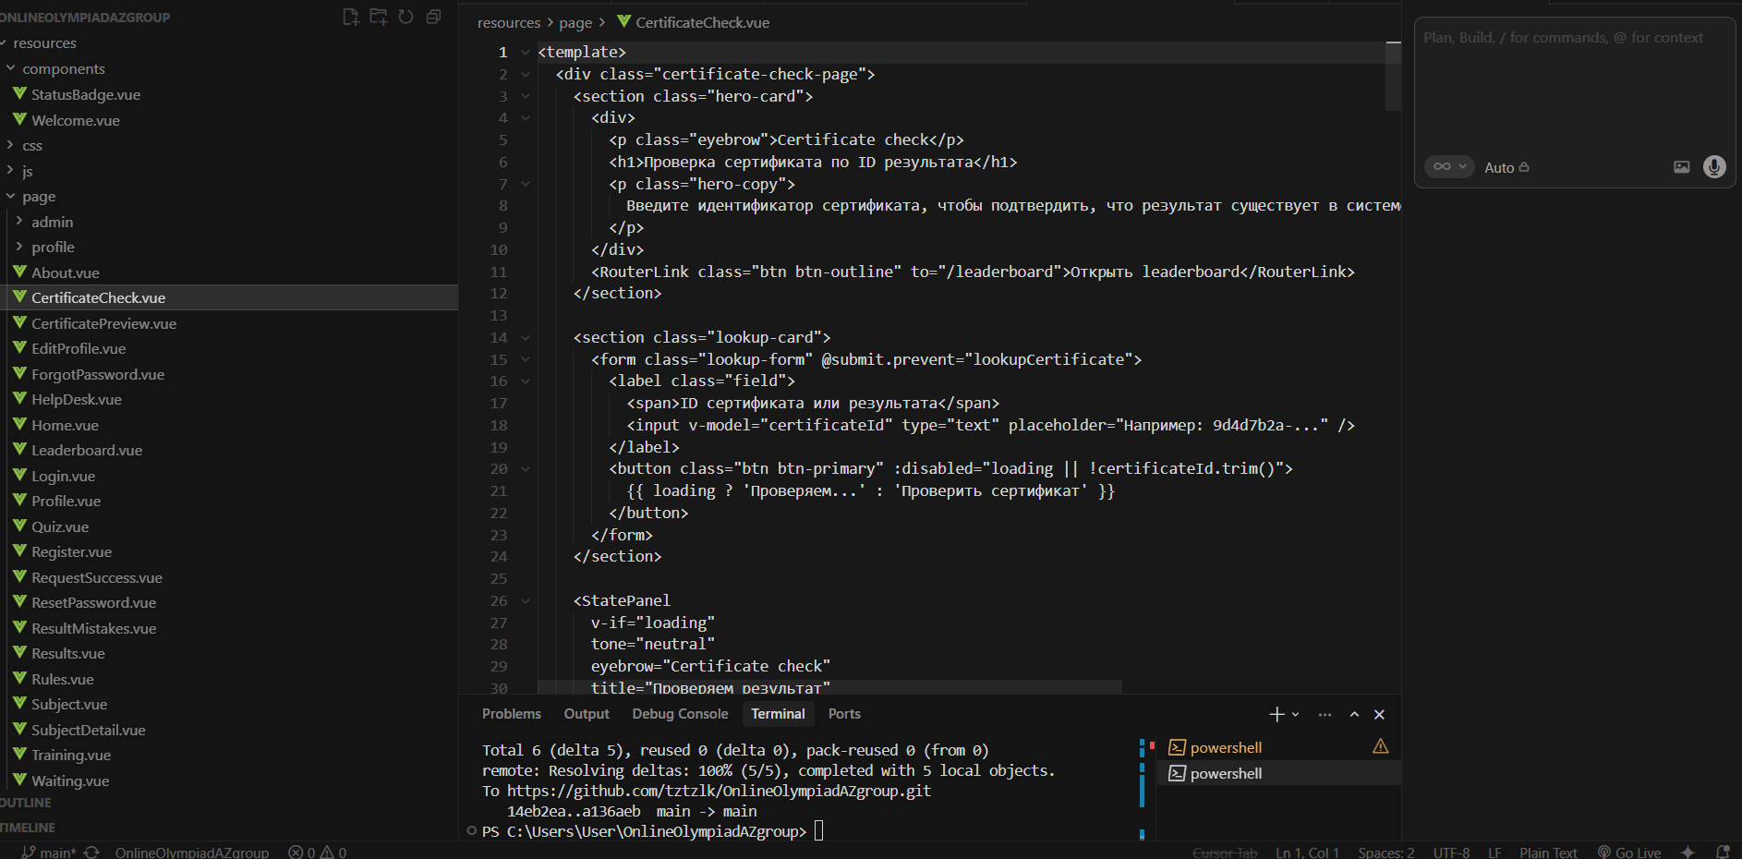

Queue System and Background Processing
Time-sensitive operations — certificate PDF generation, email dispatch, notification delivery, and Telegram alerts — are processed asynchronously through Laravel's queue system. In production, the database queue driver is used with Supervisor managing persistent queue worker processes. This ensures that a slow PDF library operation or a transient SMTP failure does not block the HTTP response cycle and degrade user experience.
The Laravel scheduler runs every minute via a cron job and handles recurring tasks: expired session cleanup, payment reconciliation sweeps, and olympiad request status aggregations for the admin dashboard. The notification workflow service (NotificationWorkflow.php) orchestrates a multi-step onboarding sequence that sends contextually timed notifications to newly registered users, guiding them through the platform's features.

Document Processing and AI Integration
To reduce the manual effort of quiz creation, the platform provides a document parsing feature (DocumentQuestionParser.php) that accepts uploaded PDF and DOCX files and extracts structured question/answer data. The parser uses smalot/pdfparser for PDF extraction and PHPOffice/PHPWord for DOCX processing, applying regular expression heuristics to identify question stems, answer options, and correct answer markers.
An AI-assisted question generation endpoint (/api/ai/generate) is also available to authorised administrators. This endpoint enforces per-user quotas to control costs, applies rate limiting, and proxies requests to an external language model API. The generated questions are returned in the standard quiz JSON format, ready for review and import through the admin panel.

CONCLUSION
The Eurika Online Olympiad Platform represents a complete, production-ready solution that addresses a genuine and well-defined need in the Kazakhstani educational technology landscape. The project successfully achieves all objectives set out in Chapter 1.3: a full-stack web application has been developed and documented, covering authentication, payment processing, quiz delivery, result certification, administrative management, and security hardening.
From a technical standpoint, the project demonstrates the effective application of modern web engineering practices. The backend — Laravel 12 with Sanctum authentication, Eloquent ORM, queued jobs, and a comprehensive middleware stack — provides a solid, maintainable foundation that can scale to thousands of concurrent participants. The frontend — Vue 3 with Pinia state management, Vue Router, and Tailwind CSS — delivers a responsive, accessible, and visually coherent user experience across desktop and mobile devices. The integration of three payment gateways with automated reconciliation and webhook idempotency handling addresses the complex payment landscape of the target market.
The security posture of the platform is a notable achievement. The implementation of Proof-of-Work anti-spam, HMAC webhook verification, behavioural violation detection, layered rate limiting, and a comprehensive security headers policy results in a defence-in-depth architecture that significantly raises the cost of common attack vectors — credential stuffing, webhook spoofing, exam cheating, and automated abuse. The accompanying PRODUCTION_READINESS_REPORT confirms that eight previously identified security gaps have been resolved prior to deployment.
The project also delivers tangible organisational value. The 165-item deployment checklist, the detailed DEPLOYMENT.md guide, and the DEPLOYMENT_AUDIT.md ensure that the platform can be reliably reproduced and maintained by operations staff who were not involved in its initial development — a critical requirement for long-term sustainability. The administrative panel's capability matrix enables the organisation to safely involve staff with different responsibility levels (operators, content creators, analysts) without granting unnecessary privileges.
In terms of social impact, the Eurika platform has the potential to meaningfully democratise access to academic competition in Kazakhstan. By removing the geographic and logistical barriers of in-person olympiads and integrating with the payment methods that Kazakhstani families already use, the platform can reach students in rural and underserved regions who would otherwise be excluded from such opportunities. This aligns directly with the national 'Digital Kazakhstan' agenda and supports the broader goal of building a knowledge-based economy.
Directions for Future Development
While the current version of the platform is fully functional and ready for production deployment, several enhancements have been identified for future development cycles:
- Native Mobile Applications: Developing iOS and Android apps using React Native or Flutter would further reduce participation barriers for students using smartphones as their primary devices.
- Kazakh Language Support: Adding a kk-KZ locale to the vue-i18n configuration and translating all user-facing strings would make the platform fully bilingual in line with Kazakhstan's state language policy.
- Adaptive Testing Engine: Implementing Item Response Theory (IRT)-based adaptive question selection would allow the platform to more precisely assess student ability levels with fewer questions, reducing exam fatigue.
- Real-Time Leaderboard: Upgrading the current poll-based leaderboard to a WebSocket or Server-Sent Events implementation (Laravel Echo + Pusher/Soketi) would create a more engaging, live competition experience.
- Proctoring Integration: Integrating with open-source or commercial AI-based proctoring services (face detection, gaze tracking) would further strengthen exam integrity for high-stakes competitions.
- Analytics Dashboard Expansion: Adding cohort analysis, subject difficulty curves, and participation trend forecasting to the admin analytics would help organisers continuously improve their content quality.
- Third-Party Olympiad API: Publishing a public API would allow partner schools and educational organisations to embed the platform's quiz engine into their own websites, multiplying the platform's reach.

In conclusion, the Eurika project demonstrates that a small, focused development team equipped with modern tools and a clear understanding of the target market can deliver a platform of professional quality within a competitive timeframe. The combination of sound architectural decisions, rigorous security practices, and thoughtful UX design produces a system that is not only technically robust but genuinely valuable to the students, parents, and organisers who will use it. The authors are confident that Eurika represents a meaningful contribution to educational technology in Kazakhstan and a strong foundation for continued innovation.

REFERENCES
[1] Laravel Framework. (2024). Laravel 12 Documentation. Laravel LLC. https://laravel.com/docs/12.x
[2] Vue.js Team. (2024). Vue 3 Official Documentation. Evan You & Vue Contributors. https://vuejs.org
[3] Tailwind CSS. (2024). Tailwind CSS v4 Documentation. Tailwind Labs Inc. https://tailwindcss.com
[4] Vite. (2024). Vite Build Tool Documentation. Evan You & Vite Contributors. https://vitejs.dev
[5] Pinia. (2024). Pinia State Management Documentation. Eduardo San Martin Morote. https://pinia.vuejs.org
[6] OWASP Foundation. (2023). OWASP Top Ten Web Application Security Risks. Open Web Application Security Project. https://owasp.org/Top10/
[7] Laravel Sanctum. (2024). Laravel Sanctum Authentication Documentation. Laravel LLC. https://laravel.com/docs/sanctum
[8] Kaspi Bank JSC. (2023). Kaspi Pay Integration API Reference. Kaspi Bank JSC, Almaty, Kazakhstan.
[9] YooKassa. (2024). YooKassa Payment Gateway API Documentation. YooMoney LLC. https://yookassa.ru/developers
[10] Stripe, Inc. (2024). Stripe API Reference and Webhook Documentation. https://stripe.com/docs/api
[11] PHPOffice. (2024). PHPWord Documentation. PHPOffice Community. https://phpword.readthedocs.io
[12] Ministry of Digital Development, Innovation and Aerospace Industry of Kazakhstan. (2018). State Programme 'Digital Kazakhstan'. Nur-Sultan: Government of Kazakhstan.
[13] MDN Web Docs. (2024). Web APIs: Fullscreen API, Page Visibility API. Mozilla Developer Network. https://developer.mozilla.org
[14] MySQL. (2024). MySQL 8.0 Reference Manual. Oracle Corporation. https://dev.mysql.com/doc/refman/8.0/en/
[15] Vue Router. (2024). Vue Router v4 Documentation. https://router.vuejs.org
[16] vue-i18n. (2024). Vue I18n v9 Documentation. Kazuya Kawaguchi. https://vue-i18n.intlify.dev
[17] Bernstein, D. J. (2003). Hashcash — A Denial of Service Counter-Measure. Technical Report. https://hashcash.org/papers/hashcash.pdf
[18] Fielding, R. T., & Taylor, R. N. (2002). Principled Design of the Modern Web Architecture. ACM Transactions on Internet Technology, 2(2), 115–150.

