First Class

David Lin

2023-07-20

## Beeswam

### Install package

install.packages('beeswam')

### sample code

data <- sample(300) #generate sample data  
library(beeswarm)  
beeswarm(data) # plot beeswarm

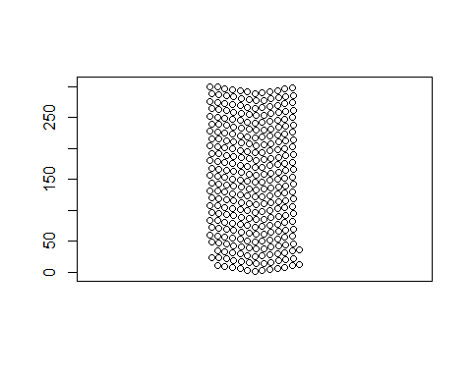

### specific color

#### show color

colors()

#### select color

beeswarm(data,col="blue")

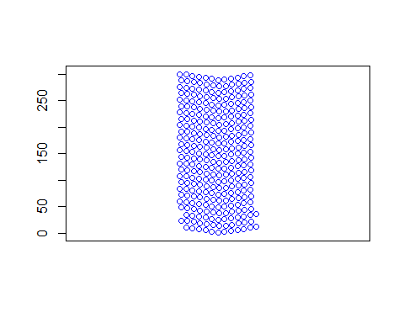 ### Sign 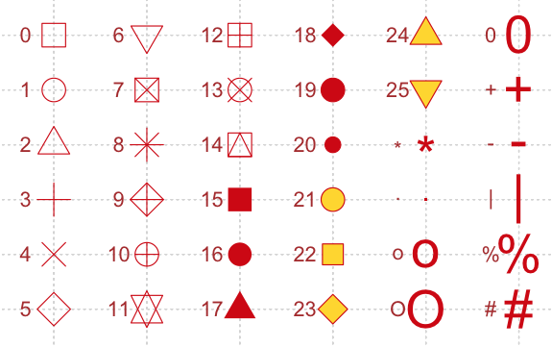

beeswarm(data,pch=19)

