**VS.4 Content**

Visual Basic Benefits

Its Features are:

* Is not case sensitive
* Is object-oriented
* Simple multi-threading
* Has a drag and drop feature in creating a user-interface
* A standard library
* Has Intellisense

Its Advantages are:

* Simplicity
  + A beginner who is new to programming can easily understand its structure. Even if Microsoft made some changes to advance it, the complexity is still less.
* Performance
  + Visual Basic makes it easy to design a Graphical User Interface (GUI) using Rapid Application Development (RAD). Its effectiveness in Visual Basic is higher than other programming languages. This makes it recommended for GUI based applications.
* Learning Curve
  + It only offers basic level especially in terminologies which is easily understandable. The syntax is also less complicated. For people struggling with learning the language, the use of online forums, blogs, and tutorials is recommended.
* Applicability
  + .Net environment wherein Visual Basic is created is a common platform for all Microsoft Visual Languages.
* Versatility
  + When creating webpages VB also allows it to be combined with JavaScript or XML platforms that can make browsers load webpages quicker.

**VS.5 Content**

In the Video you saw that you can make a simple form design in Visual Studio by using:

In the Toolbox you can use the **Button**, **Label**, **Picture Box**, and **Textbox**.

**Button –** An object that you can give command to and click by the user.

**Label –** Is a simple box that the user can’t move or edit but the programmer can.

**Picture Box** – Is an object where you can input an image. For example, the company logo

**Textbox** – Is an object where the user can input a text and the programmer can also give command too.

In the Properties Window you can edit the properties of selected object

**BackColor –** You can change the back color of your selected object.

**Text -** (Only applicable on objects with Text) Is where you can edit the displayed text

**Font** – Is where you can adjust the Font- Family, Font-Style, and Font Size.

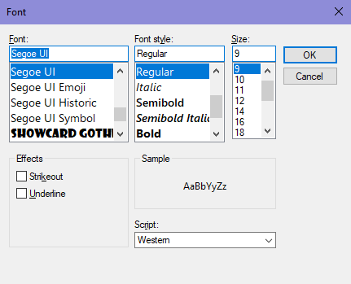

**Other Properties**

**Name** – Is where you can change the name of the object but not its displayed name (It will become useful in making an object functional in coding Visual Basic)

**Background Image** – Where you can change the background image of the selected object.

**Fore Color** – Mostly applied in text, it changes the text’s color.

**Opacity –** Is where you can control the transparency of an object.

To try to run and Debug the program you can click the Run button in the tool bar



**VS.6 Content**

To open the Visual Basic Coding Environment, you need to double click the object you want to give function.

For this instance, you need to double click the button object.



After that you will be transported to the .vb file of the form you are making.

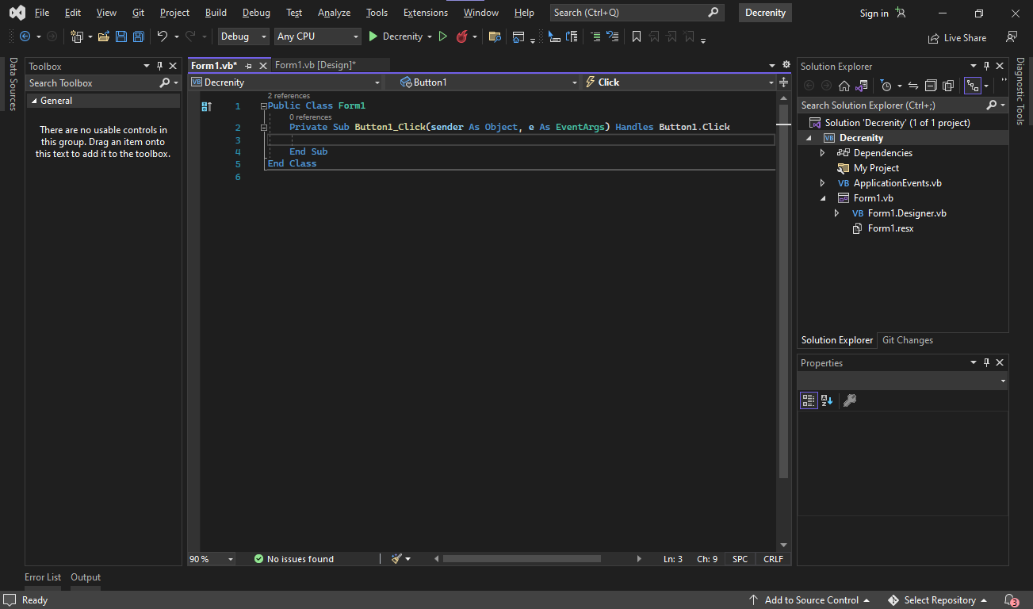

The name of object is called **Button1** which can be changed in the Properties Window



The name of the object is important in coding because the object will be identified using the name indicated in the Properties Window.

In this Example:

We will change the name of the **TextBox1** and **Text Box 2** to **Username** and **Password** respectively 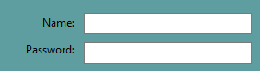

After that we will use Conditional and Logical Operators like IF, THEN, AND, OR, and ELSE

**IF** – It tells a computer on what to do based on a certain information.

**THEN** – It will become the path if the IF statement is true or followed.

**AND** – It indicates the need for both expressions to be True or False. IF both the expressions are correct then it is True, if one or either the statement is False then it is False.

**OR –** Will only return if both the conditions are False.

**ELSE –** It will become the alternative statement which will be executed if the previous path becomes False.

After learning the usage of Conditional and Logical Operat ors we can apply it in Visual Basic coding. 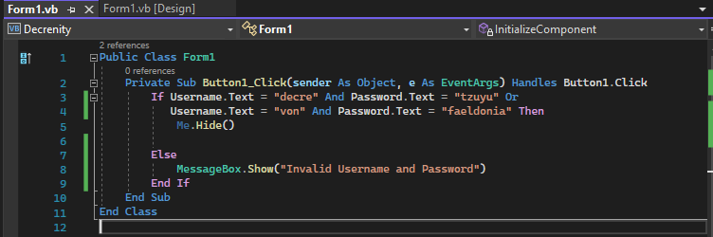

**Me.Hide** will hide the form that you are using

**OR** will help give 2 options in going to inputting the Username and Password.

**MessageBox.Show** will show an error message box having the text **“Invalid Username and Password”**



The video shows you the final output in Designing a Windows Form and making it Functional.

**VS.7 Content**

In this part you need to change the Programming Environment to Console App

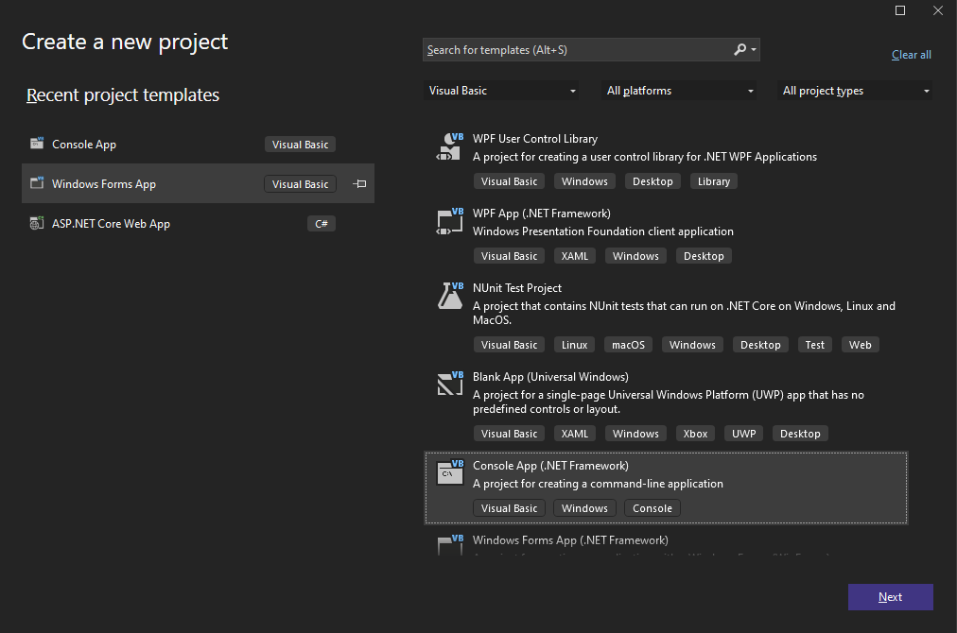

Before you dive into coding you need to understand first these Key Terms:

**Variables** – Are used for storing values or data in your program

**Data Types** – Determines what is the type of data the variable can hold.

**Dim -**  Is a reserved word which is used to declare a variable.

**Semantics** – The study of the meaning in a statement.

**Syntax** – Is a set of rules used in the language in combining symbols, phrases, clauses, and sentences together. To summarize it is the grammar in a programming language.

**Syntax Error** – A violation or error of the language syntax.

**Assignment Statement** – Stores the given value in the variable name.

**Format** – Indicates that the argument after the text or string will be evaluated and incorporated to the text.

**Example Code**

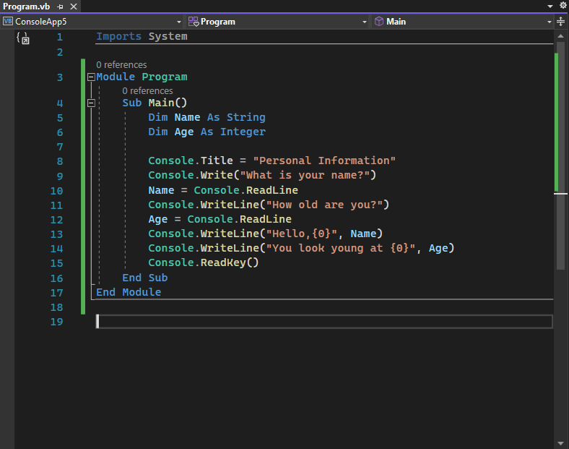

As you can see in the above the **Dim Name** is registered as a **String** (which is a data type) and **Dim Age** is registered as **Integer** (also a data type).

**Console.Title** declares the title of the application being “Personal Information”.

**Console.Write** will display the text “What is your name?” or “How old are you?”.

**Console.ReadLine** will read the input of the user if it is a string or an integer.

Name is the variable name where you can input a data which is your name.

Age is the variable name where you can input a data which is your age.

Name = Console.ReadLIne is an example of **Assignment Statement**.

**Console.WriteLine** will display the text after the first input is done.

The output program will be this:

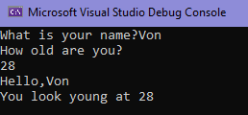

**VS.8 Content**

Arithmetic Computations

**Expression**

- Is a combination of operators, literals or constants and variables that returns a value of a specific data type.

- It is made up of two elements

**Operands** – are made up of variables that represents the value to be manipulated.

**Operator** – is a code element that performs an operation on one or more operands that holds values. It transforms the value of the operand by performing mathematical calculations, comparisons or other operations.

Example: Total Price * 0.25

* P100 * 0.25 = P25

100 and 0.25 is the **Operands**

* is the **Operator**

In the lesson VS.6 we talked **about Logical and Comparison/Relational Operators** and now we will add **Arithmetic Operators**:

**Arithmetic Operators** – performs calculations on numeric values.

**Comparison/Relational Operators** – compare numeric values using comparison operators and return a Boolean (True or False) value representing the result of the comparison.

**Logical Operators** – compares two or more Boolean expressions and returns a Boolean value.

**Arithmetic Operators:**

**Addition** - + Adds two or more numbers

**Subtraction** - - Subtracts two or more numbers

**Multiplication** - * Multiplies two or more numbers

**Exponentiation** - ^ Raises the number to the specified power

**Division** - / Divides the two numbers and returns the quotient in floating or point format (ex. 3.14)

**Division (Integer)** - \ Divides the two numbers and returns the quotient in integer format (ex. 3 in 3.14)

**Modulus Division** – Mod Divides the two numbers and returns the remainder (ex. 14 in 3.14)

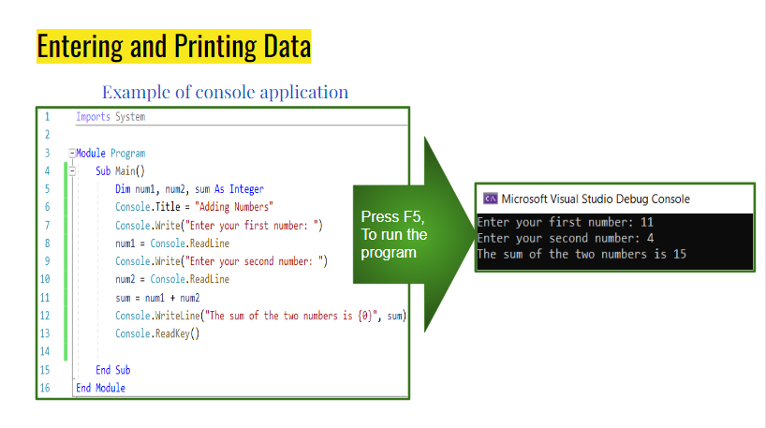

**Example Code of Computation**

Lesson VS.7 talks about Integer data type and Console syntax.

You can go back to VS.7 to learn about the function of the code and variables.

In this code tackles the use of (+) as an operator to get the sum of 2 numbers.

**Contact**

You can contact us via

Gmail: pr2gr1programming@gmail.com

For more Inquiries, you can contact Group 1 of Grade 12 Section Programming located at Flora A. Ylagan High School.

These are the Members:

Alcansado, Jeboy J.

Alcansado, Alexander J.

Apale Laurence Gerard

Cortez, Benedict C.

Calimlim, Rejeanne Rein A.

Estoesta, Rodel

Faeldonia Elias Von Isaac R.

Imbang, Mary Ruth A.

Mapa, Beatrix Barbette

Peralta, Jobert M.

Pido, Earl Laurence

Reyes, Rizza

Salayog, Armie

Turno, Renan

For Feedback Recommendations go and contact the members of Group 1 of Grade 12 Section Programming.

**About**

This website will help students to learn about the basics of using Visual Studio and has a basic introductory into coding using Visual Basic.

It teaches students on how to use and navigate Visual Studio.

It also teaches students about the syntax and semantics of Visual Basic.

This website is for educational purpose.

This is an output project for Practical Research 2 made by Grade 12 Programming students of Flora A. Ylagan High School

Alcansado, Jeboy J.

Alcansado, Alexander J.

Apale Laurence Gerard

Cortez, Benedict C.

Calimlim, Rejeanne Rein A.

Estoesta, Rodel

Faeldonia Elias Von Isaac R.

Imbang, Mary Ruth A.

Mapa, Beatrix Barbette

Peralta, Jobert M.

Pido, Earl Laurence

Reyes, Rizza

Salayog, Armie

Turno, Renan

We would like to thank our research adviser, Ms. Emmylou Petracorta for the website’s overall content and validation of the website.