CprE 381: Computer Organization and Assembly-Level Programming

Project Part 1 Report

Team Members: Anna Huggins

Christopher Sell

Project Teams Group #: 8-8

Refer to the highlighted language in the project 1 instruction for the context of the following questions.

[Part 1 (d)] Include your final MIPS processor schematic in your lab report.

[Part 2 (a.i)] Attach spreadsheet, probably!

[Part 2 (a.ii)]
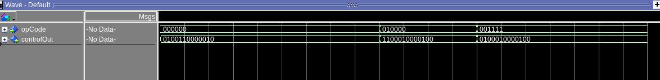
Implement the control logic module using whatever method and coding style you prefer. Create a testbench to test this module individually, and show that your output matches the expected control signals from problem 1(a).

[Part 2 (b.i)] In order to implement the required control flow possibilities we will need to add more control bits to enable branch, jump, and jump.

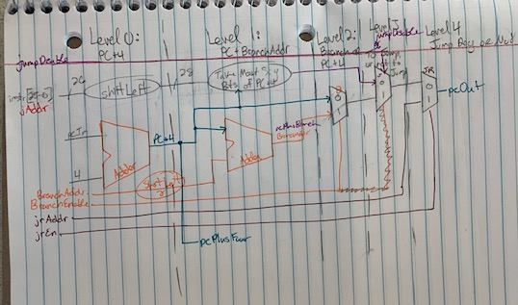
[Part 2 (b.ii)] We also needed to add jump, branch, and jump reg control signals.

[Part 2 (b.iii)]
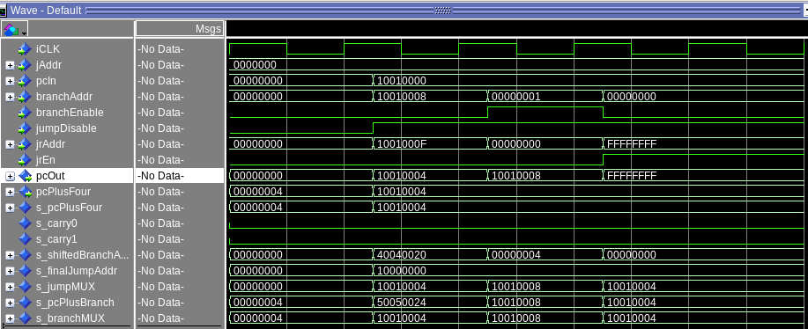
Describe how the execution of the control flow possibilities corresponds to the Modelsim waveforms in your writeup.

[Part 2 (c.i.1)]
srl: shifts the bits contained in a register to the right x times, and fills in the left with 0s.

sra: shifts the bits contained in a register to the right x times and preserves the sign of the data by keeping the most significant bit.

sll: shifts the bits contained in a register to the left x times, and fills the right with 0s.

There is not sla because there would be no purpose for preserving the sign bit, as we are shifting left, and if we were to consider preserving the rightmost bit (the least significant bit), there is no reason to do this.

[Part 2 (c.i.2)] In your writeup, briefly describe how your VHDL code implements both the arithmetic and logical shifting operations.

[Part 2 (c.i.3)] In your writeup, explain how the right barrel shifter above can be enhanced to also support left shifting operations.

[Part 2 (c.i.4)] Describe how the execution of the different shifting operations corresponds to the Modelsim waveforms in your writeup.

[Part 2 (c.ii.1)] In your writeup, briefly describe your design approach, including any resources you used to choose or implement the design. Include at least one design decision you had to make.

[Part 2 (c.ii.2)] Describe how the execution of the different operations corresponds to the Modelsim waveforms in your writeup.

[Part 2 (c.iii)] Draw a simplified, high-level schematic for the 32-bit ALU. Consider the following questions: how is Overflow calculated? How is Zero calculated? How is slt implemented?

[Part 2 (c.v)] Describe how the execution of the different operations corresponds to the Modelsim waveforms in your writeup.

[Part 2 (c.viii)] justify why your test plan is comprehensive. Include waveforms that demonstrate your test programs functioning.

[Part 3] In your writeup, show the Modelsim output for each of the following tests, and provide a discussion of result correctness. It may be helpful to also annotate the waveforms directly.

[Part 3 (a)] Create a test application that makes use of every required arithmetic/logical instruction at least once. The application need not perform any particularly useful task, but it should demonstrate the full functionality of the processor (e.g., sequences of many instructions executed sequentially, 1 per cycle while data written into registers can be effectively retrieved and used by later instructions). Name this file Proj1_base_test.s.

[Part 3 (b)] Create and test an application which uses each of the required control-flow instructions and has a call depth of at least 5 (i.e., the number of activation records on the stack is at least 4). Name this file Proj1_cf_test.s.

[Part 3 (c)] Create and test an application that sorts an array with N elements using the BubbleSort algorithm (link). Name this file Proj1_bubblesort.s.

[Part 4] report the maximum frequency your processor can run at and determine what your critical path is. Draw this critical path on top of your top-level schematics. What components would you focus on to improve the frequency?

