Roles

Procedure: Attaching a Role to an EC2 Instance

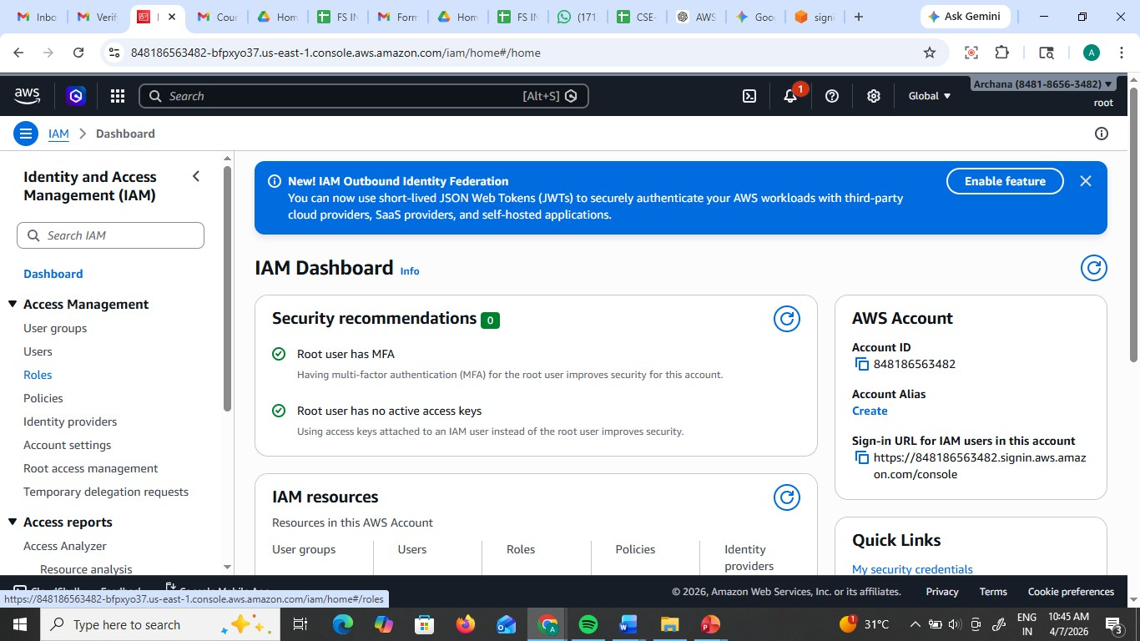

Create the Role: Go to IAM > Roles > Create role

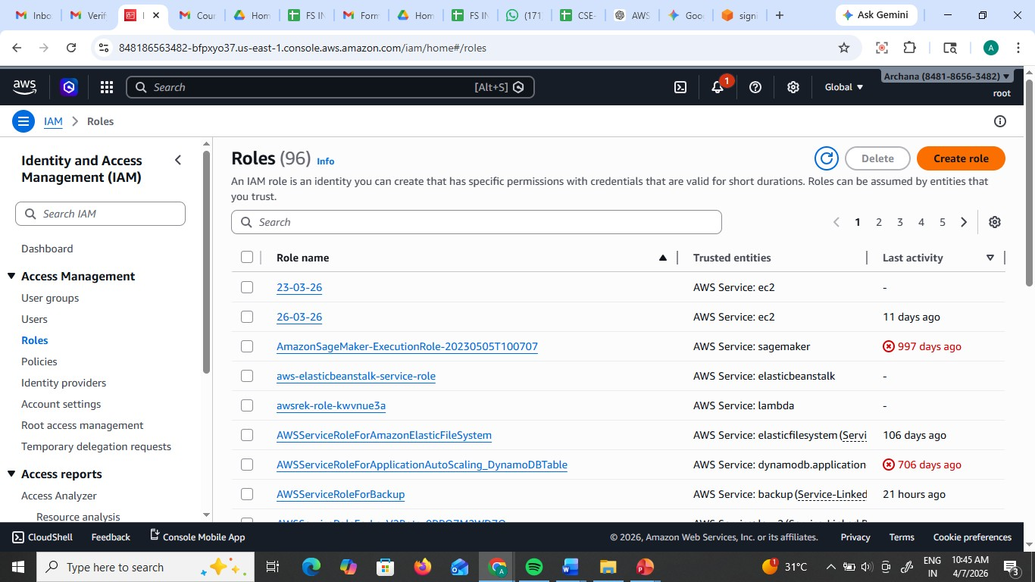

Select Trusted Entity: Choose AWS Service.

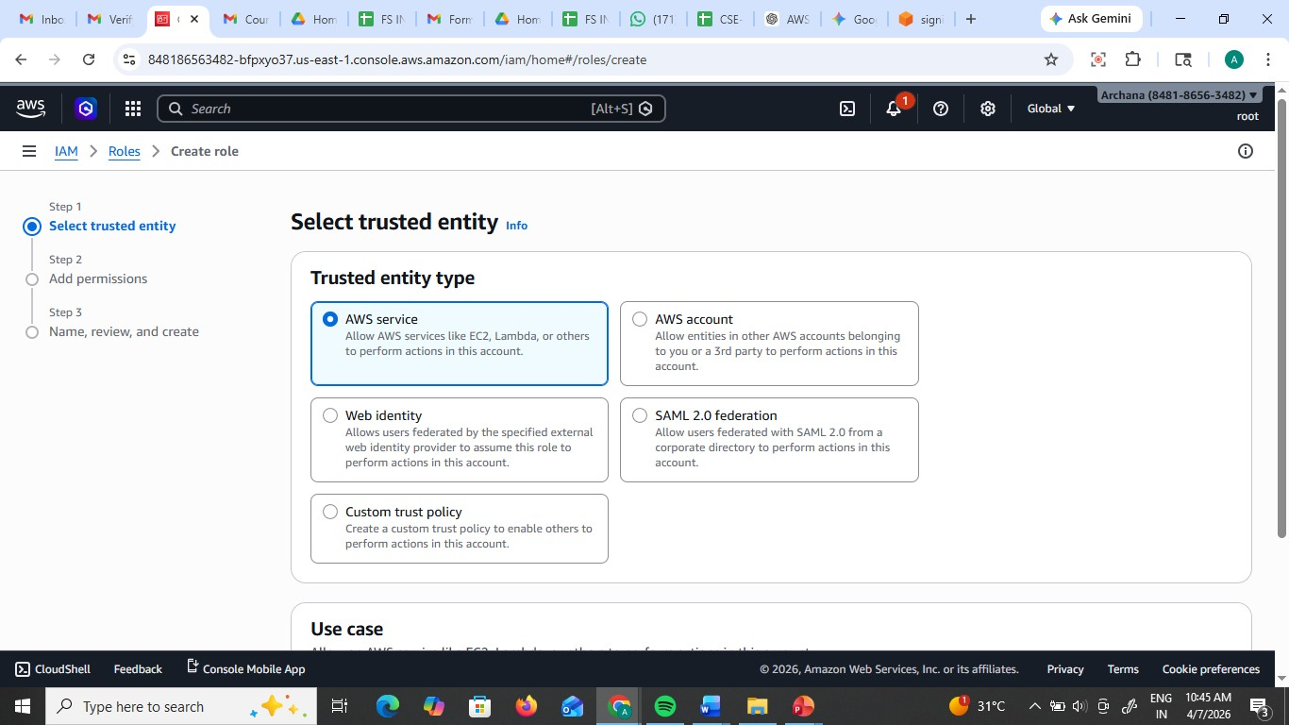

Under the "Service or use case" dropdown, select EC2. (This tells AWS: "I trust the EC2 service to use this role").

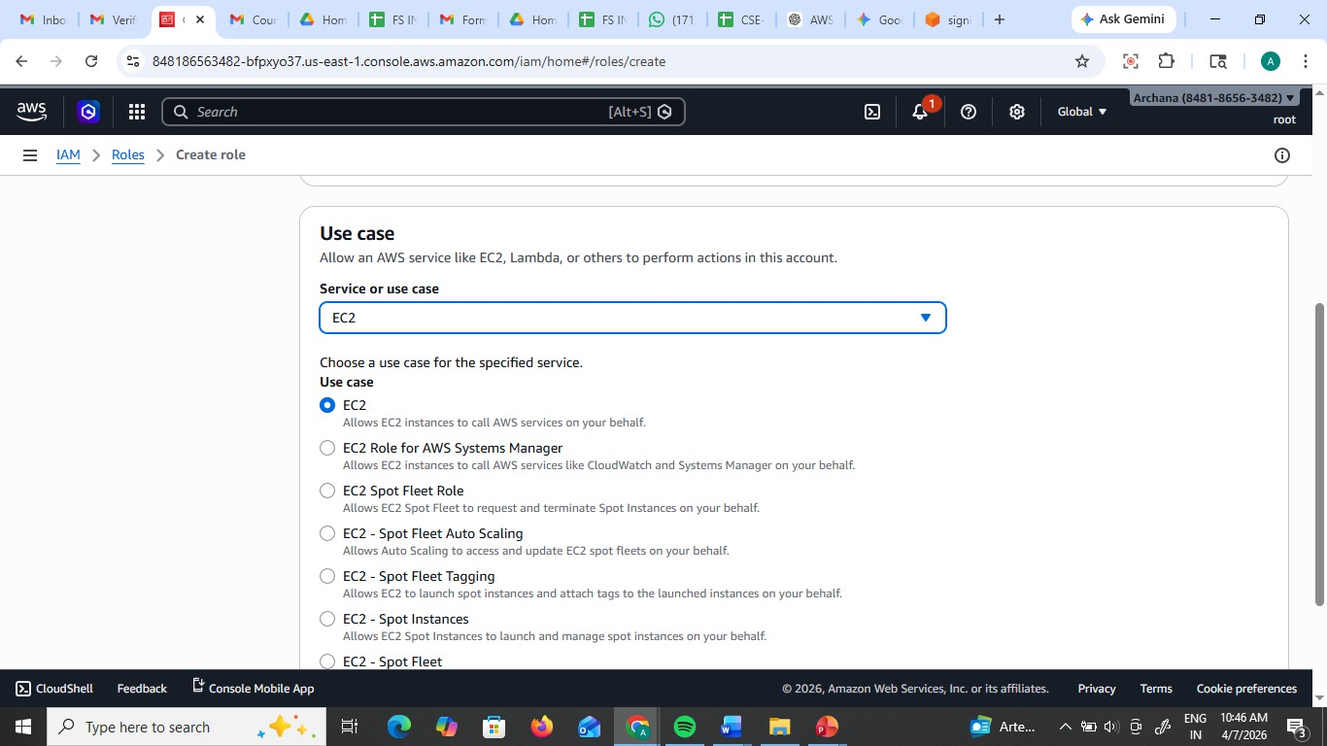

Add Permissions: Search for and check AmazonS3FullAccess.

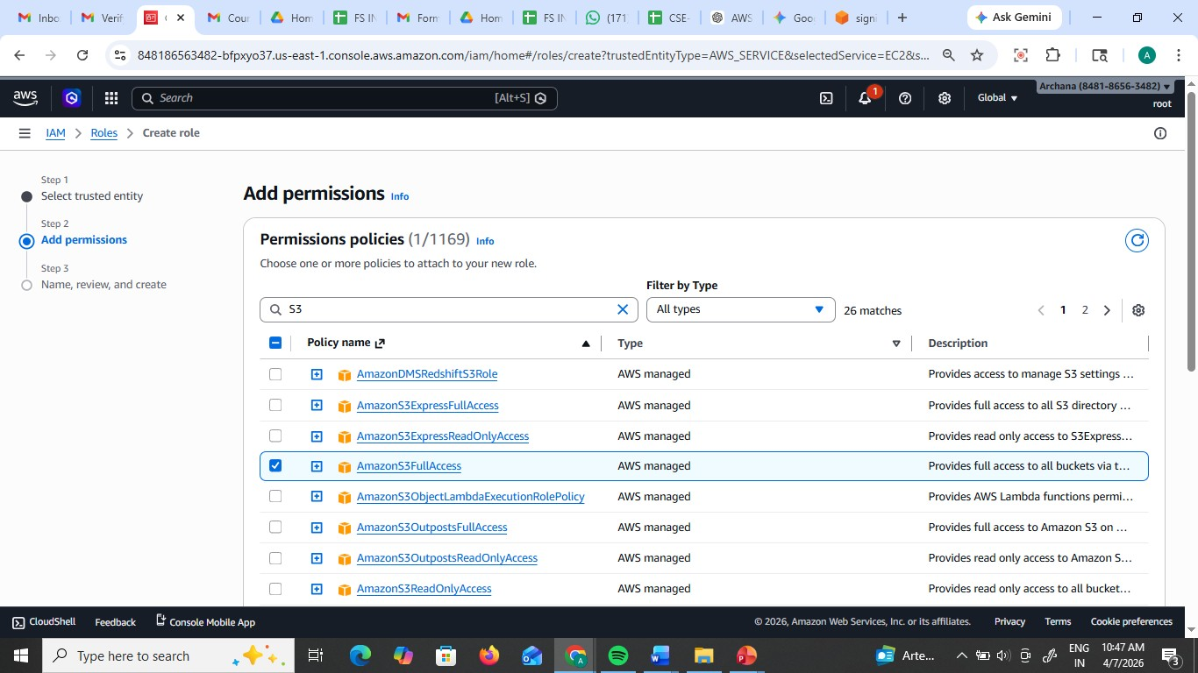

Name & Review: Name it (e.g., EC2-S3-ReadOnly-Role) and click Create role.

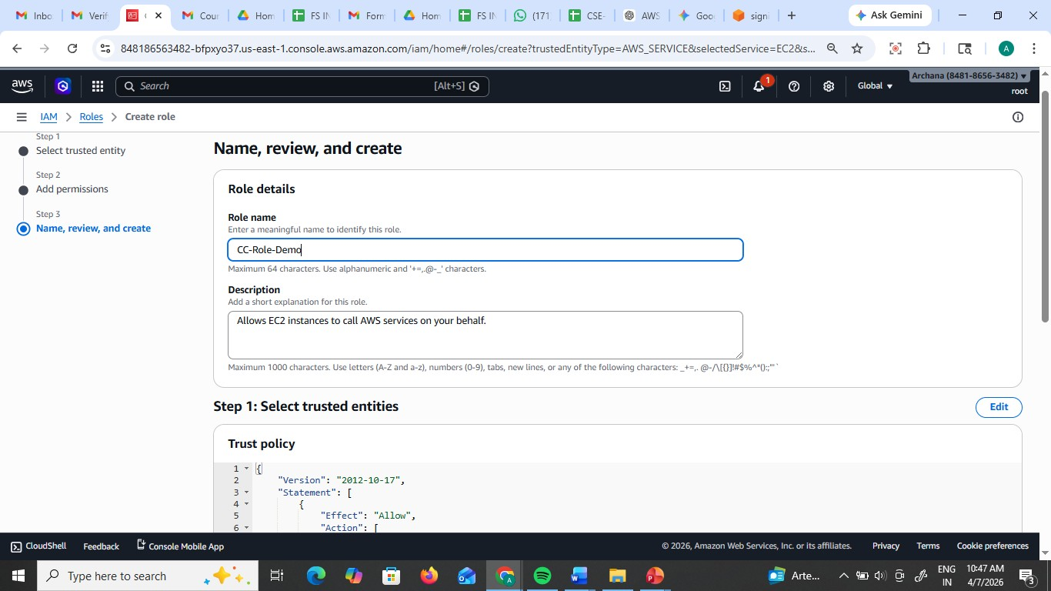

Name & Review: Name it (e.g., EC2-S3-ReadOnly-Role) and click Create role.

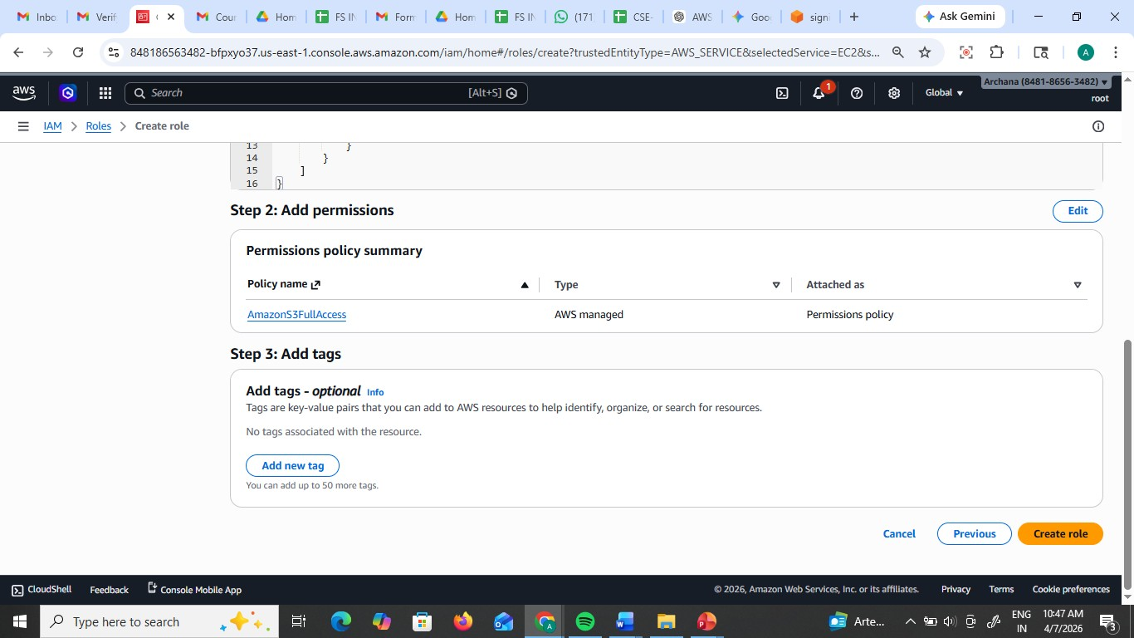

Role has been created

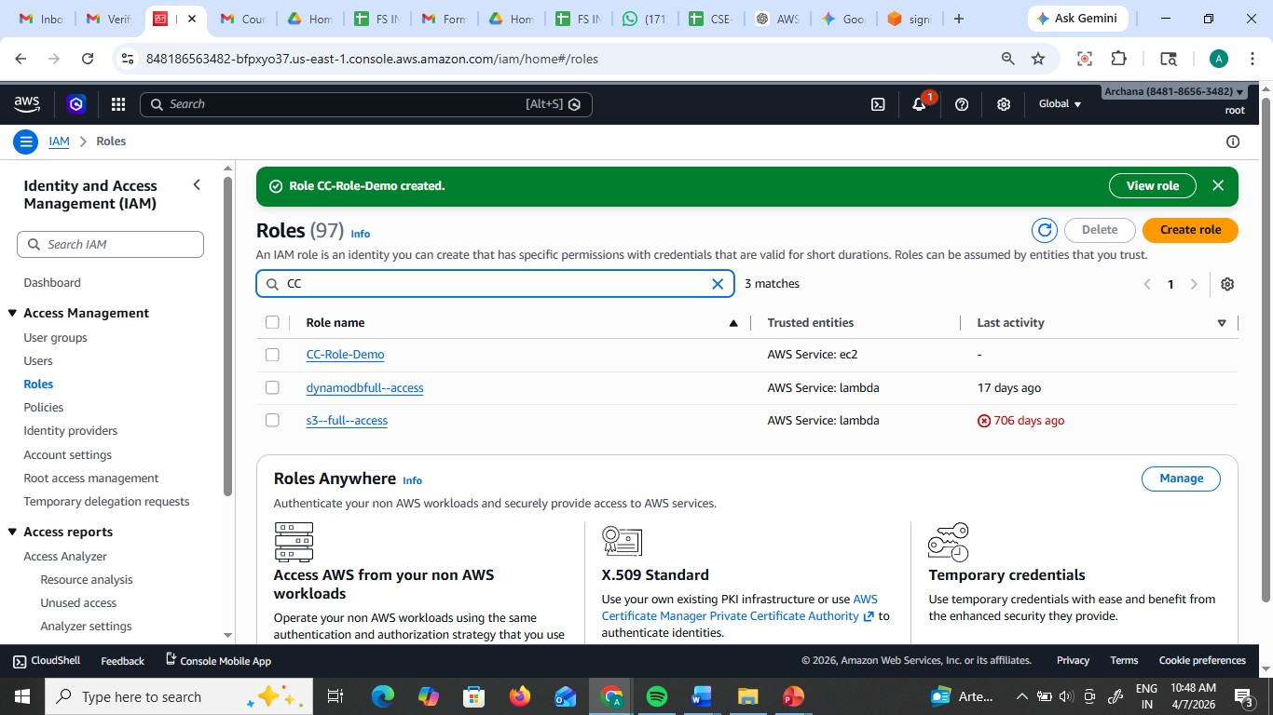

Create the ec2 instance and and connect to it and check for aws ec2 describe-instances

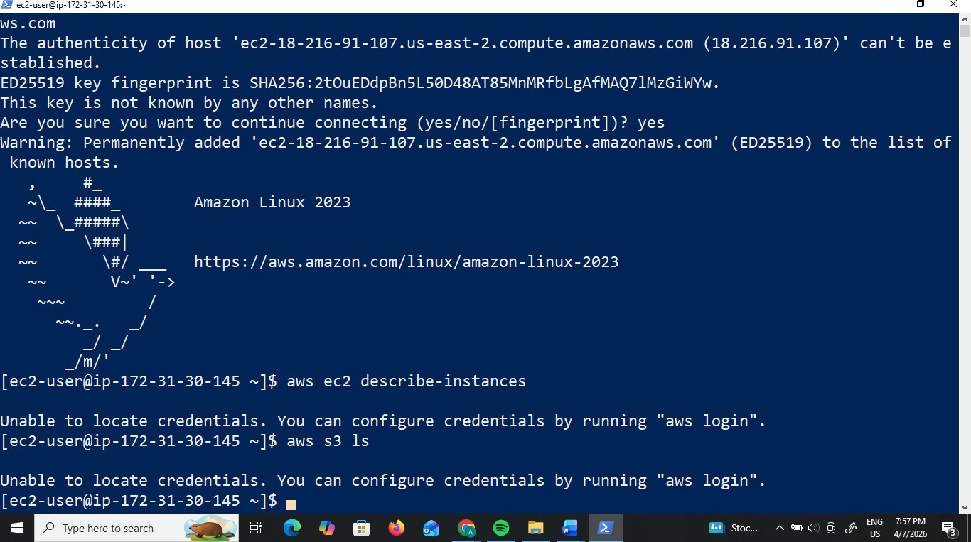

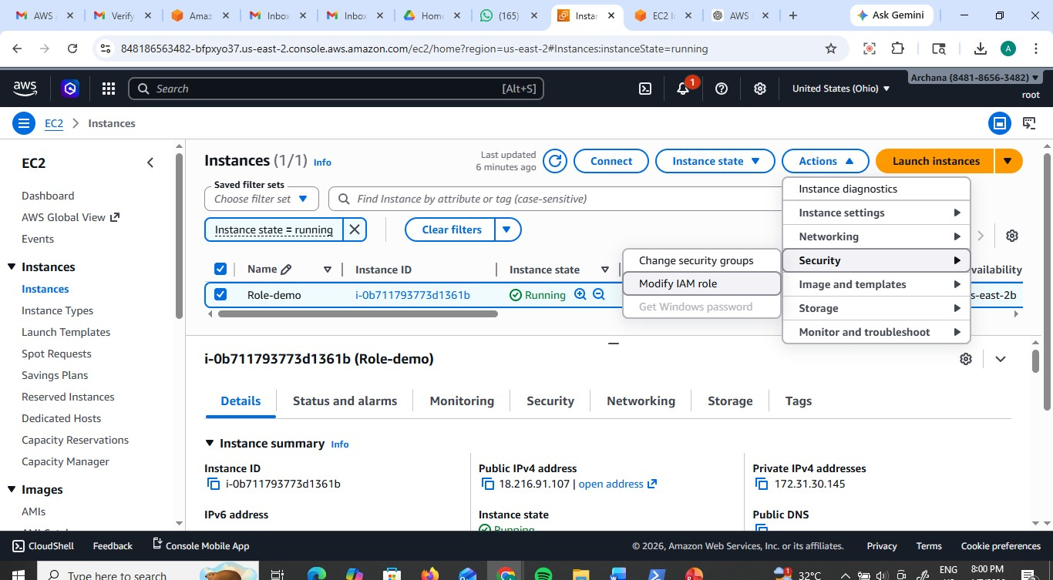
Attach to Instance:
Go to the EC2 Dashboard. Select your running instance.
Click Actions > Security > Modify IAM role.
.

Select the role you just created and click Update IAM role

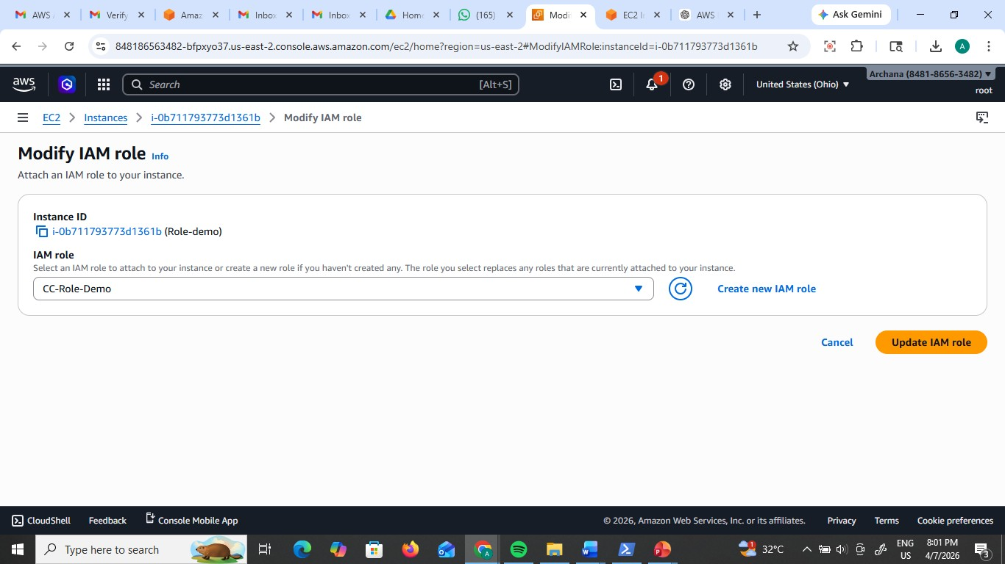

Verify via CLI:
SSH/Connect into your EC2 instance. Type aws s3 ls.
The Result: The command works immediately.

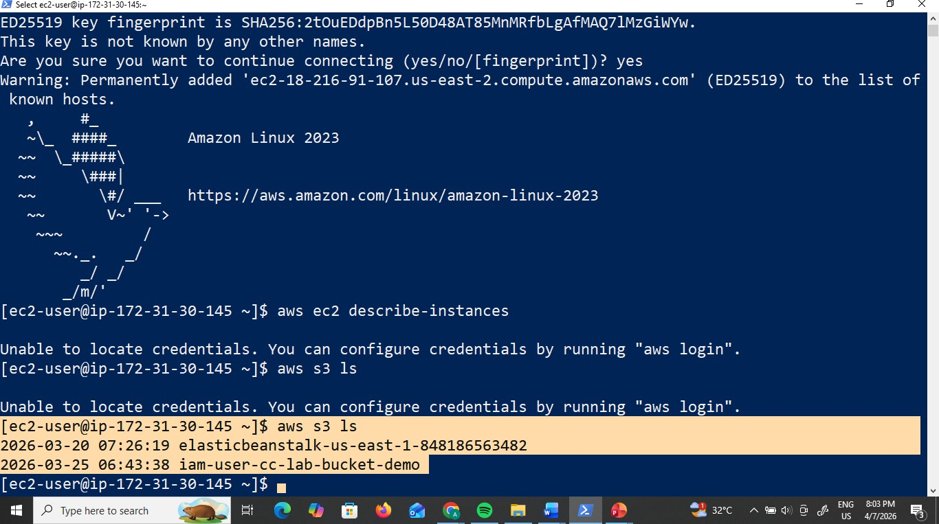

We can here role has only s3 full access only here-- aws ec2 describe-instances –
unauthorized

You did not have to provide an Access Key or Secret Key. AWS automatically provided
Temporary Security Credentials to the instance.
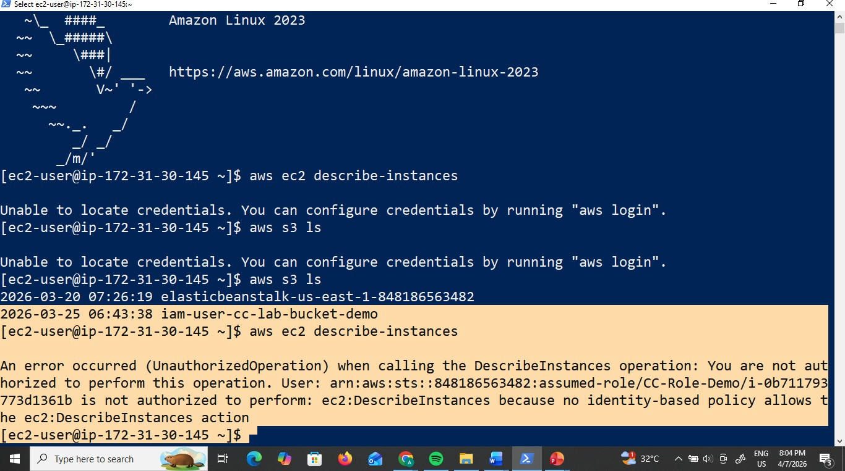

Scenario based questions:

1. Scenario: New Developer Access
You hired a new developer who needs access to EC2 and S3.
Question: How will you provide access?

2. Scenario: Temporary Access Needed
A user needs access only for 2 days. How to do this?

3. Scenario: Access Key Leak
A developer accidentally exposed access keys on GitHub.How to resolve this?

4. Scenario: CLI Access Required
User needs programmatic access. How to do this?

5. Scenario: 50 Employees Same Permissions
50 employees need same S3 access. How to do this?

6. Scenario: Change Permissions for Multiple Users
You need to revoke access from 20 users. How to do this?

7. Scenario: Different Departments
HR, Dev, Admin need different access. How to do this?

8. Scenario: EC2 Access to S3
An EC2 instance needs access to S3 without credentials.How to do this?

9. Scenario: Cross-Account Access
Account A wants to access resources in Account B. How to do this?

10. Scenario: Lambda Access to DynamoDB
Lambda needs to read/write DynamoDB. How to give this?

11. Scenario: Temporary Elevated Access
Admin access needed temporarily. How to do this?

12. Scenario: Restrict S3 Access to Specific Bucket
User should only access one bucket. How to do this?

13. Scenario: Deny Delete Actions
Users should not delete resources. Why this happens?

14. Scenario: Time-Based Access
User should access only during office hours. How to do this?

15. Scenario: IP-Based Access
Allow access only from office network. How to do?

16. Scenario: Secure Best Practice
How do you manage permissions efficiently?

17. Scenario: Root User Usage
When should root user be used?

18. Scenario: Multiple Services Access
User needs EC2 + S3 + DynamoDB. How to do this?

19. Scenario: Audit Permissions
How to track user activity?

20. Scenario: Over-Permission Issue
User has too much permission. How to solve this?

