WEEK-7
1.Basic python program---sample

🔹Step 1: aws – services-compute - lamdba
Step 2: Create a New Lambda Function
- Click Create function
- Choose Author from scratch
- Fill the details:
  - Function name: basic-python-lambda
  - Runtime: Python 3.9 (or latest available)
  - Architecture: x86_64
- Under change the default rule:
  - Select-use the existing rule-Lab Role
- Click Create function
🔹 Step 3: Understand the Default Lambda Code
AWS provides a default Python template:
import json
def lambda_handler(event, context):
return {
'statusCode': 200,
'body': json.dumps('Hello from Lambda!')
}
Explanation:
Component | Meaning
event | Input data passed to Lambda
context | Runtime info (memory, request ID, etc.)
lambda_handler | Entry point function
statusCode | HTTP response code
body | Output response

🔹 Step 4: Write a Simple Python Lambda Program
Example: Add Two Numbers
import json
def lambda_handler(event, context):
a = event.get('num1', 0)
b = event.get('num2', 0)
result = a + b
return {
'statusCode': 200,
'body': json.dumps({
'sum': result
})
}

🔹 Step 5: Deploy the Function
- Click Deploy
- Wait for the Successfully deployed message

🔹 Step 6: Create a Test Event
- Click Test
- Choose Create new event
- Event name: testInput
- Use this JSON input:
{
"num1": 10,
"num2": 20
}
- Click Test
🔹 Step 7: View Output
You will see output like:
{
"statusCode": 200,
"body": "{\"sum\": 30}"
}
✔️ This means your Lambda executed successfully.
🔹 Step 8: Set General Configuration
- Click General configuration → Edit
- Set the following values:
Setting | Value
Memory | 128 MB
Timeout | 3 seconds
Architecture | x86_64
- Click Save
✔ These values are sufficient for simple arithmetic operations.

2.Setting up an AWS Lambda function to trigger whenever an object is uploaded to an S3 bucket and update a DynamoDB table
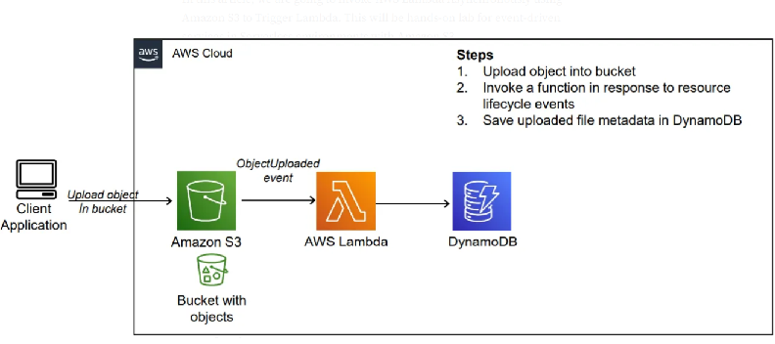
step-by-step procedure for setting up an AWS Lambda function to trigger whenever an object is uploaded to an S3 bucket and update a DynamoDB table:
1. Create an AWS Account: If you haven't already, sign up for an AWS account at https://aws.amazon.com/.
2. Access AWS Management Console: Log in to the AWS Management Console using your AWS account credentials.
3. Open AWS Lambda Console: Navigate to the Lambda service by either searching for "Lambda" in the AWS Management Console or
4. Create a New Lambda Function:
- Click on the "Create function" button.
- Choose "Author from scratch".
- Enter a name for your function (e.g., "S3ToDynamoDB").
- Choose Python as the runtime.
- Under "Permissions", create a new role with basic Lambda permissions or choose an existing role that has permissions to access S3 and DynamoDB.
- Click on the "Create function" button.
5. Upload Code:
- Write the Python code for your Lambda function. This code will be triggered whenever an object is uploaded to the specified S3 bucket.
- Here's an example code snippet:
import boto3
from uuid import uuid4
def lambda_handler(event, context):
s3 = boto3.client("s3")
dynamodb = boto3.resource('dynamodb')
# Check if the 'Records' key is present in the event
if 'Records' in event:
# Iterate over each record in the event
for record in event['Records']:
bucket_name = record['s3']['bucket']['name']
object_key = record['s3']['object']['key']
size = record['s3']['object'].get('size', -1)
event_name = record.get('eventName', 'Unknown') # Use get() method to handle missing keys
event_time = record.get('eventTime', 'Unknown') # Use get() method to handle missing keys
dynamoTable = dynamodb.Table('newtable')
dynamoTable.put_item(
Item={'unique': str(uuid4()), 'Bucket': bucket_name, 'Object': object_key,'Size': size, 'Event': event_name, 'EventTime': event_time})
else:
# Log a message indicating that the 'Records' key is missing from the event
print("No 'Records' key found in the event.")
6. Configure Trigger:
- In the Designer section, click on "Add trigger".
- Select "S3" as the trigger type.
- Configure the trigger to listen to the S3 bucket where you want to trigger the Lambda function.
- Specify the event type (e.g., "All object create events").
- Click on the "Add" button.
7. Configure Environment Variables (Optional):
- If your Lambda function requires any environment variables (e.g., credentials for accessing DynamoDB), you can set them in the "Configuration" tab under "Environment variables".
8. Test Your Function:
- You can test your Lambda function manually by clicking on the "Test" button in the Lambda console.
- You can create a sample test event or use a custom test event to simulate the S3 event that triggers your function.
9. Save and Deploy:
- Click on the "Deploy" button to deploy your function.
10. Monitor Execution:
- You can monitor the execution of your Lambda function in the Monitoring tab of the Lambda console.
- You can also view logs to troubleshoot any issues that may arise during execution.
successfully set up a Lambda function to trigger whenever an object is uploaded to an S3 bucket and update a DynamoDB table accordingly.

