CYBER SECURITY LAB EXPERIMENT

Title: Privacy Audit of Popular Apps (Desktop WhatsApp) and Websites (Facebook) & Data Breach Case Study Analysis

Aim
To analyze privacy, network behavior, and security risks of applications and websites using Kali Linux tools.

Tools Required
- Wireshark
- Burp Suite
- Kali Linux (VirtualBox)
- Desktop WhatsApp (Nativefier)
- Web Browser (Firefox)

Step 1: Install Node.js & npm
sudo apt update
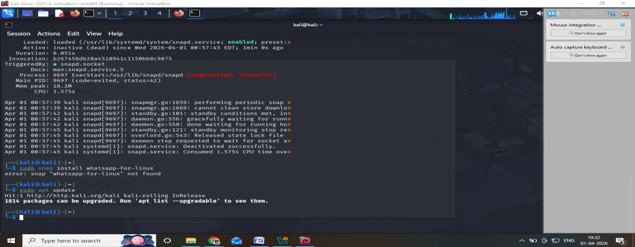
sudo apt install nodejs npm –y
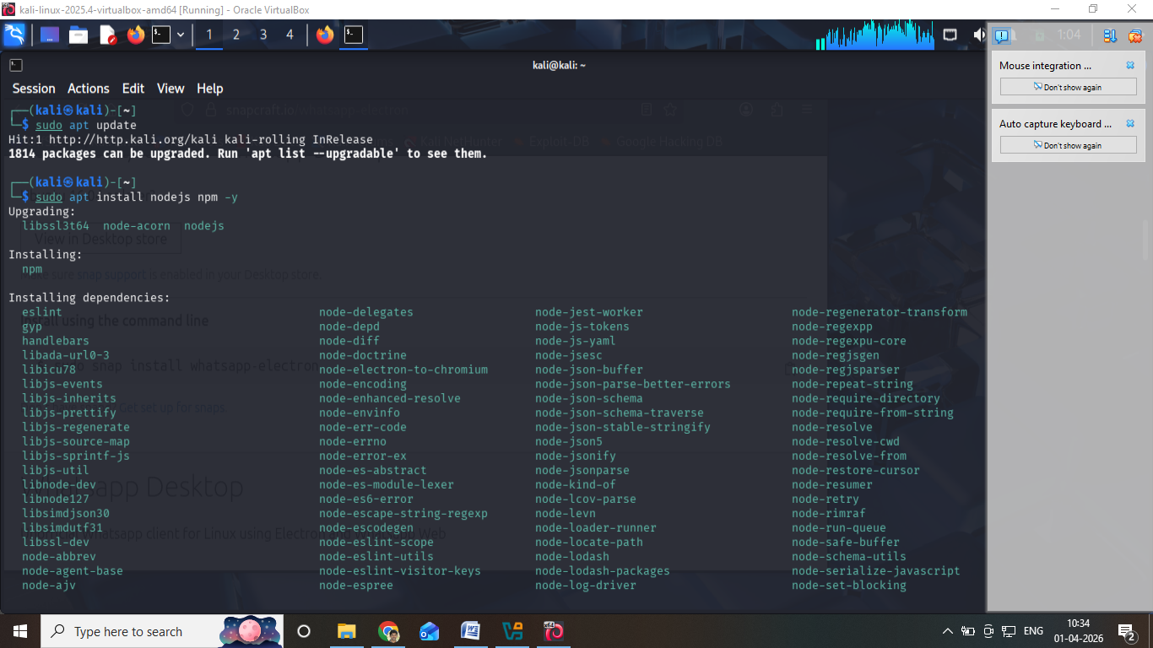
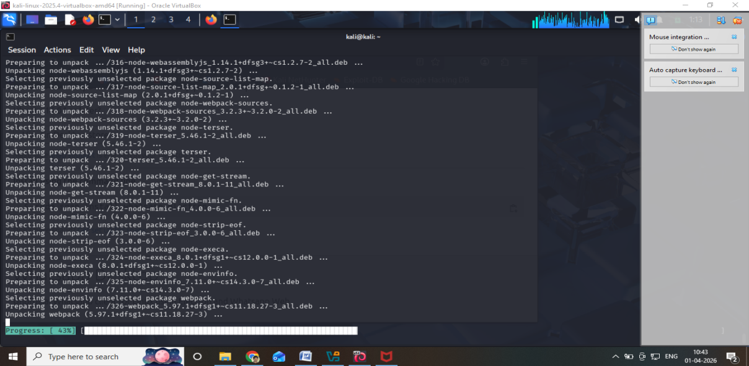

Step 2: Install Nativefier
sudo npm install -g nativefier
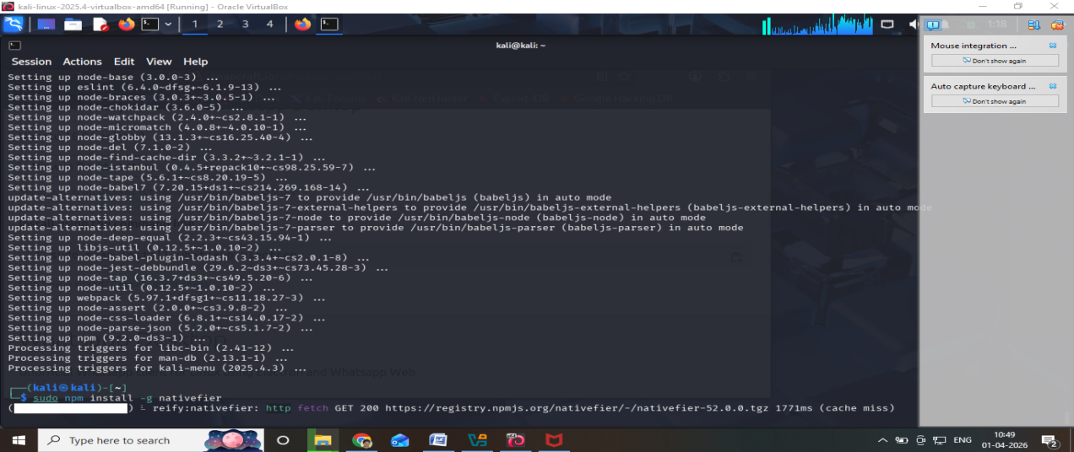
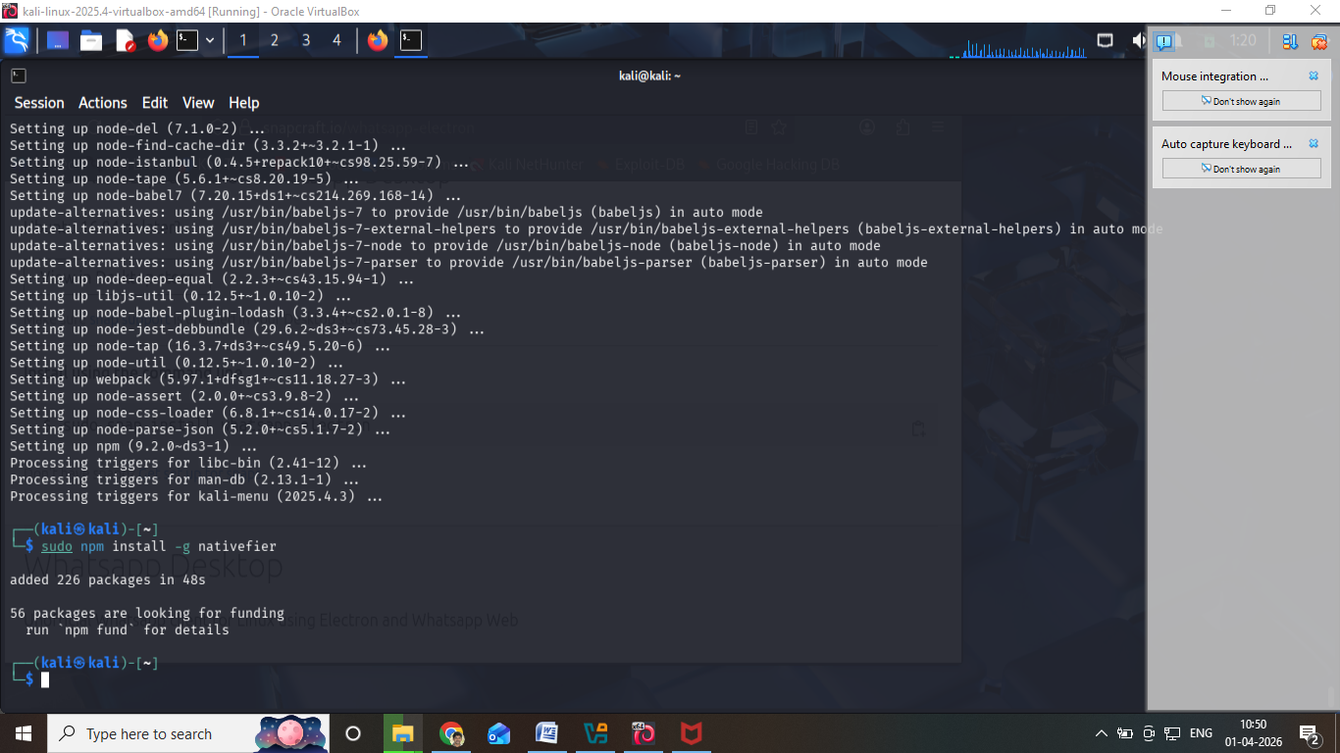

Step 3: Create WhatsApp Desktop App
nativefier https://web.whatsapp.com
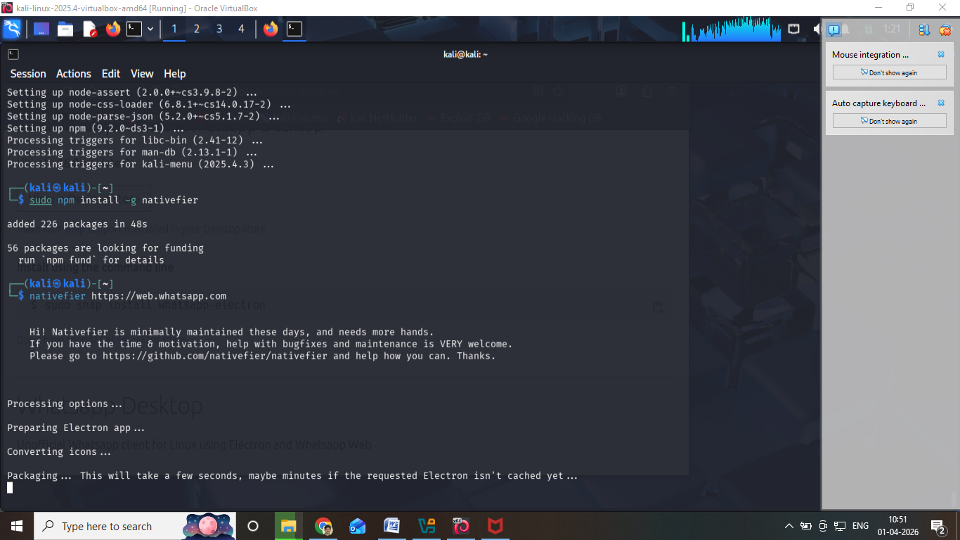
It will create a folder like:
web-whatsapp-linux-x64

Step 4: Run WhatsApp
cd WhatsAppWeb-linux-x64
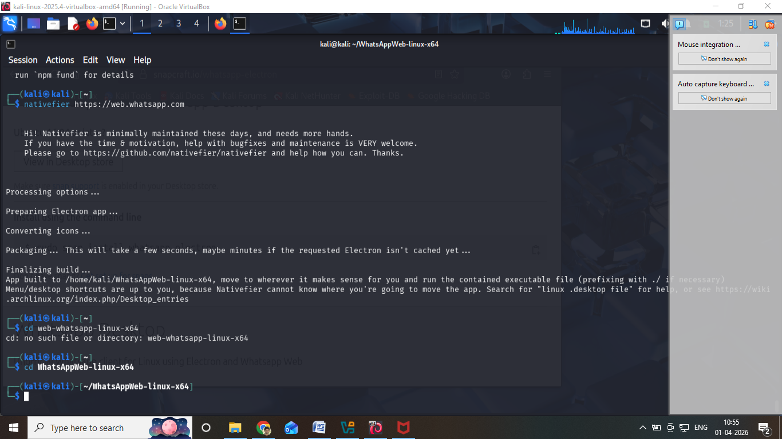
./WhatsAppWeb
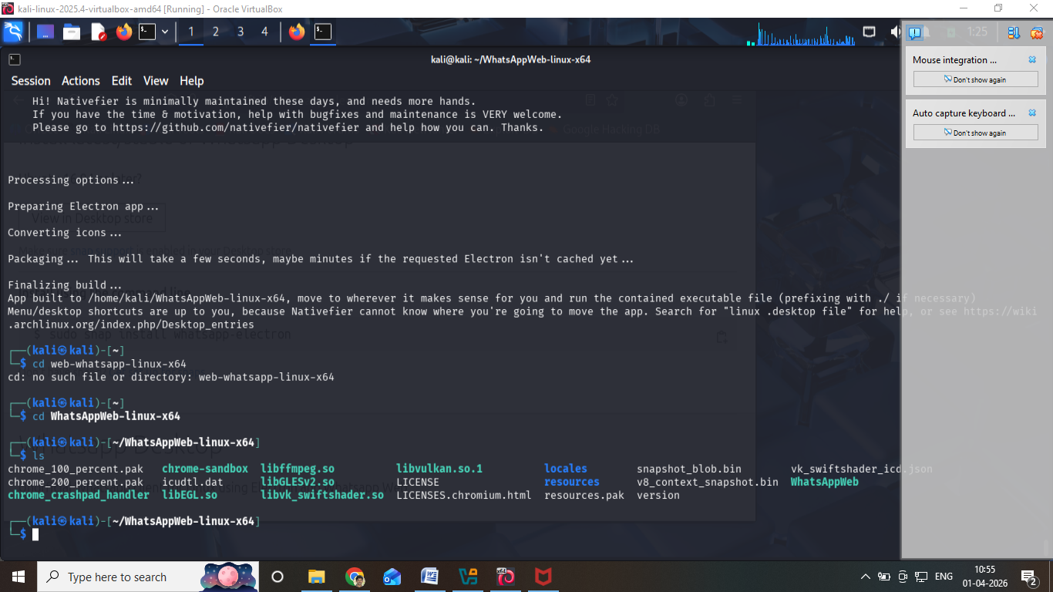

✅ Step 5: Login
- Scan QR code using mobile
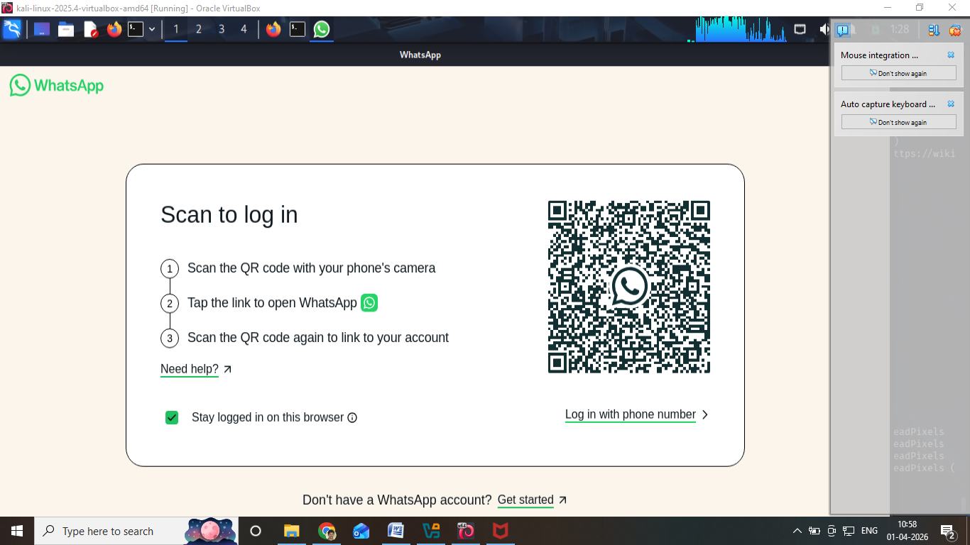
- Done

PART 1: Privacy Audit of Desktop WhatsApp

Step 1: Launch WhatsApp Desktop
cd WhatsAppWeb-linux-x64
./WhatsAppWeb
- QR Code appears
- Login using mobile → Linked Devices
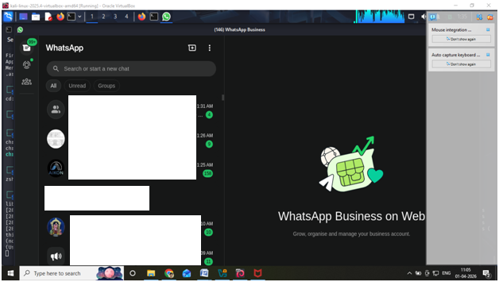

Step 1: Install WhatsApp APK (Optional in Emulator)
- Download APK from trusted source or use your mobile

Step 2: Analyze Trackers using Exodus Privacy
- Open browser in Kali
- Go to: https://reports.exodus-privacy.eu.org
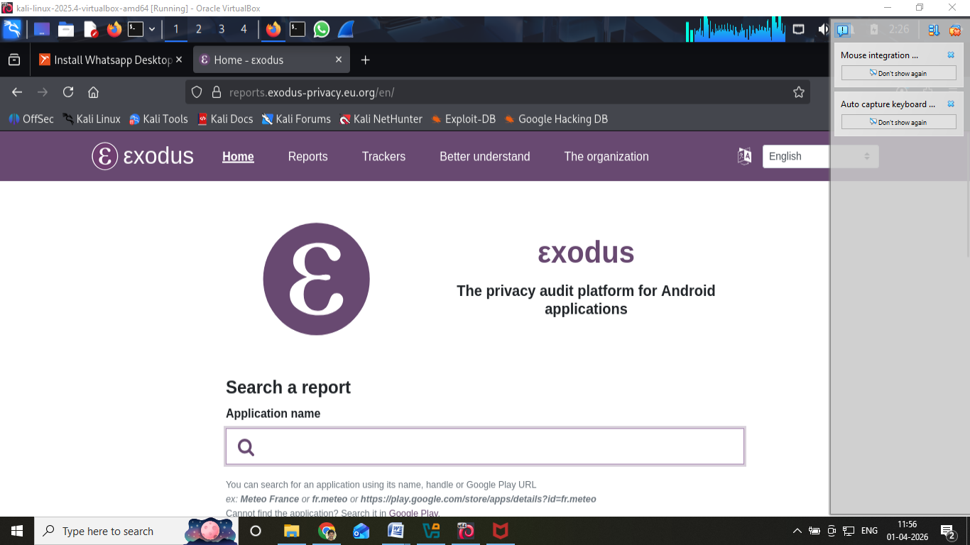
- Search for WhatsApp

Observation:
- Detects trackers like:
  - Google Analytics
  - Crashlytics
  - Facebook Analytics
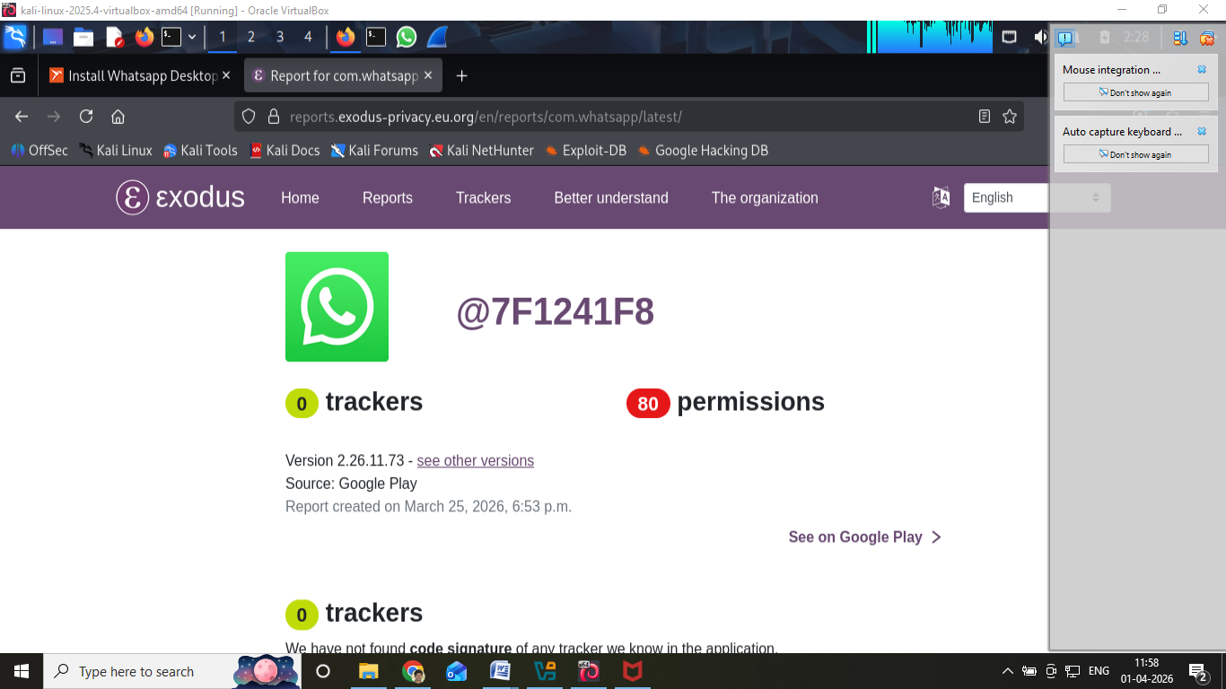
Record in lab:
- Number of trackers
- Permissions used

Step 2: Start Wireshark
Wireshark
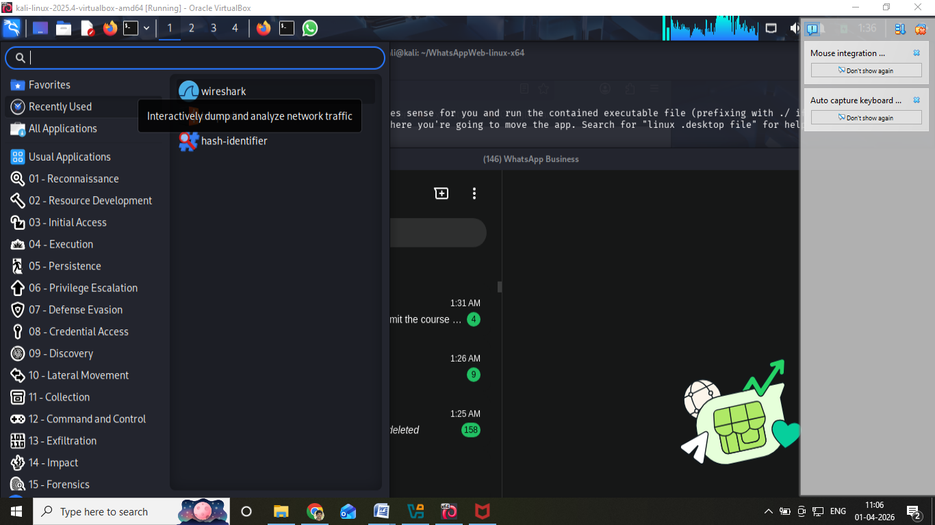
- Select interface (eth0 / wlan0)
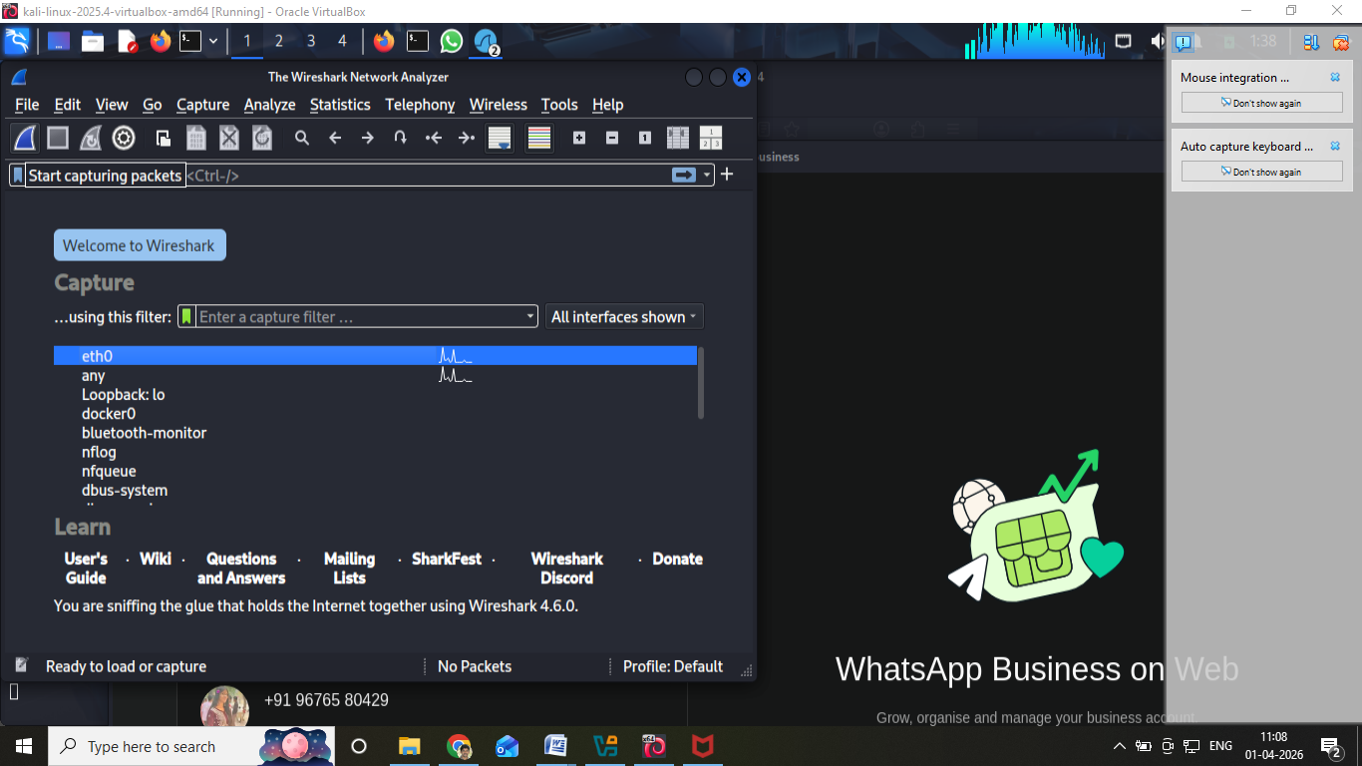

- Click Start Capture
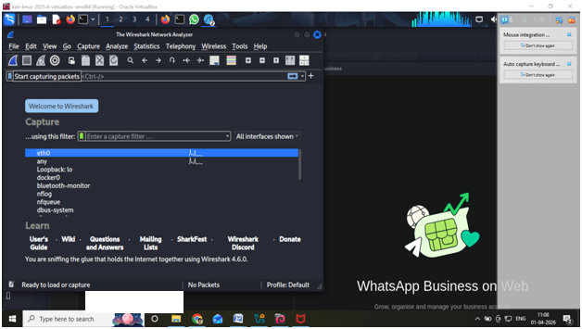

Step 3: Generate Traffic
In WhatsApp Desktop:
- Send messages
- Send images
- Open chats
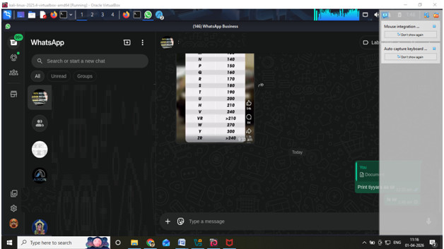

✅ Step 4: Apply Filters
Use filters:
tls
dns
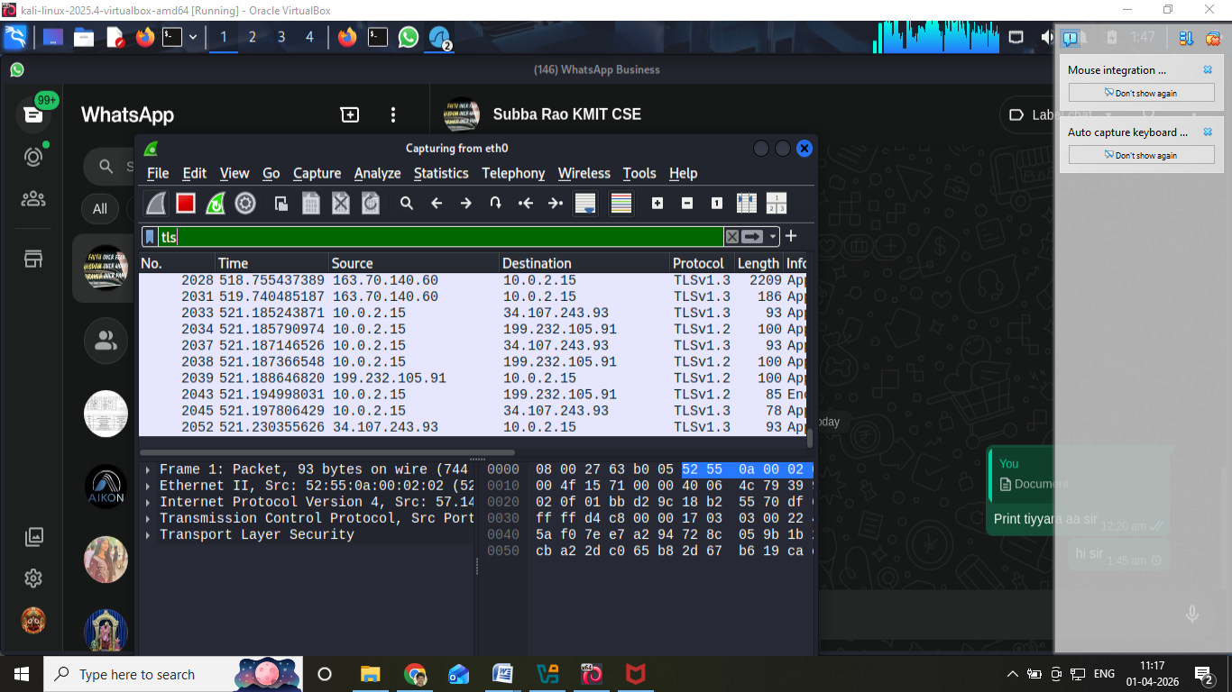

Observations
- Encrypted traffic (TLS packets)
- Domains:
  - whatsapp.net
  - facebook.com
Message content NOT visible
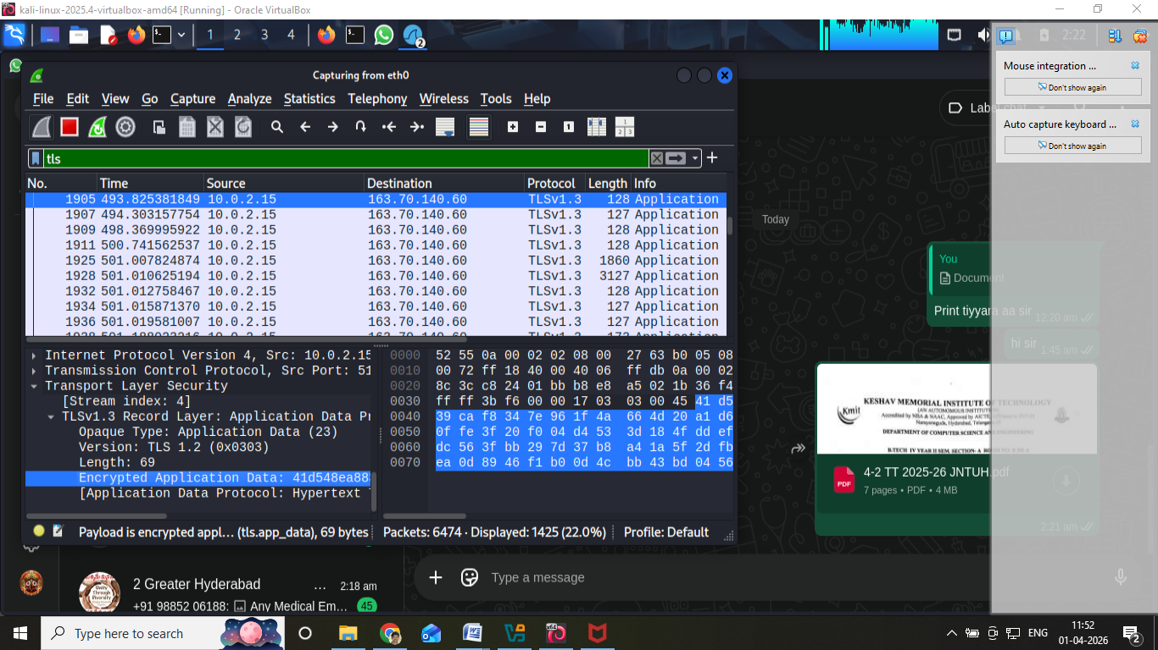

Findings
End-to-End Encryption
Secure communication
Metadata visible:
- IP address
- Time
- Server communication

PART 2: Privacy Audit of Facebook Website

Step 1: Open Facebook
https://www.facebook.com
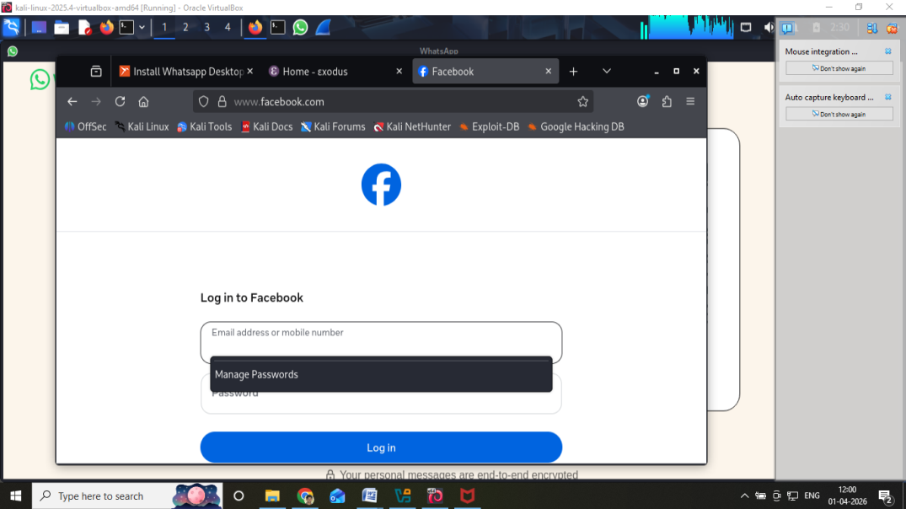
Login using test account

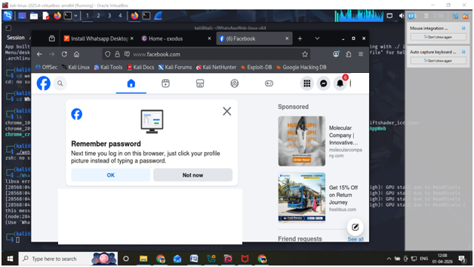

Step 2: Start Burp Suite
Burpsuite
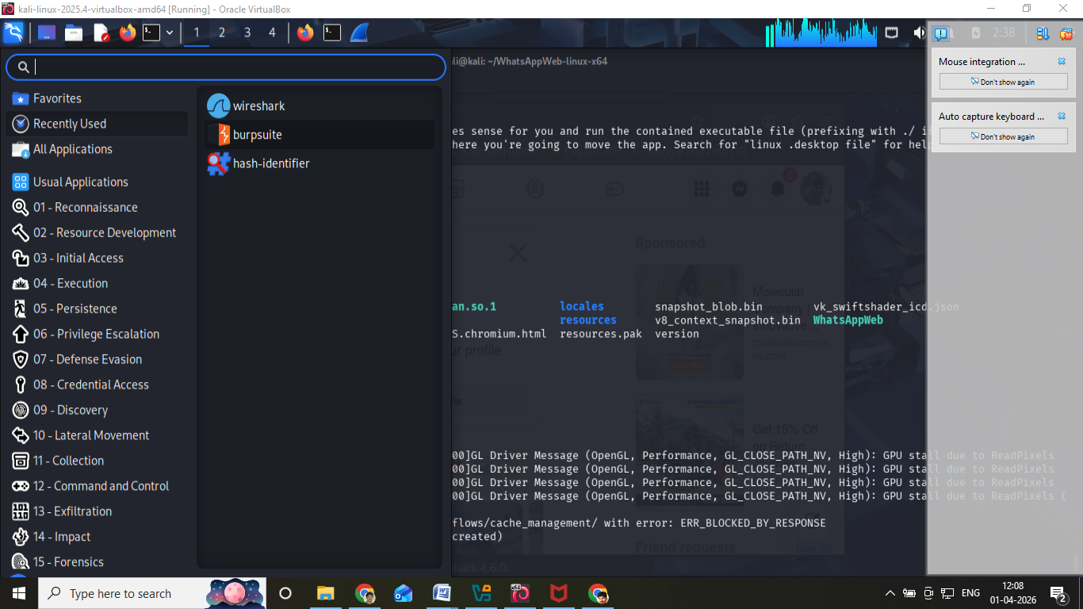
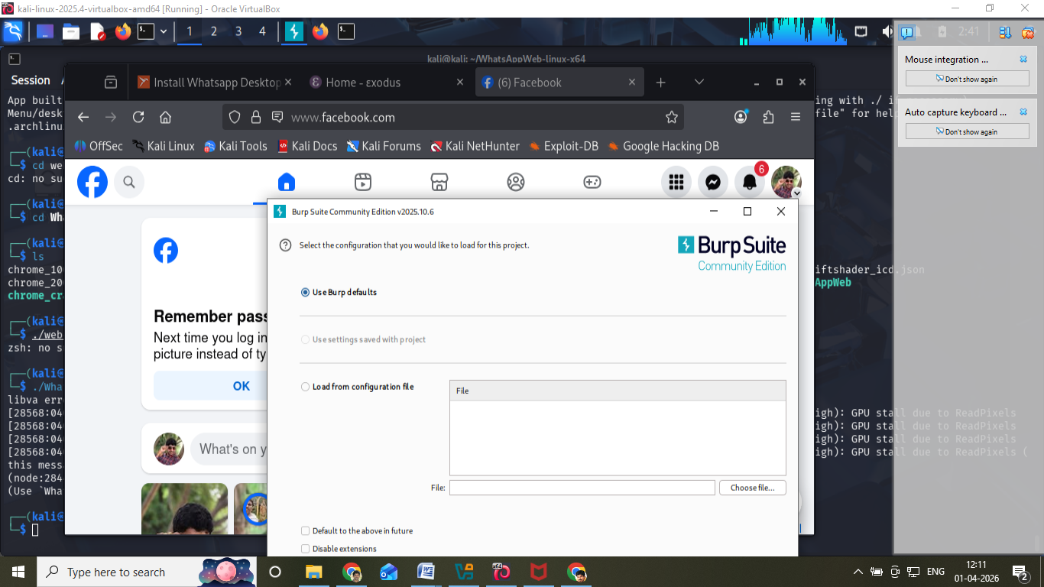

✅ Step 3: Configure Proxy
- IP: 127.0.0.1
- Port: 8080
In browser:
- Settings → Network → Manual Proxy
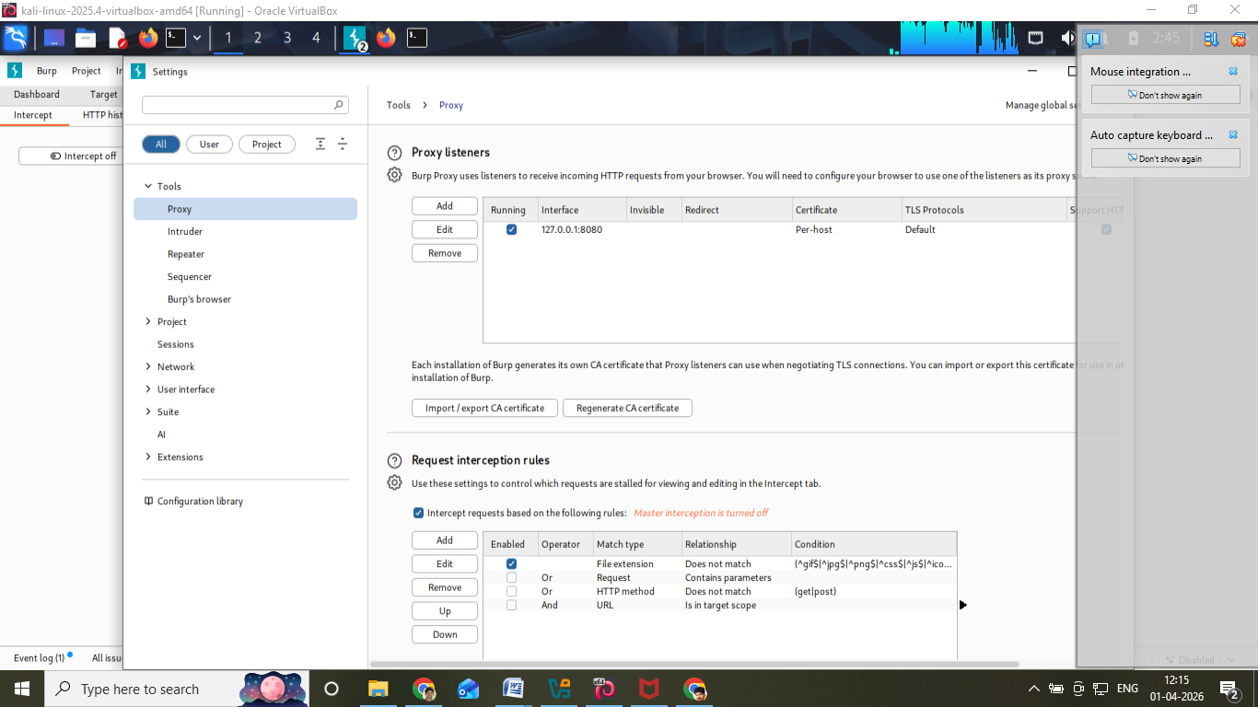

✅ Step 4: Intercept Traffic
- Turn Intercept ON
- Reload Facebook
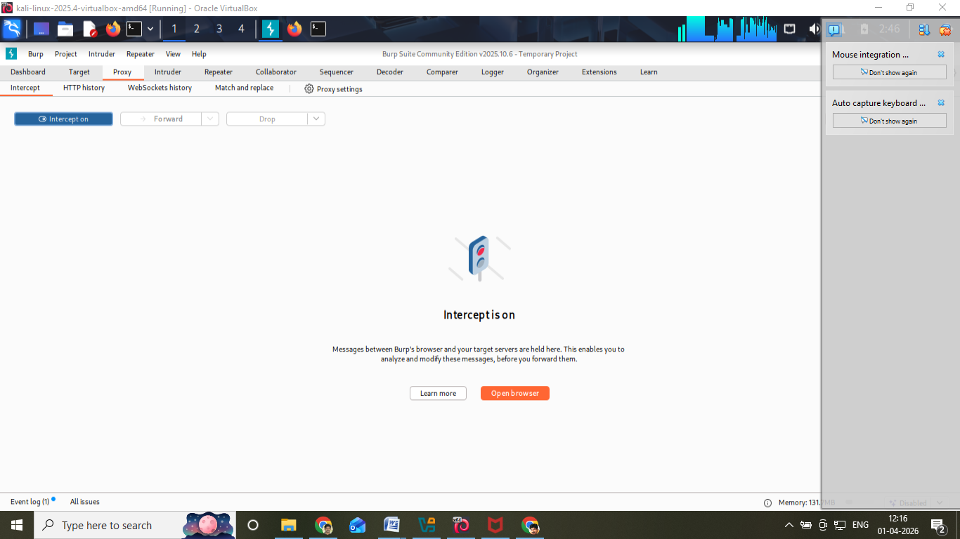

Observe:
- Cookies (datr, fr)
- Session IDs
- Headers

Step 5: Analyze Tracking
Press F12 → Network tab
Look for:
- Ads
- Analytics scripts
- Third-party requests
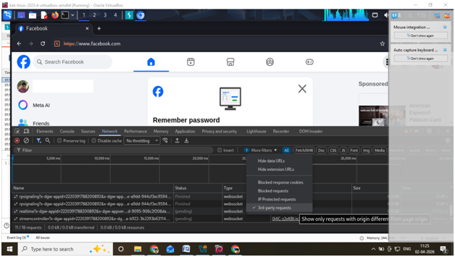

Findings
Heavy tracking
Uses cookies for personalization
Third-party integrations

PART 3: Data Breach Case Study

Case Study 1: Facebook Data Breach
- 533 million users affected
- Data leaked:
  - Phone numbers
  - Emails
Cause:
- API vulnerability

Case Study 2: WhatsApp Pegasus Attack
- Spyware attack via missed call
- Remote device access

Step 3: Check Email Breach
Go to:
👉 https://haveibeenpwned.com
Enter email → check breach status

Analysis Points
- Type of attack
- Vulnerability
- Data exposed
- Prevention

Observations
- WhatsApp uses strong encryption
- Facebook performs extensive tracking
- Data breaches occur due to vulnerabilities

Result
Privacy audit was successfully performed using Kali Linux tools. WhatsApp ensures secure communication through encryption, while Facebook shows extensive tracking behavior. Data breach analysis highlighted risks of poor security practices.

