TITLE : Medical Image Enhancement and Segmentation based on conventional and deep learning Algorithms

Report submitted to GITAM (Deemed to be University) as a partial fulfillment of the requirements for the award of the Degree of Bachelor of Technology in (write your respective branch)



DEPARTMENT OF ELECTRICAL, ELECTRONICS AND COMMUNICATION ENGINEERING

GITAM SCHOOL OF TECHNOLOGY

GITAM (DEEMED TO BE UNIVERSITY)

BENGALURU -561203

NOV 2025

**Name: Smd Younus (bu22eece0100188)**

**M.Bhanu prakash(bu22eece0100205)**

**M.Praveen(bu22eece0100506)**

**DECLARATION**

I/We declare that the project work contained in this report is original and it has been done by me under the guidance of my project guide.

Name:

Date: Signature of the Student

**Department of Electrical, Electronics and Communication Engineering GITAM School of Technology, Bengaluru-561203**



**CERTIFICATE**

This is to certify that (Student Name) bearing (Regd. No.:) has satisfactorily completed Mini Project Entitled in partial fulfillment of the requirements as prescribed by University for VIIth semester, Bachelor of Technology in “Electrical, Electronics and Communication Engineering” and submitted this report during the academic year 2025-2026.

[Signature of the Guide] [Signature of HOD]

**Table of contents**

**Chapter 1: Introduction 1**

* 1. Overview of the problem statement 1
  2. Objectives and goals 1

**Chapter 2 : Literature Review 2**

**Chapter 3 : Strategic Analysis and Problem Definition 3**

* 1. SWOT Analysis 3
  2. Project Plan - GANTT Chart 3
  3. Refinement of problem statement 3

**Chapter 4 : Methodology 4**

* 1. Description of the approach 4
  2. Tools and techniques utilized 4
  3. Design considerations 4

**Chapter 5 : Implementation5**

* 1. Description of how the project was executed 5
  2. Challenges faced and solutions implemented 5

**Chapter 6: Results 6**

* 1. outcome 6
  2. Interpretation of results 6
  3. Comparison with existing technologies 6

**Chapter 7: Conclusion 7**

**Chapter 8 : Future Work 8**

**References 9**

**Chapter 1: Introduction**

**1.1 Overview of the Problem Statement**

Medical images often suffer from **low contrast, noise, and artifacts**, which reduce clarity and make diagnosis difficult. Accurate **segmentation of anatomical structures and tumors** is critical but challenging with conventional methods, as they lack robustness in complex or noisy data. Deep learning techniques such as **U-Net** offer improved accuracy and reliability, motivating the need for a framework that combines **image enhancement** with **deep learning–based segmentation**.

**1.2 Objectives and Goals**

The objective of this project is to develop a framework for **enhancing medical images** and achieving **accurate segmentation**.

**Goals:**

* Enhance images using techniques like **CLAHE, filtering, and denoising**.
* Develop and train **deep learning models (U-Net)** for segmentation.
* Compare **conventional vs. deep learning approaches**.
* Evaluate performance using **Dice, IoU, Precision, and Recall**.
* Visualize segmentation results and compile a **final report**.

**Chapter 2 : Literature Review**

Medical image analysis has been an active research area, focusing on improving image quality and achieving accurate segmentation of anatomical and pathological regions. This section reviews conventional image enhancement techniques, classical segmentation approaches, and recent deep learning–based methods.

**2.1 Conventional Image Enhancement**

Traditional methods such as Histogram Equalization, Contrast Stretching, CLAHE (Contrast Limited Adaptive Histogram Equalization), Gaussian filtering, and median filtering are widely used to improve visibility and reduce noise. While effective for basic preprocessing, these methods often fail in preserving fine details in complex medical images.

**2.2 Classical Segmentation Approaches**

Techniques like Otsu Thresholding, Region Growing, and Watershed Segmentation have been applied to medical imaging. These approaches rely on pixel intensity and edge information but are highly sensitive to noise and intensity inhomogeneity, leading to limited accuracy in tumor detection.

**2.3 Deep Learning for Medical Image Segmentation**

The emergence of Convolutional Neural Networks (CNNs) has revolutionized image analysis. Models such as U-Net, SegNet, and Fully Convolutional Networks (FCNs) provide end-to-end learning, enabling precise segmentation even in noisy or low-contrast images. U-Net, in particular, has become the benchmark for medical image segmentation due to its encoder–decoder structure and skip connections that preserve spatial details.

**2.4 Comparative Studies**

Recent studies show that deep learning methods significantly outperform traditional approaches in terms of Dice coefficient, IoU, and robustness. Hybrid approaches, where image enhancement is combined with deep learning, have also been explored to further boost performance, especially in challenging datasets like BRATS for brain tumor segmentation.

**Chapter 3: Strategic Analysis and Problem Definition**

**3.1 SWOT Analysis**

| **Strengths** | **Weaknesses** |
| --- | --- |
| - Use of both conventional enhancement and deep learning methods.  - U-Net ensures high segmentation accuracy.  - Availability of benchmark datasets (e.g., BRATS). | - Deep learning models require high computational resources (GPU/TPU).  - Dependence on large, labeled datasets.  - Training time is relatively long. |

| **Opportunities** | **Threats** |
| --- | --- |
| - Can be extended to multiple medical imaging modalities (CT, MRI, X-ray).  - Potential for clinical decision support systems.  - Research contribution towards AI in healthcare. | - Risk of overfitting due to limited labeled data.  - Ethical and privacy concerns with medical datasets.  - Rapid advancements may lead to obsolescence of methods. |

**3.2 Project Plan – Gantt Chart**

| **Phase** | **Tasks** | **Duration** |
| --- | --- | --- |
| **Phase 1: Data Handling** | Collect and load BRATS dataset, preprocess images and masks. | Week 1–4 |
| **Phase 2: Image Enhancement** | Apply histogram equalization, CLAHE, noise filtering, artifact removal. | Week 5–8 |
| **Phase 3: Segmentation** | Implement Otsu, Watershed, and U-Net models for tumor segmentation. | Week 9–11 |
| **Phase 4: Evaluation** | Compute Dice, IoU, Precision, Recall, compare methods. | Week 12–13 |
| **Phase 5: Visualization** | Overlay masks, generate plots, compare results. | Week 14 |
| **Phase 6: Documentation** | Compile results, prepare final report and presentation. | Week 15 |

**3.3 Problem Statement**

Medical images often suffer from low contrast, noise, and artifacts, which limit the visibility of critical structures. Conventional segmentation techniques such as Otsu and Watershed provide baseline results but are not reliable for complex cases. The key challenge is to achieve accurate and robust segmentation of pathological regions (e.g., brain tumours) in MRI scans, especially when images are noisy or of low quality.

This project addresses the problem by developing a comprehensive framework that:

1. Enhances medical images using conventional preprocessing methods.
2. Segments tumours using both classical and deep learning approaches (U-Net).
3. Compares the performance of these methods using standard metrics (Dice, IoU, Precision, Recall).
4. Provides visual and quantitative validation for future medical image analysis research.

**Chapter 4: Methodology**

**4.1 Description of the Approach**

The proposed framework follows a hybrid approach combining conventional image enhancement techniques with deep learning–based segmentation to improve medical image quality and ensure accurate detection of pathological regions. The methodology consists of the following key steps:

1. **Data Loading & Preprocessing**
   * Load the BRATS dataset (.h5 format).
   * Normalize intensity values, resize images, and prepare ground-truth masks.
2. **Image Enhancement**
   * Apply Histogram Equalization, CLAHE, filtering, and denoising to improve visibility and reduce artifacts.
3. **Segmentation**
   * Implement classical methods such as Otsu thresholding and Watershed segmentation.
   * Develop and train deep learning models (U-Net) for tumor segmentation.
4. **Evaluation**
   * Assess segmentation performance using Dice coefficient, IoU, Precision, and Recall.
   * Compare conventional and deep learning approaches.
5. **Visualization and Reporting**
   * Overlay segmentation masks on original images.
   * Generate plots and compile results into a comprehensive report.

**4.2 Tools and Techniques Utilized**

* **Programming Languages**: Python
* **Libraries & Frameworks**:
  + *Image Processing*: OpenCV, scikit-image
  + *Numerical Computation*: NumPy, SciPy
  + *Deep Learning*: TensorFlow / Keras, PyTorch (for U-Net implementation)
  + *Visualization*: Matplotlib, Seaborn
* **Dataset**: BRATS dataset (Brain Tumor Segmentation Challenge)
* **Evaluation Metrics**: Dice Coefficient, Intersection over Union (IoU), Precision, Recall
* **Hardware/Software Requirements**:
  + GPU-enabled system for deep learning training
  + Python 3.x environment with required dependencies

**4.3 Design Considerations**

1. **Data Quality and Preprocessing**
   * Medical images often contain noise and low contrast. Preprocessing is critical to ensure reliable segmentation.
2. **Model Architecture**
   * U-Net was chosen due to its proven effectiveness in medical image segmentation, particularly for tasks requiring pixel-level precision.

**Chapter 5: Implementation**

**5.1 Description of How the Project Was Executed**

The project was executed in a step-by-step pipeline, combining both conventional image enhancement and deep learning–based segmentation methods. The execution involved the following stages:

1. **Dataset Loading and Preprocessing**
   * The BRATS dataset was loaded in .h5 format.
   * Images were normalized to ensure uniform intensity distribution.
   * Resizing operations were performed for consistency across samples.
   * Ground-truth masks were extracted for supervised training and evaluation.
2. **Image Enhancement**
   * Conventional techniques such as Histogram Equalization, CLAHE, Gaussian Filtering, and Median Filtering were applied.
   * These methods improved contrast and reduced noise, making tumor boundaries more visible.
   1. **Challenges Faced and Solutions Implemented**

**Chapter 6: Results**

**6.1 Outcomes**

The project successfully developed and tested a framework for medical image enhancement and tumor segmentation. Key outcomes include: original image and Enhanced image

* **Enhanced Medical Images**
  + CLAHE and filtering improved contrast and reduced noise, making tumor boundaries clearer & Brighter.

**6.2 Interpretation of Results:** This are output results of the enhanced images we can see both original and Enhanced image of dataset.

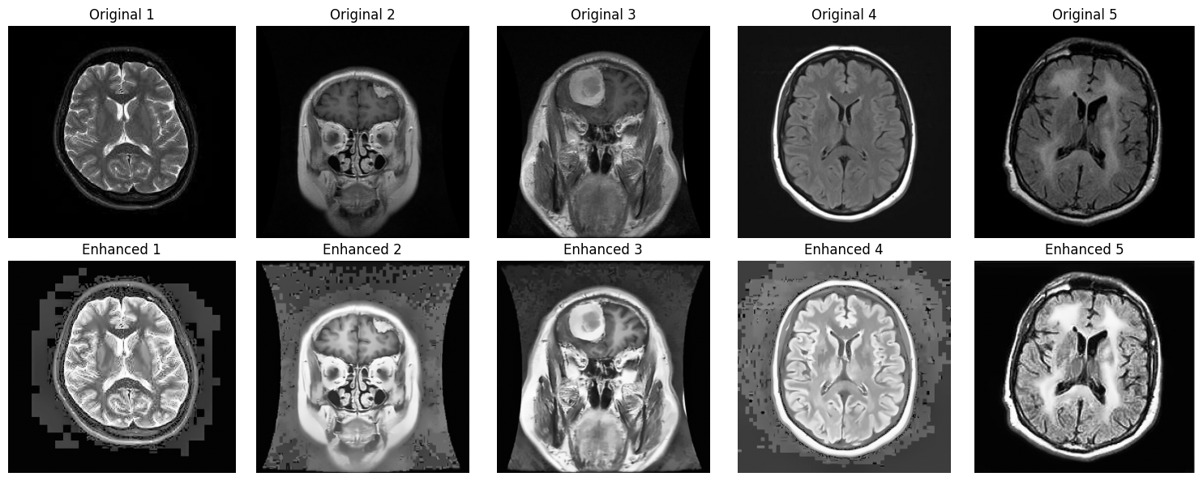

**6.3 Comparison with Existing Literature or Technologies**

**Chapter 7: Conclusion**

The project successfully developed a framework for medical image enhancement

**Suggestions for Further Research or Development**

**Potential Improvements or Extensions**

**Chapter 8: Future Work**

**8.1 Suggestions for Further Research or Development**

**8.2 Potential Improvements or Extensions**

**References IEEE Papers:**

**1)A Review Paper about Deep Learning for Medical Image Processing**

Summary: Reviews the application of current state-of-the-art deep learning approaches in medical image processing, highlighting their effectiveness and challenges.

**2)Medical Image Segmentation: A Comprehensive Review of Deep Learning Methods**

Summary: Categorizes and summarizes current representative methods and research status in the field of medical image segmentation, focusing on deep learning techniques.

**3)Advances in Medical Image Segmentation**

Summary: Explores the transformative impact of deep learning on medical image segmentation, discussing architectures like CNNs, U-Net, and GANs.

**4)A Survey on Deep Learning in Medical Image Analysis**

Summary: Provides an extensive review of deep learning techniques applied in medical image analysis, including segmentation, classification, and detection tasks**.**

Bengaluru City Office No 5/1, First Floor, Prestige Terraces, Union Street, Infantry Road, Bengaluru - 560003 Karnataka, India

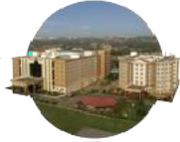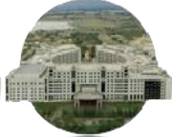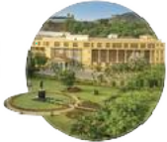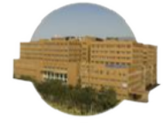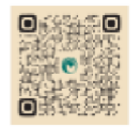

**GIMSR**

GITAM Medical College Rd, Gandhi Nagar, Rushikonda, Visakhapatnam - 530045 Andhra Pradesh, India