Movie Rental Duration prediction
u-seee
2025-08-19
rental <- read_csv(here("data", "rental_info.csv"))
# View structure
glimpse(rental)
## Rows: 15,861
## Columns: 12
## $ rental_date <dttm> 2005-05-25 02:54:33, 2005-06-15 23:19:16, 2005-07-10…
## $ return_date <dttm> 2005-05-28 23:40:33, 2005-06-18 19:24:16, 2005-07-17…
## $ amount <dbl> 2.99, 2.99, 2.99, 2.99, 2.99, 2.99, 2.99, 2.99, 2.99,…
## $ release_year <dbl> 2005, 2005, 2005, 2005, 2005, 2005, 2005, 2005, 2005,…
## $ rental_rate <dbl> 2.99, 2.99, 2.99, 2.99, 2.99, 2.99, 2.99, 2.99, 2.99,…
## $ length <dbl> 126, 126, 126, 126, 126, 126, 126, 126, 126, 126, 126…
## $ replacement_cost <dbl> 16.99, 16.99, 16.99, 16.99, 16.99, 16.99, 16.99, 16.9…
## $ special_features <chr> "{Trailers,\"Behind the Scenes\"}", "{Trailers,\"Behi…
## $ `NC-17` <dbl> 0, 0, 0, 0, 0, 0, 0, 0, 0, 0, 0, 0, 0, 0, 0, 0, 0, 0,…
## $ PG <dbl> 0, 0, 0, 0, 0, 0, 0, 0, 0, 0, 0, 0, 0, 0, 0, 0, 0, 0,…
## $ `PG-13` <dbl> 0, 0, 0, 0, 0, 0, 0, 0, 0, 0, 0, 0, 0, 0, 0, 0, 0, 0,…
## $ R <dbl> 1, 1, 1, 1, 1, 1, 1, 1, 1, 1, 1, 1, 1, 1, 1, 1, 1, 0,…
# Check unique values of special_features variable
unique(rental$special_features)
## [1] "{Trailers,\"Behind the Scenes\"}"
## [2] "{Trailers}"
## [3] "{Commentaries,\"Behind the Scenes\"}"
## [4] "{Trailers,Commentaries}"
## [5] "{\"Deleted Scenes\",\"Behind the Scenes\"}"
## [6] "{Commentaries,\"Deleted Scenes\",\"Behind the Scenes\"}"
## [7] "{Trailers,Commentaries,\"Deleted Scenes\"}"
## [8] "{\"Behind the Scenes\"}"
## [9] "{Trailers,\"Deleted Scenes\",\"Behind the Scenes\"}"
## [10] "{Commentaries,\"Deleted Scenes\"}"
## [11] "{Commentaries}"
## [12] "{Trailers,Commentaries,\"Behind the Scenes\"}"
## [13] "{Trailers,\"Deleted Scenes\"}"
## [14] "{\"Deleted Scenes\"}"
## [15] "{Trailers,Commentaries,\"Deleted Scenes\",\"Behind the Scenes\"}"
# Check missing values
sapply(rental, function(x) sum(is.na(x)))
## rental_date return_date amount release_year
## 0 0 0 0
## rental_rate length replacement_cost special_features
## 0 0 0 0
## NC-17 PG PG-13 R
## 0 0 0 0

Get response variable from your data, rent_length ie number of rental days
rental$rent_hours <- difftime(ymd_hms(rental$return_date), ymd_hms(rental$rental_date), units="hours")
head(rental$rent_hours)
## Time differences in hours
## [1] 92.76667 68.08333 173.73333 50.40000 97.08333 76.86667
# Get response variable from rent_hours
rental$rent_length <- round(as.numeric(rental$rent_hours / 24), 2)
head(rental$rent_length)
## [1] 3.87 2.84 7.24 2.10 4.05 3.20

Add new variables
# Rent day of the week
rental$rent_dow <- as.factor(weekdays(rental$rental_date))
# Rent month of the year
rental$rent_month <- as.factor( format(rental$rental_date, "%m"))
# Target variable rent_length
rental$rent_length <- round(as.numeric(rental$rent_hours / 24), 2)
# Convert rent_hours to numeric
rental$rent_hours <- as.numeric(rental$rent_hours)
# Average rental duration (in hours) of all rentals prior to that date
rental <- rental %>%
arrange(rental_date) %>%
mutate(
avg_rent_before = lag(cummean(rent_hours))
)
# View the structure of our new rental dataframe
str(rental)
## tibble [15,861 × 17] (S3: tbl_df/tbl/data.frame)
## $ rental_date : POSIXct[1:15861], format: "2005-05-25 02:53:30" "2005-05-25 02:54:33" ...
## $ return_date : POSIXct[1:15861], format: "2005-05-27 02:04:30" "2005-05-28 23:40:33" ...
## $ amount : num [1:15861] 2.99 2.99 3.99 4.99 6.99 0.99 1.99 4.99 4.99 5.99 ...
## $ release_year : num [1:15861] 2008 2005 2009 2006 2004 ...
## $ rental_rate : num [1:15861] 2.99 2.99 2.99 0.99 2.99 0.99 0.99 4.99 4.99 4.99 ...
## $ length : num [1:15861] 148 126 156 181 84 92 123 181 56 62 ...
## $ replacement_cost: num [1:15861] 22 17 15 22 30 ...
## $ special_features: chr [1:15861] "{Trailers}" "{Trailers,\"Behind the Scenes\"}" "{Trailers,\"Behind the Scenes\"}" "{Trailers,\"Behind the Scenes\"}" ...
## $ NC-17 : num [1:15861] 0 0 0 0 1 1 0 0 0 0 ...
## $ PG : num [1:15861] 0 0 0 0 0 0 0 0 0 0 ...
## $ PG-13 : num [1:15861] 0 0 0 0 0 0 1 0 1 0 ...
## $ R : num [1:15861] 0 1 0 1 0 0 0 0 0 0 ...
## $ rent_hours : num [1:15861] 47.2 92.8 191.2 218.7 197.5 ...
## $ rent_length : num [1:15861] 1.97 3.87 7.96 9.11 8.23 2.1 4.89 3 3.02 6.95 ...
## $ rent_dow : Factor w/ 7 levels "Friday","Monday",..: 7 7 7 7 7 7 7 7 7 7 ...
## $ rent_month : Factor w/ 4 levels "05","06","07",..: 1 1 1 1 1 1 1 1 1 1 ...
## $ avg_rent_before : num [1:15861] NA 47.2 70 110.4 137.4 ...
# deleted_scenes variable
rental$deleted_scenes = as.numeric(grepl("Deleted Scenes", rental$special_features))
# behind_the_scenes variable
rental$behind_the_scenes = as.numeric(grepl("Behind the Scenes", rental$special_features))
# Perform train-test split
set.seed(85)
splits <- initial_split(rental, prop = 0.8)
train <- training(splits)
test <- testing(splits)

Correlation
# Check for correlation in the predictor variable
cor_matrix <- train %>%
select_if(is.numeric) %>%
select(-rent_length) %>%
cor()
cor_matrix
## amount release_year rental_rate length
## amount 1.000000000 0.024098530 0.683593082 0.019285170
## release_year 0.024098530 1.000000000 0.039423588 0.032496754
## rental_rate 0.683593082 0.039423588 1.000000000 0.053498984
## length 0.019285170 0.032496754 0.053498984 1.000000000
## replacement_cost -0.026959452 0.069910642 -0.064034091 0.024097673
## NC-17 0.007478670 0.025478536 0.039845314 -0.026673696
## PG -0.006804329 -0.018531260 0.002810584 -0.046561547
## PG-13 0.015291712 0.016444327 0.022924777 0.051732751
## R -0.011420311 -0.041789613 -0.041372780 0.071377401
## rent_hours 0.554362890 0.010204149 -0.008804067 -0.003325379
## avg_rent_before NA NA NA NA
## deleted_scenes -0.016572679 0.009218950 -0.052376066 -0.002057774
## behind_the_scenes -0.018679407 -0.004297525 -0.002209259 0.005558727
## replacement_cost NC-17 PG PG-13
## amount -0.026959452 0.007478670 -0.006804329 0.015291712
## release_year 0.069910642 0.025478536 -0.018531260 0.016444327
## rental_rate -0.064034091 0.039845314 0.002810584 0.022924777
## length 0.024097673 -0.026673696 -0.046561547 0.051732751
## replacement_cost 1.000000000 0.001907292 -0.075573327 0.039369048
## NC-17 0.001907292 1.000000000 -0.253383628 -0.273649184
## PG -0.075573327 -0.253383628 1.000000000 -0.265937453
## PG-13 0.039369048 -0.273649184 -0.265937453 1.000000000
## R 0.019027245 -0.255334435 -0.248138833 -0.267984913
## rent_hours 0.014712984 0.003540814 -0.006319299 0.011768677
## avg_rent_before NA NA NA NA
## deleted_scenes 0.047352516 0.023042032 0.055988236 -0.036651862
## behind_the_scenes 0.018458065 0.023841228 -0.016248550 -0.002424438
## R rent_hours avg_rent_before deleted_scenes
## amount -0.011420311 0.554362890 NA -0.016572679
## release_year -0.041789613 0.010204149 NA 0.009218950
## rental_rate -0.041372780 -0.008804067 NA -0.052376066
## length 0.071377401 -0.003325379 NA -0.002057774
## replacement_cost 0.019027245 0.014712984 NA 0.047352516
## NC-17 -0.255334435 0.003540814 NA 0.023042032
## PG -0.248138833 -0.006319299 NA 0.055988236
## PG-13 -0.267984913 0.011768677 NA -0.036651862
## R 1.000000000 -0.009836569 NA -0.031523968
## rent_hours -0.009836569 1.000000000 NA -0.004820320
## avg_rent_before NA NA 1 NA
## deleted_scenes -0.031523968 -0.004820320 NA 1.000000000
## behind_the_scenes -0.001824096 -0.004999686 NA -0.082163074
## behind_the_scenes
## amount -0.018679407
## release_year -0.004297525
## rental_rate -0.002209259
## length 0.005558727
## replacement_cost 0.018458065
## NC-17 0.023841228
## PG -0.016248550
## PG-13 -0.002424438
## R -0.001824096
## rent_hours -0.004999686
## avg_rent_before NA
## deleted_scenes -0.082163074
## behind_the_scenes 1.000000000

Build recipe
rec <- recipe(rent_length ~ ., data = train) %>%
update_role(rental_date, return_date, special_features, new_role = "ID") %>%
step_rm(has_role("ID")) %>%
step_rm(rent_hours) %>% # to avoid leak since target variable was computed using rent_hours
step_nzv(all_predictors()) %>%
step_impute_mean(avg_rent_before) %>% # replace NAs due to lag() used when creating the variable with the training-set mean
step_dummy(all_nominal_predictors(), one_hot = TRUE) %>%
step_corr(all_numeric(), -all_outcomes(), threshold = 0.9) %>%
step_normalize(all_numeric(), -all_outcomes())
rec
# train with prep() and apply with bake() to know how many predictors remaining
rec_prep <- prep(rec, training = train)
# Bake it to get the processed training tibble
train_baked <- bake(rec_prep, new_data = NULL)
# View its dimensions
dim(train_baked)
## [1] 12688 24
# Compute maximum mtry parameter programmatically
max_mtry <- ncol(train_baked) - 1
max_mtry
## [1] 23
# Predictor Importance
spec <- rand_forest ()%>%
set_mode("regression")%>%
set_engine("ranger", importance = "impurity")
# fit on train
model_1 <- spec %>%
fit(rent_length ~ ., data = train)
# View variable Importance
vip::vip(model_1)
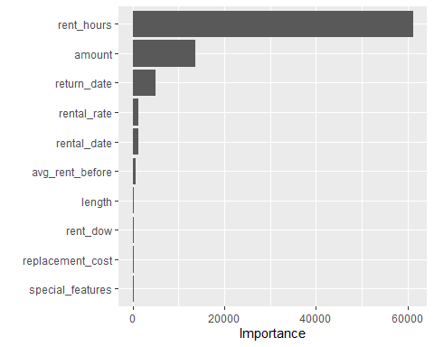
# Model specification
model_spec <- rand_forest(
mtry = tune(),
trees = tune(),
min_n = tune())%>%
set_engine("ranger") %>%
set_mode("regression")
model_spec
## Random Forest Model Specification (regression)
##
## Main Arguments:
## mtry = tune()
## trees = tune()
## min_n = tune()
##
## Computational engine: ranger
# Random grid
rf_grid <- grid_random(
mtry(range = c(1, max_mtry)),
trees(range = c(300, 1000)),
min_n(range = c(1, 50)),
size = 20
)
set.seed(123)
cv_splits <- vfold_cv(train, v = 5)
# Workflow
rf_workflow <- workflow()%>%
add_model(model_spec)%>%
add_recipe(rec)
# Create a stack_control object for stacking models
ctrl <- control_stack_grid()
# Tune
set.seed(87)
rf_tune <- rf_workflow %>%
tune_grid(
resamples = cv_splits,
grid = rf_grid,
metrics = metric_set(rmse),
control = ctrl)
# Plot model performance
autoplot(rf_tune, metric = "rmse")
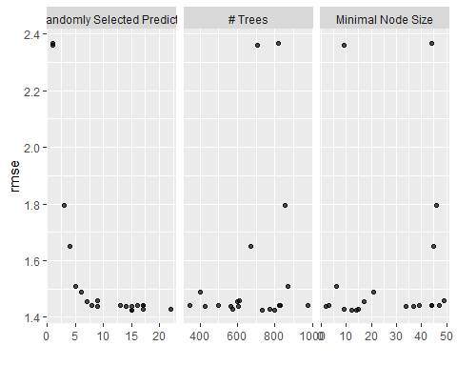
# Select the best
best_rf <- rf_tune %>%
select_best(metric = "rmse")
best_rf
## # A tibble: 1 × 4
## mtry trees min_n .config
## <int> <int> <int> <chr>
## 1 15 797 14 Preprocessor1_Model03
# Finalize Workflow with the best
final_workflow <- rf_workflow %>%
finalize_workflow(best_rf)
# Final model
rf_final_model <- last_fit(final_workflow, split = splits,
metrics = metric_set(rmse, rsq))
# Collect metrics
collect_metrics(rf_final_model)
## # A tibble: 2 × 4
## .metric .estimator .estimate .config
## <chr> <chr> <dbl> <chr>
## 1 rmse standard 1.41 Preprocessor1_Model1
## 2 rsq standard 0.710 Preprocessor1_Model1
# Collect predictions from our final model
predict <- collect_predictions(rf_final_model)
predict
## # A tibble: 3,173 × 5
## .pred id .row rent_length .config
## <dbl> <chr> <int> <dbl> <chr>
## 1 6.20 train/test split 10 6.95 Preprocessor1_Model1
## 2 3.11 train/test split 19 6.2 Preprocessor1_Model1
## 3 3.55 train/test split 32 0.83 Preprocessor1_Model1
## 4 3.69 train/test split 33 1.99 Preprocessor1_Model1
## 5 2.82 train/test split 39 5.93 Preprocessor1_Model1
## 6 3.23 train/test split 43 1.05 Preprocessor1_Model1
## 7 6.59 train/test split 48 7.97 Preprocessor1_Model1
## 8 3.91 train/test split 50 3.2 Preprocessor1_Model1
## 9 6.69 train/test split 59 7.04 Preprocessor1_Model1
## 10 6.75 train/test split 61 7.93 Preprocessor1_Model1
## # ℹ 3,163 more rows
# Calculate MSE
mse_val <- mean((predict$.pred - predict$rent_length)^2)
mse_val
## [1] 1.976036
min(predict$rent_length)
## [1] 0.75
max(predict$rent_length)
## [1] 9.25

Using xgboost
# Define the XGBoost model specification
xgb_spec <- boost_tree(
mode = "regression",
trees = tune(),
mtry = tune(),
min_n = tune(),
learn_rate = tune(),
tree_depth = tune(),
sample_size = tune(),
) %>%
set_engine("xgboost", early_stopping_rounds = 50 )
# Define the grid for hyperparameter tuning
xgb_grid <- grid_random(
trees(range = c(500, 2000)),
mtry(range = c(3, max_mtry)),
min_n(range = c(1, 50)),
learn_rate(range = c(0.001, 0.3)),
tree_depth(range = c(3, 10)),
sample_prop(range = c(0.5, 1)),
size = 30
)
# Define the workflow to use the XGBoost model and recipe
xgb_workflow <- workflow() %>%
add_model(xgb_spec) %>%
add_recipe(rec)
# Tune the XGBoost model with cross-validation
set.seed(75)
xgb_tune <- xgb_workflow %>%
tune_grid(
resamples = cv_splits,
grid = xgb_grid,
metrics = metric_set(rmse),
control = ctrl)
# Plot the RMSE performance
autoplot(xgb_tune, metric = "rmse")
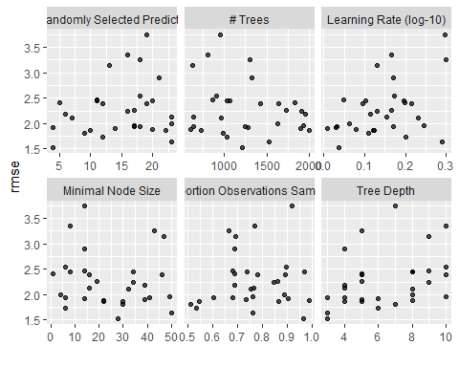
# Get the best model based on RMSE
best_xgb <- xgb_tune %>%
select_best(metric = "rmse")
# Finalize the workflow with the best model hyperparameters
final_xgb_workflow <- xgb_workflow %>%
finalize_workflow(best_xgb)
# Fit the final model using the entire training data
xgb_final_model <- last_fit(final_xgb_workflow, split = splits,
metrics = metric_set(rmse, rsq))
# Collect model metrics
collect_metrics(xgb_final_model)
## # A tibble: 2 × 4
## .metric .estimator .estimate .config
## <chr> <chr> <dbl> <chr>
## 1 rmse standard 1.48 Preprocessor1_Model1
## 2 rsq standard 0.683 Preprocessor1_Model1
# Collect predictions
predictions <- collect_predictions(xgb_final_model)
predictions
## # A tibble: 3,173 × 5
## .pred id .row rent_length .config
## <dbl> <chr> <int> <dbl> <chr>
## 1 6.44 train/test split 10 6.95 Preprocessor1_Model1
## 2 3.21 train/test split 19 6.2 Preprocessor1_Model1
## 3 5.30 train/test split 32 0.83 Preprocessor1_Model1
## 4 4.36 train/test split 33 1.99 Preprocessor1_Model1
## 5 2.74 train/test split 39 5.93 Preprocessor1_Model1
## 6 4.51 train/test split 43 1.05 Preprocessor1_Model1
## 7 7.51 train/test split 48 7.97 Preprocessor1_Model1
## 8 2.87 train/test split 50 3.2 Preprocessor1_Model1
## 9 8.10 train/test split 59 7.04 Preprocessor1_Model1
## 10 7.98 train/test split 61 7.93 Preprocessor1_Model1
## # ℹ 3,163 more rows
# Calculate MSE
mse_xgb <- mean((predictions$.pred - predictions$rent_length)^2)
mse_xgb
## [1] 2.187124

Stacking the models
# Create a data stack
ensemble_reg <- stacks() %>%
add_candidates(rf_tune) %>%
add_candidates(xgb_tune)
# Blend predictions first (without model specification)
ensemble_reg <- ensemble_reg %>%
blend_predictions(penalty = 10^seq(-3, 0, length = 10))
# Explicitly use linear regression as the meta-learner
stack_reg <- ensemble_reg %>%
fit_members()
# Visualise model contributions to see the influence of each base model on the final
# predictions
autoplot(stack_reg)
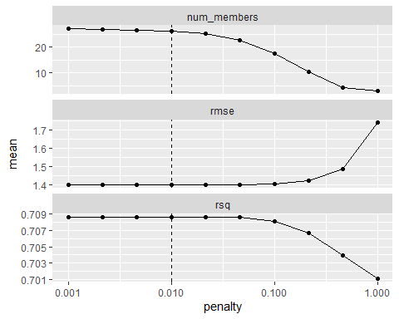
# See the model contributions or weights in the stacking
print(stack_reg)
## # A tibble: 10 × 3
## member type weight
## <chr> <chr> <dbl>
## 1 rf_tune_1_03 rand_forest 0.471
## 2 xgb_tune_1_02 boost_tree 0.131
## 3 xgb_tune_1_30 boost_tree 0.0949
## 4 xgb_tune_1_19 boost_tree 0.0386
## 5 xgb_tune_1_17 boost_tree 0.0324
## 6 xgb_tune_1_28 boost_tree 0.0240
## 7 xgb_tune_1_18 boost_tree 0.0223
## 8 xgb_tune_1_27 boost_tree 0.0195
## 9 xgb_tune_1_13 boost_tree 0.0173
## 10 xgb_tune_1_05 boost_tree 0.0170
# Predict
stacked_pre <- test %>%
mutate(.pred = predict(stack_reg, new_data = test)$.pred)
stacked_pre
## # A tibble: 3,173 × 20
## rental_date return_date amount release_year rental_rate
## <dttm> <dttm> <dbl> <dbl> <dbl>
## 1 2005-05-25 04:02:21 2005-06-01 02:44:21 5.99 2007 4.99
## 2 2005-05-25 05:17:24 2005-05-31 10:00:24 4.99 2007 4.99
## 3 2005-05-25 08:06:21 2005-05-26 03:55:21 0.99 2010 0.99
## 4 2005-05-25 08:18:51 2005-05-27 07:58:51 0.99 2008 0.99
## 5 2005-05-25 08:51:46 2005-05-31 07:14:46 0.99 2005 0.99
## 6 2005-05-25 09:39:25 2005-05-26 10:54:25 2.99 2004 2.99
## 7 2005-05-25 10:20:46 2005-06-02 09:42:46 1.99 2004 0.99
## 8 2005-05-25 10:44:53 2005-05-28 15:28:53 2.99 2007 2.99
## 9 2005-05-25 12:56:42 2005-06-01 13:52:42 5.99 2005 4.99
## 10 2005-05-25 13:01:57 2005-06-02 11:22:57 5.99 2009 4.99
## # ℹ 3,163 more rows
## # ℹ 15 more variables: length <dbl>, replacement_cost <dbl>,
## # special_features <chr>, `NC-17` <dbl>, PG <dbl>, `PG-13` <dbl>, R <dbl>,
## # rent_hours <dbl>, rent_length <dbl>, rent_dow <fct>, rent_month <fct>,
## # avg_rent_before <dbl>, deleted_scenes <dbl>, behind_the_scenes <dbl>,
## # .pred <dbl>
# Find RMSE
stack_metrics <- stacked_pre %>%
rmse(truth=rent_length, estimate=.pred)
stack_metrics
## # A tibble: 1 × 3
## .metric .estimator .estimate
## <chr> <chr> <dbl>
## 1 rmse standard 1.36
# Find MSE
stack_mse <- mean((stacked_pre$rent_length - stacked_pre$.pred)^2)
stack_mse
## [1] 1.858457
# Prepare a summary tibble of your three models’ metrics
metrics_df <- tibble(
model = c("Random Forest", "XGBoost", "Stacked Ensemble"),
RMSE = c(1.41, 1.48, 1.36),
MSE = c(1.97, 2.18, 1.85)
)
metrics_df
## # A tibble: 3 × 3
## model RMSE MSE
## <chr> <dbl> <dbl>
## 1 Random Forest 1.41 1.97
## 2 XGBoost 1.48 2.18
## 3 Stacked Ensemble 1.36 1.85
# RMSE Comparison bar plot across models
rmse_plot <- ggplot(metrics_df, aes(x = model, y = RMSE, fill = model)) +
geom_col(show.legend = FALSE) +
labs(
title = "RMSE Comparison Across Models",
x = "Model",
y = "RMSE"
) +
theme_minimal()
rmse_plot
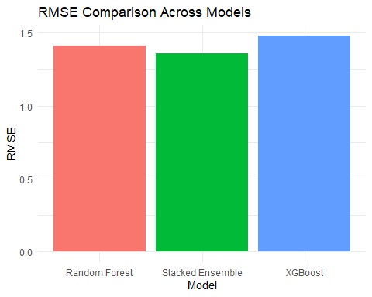
# MSE Comparison bar plot across models
mse_plot <- ggplot(metrics_df, aes(x = model, y = MSE, fill = model)) +
geom_col(show.legend = FALSE) +
labs(
title = "MSE Comparison Across Models",
x = "Model",
y = "MSE"
) +
theme_minimal()
mse_plot
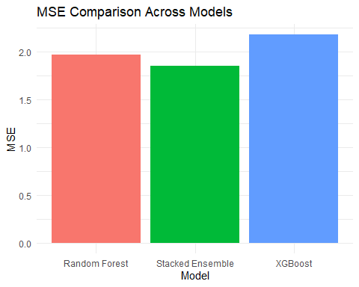
# Put all predictions in one dataframe
test_predictions <- test %>%
mutate(
rf_pred = predict$.pred,
xgb_pred = predictions$.pred,
stacked_pred = stacked_pre$.pred
)
colnames(test_predictions)
## [1] "rental_date" "return_date" "amount"
## [4] "release_year" "rental_rate" "length"
## [7] "replacement_cost" "special_features" "NC-17"
## [10] "PG" "PG-13" "R"
## [13] "rent_hours" "rent_length" "rent_dow"
## [16] "rent_month" "avg_rent_before" "deleted_scenes"
## [19] "behind_the_scenes" "rf_pred" "xgb_pred"
## [22] "stacked_pred"
# Visually compare how the different models' predictions align with the actual rent length
pred_vs_actual <- ggplot(test_predictions, aes(x = rent_length)) +
geom_abline(slope = 1, intercept = 0,
color = "black",
linetype = "dashed",
linewidth = 0.8) +
geom_point(aes(y = rf_pred, color = "Random Forest"), alpha = 0.5) +
geom_point(aes(y = xgb_pred, color = "XGBoost"), alpha = 0.5) +
geom_point(aes(y = stacked_pred, color = "Stacked Model"), alpha = 0.5) +
labs(title = "Model Predictions vs Actual Values", x = "Actual Rent Length", y = "Predicted Rent Length") +
scale_color_manual(values = c("Random Forest" = "red", "XGBoost" = "blue", "Stacked Model" = "green")) +
theme_minimal()
pred_vs_actual
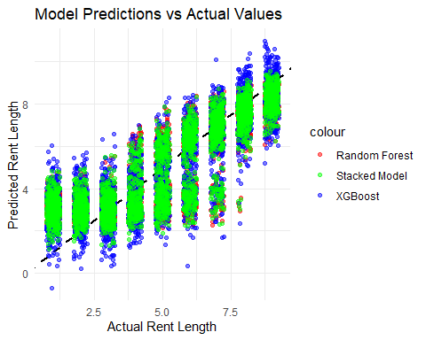
# All three sets of points trend upward, showing each model generally captures the positive relationship between actual and predicted rent length.
# The stacked ensemble’s (green) points lie closest to the 45-degree line (where prediction equals reality), indicating it has the lowest overall bias and tighter spread.
# Prepare a long‐format data frame with predictions and residuals
df_long <- test_predictions %>%
pivot_longer(
cols = c(rf_pred, xgb_pred, stacked_pred),
names_to = "model",
values_to = "predicted") %>%
mutate(
model = recode(model,
rf_pred = "Random Forest",
xgb_pred = "XGBoost",
stacked_pred = "Stacked Ensemble"),
residual = rent_length - predicted
)
# Residuals vs. Predicted plot
resid_plot <- ggplot(df_long, aes(x = predicted, y = residual)) +
geom_point(alpha = 0.5) +
facet_wrap(~ model, scales = "free_x") +
geom_hline(yintercept = 0, linetype = "dashed", color = "red") +
labs(
title = "Residuals vs. Predicted Rent Length",
x = "Predicted Rent Length (days)",
y = "Residual (Actual − Predicted)"
) +
theme_minimal()
resid_plot
