**Effect of mineral particle size on microwave heating: from experiment to numerical simulation**

# Duona Chena, Chunshun Zhanga*

a*Department of Civil Engineering, Monash University, Clayton, VIC 3800, Australia*

# Corresponding author: Chunshun Zhang; [Ivan.Zhang@monash.edu](mailto:Ivan.Zhang@monash.edu)

# Abstract: size越小，矿物颗粒吸收微波的能力越强，这已经在试验中得到验证。然而其原因、涉及机理尚不明晰，众说纷纭，一直没有达成一致。本文aims to 通过数值模拟来探究颗粒szie的effect on microwave heating. 我们基于什么方法和理论，我们做了什么工作，得到了什么结论。这些发现有助于完善对微波和矿物颗粒相互关系的深入理解。

**Keywords:**

# 1 Introduction

establishing the problem, background, literature review, unmet need for work, aims

# 2 Methodology

description of methods used to carry out your research, experimental protocols, measurements, analysis approaches, reason for their selection and critical discussion of their limitations.

The simulation undertook in this experiment involves the use of MEEP, an industrial state-of-the-art simulation platform for Electromagnetic simulation.

## Geometric Construction

The main geometric construction is divided into 2 parts. The first involves construction of simple geometry. The geometry normally contains 2 particles of different the configurations include different particle sizes, shapes and different distant between the particles.

The simple geometries give us an understanding of the nature of EM wave propagation. The parameters associated with the propagation of the wave in the medium and the absorption rate can be measured and quantified using statistical methods.

4 different geometry shapes, namely circle, triangle, hexagon and cube, are chosen to represent the different geometry shapes that occur in nature.

Complex geometry involves array of geometry shape evenly distributed inside the medium. This distribution is more closely resemble the real-life situation.

The property of the micro-structure such as the particle size and dielectric constant are randomized using Gaussian distribution.

## Electromagnetic simulation

The MEEP is an open source Finite Difference Time Domain (FDTD) software. The MEEP simulation is set up as such that the simulation frequency is 2.45 GHz. The size of the simulation cell is 10cm. The PML is 1cm, the transition zone where results are not recorded is 1 cm.

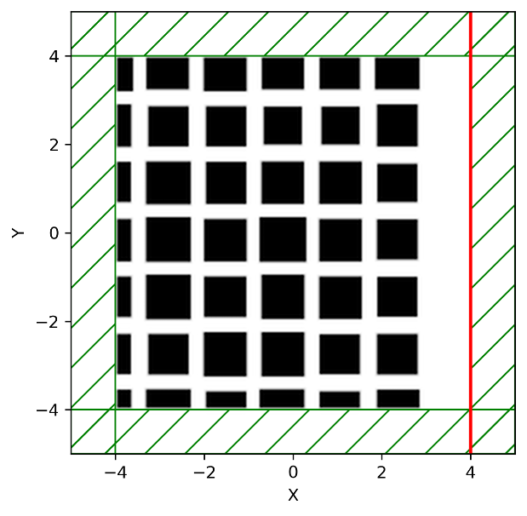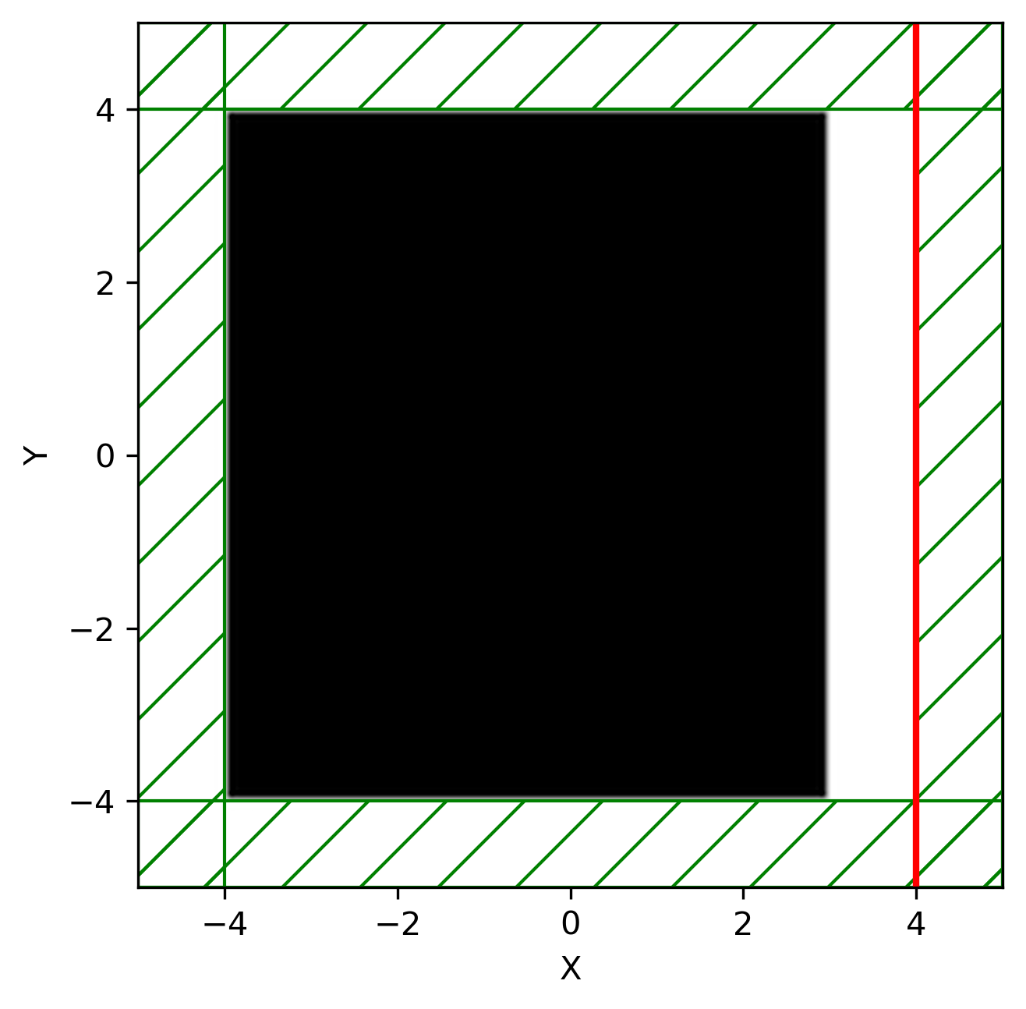

*Figure to do. simulation setup with particles in them, left simple setup, right complex*

# 3 Results and discussions

**presentation of results, sensible discussions, supported plots, comparison with literature,**

**consideration of errors and logical conclusions, technical depth of the work.**

# 4 Conclusions

overall outcomes, higher-level significance of the results.

**Acknowledgement**

The work described in this paper was supported by a grant from….

# References

1. Yang SQ, Chen M, Fang G, Wang YC, Meng B, Li YH, Jing HW. Physical experiment and numerical modelling of tunnel excavation in slanted upper-soft and lower-hard strata. *Tunn Undergr Sp Tech*. 2018; 82:248-264.