Trunk |  |  | 
Scapula |  | 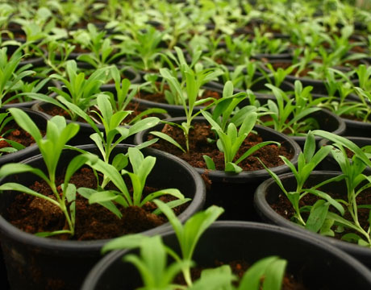 | 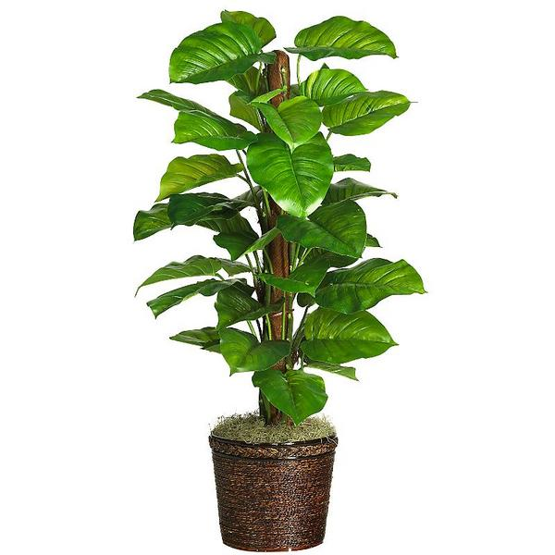
Shoulder | 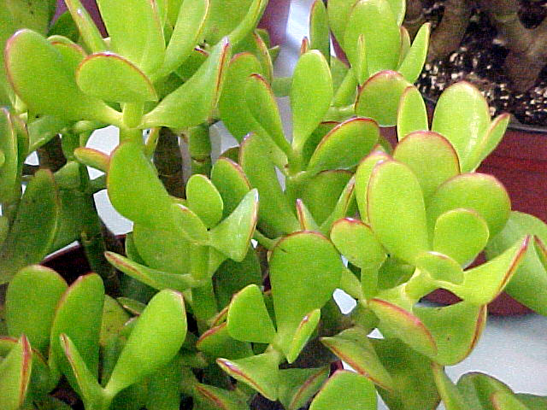 | 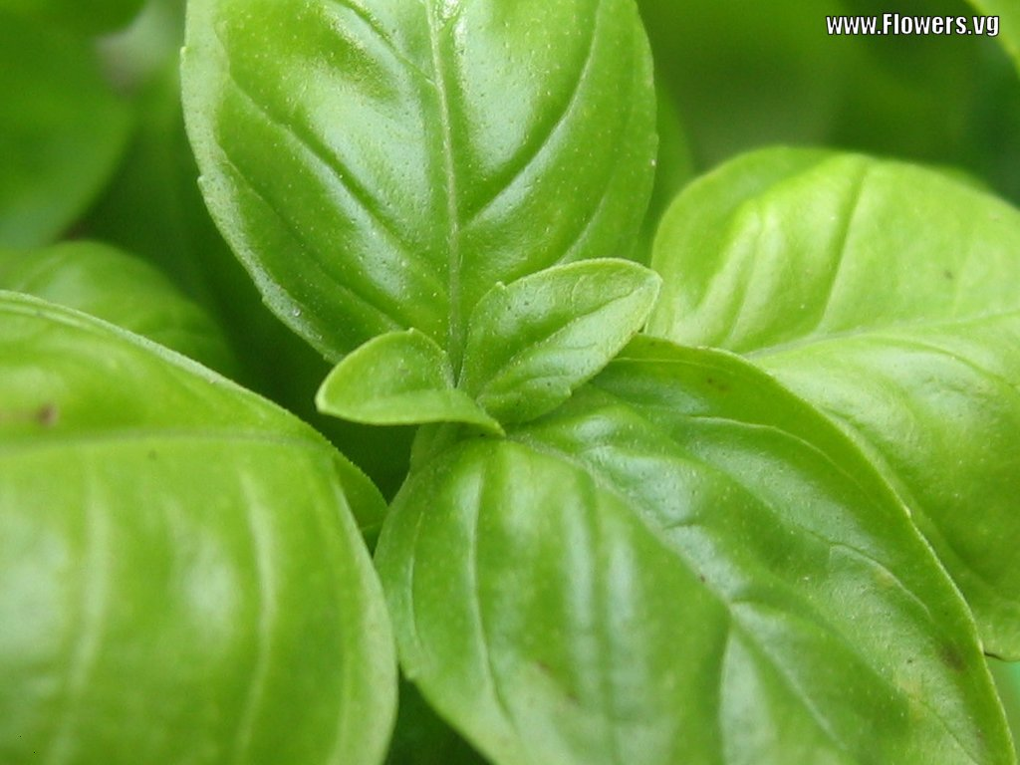 | 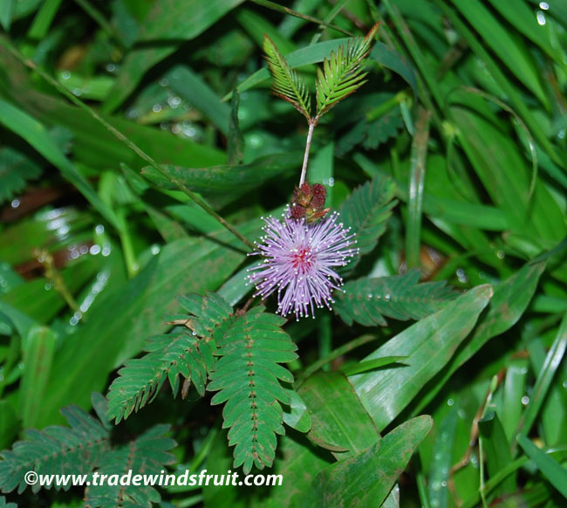
Elbow | 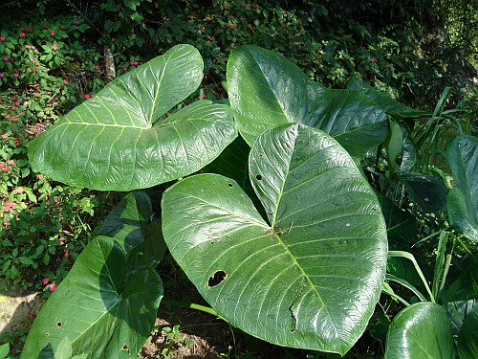 |  | 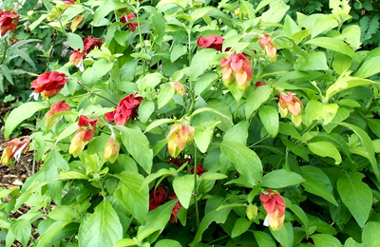
Wrist | 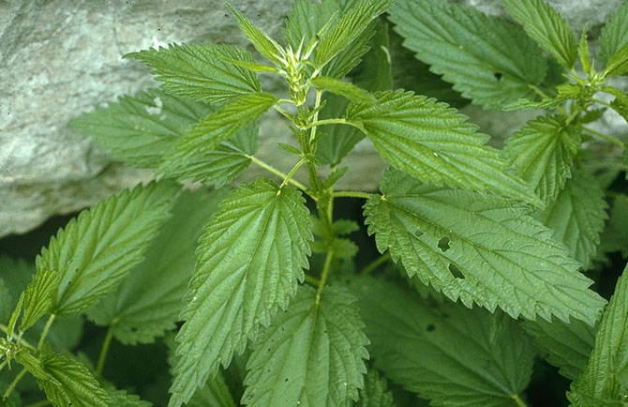 | 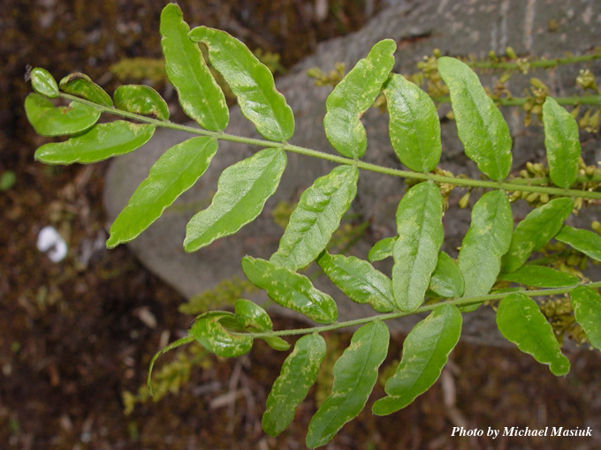

Typically developing children One random typically developing child

As an example, only trunk angles are indicated:

Joint | Angle | Min value  (SD) | Max value  (SD) | Initial value  (SD) | Final value  (SD)
Trunk | Flexion | <<mTrFl_mean>>  (<<mTrFl_std>>) | <<MTrFl_mean>>  (<<MTrFl_std>>) | <<iTrFl_mean>>  (<<iTrFl_std>>) | <<fTrFl_mean>>  (<<fTrFl_std>>)
Trunk | Lateral Flexion
Trunk | Rotation
Scapula | Tilting
Scapula | MedLat Rotation
Scapula | ProRetraction
Shoulder | Elevation Plane
Shoulder | Elevation
Shoulder | Rotation
Elbow | Flexion
Elbow | ProSupination
Wrist | Flexion
Wrist | Deviation

Point | Time of max velocity (s)  (SD) | Max velocity (mm/s)  (SD) | Trajectory  (SD)
LMC3 | <<time_max_vel_mean>>  (<<time_max_vel_std>>) | <<max_vel_mean>>  (<<max_vel_std>>) | <<traj_mean>>  (<<traj_std>>)

