U.L.E.M.A. in 8 steps (in a nutshell):

- Extract the demo data on your hard-disk. The available data (DemoDataUL / C3D) are obtained from a typically developing child Subject1 (left arm). The session folder contains all the C3D calibration files (each composed by the prefix cal and the name of the calibrated anatomical landmark) and 2 different tasks: HTH (Hand-to-Head) and RF (Reach Forward). There are 3 files per task (3 dynamic recordings), with 2 motion cycles (repetitions) per file. Each motion cycle is defined by 2 events (start and endpoint of the movement) of the type "General Event" (Context: General).

- Download and run the U.L.E.M.A. application. After starting MATLAB, set the U.L.E.M.A. directory (ULEMA_UpperLimbAnalyzer_x.y.z) as the current working directory and type mainGUI in the Command window. The main window of the GUI should appear in a few seconds, after automatically including all the necessary paths in MATLAB.
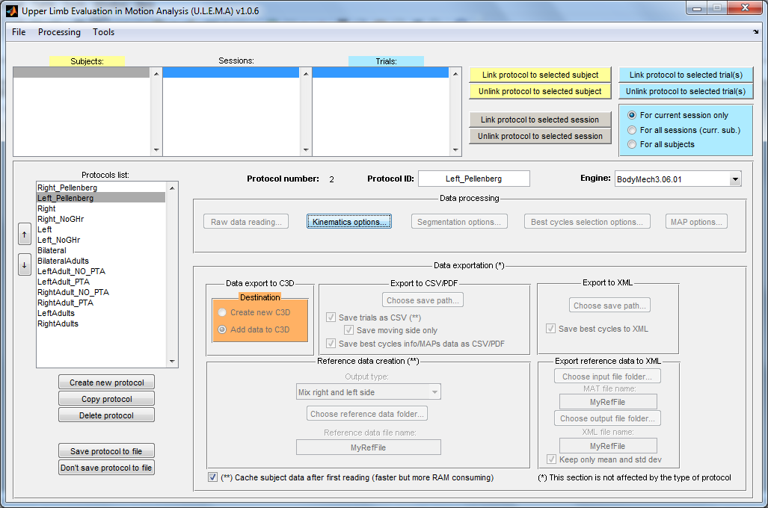
- Load the folder structure in the application. Click on File → Load → C3D tree (single subject) and select the demo data folder Subject1. The structure should be loaded in the GUI.

- Create a protocol with the correct processing settings. A protocol in this context refers to a set of processing options that can manually be selected. The user can create a custom protocol by clicking on Create new protocol. A new item should be added to the list of available protocols. You can also change the name of the protocol (e.g. DemoDataLeft) by editing the field Protocol ID. After that, you should click on Save protocol to file. Modifications will be saved to file ProtDB.mat into the folder Prot. By clicking on the menu Processing → Options you can enable/disable single parts of the whole processing/exportation pipeline. If the section is checked in the menu, the corresponding button/panel will be activated in the main window. This will allow to modify the related processing options. Enable these sections and set the following parameters:

Section | Options
Raw data read | There are no options (future releases), enable this section.
Kinematics | 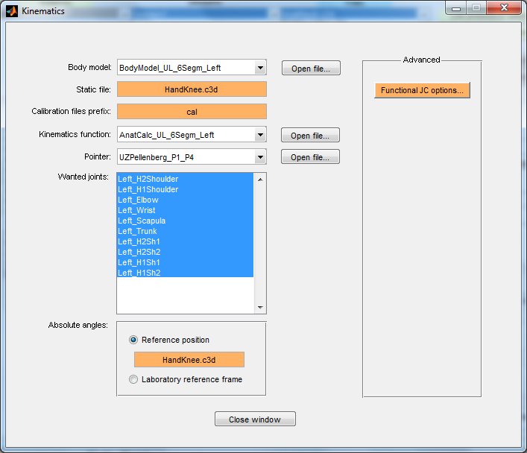  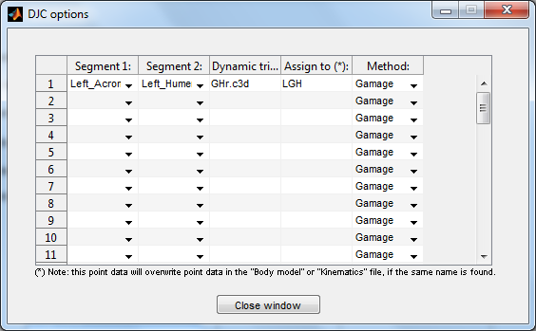  Body model (*): the BodyMech file defining the body model (in the folder BodyModels).  Static file: the static recording that will be used to define the reference position of the technical coordinate frames.  Calibration modality: it is possible ot use different files for calibration (one per anatomical landmark), or only one file where markers are placed directly on all the needed anatomical landmarks (single calibration file).  Calibration files prefix: string that must be present in the name of each calibration file (e.g.cal); the remaining part of the file name indicates the calibrated anatomical landmark.  Kinematics function (*): the BodyMech file for calculating the joint angles (in the folder AnatCalcs).  Pointer (**): the BodyMech file for calculating the location of the calibrated anatomical landmarks (in the folder Pointers).  Wanted joints (*): list of joints that are present in the selected body model file. Only the selected ones will be processed.  Reference position (*): in a Body model file, some joints can have the proximal segment set at 0 (no explicit segment). For these joints, you can set the proximal reference frame as: 1) Laboratory reference frame. It is also possible to type the affine matrix to express the rototranslation from the real laboratory reference frame to a more convenient one, with respect to which absolute angles will be expressed. 2) A non-moving segment having the same 3D attitude of the distal segment in a specific file (HandKnee.c3d in the example). 3) A non-moving segment having the same 3D attitude of the distal segment in the current file, in a certain time window.  Functional Dynamic Joint Center: every row represents the settings for a single joint centre to be computed. Segment 1 and 2 are the proximal and distal segments respectively; dynamic trial refers to the trial containing the functional motion (i.e shoulder circumbduction); assign to indicates the name of the joint centre (to be used into custom joint kinematics functions); method defines which method has to be used to compute the joint centre.  Functional Axis: every row represents the settings for a single functional axis to be computed. Segment 1 and 2 are the proximal and distal segments respectively; dynamic trial refers to the trial containing the functional motion (i.e active/passive elbow flexion/extensions); assign to indicates the name of the functional axis (to be used into custom joint kinematics functions); method defines which method has to be used to compute the axis.
Segmentation | 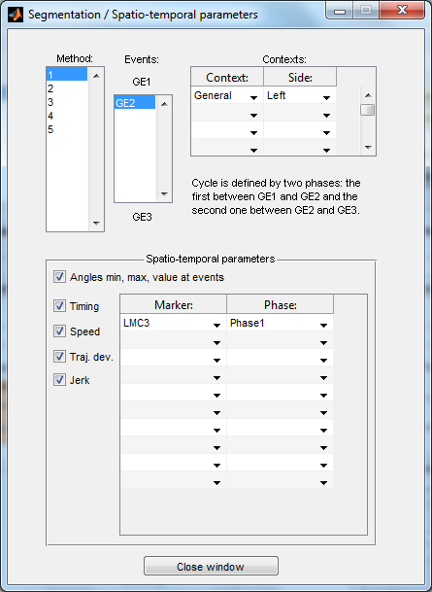  Method: method used for the segmentation; the full list can be found in the file EventsConfig.txt in the folder Seg (customisable). A brief description of the method is shown as well.  Events: list of events defining a motion cycle; the first and the last are used to split the entire data into separate motion cycles. In the example, GE stands for General Event.  Contexts: associates an event context (see Vicon Nexus) to a specific body side. This association can be done for multiple contexts.  Spatiotemporal parameters: each row of the table indicates a combination of marker and temporal phase in which the selected spatiotemporal parameters should be calculated. For every motion cycle, Phase1 represents the time window between the first and second event (defined in Vicon Nexus), phase2 the time between the second and third event, and so on. EntireCycle represents the entire motion cycle, even if multiple events are marked in the c3d file.
Best cycles selection | 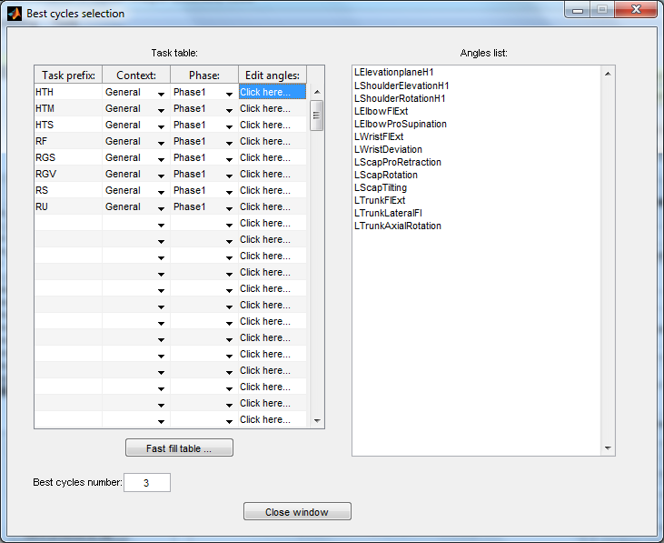  Task table: every row of the table represents a set of curves that will be ranked and the best motion cycles will be indentified (see full documentation to understand how to create ranking for cycles). Task prefix represents the prefix that all the files names belonging to that task must have (with this demo data, only RF and HTH will be considered during processing); the second and third column are used to filter data by context and phase; by clicking on the last column, it is possible to indicate which angles will be used to rank all the available motion cycles. These angle names must be present in the Body model file (*). In this example, just replicate the list in the picture above for HTH and RF.  Best cycles number: the number of motion cycles to be kept as best cycles, i.e. the most representative/consistent cycles for the task execution. If the chosen number is greater than the number of all available cycles N, this number will be automatically decreased to N (and all cycles will be used for further processing).
MAP | 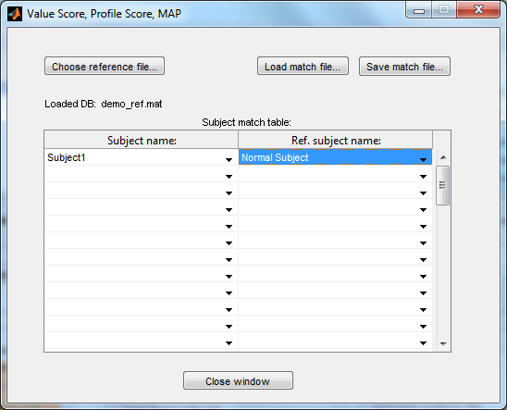  Choose reference file: select the reference file to be used for the MAP calculation (reference database of typically developing children).  Subject match table: this table was once created to individually match a measured subject (patient) with a control subject. Currently, the reference database file created by U.L.E.M.A. contains only one subject (Normal Subject), which is the average based on 20 typically developing children. Hence, the only possible association is between each individual subject (patient) and this average normal subject.
Export to C3D | Destination: choose if you wish to create a new c3d file containing a copy of the original data of the loaded c3d files and all calculated data (calibrate anatomical landmarks, angles, …): Create new C3D; or choose to add newly calculated data to the loaded ones (Add data to C3D). In the first case, a new subfolder will be created into the session folder containing the new c3d files.  For this exportation option, it is mandatory to click on the menu Processing → Options → Set recovery path and select the folder containing the original data structure. In this example, that would be the folder containing the subfolder Subject1. The software is now able to automatically retrieve the original C3D files, copy and/or append data to them, and save them again.
Export to CSV/PDF | Choose save path: choose the folder where the CSV files (containing waveform data, best cycles ranking data...) and the PDF files (containing the MAP graphs) will be saved.  Save moving side only: if checked, each exported motion cycles will only contain data for angles beloging to the same side as the cyle. For instance, for a right side cycle, only angles whose name begins with R will be exported.
(*) Read BodyMech documentation for more details. (**) The pointer is a custom made tool (with concurrent code) for every centre.

- Link the protocol to the selected trials. This way, the software knows how to process each of the C3D files. Each file (dynamic trial) can have only one linked protocol. However, multiple different protocols can be used within one session, e.g. different protocols for different tasks. Select DemoDataLeft protocol and the trials RF1.c3d, RF2.c3d, RF3.c3d, HTH1.c3d, HTH2.c3d, HTH3.c3d, then click on Link protocol to selected trial(s). The protocol name should be appended to the right of the files name.

- Process data (finally!). Before the processing can take place, click on Processing → Options → Set proc. data path. and select a folder that will contain the MAT files created during data processing. You can now start the processing phase by clicking on Processing → RUN. For U.L.E.M.A. 1.0.6+, you must also select the recovery path (Processing → Options → Set recovery path): choose DemoDataUL / C3D.

- Check the new content of into C3D files. After exporting new data to C3D, reconstructed anatomical landmarks and joint angles can be visualised with your preferred software (Vicon Nexus / Polygon, Mokka,...) as any other marker. Spatiotemporal parameters are also stored into the C3Ds. Below is an example using Vicon Nexus (reconstructed anatomical landmarks are depicted in grey, while the technical markers are depicted in yellow):

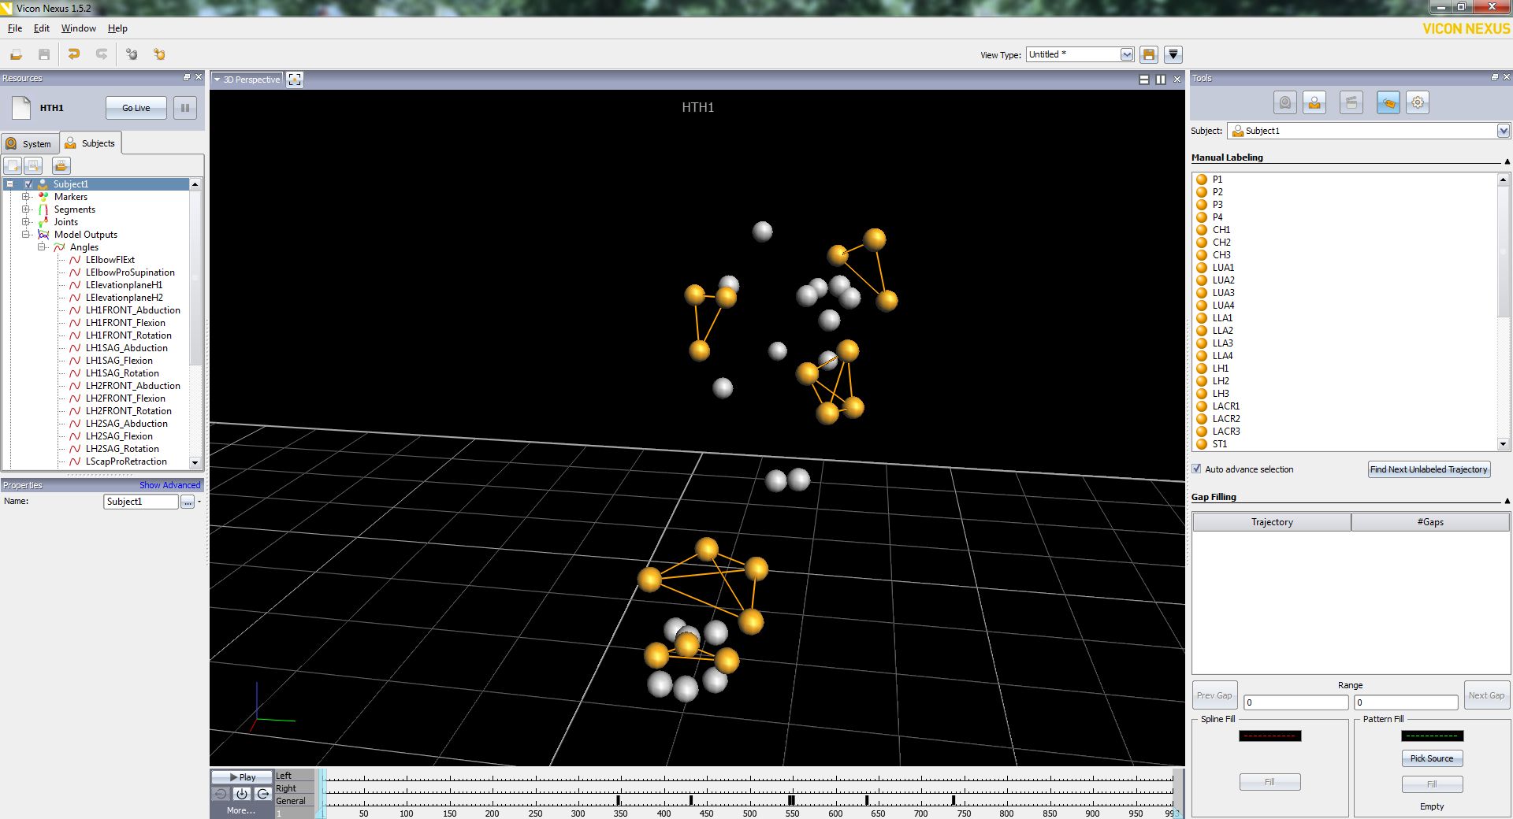
- Wait! I would like to change some processing settings and re-process some sections. Can I do that?. Of course! You can load the MAT files that where saved during the processing phase (in the processing data path). By clicking on File → Load you can choose to load one single MAT file or many MAT files in batch (read full documentation). And you can re-process whatever you want (don't forget to enable the option Processing → Options → Force re-processing).
Data for another subject is available for testing purpose. It is located into DemoDataUL / C3D / Subject2. The subject is a patological kid (CP) performing passive elbow flexion/extension (file calRMAH.c3d). For this subject, you can use the included protocol DemoDataRight_Fun, to process cal RMAH.c3d, where the elbow functional axis calibration will be performed. Just click on Functional Axis Options in the Kinematics section. Into the exported C3D file, two new markers (RMAHMarker1 and RMAHMarker2), both lying on the axis at a distance of 2 cm, will appear for visual check of the functional axis direction / position.

For any detail, please read the full doc PDF contained in every distribution of the application.

