Trunk | 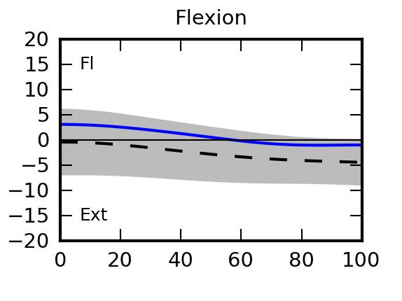 | 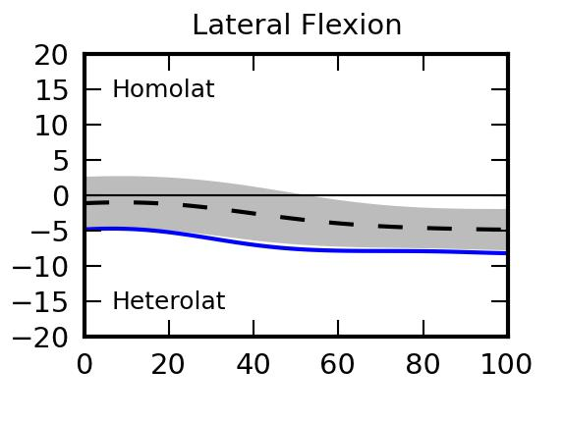 | 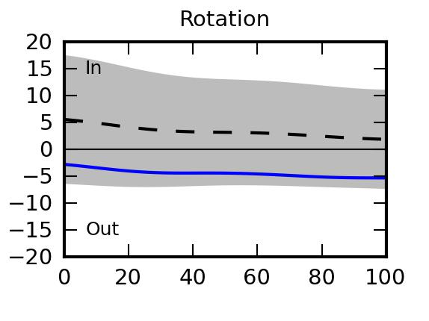
Scapula | 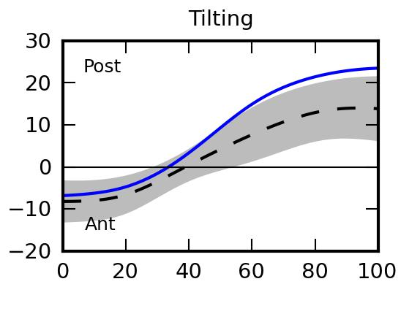 | 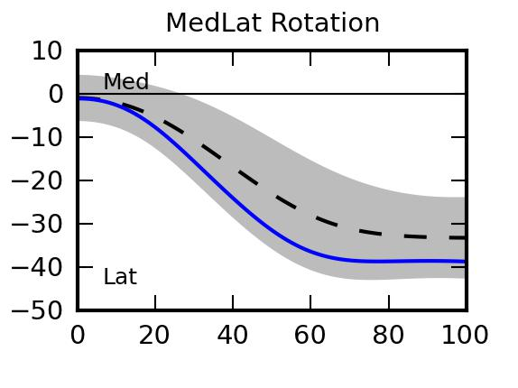 | 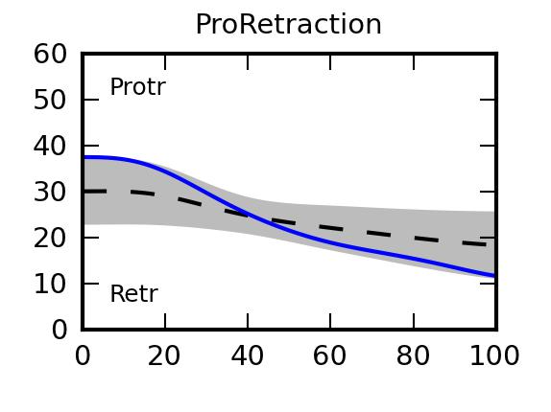
Shoulder | 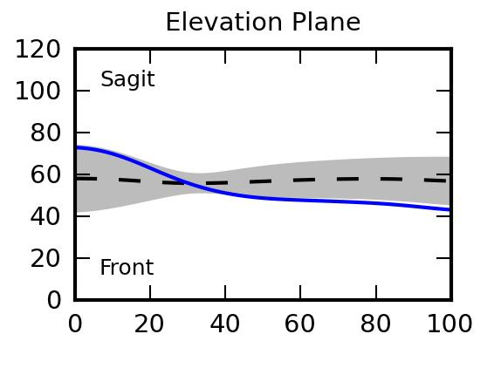 | 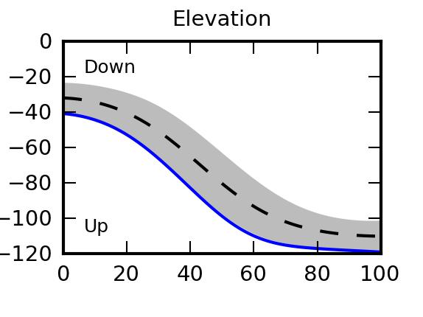 | 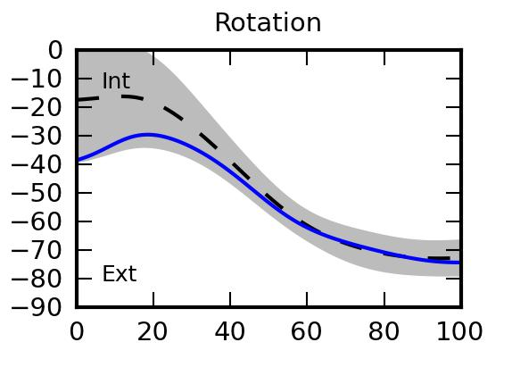
Elbow | 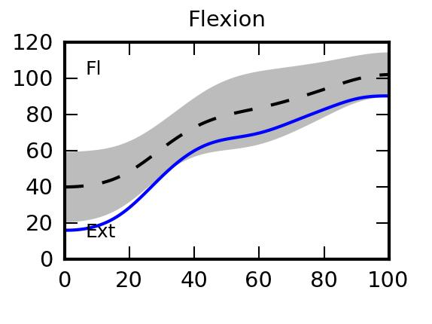 |  | 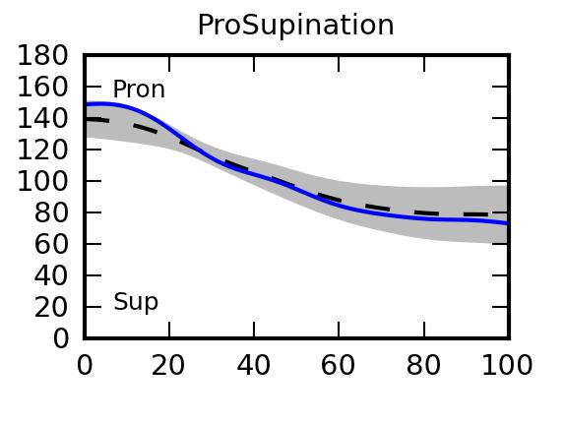
Wrist | 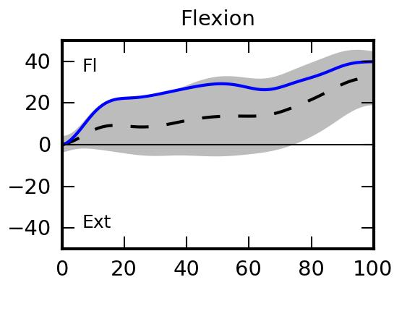 | 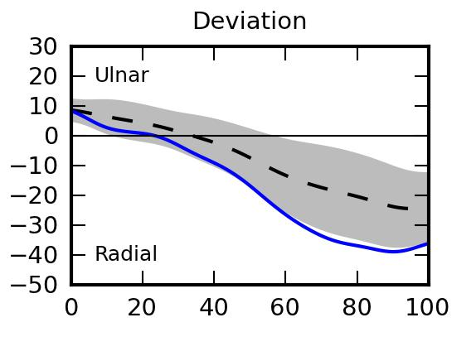

Typically developing children One random typically developing child

As an example, only trunk angles are indicated:

Joint | Angle | Min value  (SD) | Max value  (SD) | Initial value  (SD) | Final value  (SD)
Trunk | Flexion | -1.38  (1.33) | 3.11  (1.04) | 3.09  (1.04) | -0.99  (1.26)
Trunk | Lateral Flexion
Trunk | Rotation
Scapula | Tilting
Scapula | MedLat Rotation
Scapula | ProRetraction
Shoulder | Elevation Plane
Shoulder | Elevation
Shoulder | Rotation
Elbow | Flexion
Elbow | ProSupination
Wrist | Flexion
Wrist | Deviation

Point | Time of max velocity (s)  (SD) | Max velocity (mm/s)  (SD) | Trajectory  (SD)
LMC3 | 34.83  (4.52) | 1846.11  (103.59) | 1.28  (0.03)

