# Change Log

|  |  |  |  |
| --- | --- | --- | --- |
| Date | Version | Description | Person |
| 23-06-2013 | 0.1 | Initial Document | Zane Bloom |
| 23-06-2013 | 0.1.1 | Added Pipeline Image Processing | Zane Bloom |
| 24-06-2013 | 0.1.2 | Added Image PreProcessing Filter | Zane Bloom |
| 24-06-2013 | 0.1.3 | Added Image FaceDetect Filter | Heelin Mistry |
| 25-06-2013 | 0.1.4 | Added Sampling Filter | Verushka Moodley |

# Functional Requirements

## Pipeline attachments

The user must be able to attach a Capturer, Persister and zero to many Filters to the pipeline.

## Pipeline Image Processing

The pipeline must capture an image from a camera, push the image through the attached filters and persist the image and its data for reference later on.

### Service ContractG:\University\2014\COS 301\Main Project\Documents\UML Pictures\PipelineClass.jpg

### Functional Use Case

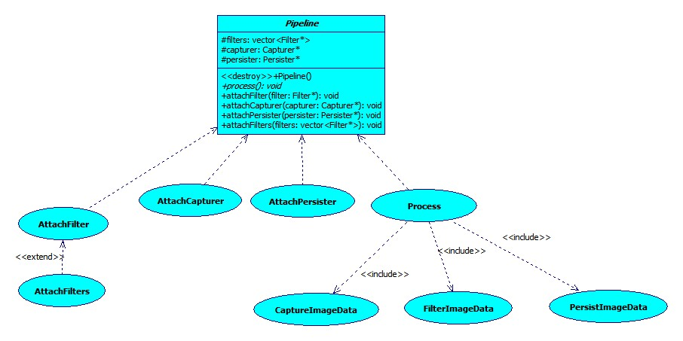

### Sequential Pipeline Process Specification

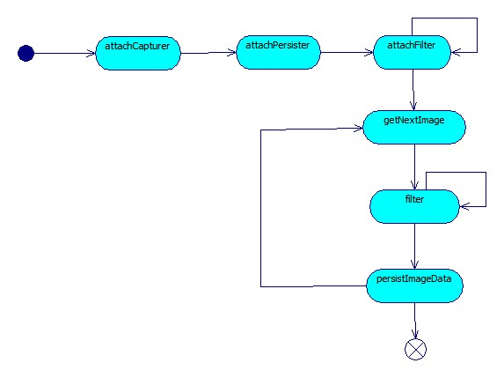

### Parallel Pipeline Process Specification

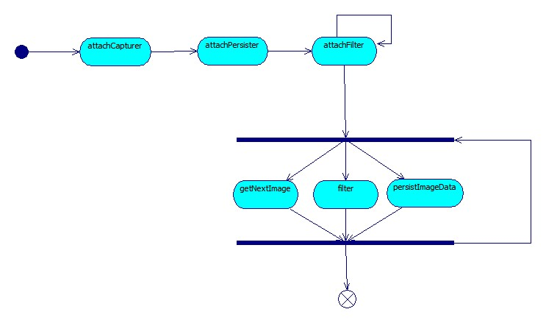

## Filtering an Image

### Functional Use Case

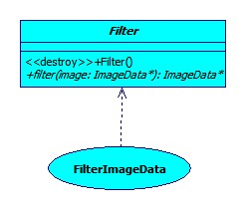

### Service Contract

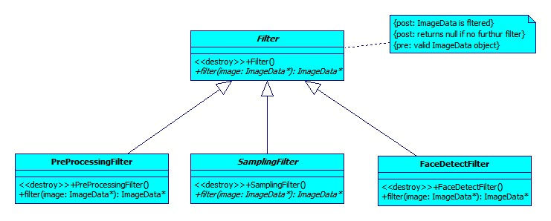

## PreProcessing an Image

An image has to be pre-processed to ensure better facial recognition quality. Image pre-processing includes:

* Resizing the images to the same size. Images have to be the same dimensions in order to use them for facial recognition.
* Correcting the colour of the image. Images must be made greyscale as colour images are more susceptible to lighting conditions.
* Histogram equalisation of the image. This includes standardizing the brightness and contrast of the image.

### Functional Use Case

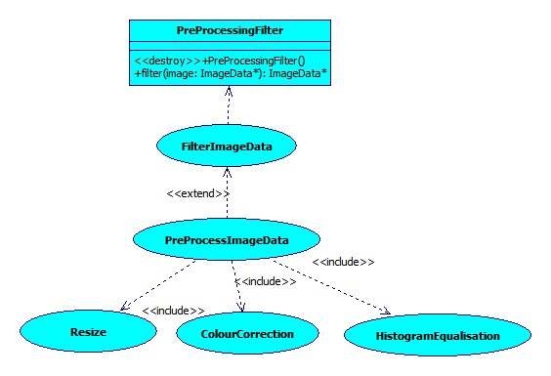

### Image PreProcessing Process Specification

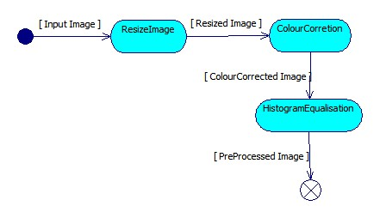

## FaceDetectFilter

The FaceDetectFilter will be applied to a specific frame.Image FaceDetectFilter includes:

* Identify all faces within a frame.
* Crop facial images and add them to face vector for further processing. FaceDetectFilter attachments

## FaceDetectFilter attachments

The filter must accept a valid location for the HaarCascading xml file.

## FaceDetectFilter processing

Thisfilter must capture faces from an image, push the facial images through the attached filters.

## Functional Use Case

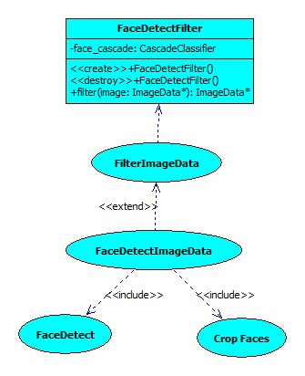

### Image FaceDetectSpecification

### E:\Users\Mistry\Documents\GitHub\Andrologists2014\Documents\UML Pictures\FaceDetectActivity.jpgProcess

## Sampling Filter

The Sampling Filter will be applied to a specific frame. It includes two subclasses:

* NSamplingFilter: Accepts an image in a frame and returns every nth image, returns null otherwise
* DiffSamplingFilter: Accepts an image in a frame and compares it to the previous frame via histogram comparison. If the frames are similar, it returns the image. It returns null if the images in the frames are more than a certain percentage different.

## Sampling Filter Attachments

This filter must accept valid images.

## Sampling Filter Processing

This filter must reduce the number of images that are returned. It must do comparisons in order to determine which images are returned.

## Functional Use Case

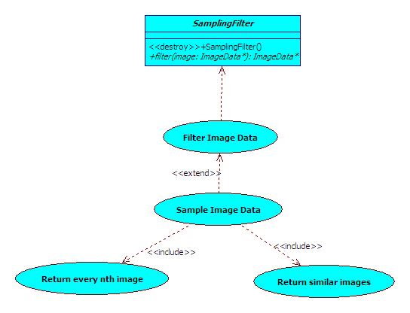

## Image Sampling Filter Specification

