# Change Log

|  |  |  |  |
| --- | --- | --- | --- |
| Date | Version | Description | Person |
| 23-06-2014 | 0.1 | Initial Document | Zane Bloom |
| 23-06-2014 | 0.1.1 | Added Pipeline Image Processing | Zane Bloom |
| 24-06-2014 | 0.1.2 | Added Image PreProcessing Filter | Zane Bloom |
| 24-06-2014 | 0.1.3 | Added Image FaceDetect Filter | Heelin Mistry |
| 25-06-2014 | 0.1.4 | Added Sampling Filter | Verushka Moodley |
| 29-06-2014 | 0.1.5 | Added Capture | Heelin Mistry |
| 01-07-2014 | 0.2 | Added Persister |  |
| 02-07-2014 | 0.2.1 | Added Database Persister | Verushka Moodley |
| 23-07-2014 | 0.2.2 | Added Domain Objects | Zane Bloom |
| 31-07-2014 | 0.2.3 | Updated UML model and added Facial Recognition | Zane Bloom |

# Functional Requirements

## Pipeline attachments

The user must be able to attach a Capturer, Persister and zero to many Filters to the pipeline.

## Pipeline Image Processing

The pipeline must capture an image from a camera, push the image through the attached filters and persist the image and its data for reference later on.

### Service Contract

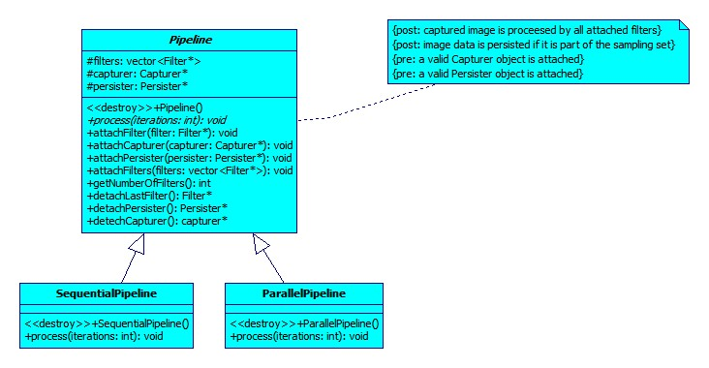

### Functional Use Case

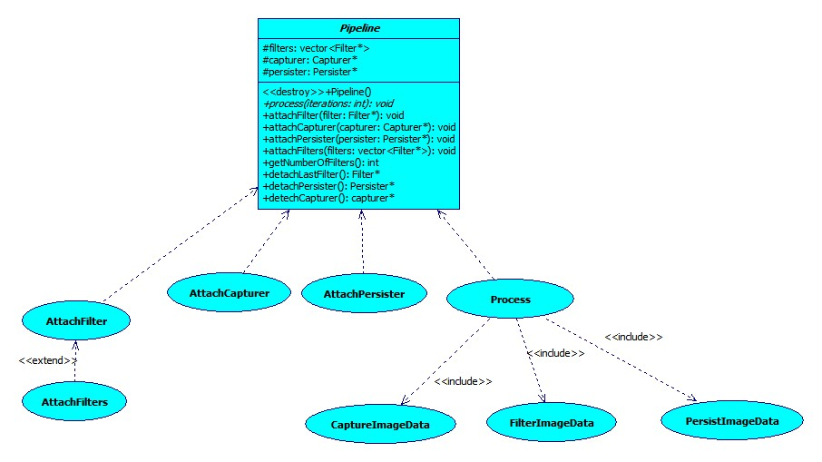

### Sequential Pipeline Process Specification

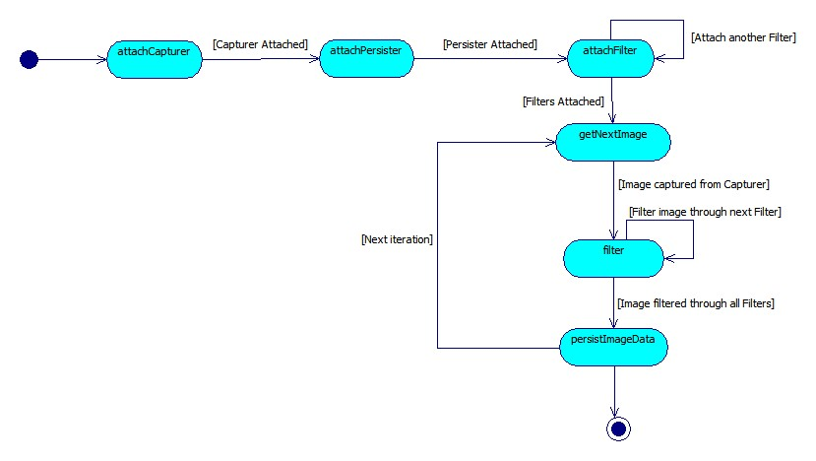

## Filtering an Image

### Functional Use Case

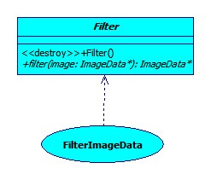

### Service Contract

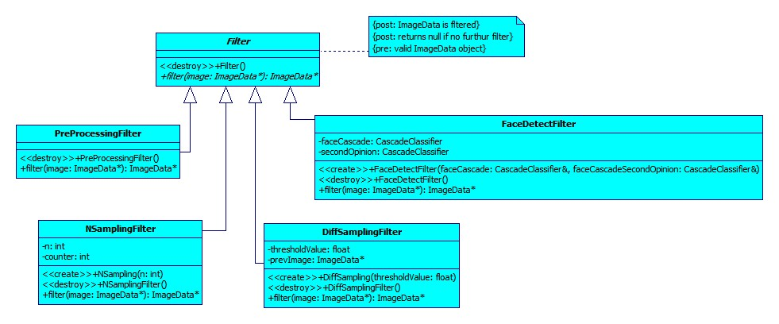

## PreProcessing an Image

An image has to be pre-processed to ensure better facial recognition accuracy. Image pre-processing includes:

* Resizing the images to the same size. Images have to be the same dimensions in order to use them for facial recognition.
* Aligning the face.
* Correcting the colour of the image. Images must be made greyscale as colour images are more susceptible to lighting conditions.
* Histogram equalisation of the image. This includes standardizing the brightness and contrast of the image.

### Functional Use Case

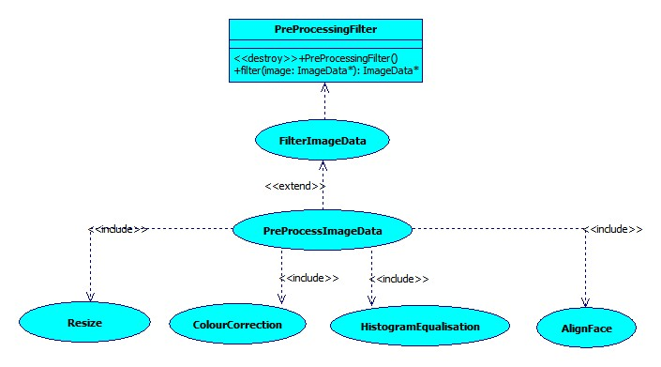

### Image PreProcessing Process Specification

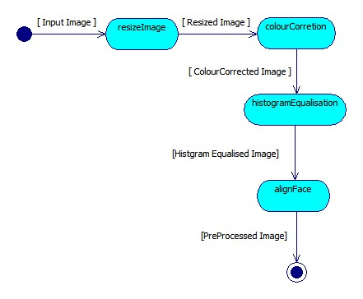

## FaceDetectFilter

The FaceDetectFilter must be able to:

* Identify all faces within a frame.
* Crop facial images and add them to face vector for further processing.

### Functional Use Case

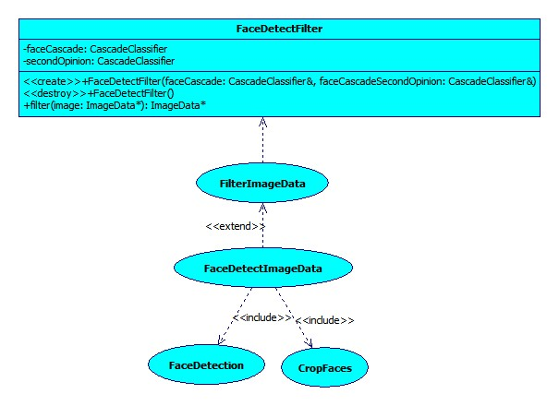

### FaceDetect Filter Process Specification

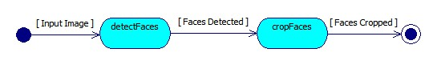

## NSamplingFilter

The NSamplingFilter is responsible for sampling every Nth frame captured.

### Functional Use Case

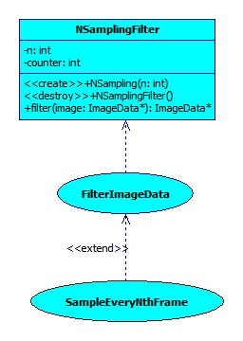

### Process Specification

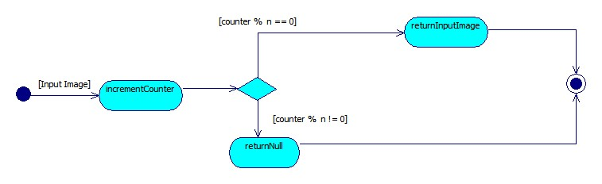

## DiffSamplingFilter

The DiffSamplingFilter is responsible for sampling a frame if it is different enough compared to the previously sampled frame.

### Functional Use Case

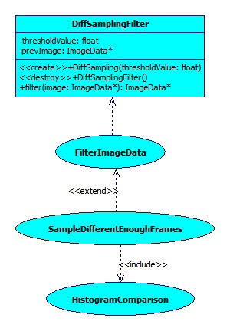

### Process Specification

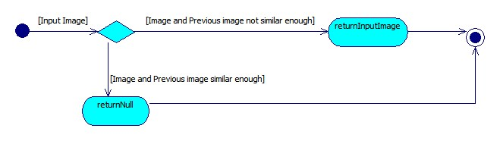

## Capturer

The Capturer will be used to get frames from a camera. It includes two subclasses:

* StreamCapturer: Connects to a video stream using a connection string to specify the location of the stream.
* DirectoryCapturer: Gets images stored in a directory.

### Capturer Service Contract

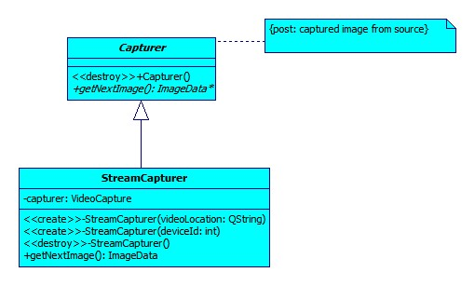

### Capturer Functional Use Case

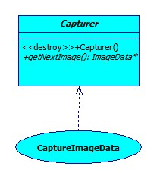

### StreamCapturer Functional Use Case

### G:\University\2014\COS 301\Main Project\Documents\UML Pictures\StreamCapturerUC.jpg

### StreamCapturer Process Specification

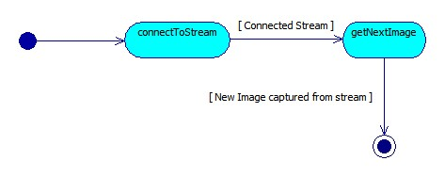

## Persister

A Persister is responsible for storing the image and its relative data to secondary storage.

### Service Contract

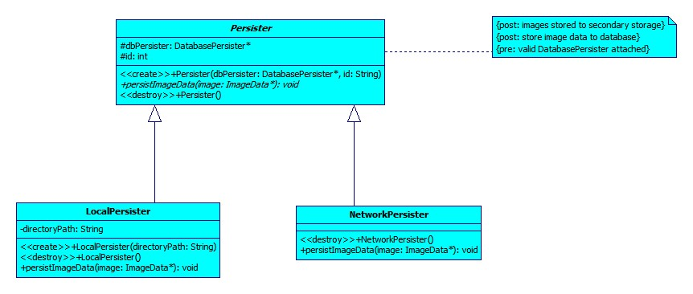

### Functional Use Case

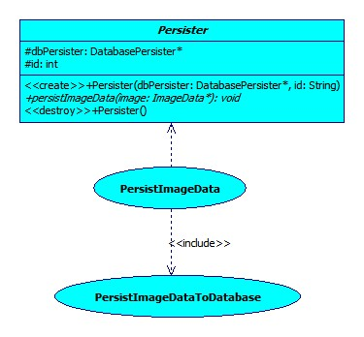

## LocalPersister

The LocalPersister is responsible for persisting the images locally (on the same machine).

### Functional Use Case

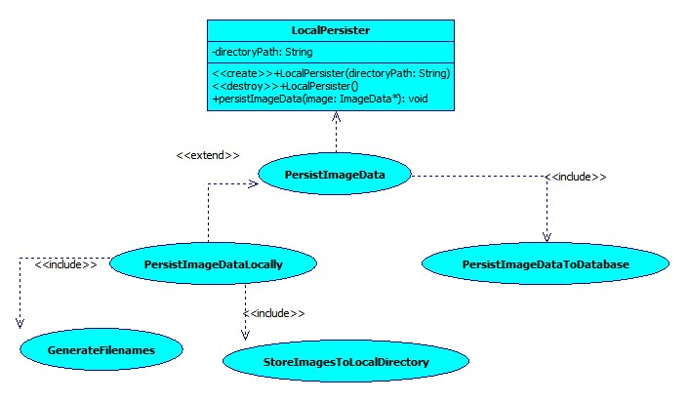

### LocalPersister Process Specification

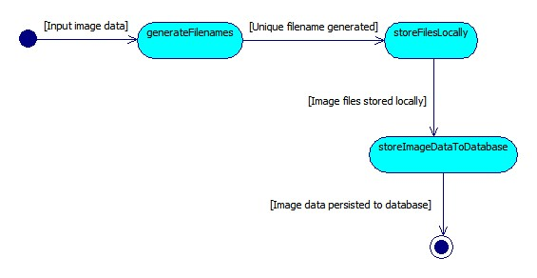

## DatabasePersister

The DatabasePersister will be used to store the image data such as filename and timestamp to the database.

### Functional Use Case

## G:\University\2014\COS 301\Main Project\Documents\UML Pictures\DatabasePersisterUC.jpg

### Database Persister Process Specification

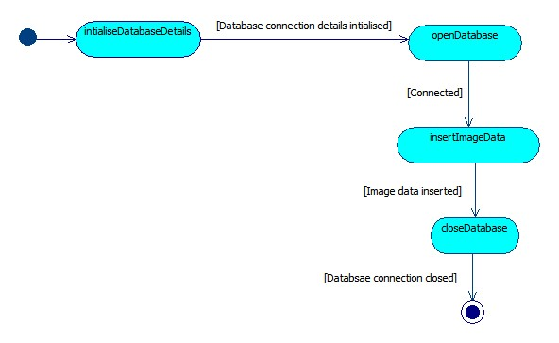

## FacialFeatureRecognizer

The FacialFeatureRecognizer is responsible for comparing the similarity between two faces.

### Functional Use Case

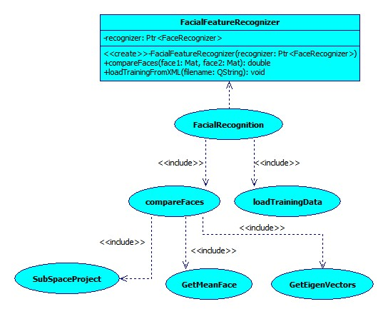

### Design

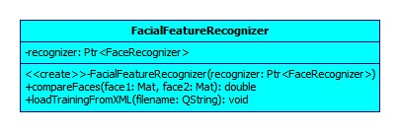

### Process Specification

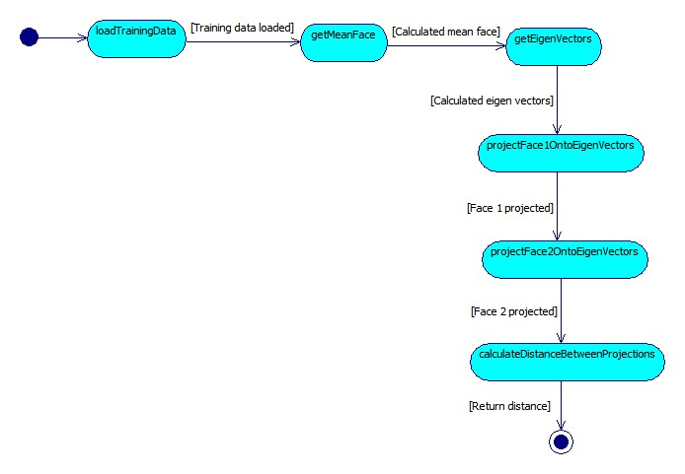

# Global Design

