Project Tender

Project: *Financial markets simulation with multiple competing algorithmic trading entities*

Client: *Cortical Systems*

Team: *Not Like This*

*Jedd Shneier*

*Daniel Andrew King*

*Joseph Jürgen Muller Potgieter*

*Duncan William Smallwood*

Department of Computer Science, University of Pretoria

Date: 01/05/2016

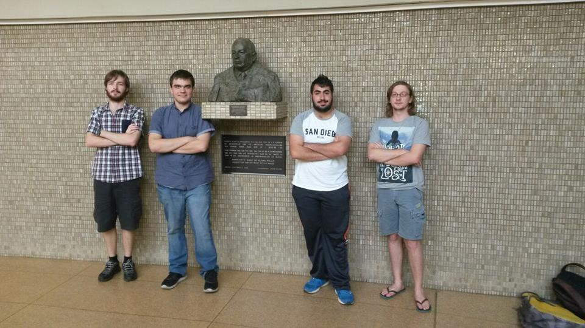

# The Team

Jedd Shneier



My interests include:

Artificial Intelligence focusing on evolutionary algorithms

Computer networks and Network Security

Logic puzzles and problem solving

History and classic literature

Anime and Animation

Science fiction series

Fantasy Novels

Harmonica

Tennis

My technical skills:

1. Coding proficiency in:
   1. Java
   2. C++
   3. Python
   4. Delphi
   5. HTML
   6. CSS
   7. Javascript
   8. PHP
   9. SQL
2. Coding experience in:
   1. Ruby
   2. C#
   3. Scheme
   4. F#
3. Experience with cloud systems
4. Proficiency with Latex, GIT, Java EE, JPA and Linux

In the past I have completed modules within the university such as:

* Netcentric computer systems
* Data structures and algorithms
* Concurrent Systems
* Software modelling
* Operating Systems
* Computer Security
* Programming languages
* Computer Networks
* Informatics

And am currently doing:

* Artificial Intelligence
* Software Engineering
* 3rd Year psychology
* Human Computer Interaction

Past experiences:

I was part of the 2008 JSE challenge winning team and the 2009 third place team thus I have experience with market trading. I have 6 years of programming experience, outside of university I have interned at Lepsta Pty Ltd working on their Black Hole system which was a ”Platform as a service” and so I have experience with cloud service development. I have job shadowed at SensePost, Liberty Life and have developed applications for Johannesburg based company Freight Training. I have experience as a freelance programmer and consultant and as such I am no stranger to fulfilling customer requirements and meeting deadlines.

Non-technical Skills:

I am very good at managing teams and maintaining communication over large projects. I work well under pressure. I am able to stay organized and meet deadlines while at the same time maintaining high quality throughout my work. I learn new topics very quickly. I am a creative and logical problem solver. My greatest skill is my ability to get people from different backgrounds to get together and understand each other. My social networking abilities allow me to get people who may not get along to work constructively and efficiently to produce content that always goes beyond expectation.

Why I want to do this project:

I have a deep interest in AI and machine intelligence, and I have thought before on applying algorithms to financial trading. This project I believe is exciting, challenging and I will be a great opportunity to gain knowledge on competitive algorithms and different trading entities.

Daniel King



My interests include:

* Competitive gaming
* Various sports such as tennis, cricket golf and football
* Table-top miniature wargames
* Artificial intelligence
* Game viewing
* Science fiction

My technical skills:

1. Coding in
   1. Java
   2. C++
   3. HTML
   4. CSS
   5. Javascript
   6. WebGL
2. Some image manipulation (Photoshop)
3. Video editing

In the past I have completed modules within the university such as:

* Netcentric computer systems
* Data structures and algorithms
* Concurrent Systems
* Operating Systems
* Software modelling
* Calculus and Linear Algebra
* Mathematical Statistics
* Mathematical modelling
* Information Science

And am currently doing:

* Computer Networks
* Computer Graphics
* Software Engineering
* Human Computer Interactions

These are only a portion of the topics I have gone through in my studies however I believe they will allow me to complete the system in a high quality manner.

Past Experience:

Have done web development for company Black Plan

Some non-technical strengths I have are:

* I can focus well on single tasks and make sure they are completed to a quality I deem is acceptable in comparison to the standard
* If I come across aspects which I do not understand or a problem I cannot complete I am able to find and digest information quickly, allowing me to learn how to complete the task in a short amount of time
* I can be critical of members in a group in a constructive way, so that the quality of work stays at an acceptable level
* My biggest strength is my ability to think logically and reason through problems

Why I want to do this project:

When I first came across the proposal I was intrigued at the concept to apply AI to financial markets and I expanding my knowledge base into a new field like entity trading is exciting for me. I like the competitive aspect of this project as well seeing different algorithms compete to see which performed best.

Joseph Jürgen Muller Potgieter



My interests include:

·         Reading

·         Gaming

·         Nerd culture

Technical skills:

·         Java

·         C++

·         HTML and Javascript

·         WebGL

·         SQL

·         Artificial Intelligence

Past experience:

I have previous experience with a professional employer, where I worked in a team. We were tasked with the completion of an Android application and delivered a satisfactory product.

Non-technical skills:

·         Work well in teams

·         Can draft professionally worded documents

·         Experience in public speaking

·         Highly organized

Interest in the project:

It seems as though the project could provide an interesting challenge and provide valuable experience in a professional environment.

Duncan William Smallwood



My interests include:

* Competitive gaming
* Reading
* Online discussions
* Water Sports
* Music

My technical skills:

1. Coding in
   1. Java
   2. C++
   3. HTML
   4. CSS
   5. Javascript
   6. PHP
   7. SQL

In the past I have completed modules within the university such as:

* Netcentric computer systems
* Data structures and algorithms
* Concurrent Systems
* Operating Systems
* Software modelling
* Calculus and Linear Algebra
* Mathematical Statistics
* Mathematical modelling
* Philosophy

And am currently doing:

* Computer Networks
* Computer Graphics
* Software Engineering
* Human Computer Interactions

Some non-technical strengths I have are:

* Evaluation importance and relevance of new information to a current project.
* Learning new skills.

Why I want to do this project:

I’ve considered this a challenging project and I like to rise up to challenges. I also think this will be valuable learning experience for me and help me realise how to operate in a working environment. I have always wanted to work with machine learning algorithms and I think its an interesting context.

# Project execution

We intend to follow the Test driven Development methodology cause from our experience it is the most sure fire way to reduce bugs in development and reduces code bulk which will allow easier and cheaper maintainability.

We are planning to keep the client informed with our development blog, weekly update emails and a Git repository to add the client to so they can see the progress.

The first big technical challenge of learning the different trading algorithms we think we can overcome very quickly and as we are all well versed in AI devising the algorithms is not a problem for us. We all are every comfortable working with Java and as that is a presence, believe everyone will be happy.

At the end of this project the client will have a working system that meets all requirements and goes beyond expectations. They will have self-contained simulation system that accurately models free market principles.