Department of Computer Science

COS 301 - Software Engineering

Not Like This

Functional Specifications

Authors: Student number:
Jedd Shneier 13133064
Duncan Smallwood 13027205
Daniel King 13307607
Muller Potgieter 12003672

28 July 2016

Overview
This report contains the functional specifications for the AWS Network Visualizer system. The specifications define the user-system interaction and relationship between users and the product. It will provide the expected functionality for all user cases as well as the activity processes for the system.

Product description
Amazon web services provide a cloud based service for hosting a clients network. There is a lack of information regarding ones network, specifically the logical representation on the system for the client to make sense of their network. The network visualizer aims to improve clients understanding of their own network, how AWS works and possible insights in the managing of their network.

Product functional capabilities
This system needs to be able to be:
1) Accessed by valid AWS customers to;
2)Scan their networks located in specified regions;
3)Provide an interactive hierarchical and visual representation of the networks as well as;
4)Give additional information on the network statistics, construction and options to;
5)Provide a clearer concise and valuable picture of the clients virtual networks and;
6)Improve AWS clients experience.
7)Additional functionality to be added upon decision

User Roles
There are two user groups:
*Users with access to view the network
*Users with ownership of the network
The distinction between the two user groups is that owners of the network can specify who can view their network through security groups(done on the account side not through our system) and can potentially mutate the network (future possible functionality).While other users only able to visualize the network and see network data. At this point in development functionally speaking both users are one and the same.

Use Case
The usage of the system will typically consist of passing credentials to the system in the form of users access and private key for their AWS account. If valid the system will ask the user to choose a region to be scanned. All artefacts in that region will be scanned and a network representation will be constructed that will be the displayed to the user. The representation can also be interacted with to expand nodes and request further information.

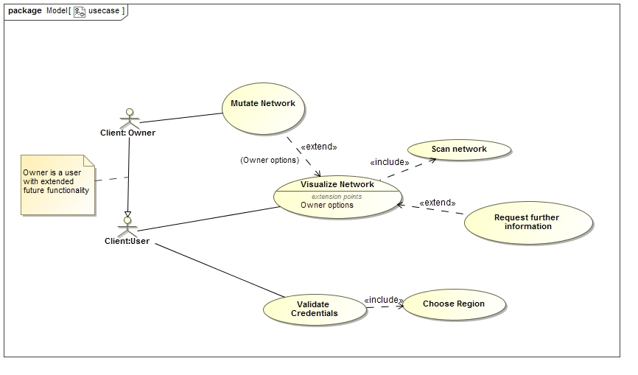

General constraints
User has to have an AWS account. If the user wants to let another person visualize the network that person needs to have an account as well and be part of the owners security group. Due to data transfer delays user has to specify region ahead of scan. Scanning all regions at once takes too much time as security credentials are revalidated by AWS on region change. For large networks parts will be incrementally scanned and shown to prevent user waiting for a full representation.

Assumptions
We assume that the user of the system will have a properly configured virtual network on AWS to be scanned. If they just running instances with no structure well they will still be logically shown but it will not provide useful information to a user. The user must also have set up their access key and private key.

Other software
The system uses the Viz.js library to graphically render the network. Communication between the user interface and application will be using AJAX protocols. The AWS API is integrated with and its calls are used to scan the network. Additional Java libraries will be added as they are decided upon. Additional software will be decided upon at a later date to build the user interface.

Specific Function Descriptions
This section is repeated for each function of the software. Some examples of functions are: engineering calculations, sorting or sequencing, other operations relating inputs to outputs, validity checks on inputs, error handling and recovery.

Description
Describe the function and its role in the software.

Inputs
Describe the inputs to the function. Where user interface (UI) elements are present, these are described. Examples of UI elements are check boxes, dropdown lists, and alphanumeric fields. Input validation strategy, allowed data types and value ranges are specified for each input.

Processing
Describe what is done by the function. Where algorithms, equations, or other logic are used, they are described here. If calculations are done utilizing the methods of specific standards or references, these are cited. Database definitions are also included where relevant.

Outputs
Describe the outputs of the function. Where a user interface description is relevant, it is included. Define any reports.

External Interfaces
The interfaces in this section are specified by documenting: the name and description of each item, source or input, destination or output, ranges, accuracy and tolerances, units of measure, timing, display formats and organization, and data formats.

User Interfaces
Describe all major screens, pages, forms, including any complex dialog boxes. This is usually best done via simulated, non-functioning screen shots, and may take the form of a separate document.
The navigation flow of the windows, menus, and options is described, along with the expected content of each window. Examples of items included are screen resolutions, color scheme, primary font type and size. Discussion also includes how input validation will be done, and how data will be protected from accidental changes. Specific items are described for each screen such as input fields, control buttons, sizing options, and menus.

Hardware Interfaces
Describe the equipment needed to run the software, and also other output or input devices such as printers or handheld devices.

Software Interfaces
Describe any software that will be required in order for the product to operate fully. Include any in-house software or commercial applications that customers will be utilizing together with the planned software. Also describes any software that the software product will interact with such as operating system platforms supported, file import and export, networking, automation, or scripting. Specify whether the users must provide the interfacing software themselves, and any special licensing requirements.

Communication Interfaces
Describes how the software product will communicate with itself (for multi-platform applications) or other software applications, including items such as networking, email, intranet, and Internet communications.

Performance
Discuss items such as response times, throughput requirements, data volume requirements, maximum data file size or problem complexity, maximum number of concurrent uses, and peak load requirements (for web-based applications). Includes expected response times for entering information, querying data files and databases, performing calculations of various complexities, and importing/exporting data.

Design Constraints
Examples of constraints that affect software design choices are items such as memory constraints involving minimum and maximum RAM and hard disk space, and limitations arising from hardware, software or communications standards.

Attributes

Security
Describe any password-protected access levels such as operator, engineer/modeler, manager, database administrator-and which functionality will be accessible to each access level. If relevant, describes the planned approach to locking the software.

Reliability, Availability, Maintainability
Describe requirement items such as uptime, hours or days or weeks of operation, strategy for data recovery, code structuring for ease of future modification, etc.

Configuration and Compatibility
Describe requirements such as those connected with individual customization or operation in specific computing environments.

Installation
Describe the planned method for installation: done by the user independently, done by customer company internal IT services, done by an external contractor. Specifies the handling of such items as data transfer from prior releases, and the presence of software elements from prior releases.

Usability
Describe items that will ensure the user-friendliness of the software. Examples include error messages that direct the user to a solution, input range checking as soon as entries are made, and order of choices and screens corresponding to user preferences.

Additional Requirements

Internet connection
The network is based in the cloud therefore to access it to scan an internet connection is required. Furthermore for large networks that are only scanned incrementally the connection needs to remain stable and persistent.

Administration
Team needs to complete sprints according to deadlines and produce solid artefacts that can be integrated immediately. All code produced needs to be tested and burn down charts need to be drawn up.

User documentation
In addition to this report, a user manual, architecture specification and testing documentation will also be delivered.

Other requirements
Server to deploy application, will probably deploy it on an AWS instance server from our account.

