Step 1:

Open the Project:

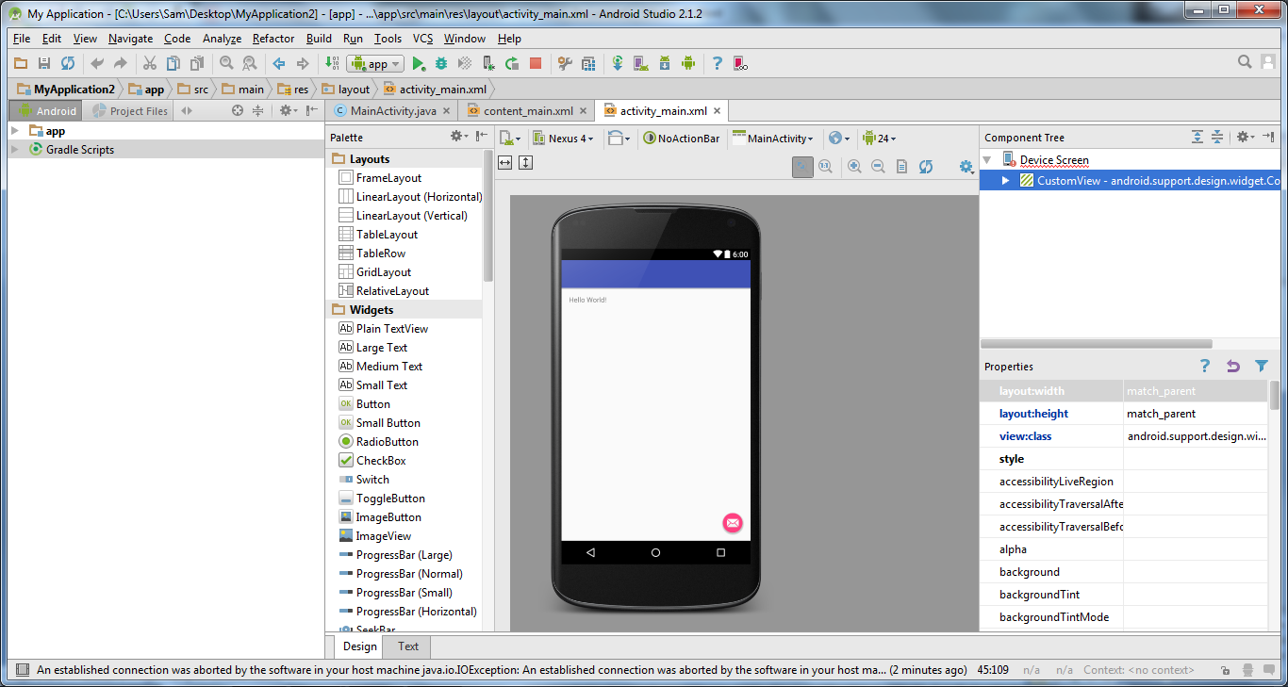

Step 2:

Go to app runner and deployment target

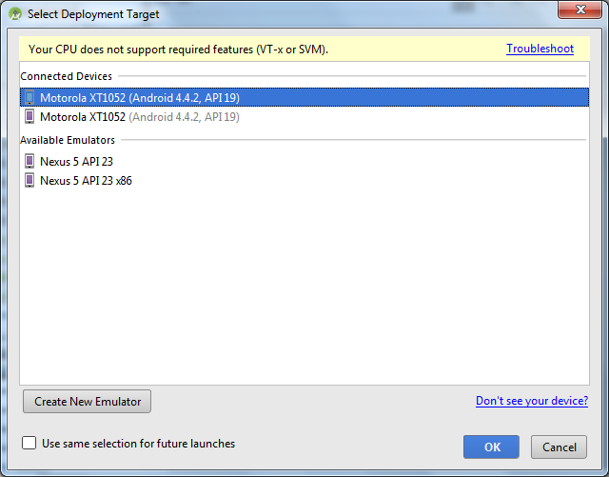

Step 3:

Select Connected device and press Ok:

Step 4:

App opens in Bluestacks:

