Name: Uvan Shankar A P

Roll No. : CH.EN.U4CSE20173

**Cognizance**

**Task-3**

Q-1

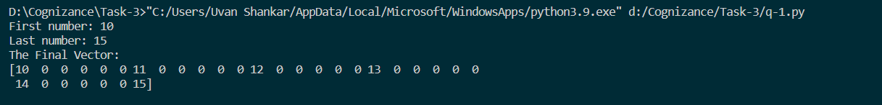

Q-2

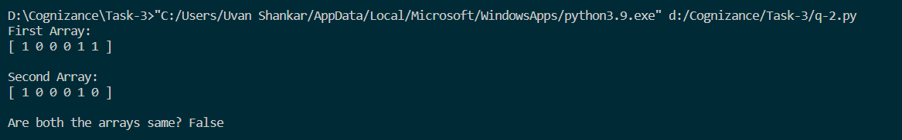

Q-3

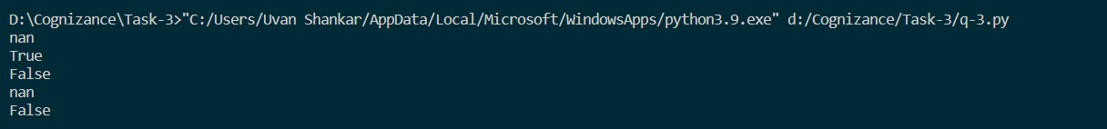

Q-4



Q-5-1

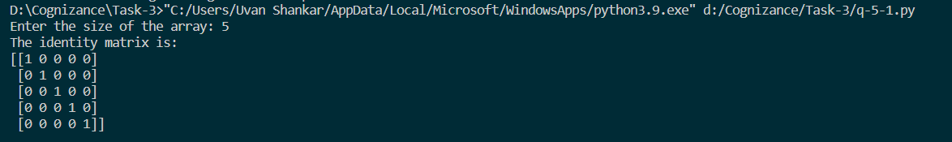

Q-5-2

