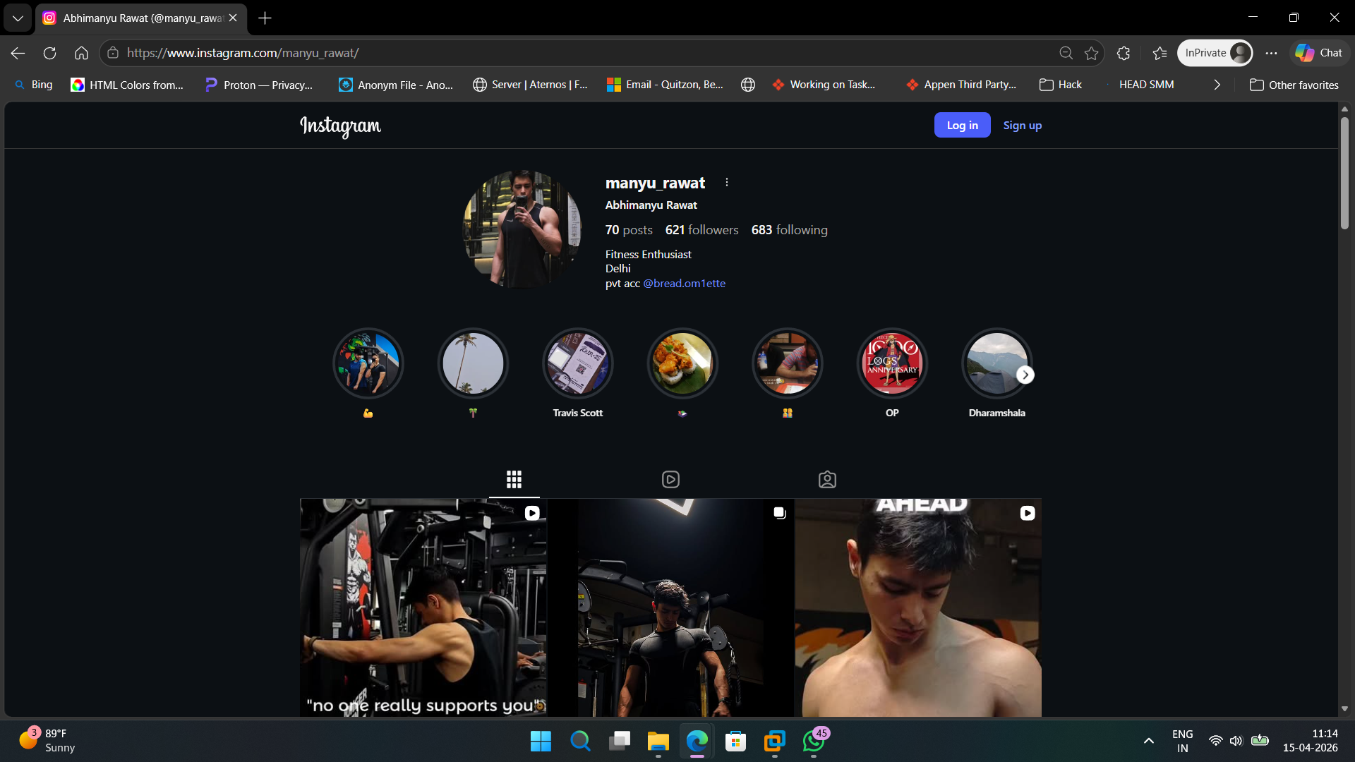

- Account is Open, All highlights are visible
- All post, followers and following are visible
- Bio dosent have much but leads to another ID of the user

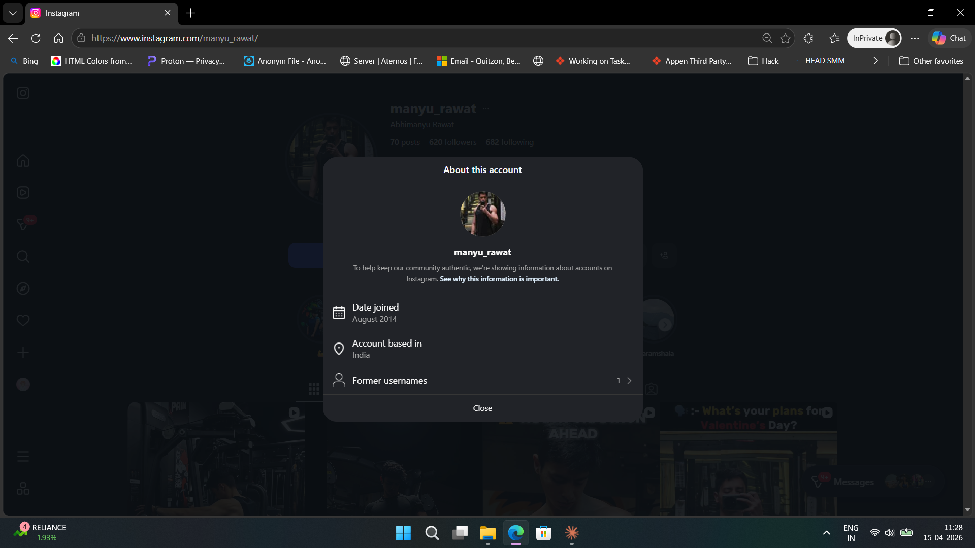
- Determine how legit the account is, date it was created, no of times username changed

