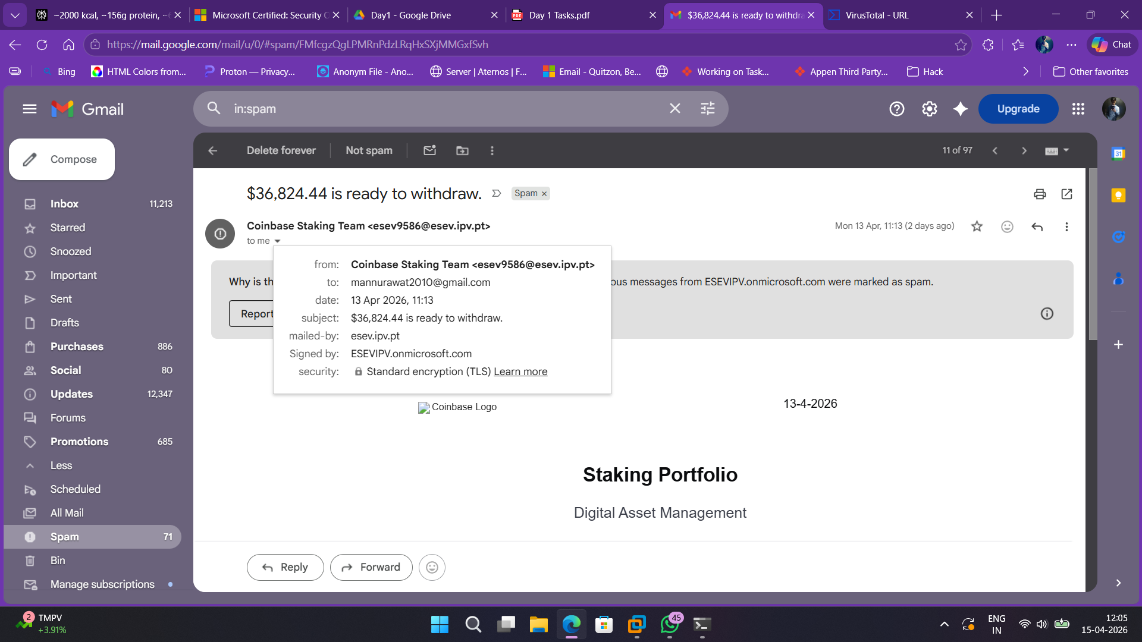

- Not valid coinbase domain, suspicious domain esev9586@esev.ipv.pt
- To good to be true offer - $36,824.44 is ready to withdraw
- Previous connection with domain ESEVIPV.onmicrosoft.com which is already a spam

D1-05

INCIDENT REPORT – Phishing Click Simulation

Date: April 15, 2026
Analyst Name: Abhimanyu Singh Rawat

Scenario: User received a phishing email impersonating Coinbase,
claiming "$36,824.44 is ready to withdraw" sent from
esev9586@esev.ipv.pt

Initial Actions:
1. Marked email as phishing and did not click any links or attachments
2. Noted the sender domain and cross-referenced against
Coinbase's legitimate domain (@coinbase.com) — mismatch confirmed

Evidence Collected:
- Sender esev9586@esev.ipv.pt,
associated with ESEVIPV.onmicrosoft.com
- Attached withdrawal link pointing to a
non-Coinbase domain

Containment Steps:
1. Blocked sender domain (esev.ipv.pt) and
ESEVIPV.onmicrosoft.com at endpoint level from gmail client and further emails from this
2. Reported phishing email to gmail from the options

Next Steps / Recommendations:
- Flag ESEVIPV.onmicrosoft.com to the team and discuss
- Add email gateway rule to block emails
- Conduct user awareness training on phishing

