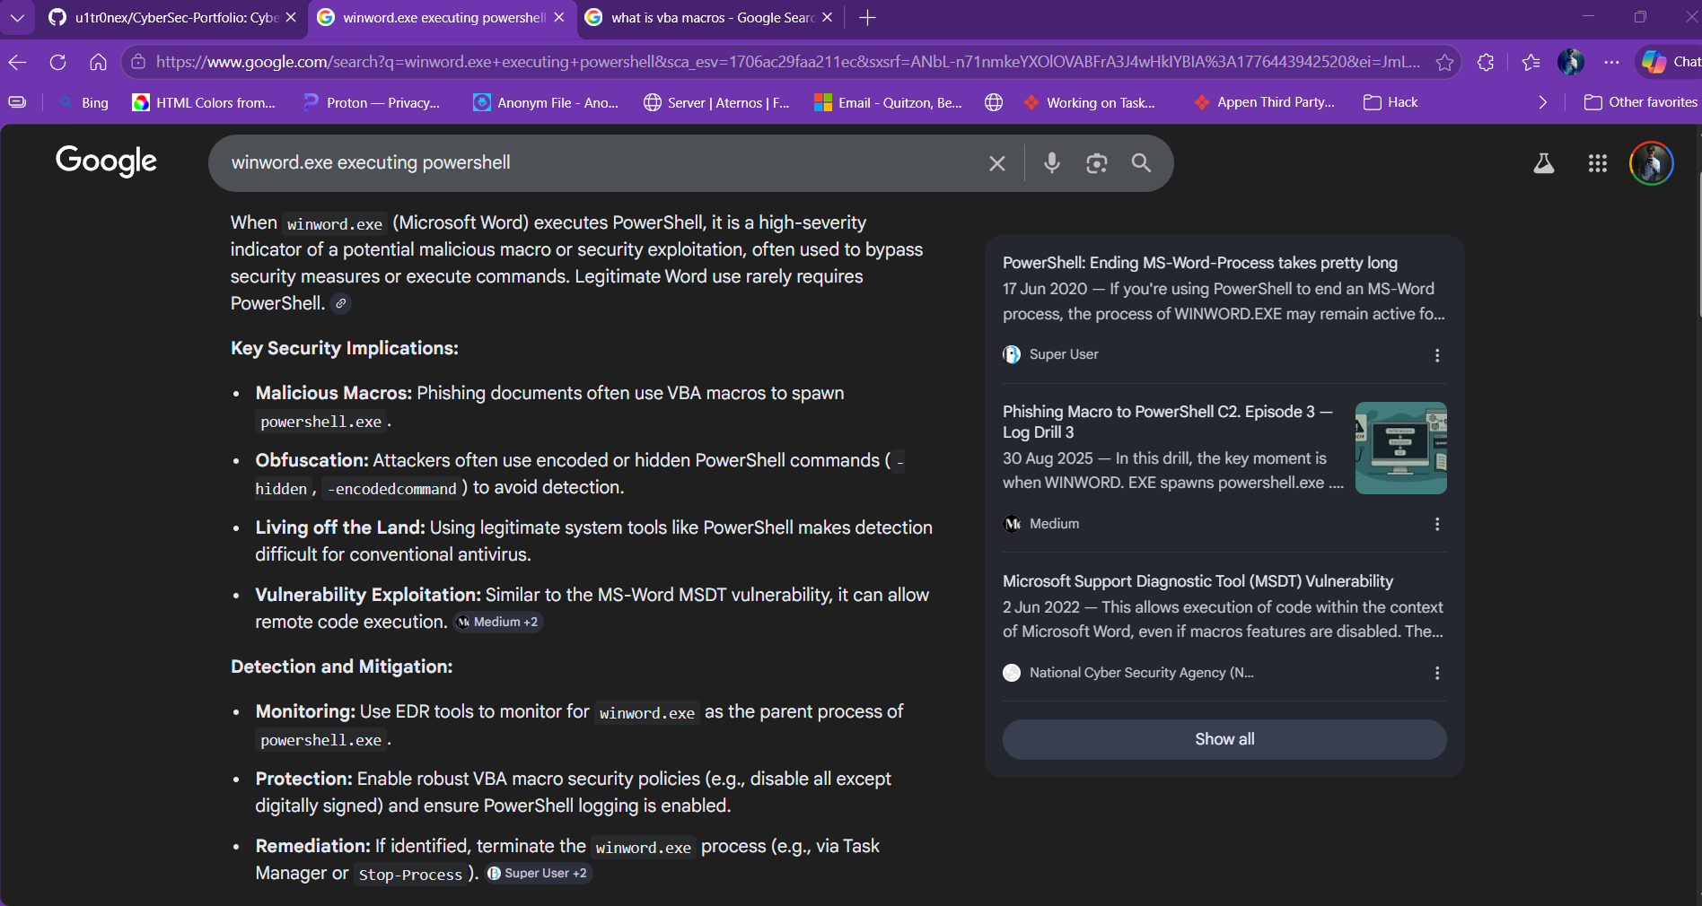
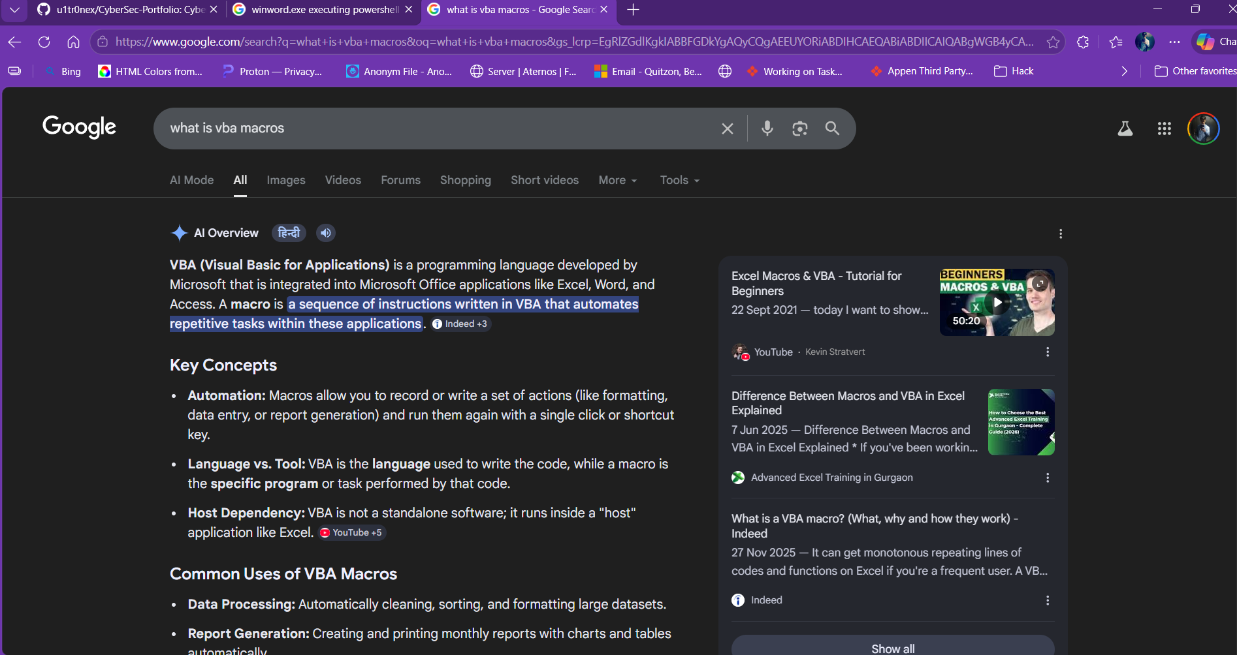

Winword.exe is the executable file for Microsoft Word. The trigger of PowerShell is caused by the macros, which use VBA(Visual Basic Application) language to run tasks and routines for the word like deletion, daily modifications, saves, etc., but hackers take advantage of this to inject malicious code into macros, which may lead to a true positive like this.

