Windows
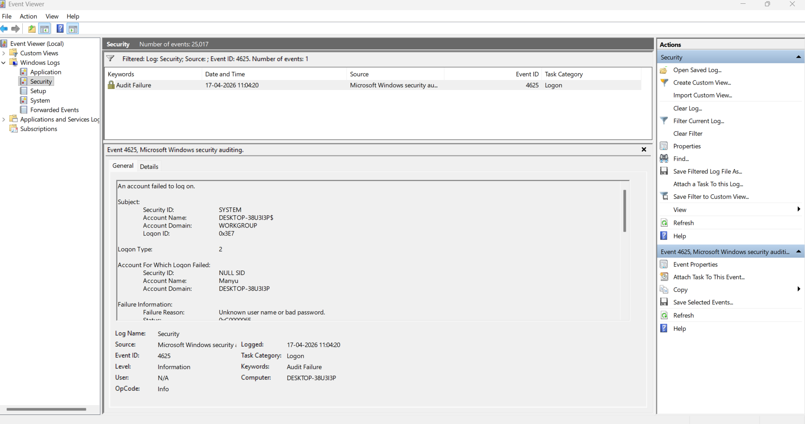

No of events: 1

Kali Linux
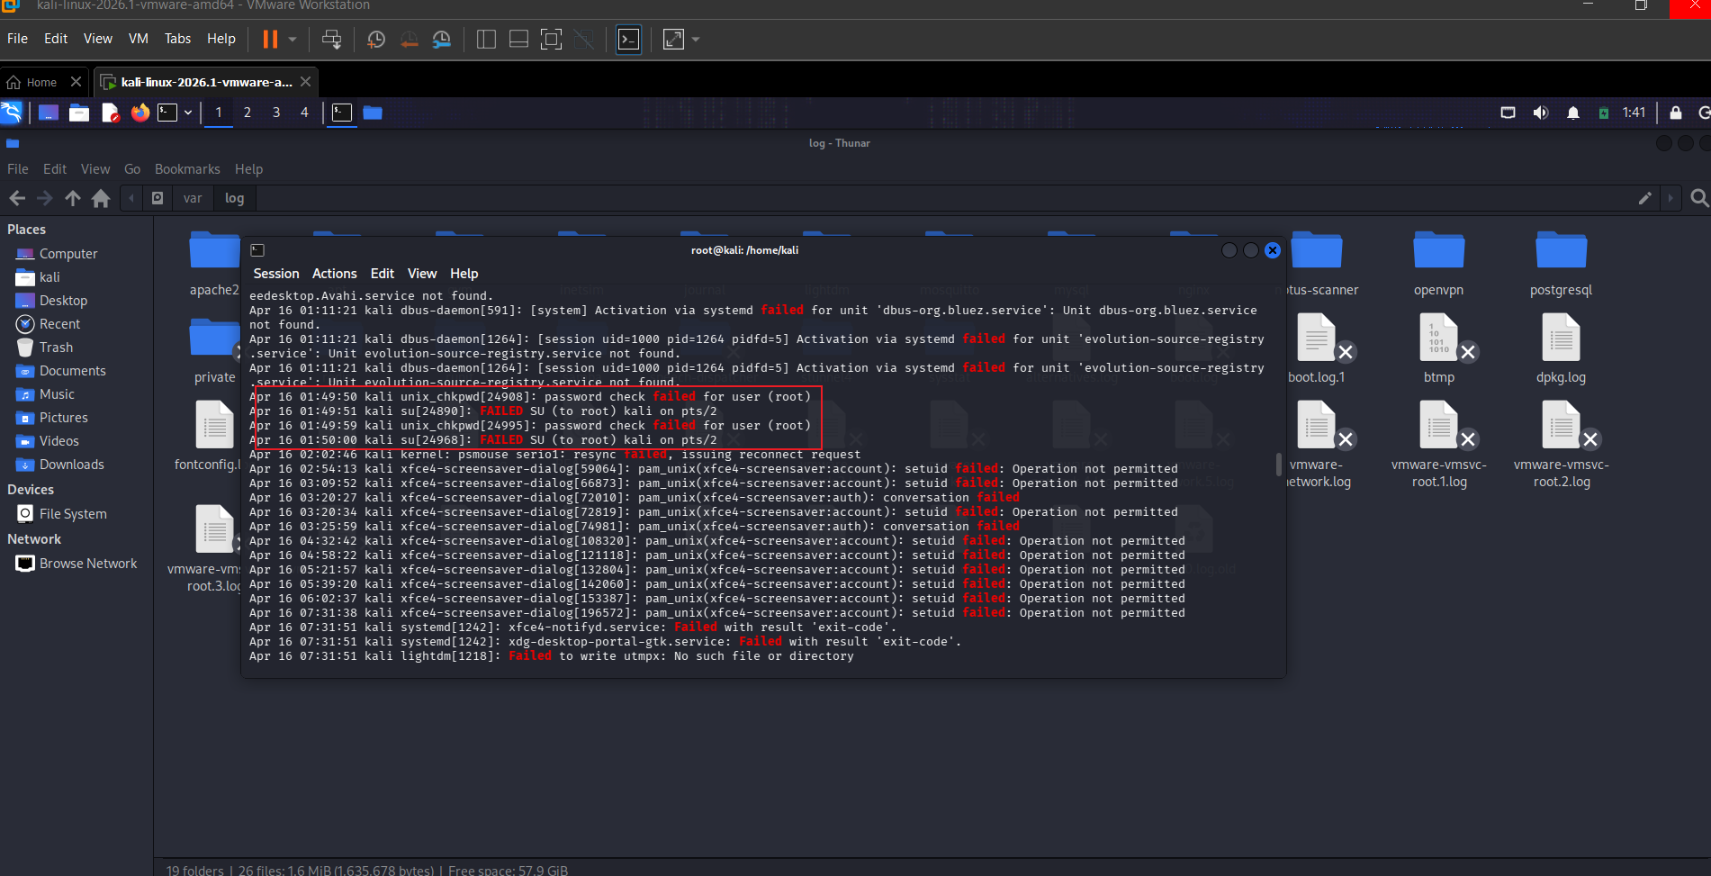

Lastb has been removed in kali after 2026.01 build dur to the year 2038 problem in btmp, a computing bug which will occur on jan 19 2038.

Commands used:

journalctl | grep -i “failed”
No. of events: 4

