Windows
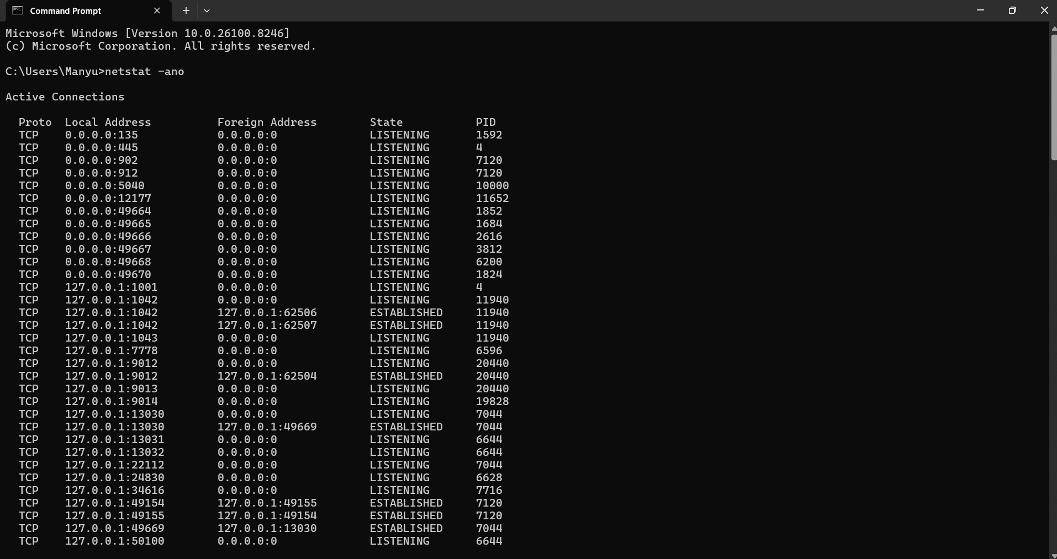

Microsoft Windows [Version 10.0.26100.8246]
(c) Microsoft Corporation. All rights reserved.

C:\Users\Manyu>netstat -ano

Active Connections

Proto Local Address Foreign Address State PID
TCP 0.0.0.0:135 0.0.0.0:0 LISTENING 1592
TCP 0.0.0.0:445 0.0.0.0:0 LISTENING 4
TCP 0.0.0.0:902 0.0.0.0:0 LISTENING 7120
TCP 0.0.0.0:912 0.0.0.0:0 LISTENING 7120
TCP 0.0.0.0:5040 0.0.0.0:0 LISTENING 10000
TCP 0.0.0.0:12177 0.0.0.0:0 LISTENING 11652
TCP 0.0.0.0:49664 0.0.0.0:0 LISTENING 1852
TCP 0.0.0.0:49665 0.0.0.0:0 LISTENING 1684
TCP 0.0.0.0:49666 0.0.0.0:0 LISTENING 2616
TCP 0.0.0.0:49667 0.0.0.0:0 LISTENING 3812
TCP 0.0.0.0:49668 0.0.0.0:0 LISTENING 6200
TCP 0.0.0.0:49670 0.0.0.0:0 LISTENING 1824
TCP 127.0.0.1:1001 0.0.0.0:0 LISTENING 4
TCP 127.0.0.1:1042 0.0.0.0:0 LISTENING 11940
TCP 127.0.0.1:1042 127.0.0.1:62506 ESTABLISHED 11940
TCP 127.0.0.1:1042 127.0.0.1:62507 ESTABLISHED 11940
TCP 127.0.0.1:1043 0.0.0.0:0 LISTENING 11940
TCP 127.0.0.1:7778 0.0.0.0:0 LISTENING 6596
TCP 127.0.0.1:9012 0.0.0.0:0 LISTENING 20440
TCP 127.0.0.1:9012 127.0.0.1:62504 ESTABLISHED 20440
TCP 127.0.0.1:9013 0.0.0.0:0 LISTENING 20440
TCP 127.0.0.1:9014 0.0.0.0:0 LISTENING 19828
TCP 127.0.0.1:13030 0.0.0.0:0 LISTENING 7044
TCP 127.0.0.1:13030 127.0.0.1:49669 ESTABLISHED 7044
TCP 127.0.0.1:13031 0.0.0.0:0 LISTENING 6644
TCP 127.0.0.1:13032 0.0.0.0:0 LISTENING 6644
TCP 127.0.0.1:22112 0.0.0.0:0 LISTENING 7044
TCP 127.0.0.1:24830 0.0.0.0:0 LISTENING 6628
TCP 127.0.0.1:34616 0.0.0.0:0 LISTENING 7716
TCP 127.0.0.1:49154 127.0.0.1:49155 ESTABLISHED 7120
TCP 127.0.0.1:49155 127.0.0.1:49154 ESTABLISHED 7120
TCP 127.0.0.1:49669 127.0.0.1:13030 ESTABLISHED 7044
TCP 127.0.0.1:50100 0.0.0.0:0 LISTENING 6644
TCP 127.0.0.1:50100 127.0.0.1:63419 ESTABLISHED 6644
TCP 127.0.0.1:50923 0.0.0.0:0 LISTENING 6596
TCP 127.0.0.1:51100 0.0.0.0:0 LISTENING 11652
TCP 127.0.0.1:57301 127.0.0.1:63422 ESTABLISHED 18324
TCP 127.0.0.1:62504 127.0.0.1:9012 ESTABLISHED 11652
TCP 127.0.0.1:62506 127.0.0.1:1042 ESTABLISHED 28440
TCP 127.0.0.1:62507 127.0.0.1:1042 ESTABLISHED 20440
TCP 127.0.0.1:63419 127.0.0.1:50100 ESTABLISHED 11652
TCP 127.0.0.1:63422 0.0.0.0:0 LISTENING 27004
TCP 127.0.0.1:63422 127.0.0.1:57301 ESTABLISHED 27004
TCP 192.168.1.3:139 0.0.0.0:0 LISTENING 4
TCP 192.168.1.3:49420 4.213.25.241:443 ESTABLISHED 5940
TCP 192.168.1.3:50664 20.42.65.84:443 ESTABLISHED 18324
TCP 192.168.1.3:50672 172.188.155.25:443 ESTABLISHED 18324
TCP 192.168.1.3:51259 44.193.140.57:443 ESTABLISHED 18324
TCP 192.168.1.3:52400 52.123.129.14:443 ESTABLISHED 6876
TCP 192.168.1.3:53067 54.192.142.18:443 ESTABLISHED 18324
TCP 192.168.1.3:55316 44.213.242.156:443 ESTABLISHED 18324
TCP 192.168.1.3:55768 52.1.184.81:443 ESTABLISHED 18324
TCP 192.168.1.3:55769 52.140.118.28:443 TIME_WAIT 0
TCP 192.168.1.3:55770 52.140.118.28:443 TIME_WAIT 0
TCP 192.168.1.3:55771 52.140.118.28:443 TIME_WAIT 0
TCP 192.168.1.3:56193 44.213.242.156:443 ESTABLISHED 18324
TCP 192.168.1.3:57067 52.1.184.81:443 ESTABLISHED 18324
TCP 192.168.1.3:58511 104.18.26.48:443 ESTABLISHED 21636
TCP 192.168.1.3:58719 100.51.130.179:443 ESTABLISHED 18324
TCP 192.168.1.3:59282 18.211.27.106:443 ESTABLISHED 18324
TCP 192.168.1.3:59584 13.201.105.215:443 ESTABLISHED 18324
TCP 192.168.1.3:59822 172.66.147.20:443 ESTABLISHED 18324
TCP 192.168.1.3:60185 104.18.1.46:443 ESTABLISHED 18324
TCP 192.168.1.3:60661 18.211.27.106:443 ESTABLISHED 18324
TCP 192.168.1.3:60662 3.233.158.111:443 ESTABLISHED 21636
TCP 192.168.1.3:60663 3.233.158.111:443 ESTABLISHED 21636
TCP 192.168.1.3:63162 13.225.103.89:443 ESTABLISHED 18324
TCP 192.168.1.3:63542 34.201.254.173:443 ESTABLISHED 18324
TCP 192.168.1.3:64041 104.20.2.154:443 ESTABLISHED 18324
TCP 192.168.59.1:139 0.0.0.0:0 LISTENING 4
TCP 192.168.153.1:139 0.0.0.0:0 LISTENING 4
TCP [::]:135 [::]:0 LISTENING 1592
TCP [::]:445 [::]:0 LISTENING 4
TCP [::]:49664 [::]:0 LISTENING 1852
TCP [::]:49665 [::]:0 LISTENING 1684
TCP [::]:49666 [::]:0 LISTENING 2616
TCP [::]:49667 [::]:0 LISTENING 3812
TCP [::]:49668 [::]:0 LISTENING 6200
TCP [::]:49670 [::]:0 LISTENING 1824
TCP [::1]:34616 [::]:0 LISTENING 7716
TCP [::1]:34616 [::1]:52392 ESTABLISHED 7716
TCP [::1]:49156 [::1]:49157 ESTABLISHED 24832
TCP [::1]:49157 [::1]:49156 ESTABLISHED 24832
TCP [::1]:52392 [::1]:34616 ESTABLISHED 22700
UDP 0.0.0.0:500 *:* 6844
UDP 0.0.0.0:4500 *:* 6844
UDP 0.0.0.0:5050 *:* 10000
UDP 0.0.0.0:5353 *:* 10544
UDP 0.0.0.0:5353 *:* 10544
UDP 0.0.0.0:5353 *:* 10544
UDP 0.0.0.0:5353 *:* 10544
UDP 0.0.0.0:5353 *:* 10544
UDP 0.0.0.0:5353 *:* 10544
UDP 0.0.0.0:5353 *:* 2704
UDP 0.0.0.0:5355 *:* 2704
UDP 0.0.0.0:49824 8.8.8.8:443 18324
UDP 0.0.0.0:50173 *:* 2704
UDP 0.0.0.0:50282 142.250.73.142:443 18324
UDP 0.0.0.0:53050 142.250.182.238:443 18324
UDP 0.0.0.0:54627 142.251.46.74:443 18324
UDP 0.0.0.0:56020 *:* 2704
UDP 0.0.0.0:62477 142.251.223.195:443 18324
UDP 0.0.0.0:64397 *:* 2704
UDP 127.0.0.1:1900 *:* 8944
UDP 127.0.0.1:51238 *:* 6112
UDP 127.0.0.1:51988 127.0.0.1:51988 6864
UDP 127.0.0.1:57947 *:* 8944
UDP 192.168.1.3:137 *:* 4
UDP 192.168.1.3:138 *:* 4
UDP 192.168.1.3:1900 *:* 8944
UDP 192.168.1.3:2177 *:* 6384
UDP 192.168.1.3:57946 *:* 8944
UDP 192.168.59.1:137 *:* 4
UDP 192.168.59.1:138 *:* 4
UDP 192.168.59.1:1900 *:* 8944
UDP 192.168.59.1:2177 *:* 6384
UDP 192.168.59.1:57944 *:* 8944
UDP 192.168.153.1:137 *:* 4
UDP 192.168.153.1:138 *:* 4
UDP 192.168.153.1:1900 *:* 8944
UDP 192.168.153.1:2177 *:* 6384
UDP 192.168.153.1:57945 *:* 8944
UDP [::]:500 *:* 6844
UDP [::]:4500 *:* 6844
UDP [::]:5353 *:* 10544
UDP [::]:5353 *:* 2704
UDP [::]:5353 *:* 10544
UDP [::]:5353 *:* 10544
UDP [::]:5355 *:* 2704
UDP [::]:50173 *:* 2704
UDP [::]:56020 *:* 2704
UDP [::]:64397 *:* 2704
UDP [::1]:1900 *:* 8944
UDP [::1]:57943 *:* 8944
UDP [fe80::4144:2d09:2953:66f3%9]:1900 *:* 8944
UDP [fe80::4144:2d09:2953:66f3%9]:2177 *:* 6384
UDP [fe80::4144:2d09:2953:66f3%9]:57940 *:* 8944
UDP [fe80::54cb:c2ca:cdb1:af6a%20]:1900 *:* 8944
UDP [fe80::54cb:c2ca:cdb1:af6a%20]:2177 *:* 6384
UDP [fe80::54cb:c2ca:cdb1:af6a%20]:57941 *:* 8944
UDP [fe80::f274:31:467:af3d%18]:1900 *:* 8944
UDP [fe80::f274:31:467:af3d%18]:2177 *:* 6384
UDP [fe80::f274:31:467:af3d%18]:57942 *:* 8944

IP 185.130.5.253 was NOT present in netstat output.
No connection on port 4444 detected.

Linux

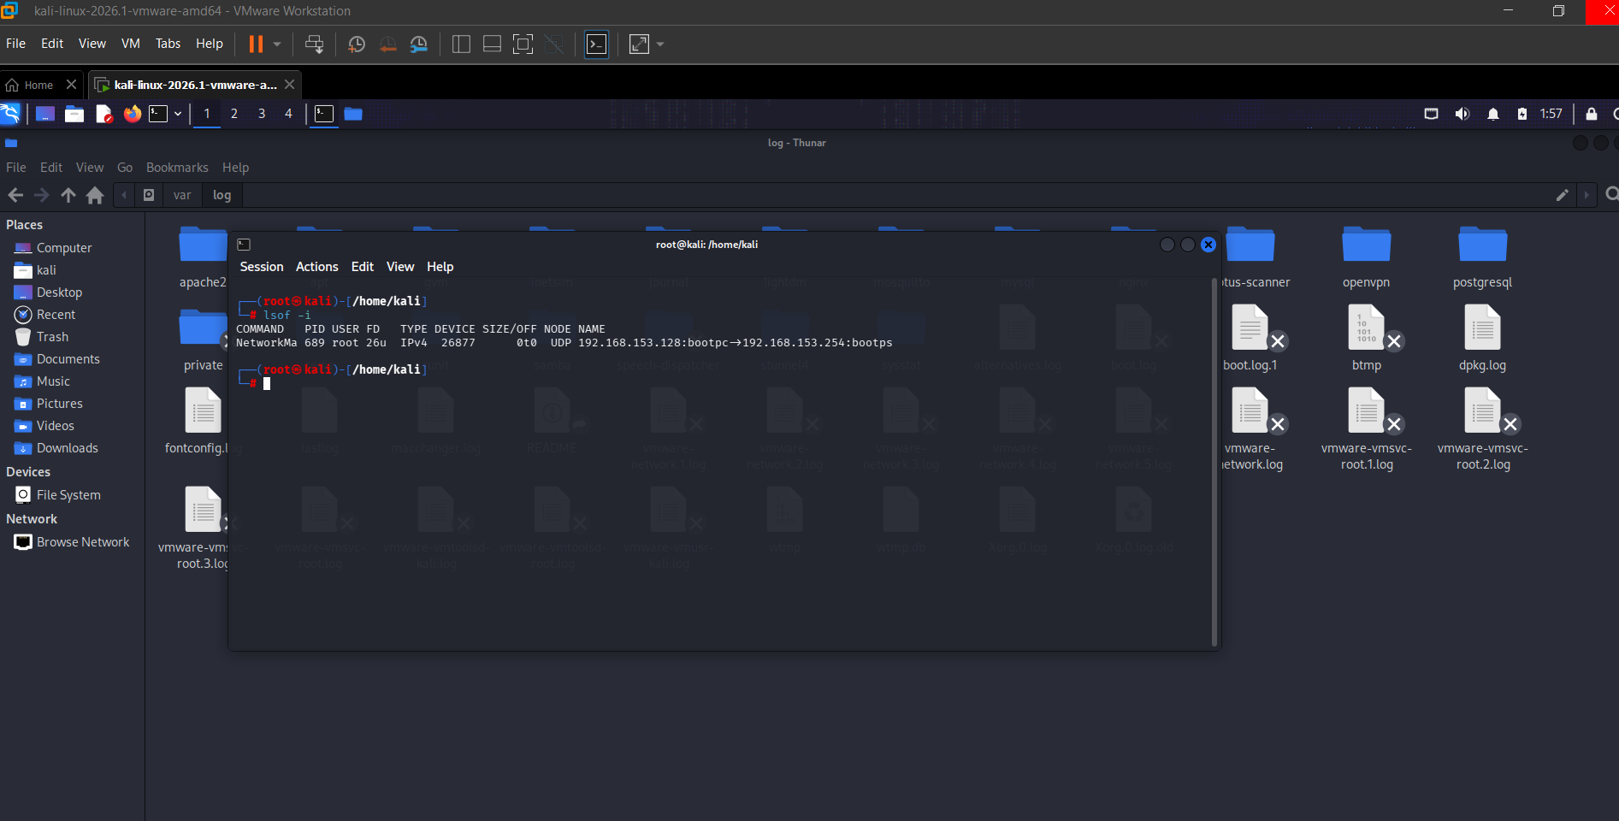
Linux Verification (Kali VM):
Command: lsof -i
Result: Single connection found, but not suspicious.

