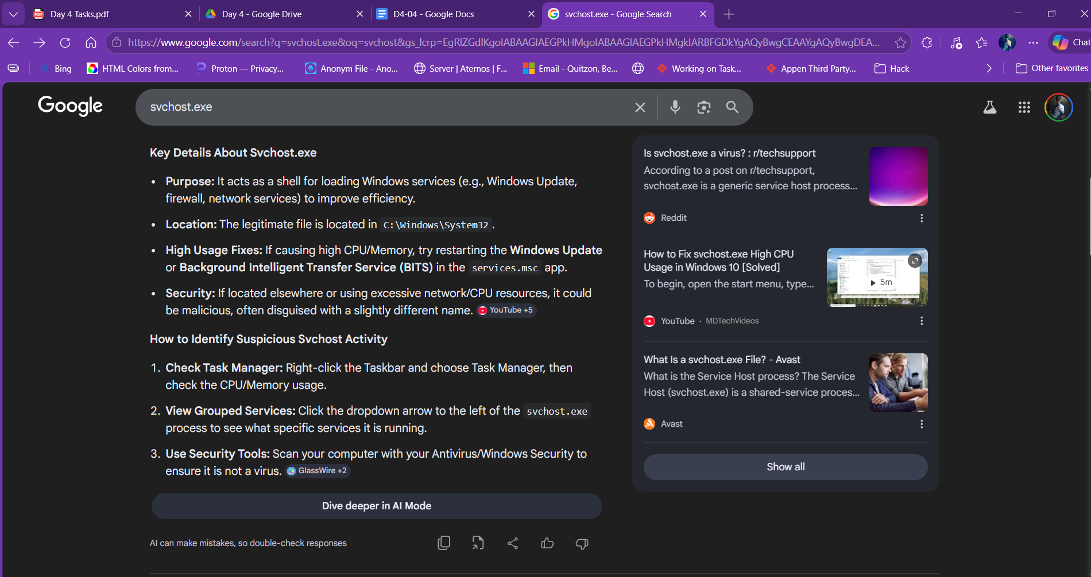
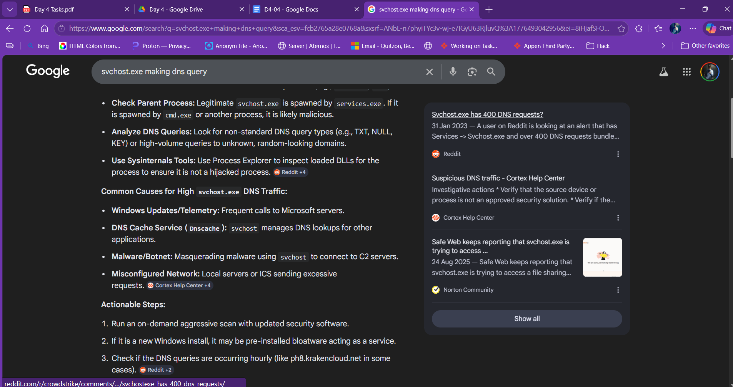

Svchost.exe is a windows process that hold multiple background services using DLLs (Dynamic Link Libraries) which also includes dns query service (dnscache) where it resolves the host name. However, if the mount of query is absurdly high , it might be due to malicious process and should be further inspected.

To show all svchost and theri services usec command
tasklist /svc /fi "imagename eq svchost.exe"

