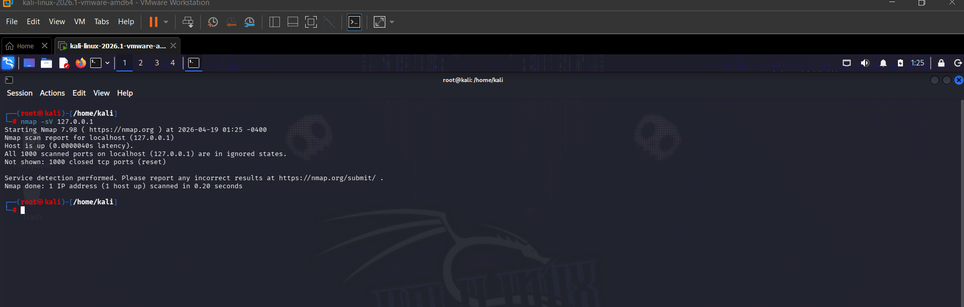

All 1000 scanned TCP ports are in closed/reset state.
No open ports or running services detected on localhost.

