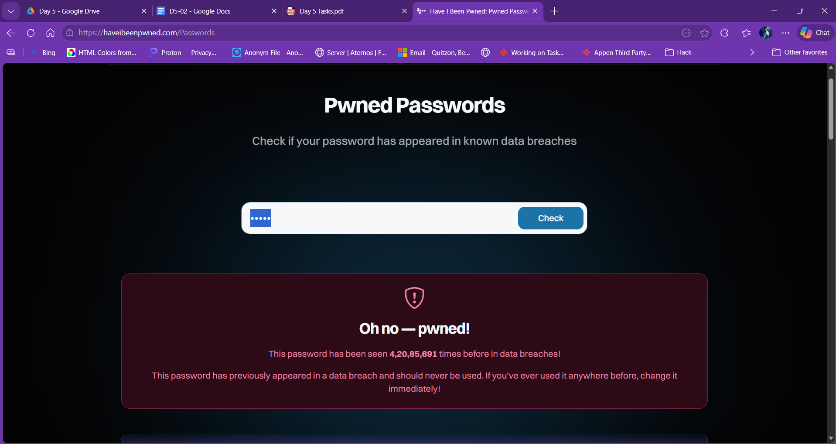

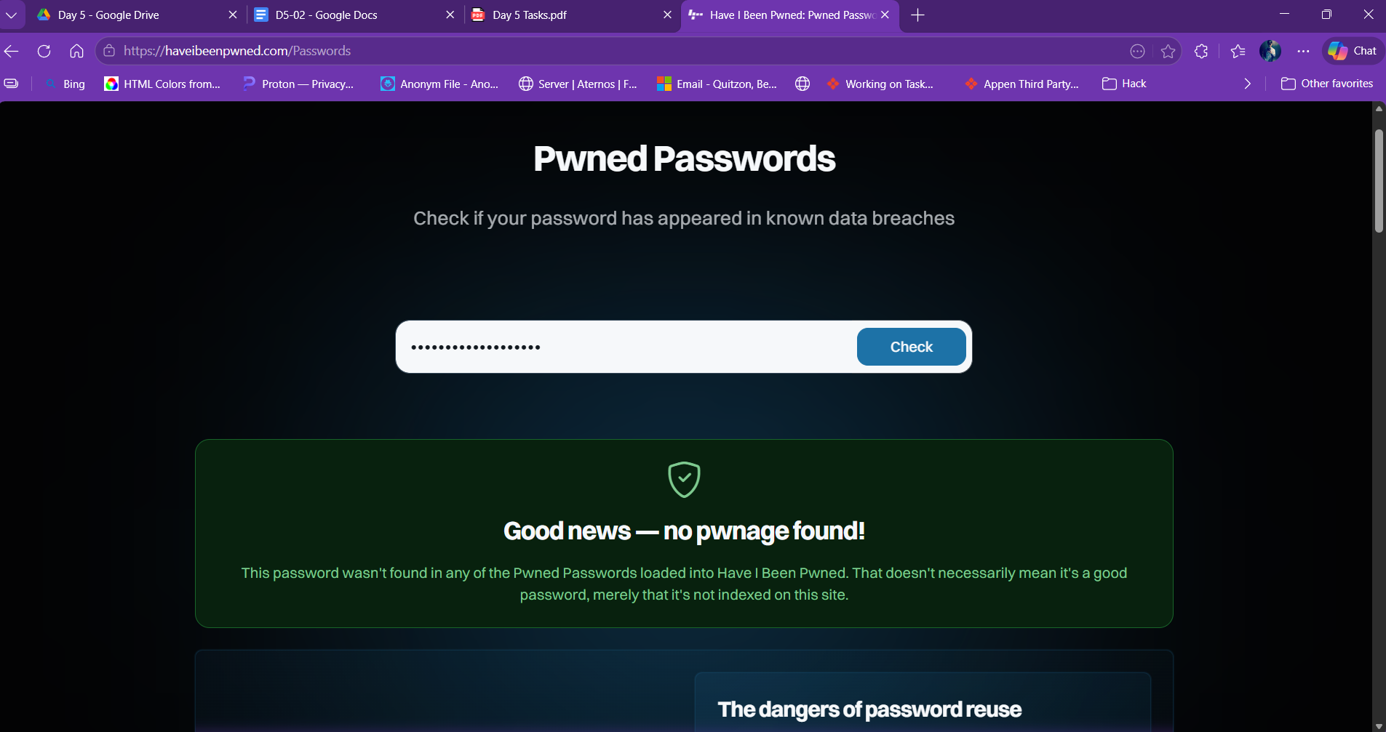

Passwords Tested:

1. password123 – PWNED (found in breach databases)
2. administrator – PWNED (found in breach databases)
3. admin – PWNED (found in breach databases)
4. Youngdumbroke@6497 – NOT PWNED (no breach records found)

Conclusion:
Weak passwords like "admin" and "password123" appear in
millions of credential dumps and are the first entries
tried in any brute force or credential stuffing attack.
A strong password combining uppercase, lowercase, numbers,
and special characters with sufficient length — such as
Youngdumbroke@6497 — has no recorded breach exposure and
would resist dictionary and brute force attacks.

MITRE ATT&CK: T1110.003 – Brute Force: Password Spraying
T1110.001 – Brute Force: Password Guessing

