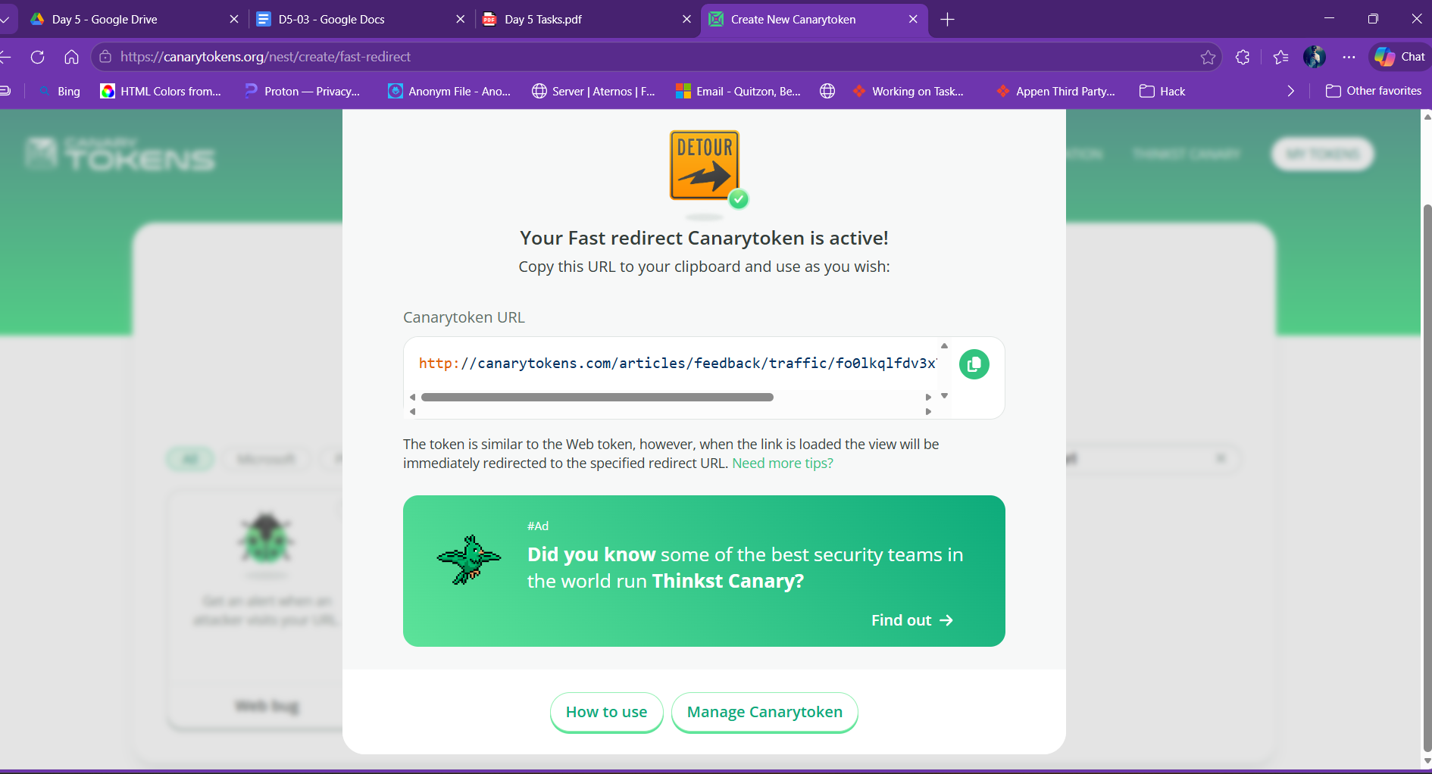

Click here to view your 10,000$ invoice.

Attackers embed Canarytoken-style tracking URLs inside fake invoice PDFs or phishing mails. When the target opens the document or clicks the link, the attacker receives the victim's IP address and device information silently — without any malware being installed.

