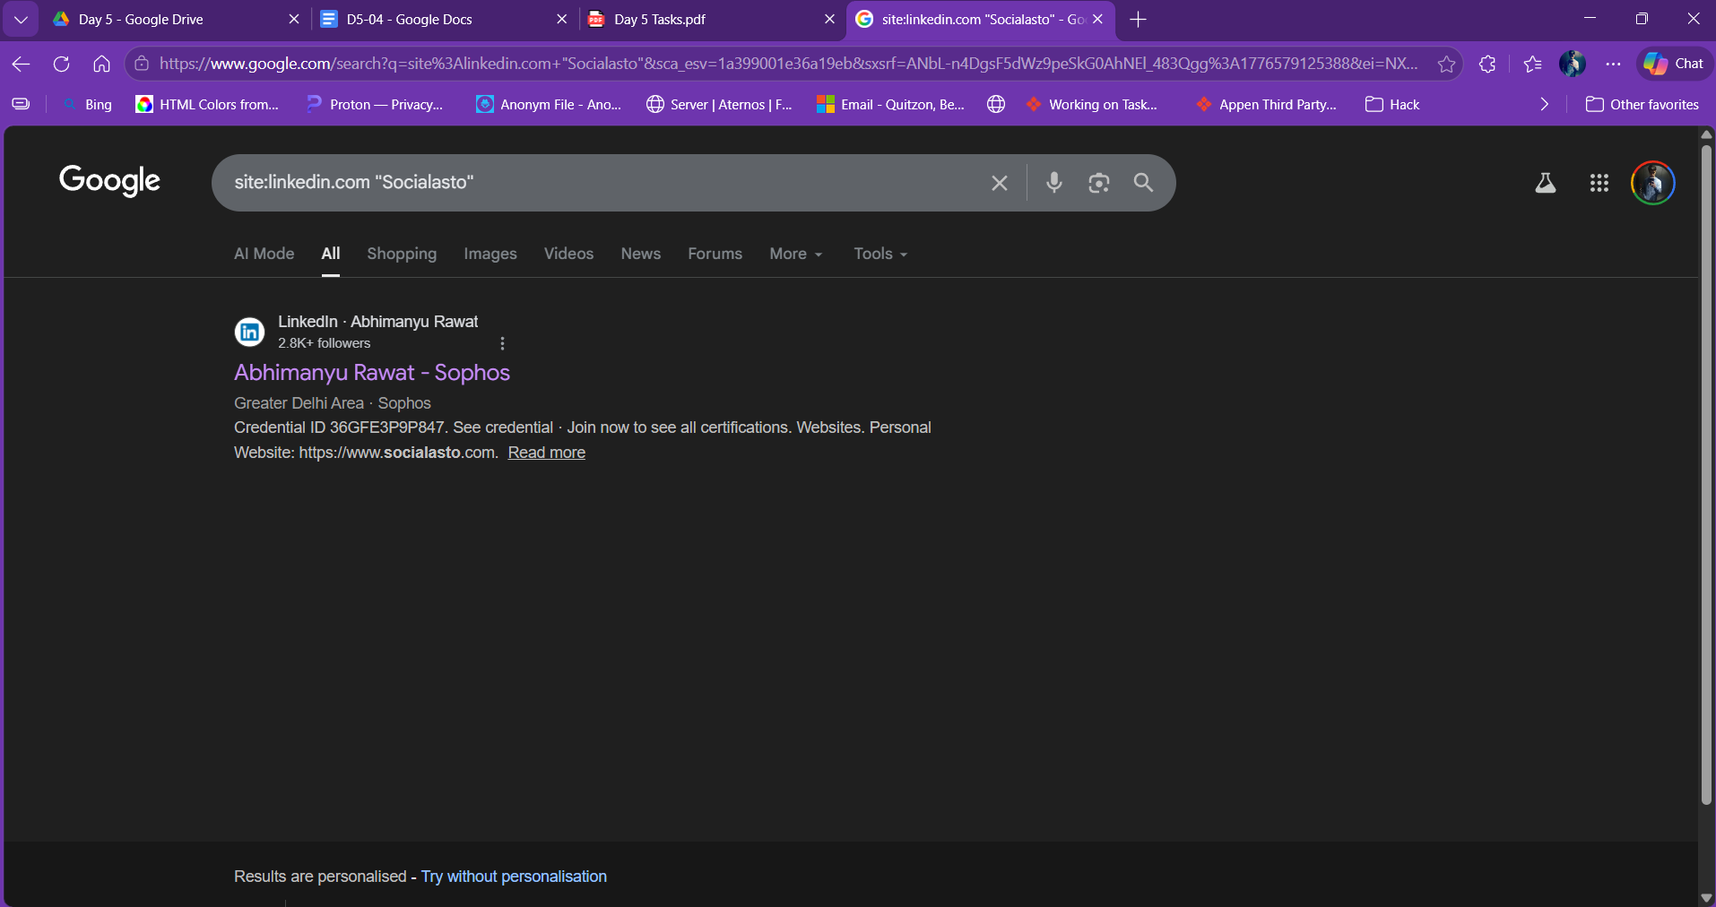
site:linkedin.com "Socialasto"

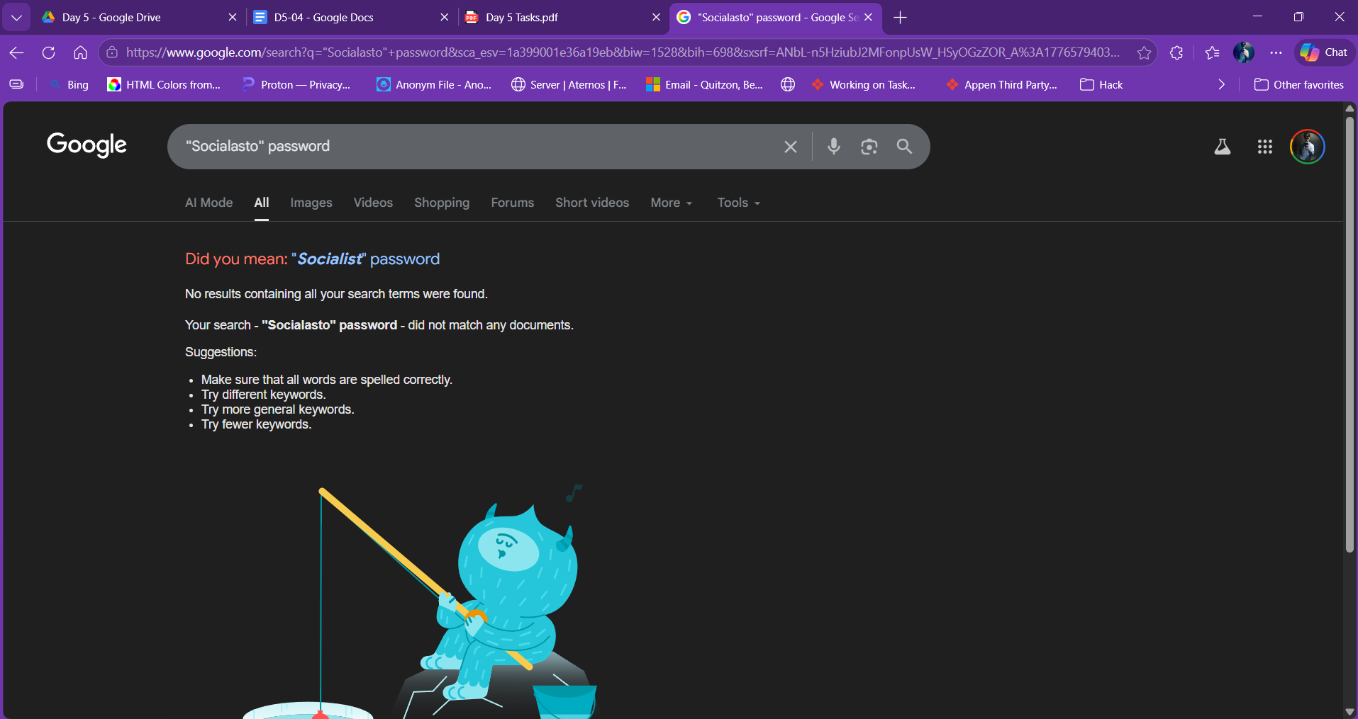
"Socialasto" password

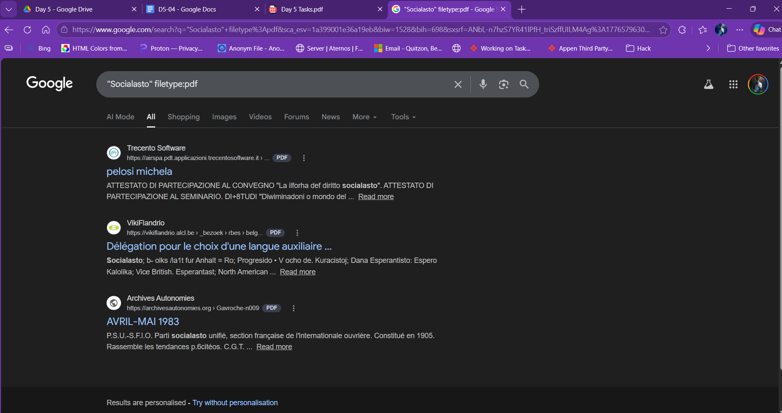
“Socialasto” filetype:pdf

3 Pieces of Information Useful to an Attacker:

1. Employee names and job titles via LinkedIn Enables targeted spearphishing by identifying the IT admin, CEO, or finance team by name.

2. Searching "Socialasto" + "password" may password leaks from forums and pastebin etc
3. Public documents revealing internal infrastructure PDFs like reports or technical docs

