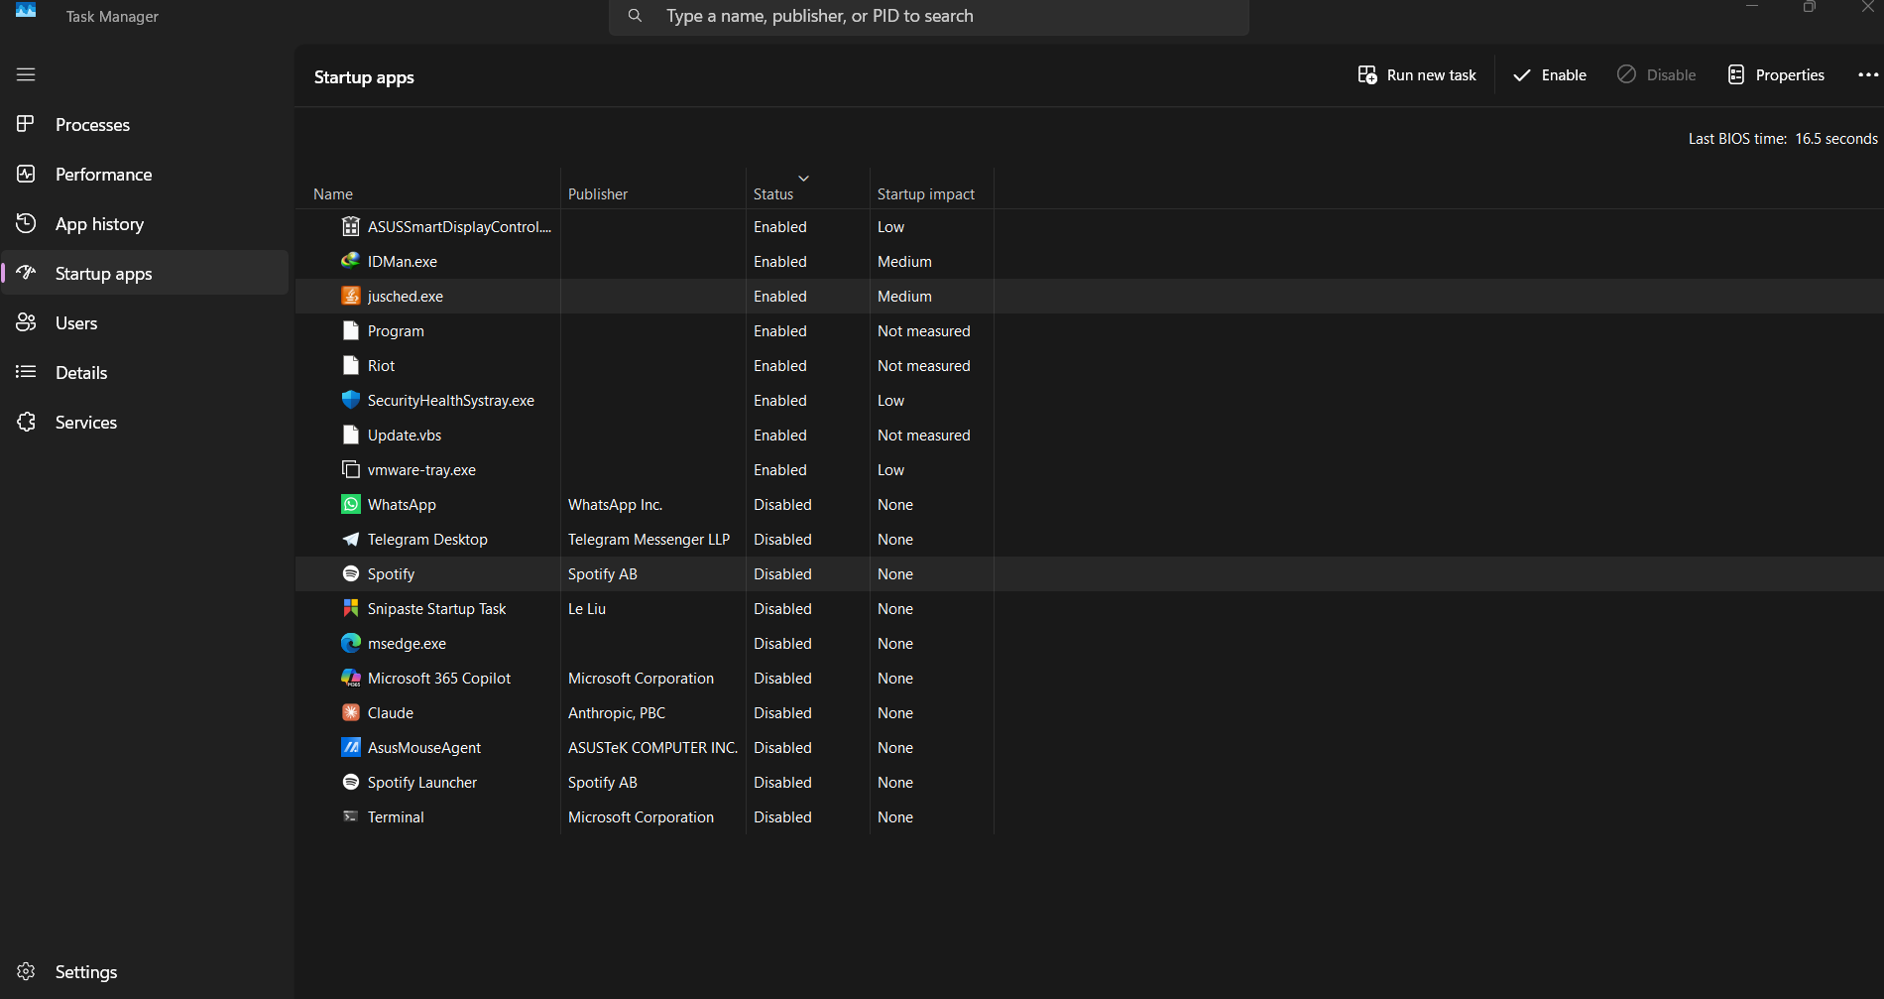

Tool used: Task Manager – Startup Apps (Windows)

Startup Items List (Enabled):

Name
- ASUSSmartDisplayControl
- IDMan.exe
- jusched.exe
- Riot
- SecurityHealthSystray.exe
- Program
- Update.vbs
- vmware-tray.exe
- SecurityHealthSystray.exe

Legitimate Entry: SecurityHealthSystray.exe - Windows security health tray icon used for notification of antivirus and firewall.

Suspicious/Unnecessary Entry:
Update.vbs – A VBScript (.vbs) file in the startup list
with no publisher listed and impact "Not measured" is a
significant red flag. VBScript is commonly used by malware
and adware to execute payloads at boot. Legitimate software
rarely uses .vbs files as startup entries.

Secondary Flag:
"Program" – An entry named simply "Program" with no
publisher and not measured impact. This often
indicates a broken or incomplete registry startup entry,
or a renamed malicious executable.

