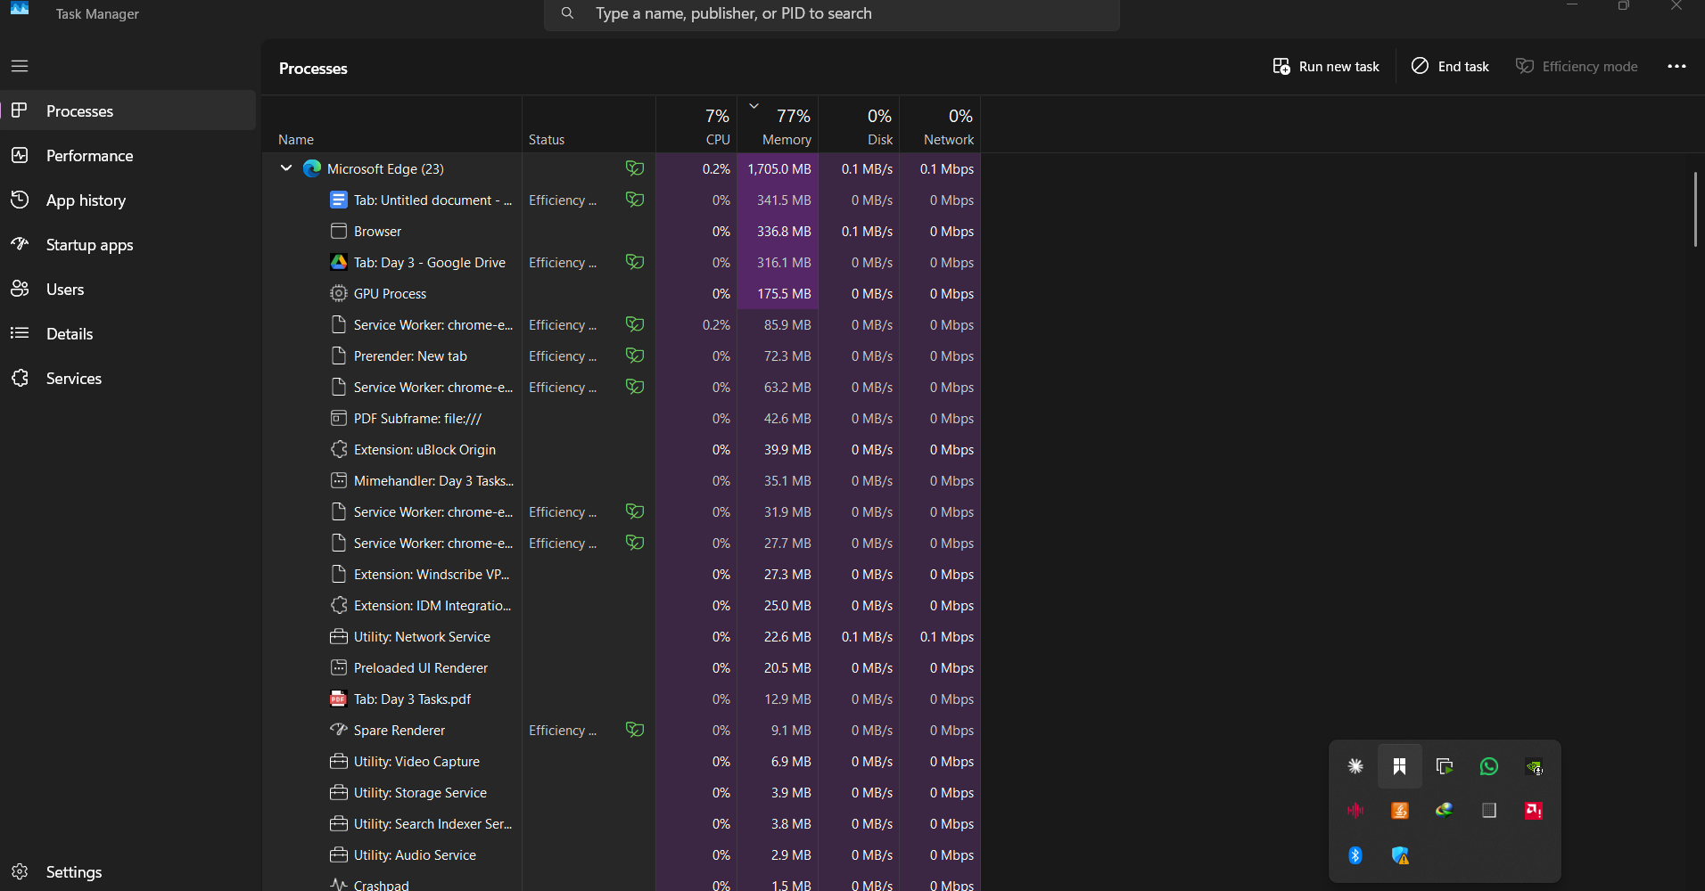

Tree of Microsoft Edge showing 21 sub-branches/child processes

