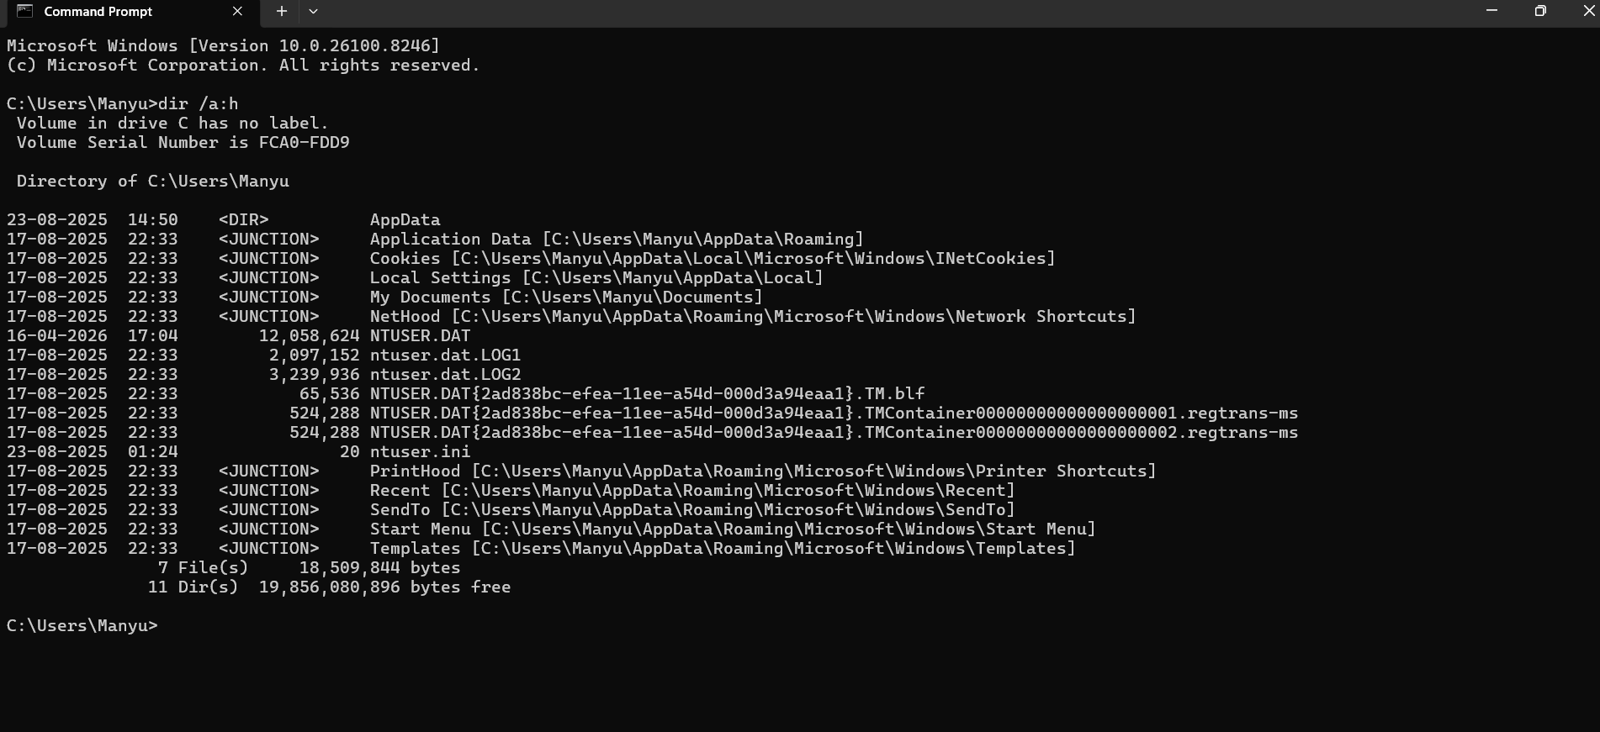

Scan revealed standard hidden system files. No suspicious naming patterns or double extensions were detected, indicating a low immediate risk.

