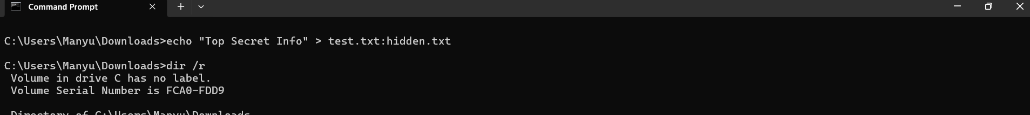
Created an ADS in test.txt file
Command used: echo "Top Secret Info" > test.txt:hidden.txt
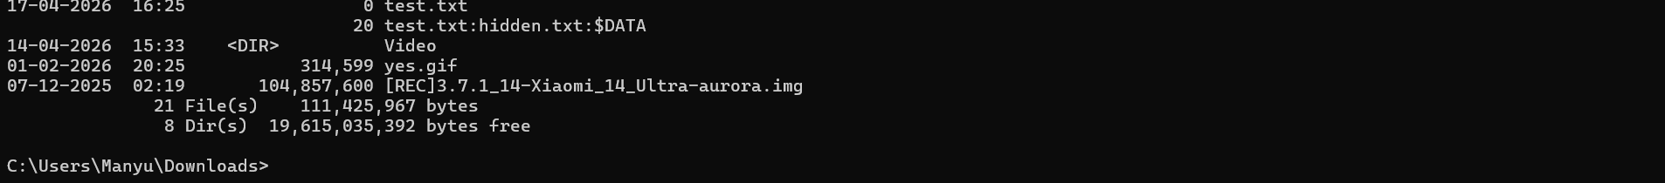

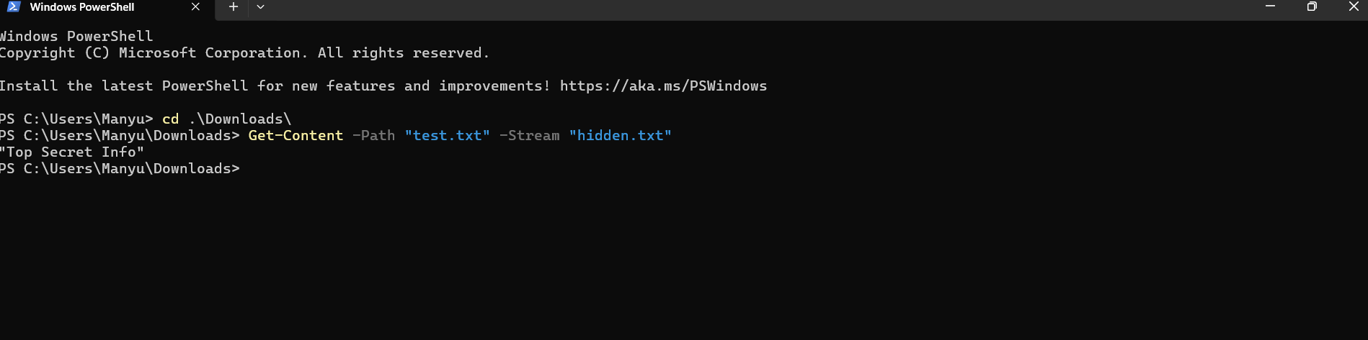
Verified using Powershell
Command: Get-Content -Path "test.txt" -Stream "hidden.txt"

