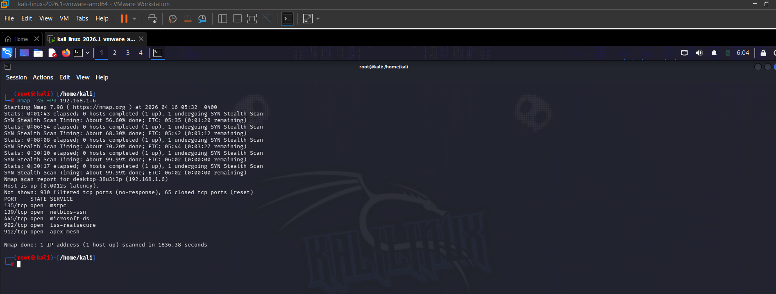

Scanned my windows machine and some of the ports open were:
Port 445 – Microsoft-DS (SMB – File and Printer Sharing)
Port 139 – NetBIOS-SSN (Windows Network File Sharing)
Port 135 – MSRPC (Windows Remote Procedure Call)
Port 902 – VMware
Port 912 - Vmware

